* **Structural Design Pattern**
* **Introduction:**

Structural patterns deal with how classes and objects are arranged or composed.

* **List of Structural Design Patterns:**
  + **Adapter**
  + **Bridge**
  + **Decorator**
  + **Composite**
  + **Façade**
  + **Flyweight**
  + **Proxy**
* **Adapter Introduction:**

What is Adapter?

* + We have an existing object which provides functionality that client needs. But client code can’t use this object because it expects an object with different interface.
  + Using adapter design pattern we make this existing object work with client by adapting the object to client’s expected interface.
  + This patter is also called as “Wrapper” as it “Wraps” existing object.
  + Note: There are two different implementations available, class adapter / two way adapter and object adapter.
* **UML:**

* **Implementation Steps:**
  + We start by creating a class for Adapter
    - Adapter must implement the interface expected by the client.
    - First we are going to try out a class adapter by also extending from our existing class.
    - In the class adapter implementation we’re simply going to forward the method to another method inherited from adaptee.
    - Next for object adapter, we are only going to implement target interface and accept adaptee as constructor argument i.e. make use of composition.
    - An object adapter should take adaptee as an argument in constructor or as a less preferred solution, you can instantiate it in the constructor thus tightly coupling with a specific adaptee.
* **Example UML:**

* **Implementation & Design Consideration:**

**Implementation Consideration:**

* + How much work the adapter does depends upon the differences between target interface and object being adapted. If method arguments are same or similar adapter has very less work to do.
  + Using class adapter “allows” you to override some of the adaptee’s behaviour. But this has to be avoided as you end up with adapter that behaves differently than adaptee. Fixing defect is not easy anymore.
  + Using object adapter allows you to potentially change the adaptee object to one of its subclasses.

**Design Consideration:**

* + In java “class-adapter” may not be possible if both target and adaptee are concrete classes. In such cases the object adapter is the only solution. Also since there is no private interface in Java, it’s better to stick with object adapter.
  + A class adapter is also called as two way adapter, since it can stand in for both the target interface and for the adaptee. That is we can use object of adapter where either target interface is expected as well as where an adaptee object is expected.
* **Example:**
  + The java.io.InputStreamReader and java.io.OutputStreamWriter classes are examples of object adapters.
  + These classes adapt existing InputStream / OutputStream object to a Reader / Writer interface.

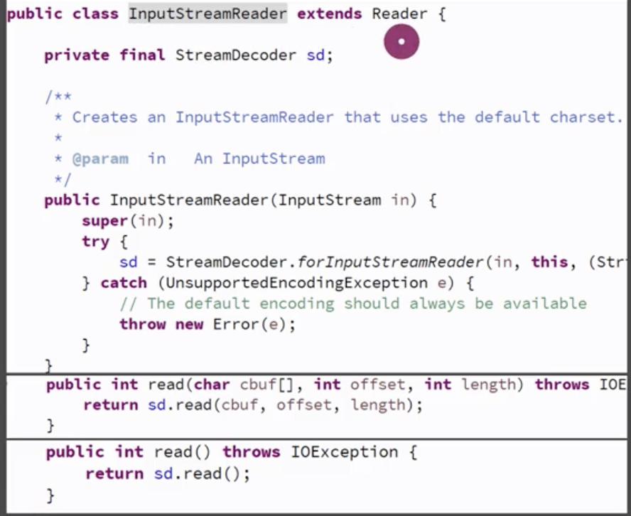

* **Comparison With Decorator:**

|  |  |
| --- | --- |
| **Adapter** | **Decorator** |
| Simply adapts an object to another interface without changing behaviour | Enhances object behaviour without changing its interface. |
| Not easy to use recursive composition, that is an adapter adapting another adapter since adapters change interface. | Since decorators do not change the interface, we can do recursive composition or in other words decorate a decorator with ease. Since a decorator is indistinguishable from main object. |

* **Pitfalls:**
  + Using target interface and adaptee class to extend our adapter we can create a “class adapter” in Java. However it creates an object which exposes unrelated methods in parts of your code, polluting it. Avoid class adapters. It is mentioned here only for sake of completeness.
  + It is tempting to do a lot of things in adapter besides simple interface translation. But this can result in an adapter showing different behaviour than the adapted object. Example, doing validation at adapter.
  + Not a lot of other pitfalls, As long as we keep them true to their purpose of simple interface translations they are good.
* **Quiz:**

