**Proxy Pattern**

* **Introduction:**
  + We need to provide a placeholder or surrogate to another object.
  + Proxy acts on behalf of the object and is used for lots of reason some of the main reasons are:
    - Protection Proxy – Control access to original objects operation.
    - Remote Proxy – Provides a local representation of a remote object.
    - Virtual proxy – Delays construction of original object until absolutely necessary.
  + Client is unaware of existence of proxy. Proxy performs its works transparently.
  + Lazy loading of collections by hibernate, AOP based method level security, RMI/Web service stubs are examples of real life proxy usage.
* **UML:**

**Note:** Not all proxies requires a reference of Real object.

* **Implementation Steps Part-1:**
  + We start by implementing proxy
    - Proxy must implement same interface as the real subject.
    - We can either create actual object later when required or ask for one in constructor.
    - In method implementations of proxy we implement proxy’s functionality before delegating to real object.
  + How to provide client with proxies instance is decided by application. We can provide a factory or compose client code with proxies instance.
  + What we are implementing above is called static proxy. Java also provides “dynamic proxies”
* **Example UML:**

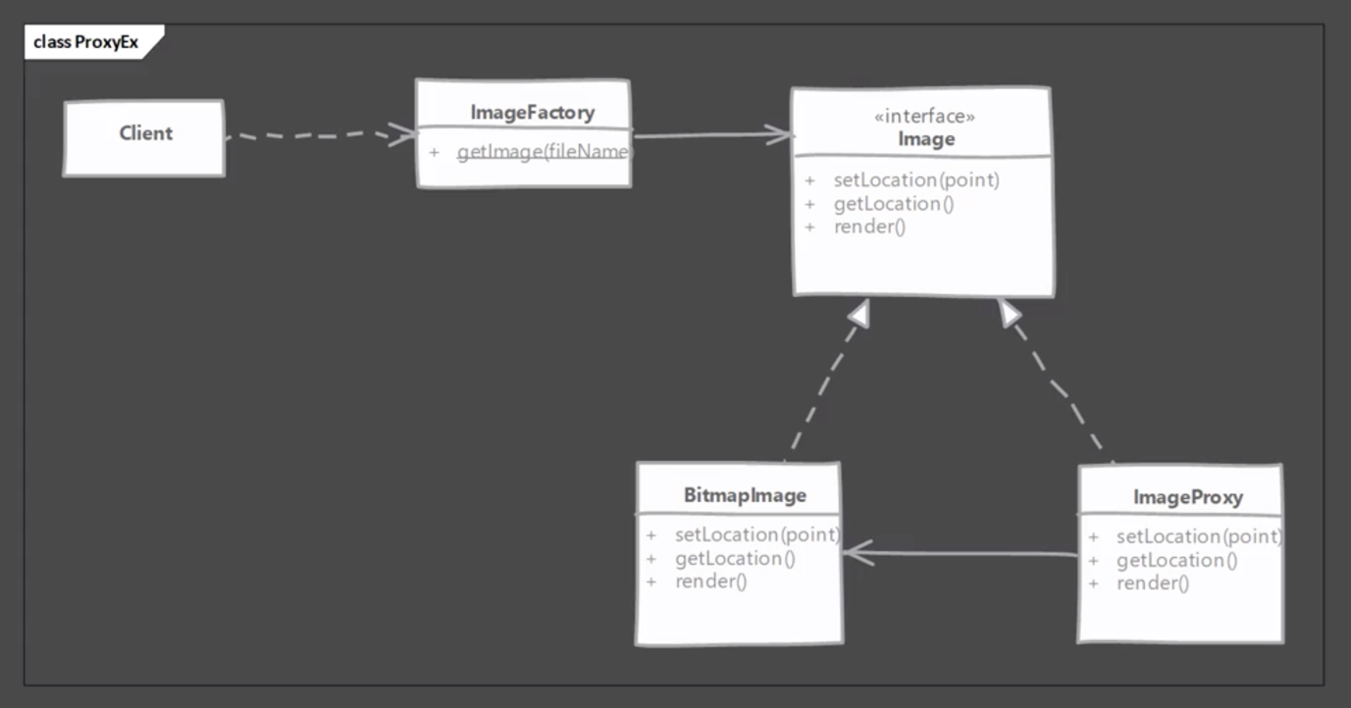

* **Dynamic Proxy Implementation Steps:**
  + We start by implementing java.lang.reflect.InvocationHandler
    - Invocation handler implements invoke method which is called to handle every method invocation.
    - We need to take action as per the method invoked. We’ll cache the Method instances on image interface so that we can compare them inside invoke method.
    - Our invocation handler will accept same argument in constructor as needed by constructor or real object.
  + Actual proxy instance is created using java.lang.reflect.Proxy by client.
* **Implementation & Design Considerations:**
  + How proxy gets hold of the real object depends on what purpose proxy serves. For creation on demand type of proxies; actual object is created only when proxy can’t handle client request. Authentication proxies use pre-built objects so they are provided with object during construction of proxy.
  + Proxy itself can maintain / cache some state on behalf of real object in creation of demand use cases.
  + Pay attention to performance cost of proxies as well synchronization issues added by proxy itself.

**Design Consideration:**

* + Proxy typically do not need to know about the actual concrete implementation of real object.
  + With java you can use dynamic proxy allowing you to create proxies for any object at runtime.
  + Proxies are great for implementing security or as stand-ins for real objects which may be a costly object that you want to defer loading. Proxies also make working with remote service / APIs easy by representing them as regular objects and possibly handling network communications behind the scene.
* **Example:**
  + This is one pattern where you’ll find numerous examples.
  + Hibernate uses a proxy to load collections of value types. If you have a relationship in entity class mapped as a collection, marked as candidate for lazy loading then hibernate will provide a virtual proxy in its place.
  + Spring uses proxy pattern to provide support for feature like transactions, caching and general AOP support. They use third party frameworks like cglib, aspectJ to create dynamic proxies (remember, Java’s dynamic proxy needs interface) at runtime.
* **Comparison with Decorator:**

|  |  |
| --- | --- |
| **Proxy** | **Decorator** |
| Depending on type of proxy it doesn’t need real object all the time. | A decorator needs to have a real object for it to work. |
| Purpose of proxy is to provide features like access control, lazy loading, auditing etc. | A decorator is meant to add functionality to existing functionality provided by object & used by client directly. |

* **Pitfalls:**
  + Java’s dynamic proxy only works if your class is implementing one or more interfaces. Proxy is created by implementing these interfaces.
  + If you need proxies for handling multiple responsibilities like auditing, authentication, as a stand-in for the same instance, then it is better to have a single proxy to handle all these requirements. Due to the way some proxies create object on their own, it becomes quite difficult to manage them.
  + Static proxies look quite similar to other patterns like decorator & adapter patterns. It can be confusing to figure it out from code alone for someone not familiar with these patterns.
* **Quiz:**

