**java.lang package – Part-08**

* **Wrapper Classes:**

The main objectives of Wrapper classes are

1. To wrap primitive into object form. So that we can handle primitives also just like objects.
2. To define several utility methods which are required for the primitives.

* **Constructors:**

Almost all wrapper classes contains two constructors one can take corresponding primitive as argument, and the other can take String as argument.

Example_01:

Integer I = new Integer(10);

Integer I = new Integer(“10”);

Example_02:

Double D = new Double(10.5);

Double D = new Double(“10.5”);

Note:

If the String argument not representing a number, then we will get Runtime Exception saying: NumberFormatException

Example:

Integer I = new Integer(“ten”);

RE: NumberFormatException

Float:

Float class contains three constructors with float, double and String arguments.

Example:

Float f = new Float(10.5f); // valid

Float f = new Float(“10.5f”); // valid

Float f = new Float(10.5); // valid

Float f = new Float(“10.5”); // valid’

Character:

Character class contains only one constructor, which can take char argument.

Character ch = new Character(‘a); // valid

Character ch = new Character(“a”); // Invalid

Boolean:

Boolean class contains two constructors one can take primitive as argument and the other can take String argument.

If we pass boolean primitive as argument the only allowed values are “true or false”. Where case is important and content is also important.

Example:

Boolean b = new Boolean(true); // Valid

Boolean b = new Boolean(false); // Valid

Boolean b = new Boolean(True); // Invalid

Boolean b = new Boolean(durga); // Invalid

If we are passing String type as argument then case and content both are not important, if the content is case insensitive String of “true” then it is treated as true, otherwise it is treated as false.

Example:

Boolean B = new Boolean(“true”); // true

Boolean B = new Boolean (“True”); // true

Boolean B = new Boolean(“TRUE”); // true

Boolean B = new Boolean(“Malaika”); // false

Boolean B = new Boolean(“mallika”); // false

Boolean B = new Boolean(“jerina”); // false

class Test{

public static void main(String[] args){

Boolean X = new Boolean(“yes”);

Boolean Y = new Boolean(“no”);

System.out.println(X);

System.out.println(Y);

System.out.println(X.equals(Y));

}

}

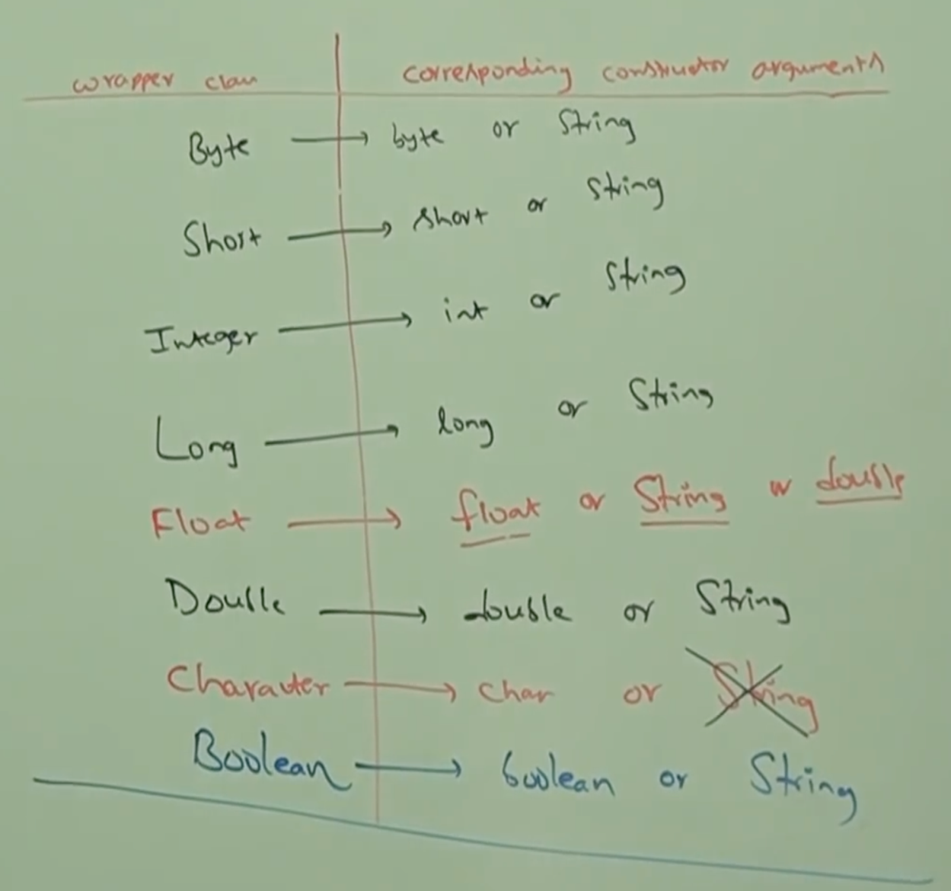

**Note: Different in FCB, just remember Football Club Barcelona**

**Note:**

**In all wrapper classes toString() method is overridden to return content directly.**

**In all wrapper classes .equals() method is overridden for content comparison.**

* **Utility Methods:**

1. valueOf()
2. xxxValue()
3. parseXXX()
4. toString()

* **valueOf()**

We can use valueOf() methods to create Wrapper object for the given primitive or String.

**Form_01:**

Every Wrapper class except Character class contains a static valueOf() method to create Wrapper object for the given String.

public static wrapper valueOf(String s)

Example:

Integer I = Integer.valueOf(“10”);

Double D = Double.valueOf(“10.5”);

Boolean B = Boolean.valueOf(“durga”);

**Form_02:**

Every Integral type Wrapper class (Byte, Short, Integer, Long) contains the following valueOf() method to create Wrapper object for the given specified radix String.

public static wrapper valueOf(String s, int radix)

The allowed range of radix is: 2 to 36

Example:

Integer I = Integer.valueOf(“100”, 2);

System.out.println(I); // 4

Integer I = Integer.valueOf(“101”, 4);

System.out.println(I); // 17

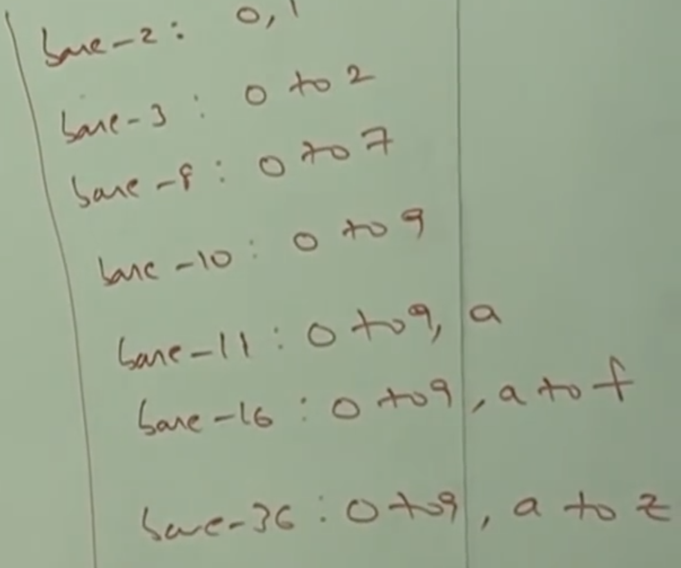

**Form_03:**

Every Wrapper class including Character class contains a static valueOf() method to create Wrapper object for the given primitive.

public static wrapper valueOf(primitive p);

Example:

Integer I = Integer.valueOf(10);

Character CH = Character.valueOf(‘a’);

Boolean B = Boolean.valueOf(true);

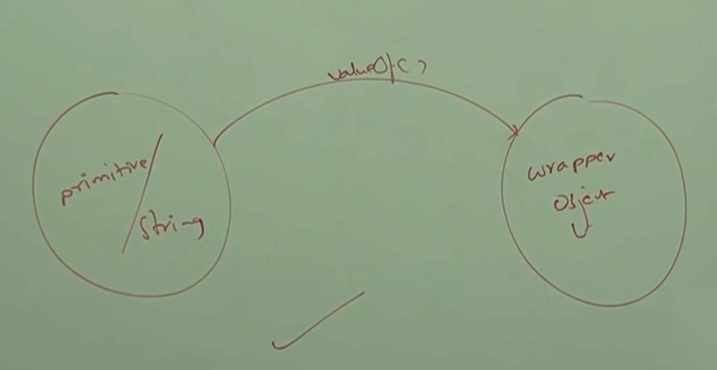

* **xxxValue()**

We can use xxxValue() methods to get primitive for the given wrapper object.

Every Number type Wrapper (Byte, Short, Integer, Long, Float & Double) contains the following six methods to get primitive for the given Wrapper object.

public byte byteValue();

public short shortValue();

public int intValue();

public long longValue();

public float floatValue();

public double doubleValue();

Example:

Integer I = new Integer(130);

System.out.println(I.byteValue()); // -127

System.out.println(I.shortValue()); // 130

System.out.println(I.intValue()); // 130

System.out.println(I.longValue()); //130

System.out.println(I.floatValue()); //130.0

System.out.println(I.doubleValue()); //130.0

* **charValue():**

Character class contains method charValue() to get char primitive for the given Character object.

public char charValue()

Example:

Character ch = new Character(‘a’);

char c = ch.charValue();

System.out.println(c); //a

* **booleanValue():**

Boolean class contains booleanValue() method to get boolean primitive for the given Boolean object.

public boolean booleanValue()

Example:

Boolean B = Boolean.value(“durga”);

Boolean b = B.booleanValue();

System.out.println(b);

* **Note:**

In total 38 (= 6 x 6 + 1 + 1) xxxValue() methods are possible.

