**java.lang package – Part-10**

* **parseXxx():**

We can use parseXxx() methods to convert String to primitive.

* **Form_01:**

Every Wrapper class except Character class contains the following parseXxx() method to find primitive for the given String object.

public static primitive parseXxx(String s);

Example:

int i = Integer.parseInt(“10”);

double d = Double.parseDouble(“10.5”);

boolean b = Boolean.parseBoolean(“true”);

* **Form_02:**

Every Integral type Wrapper class (Byte, Short, Integer, Long) contains the following parseXxx() method to convert specified radix String to primitive.

public static primitive parseXxx(String s, int radix);

The allowed range of radix is: 2 to 36

Example:

int i = Integer.parseInt(“1111”, 2);

System.out.println(i); // 15

* **Diagram:**

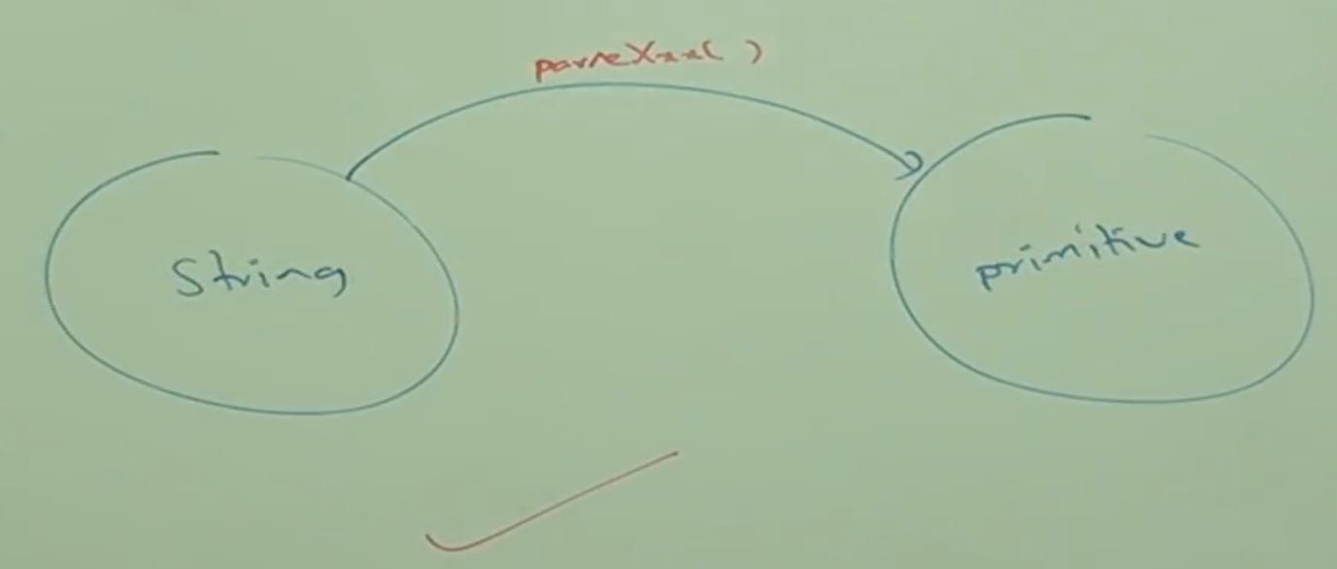

* **toString():**

We can use toString() method to convert Wrapper object or primitive to String.

**Form_01:**

Every Wrapper class contains the following toString() method to convert Wrapper object to String type.

public String toString();

Note:

It’s the overridden version of Object class toString().

Whenever we are trying to print Wrapper object reference internally this toString() method will be called.

Example:

Integer I = new Integer(10);

String s = I.toString();

System.out.println(s);

System.out.println(I) 🡪 System.out.println(I.toString());

**Form_02:**

Every Wrapper class including Character class contains, the following static toString() method to convert primitive to String.

public static String toString(primitive p);

Example:

String s = Integer.toString(10);

String s = Boolean.toString(true);

String s = Character.toString(‘a’);

**Form_03:**

Integer and Long classes contain the following toString() method to convert primitive to specified radix String.

public static String toString(primitive p, int radix);

The allowed range of radix: 2 to 36

Example:

String s = Integer.toString(15, 2);

System.out.println(s);

Note:

The above method is only available on Integer and Long classes.

**Form_04: toXxxString() Methods**

Integer and Long classes contains the following toXxxString() methods

public static String toBinaryString(primitive p)

public static String toOctalString(primitive p)

public static String toHexString(primitive p)

Example:

String s = Integer.toBinaryString(10);

System.out.println(s); //1010

String s = Integer.toOctalString(10);

System.out.println(s); //12

String s = Integer.toHexString(10);

System.out.println(s); //a

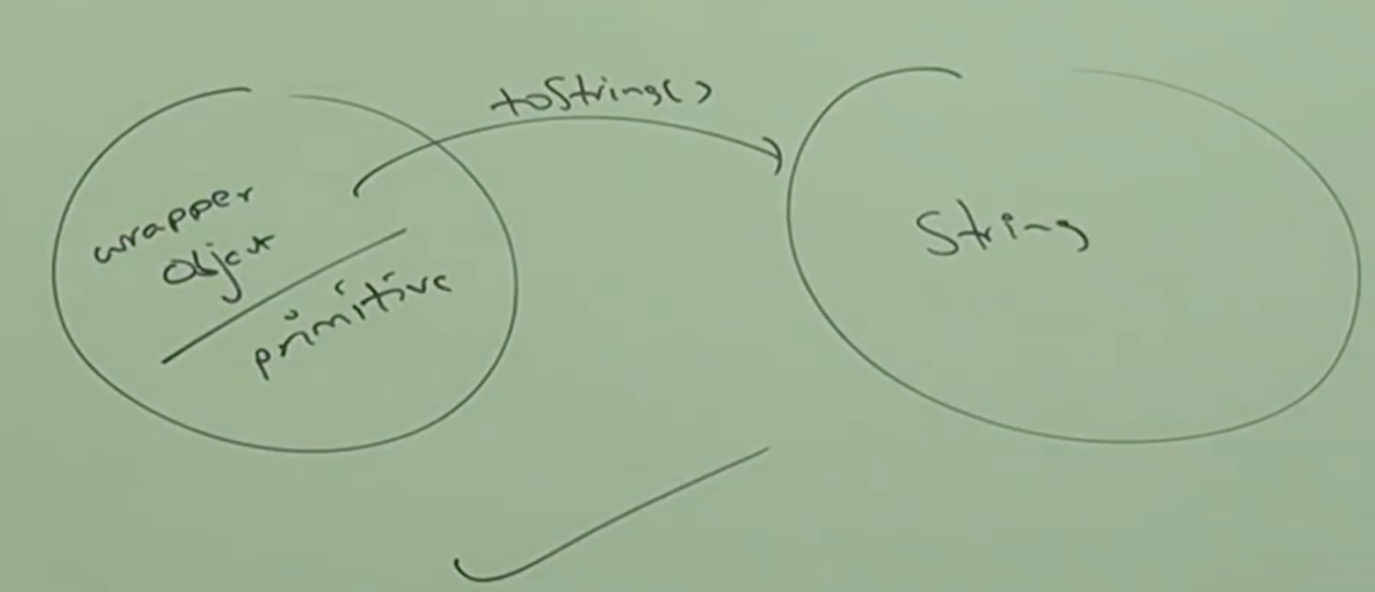

* **Dancing between String, Wrapper object and primitive:**

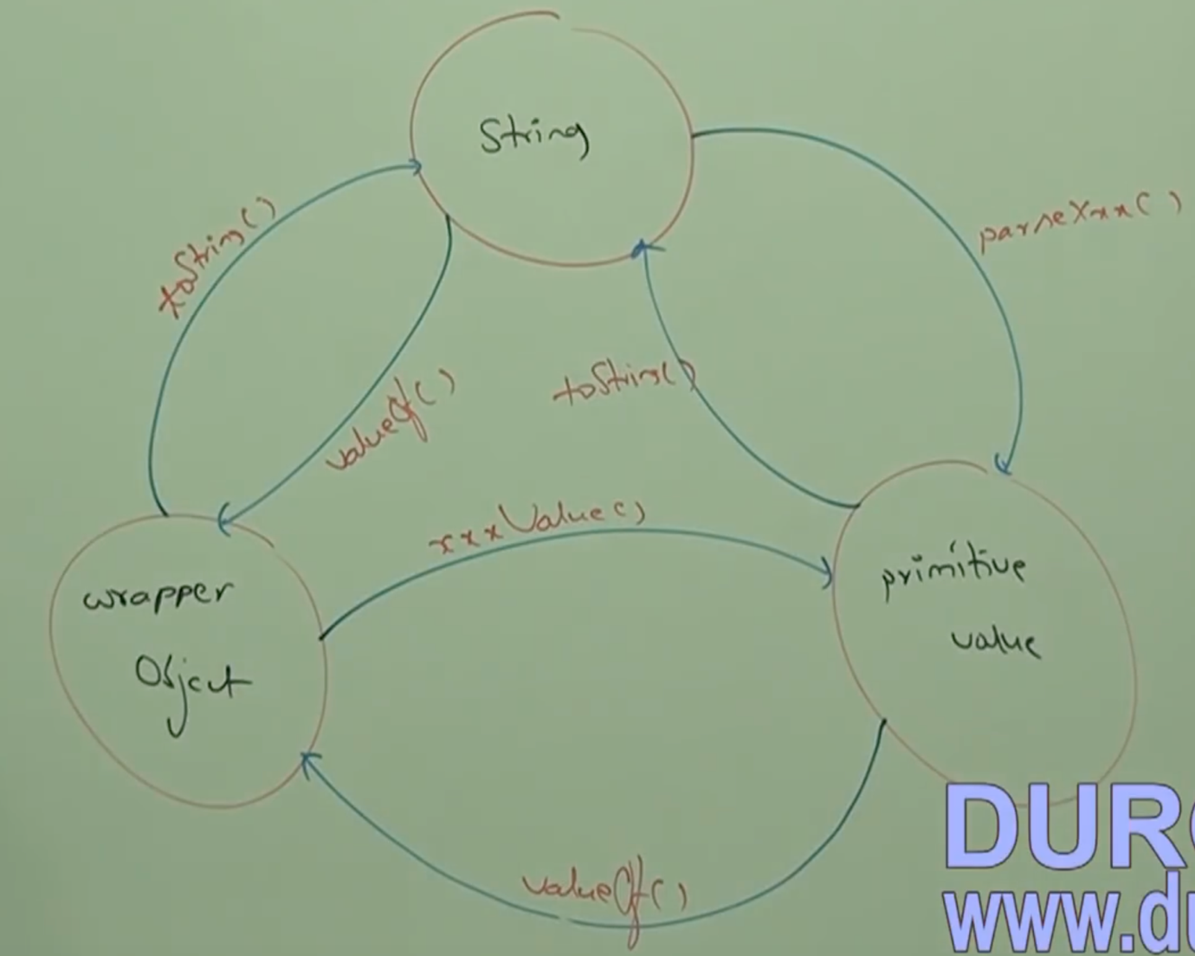

* **Partial Hiearchy of java.lang package:**

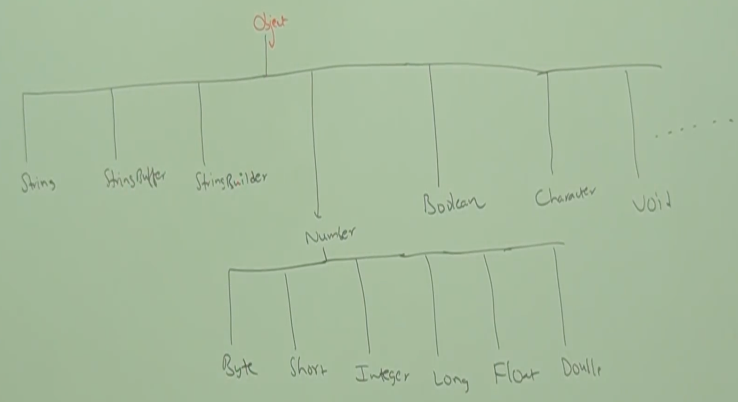

* **Conclusions:**

The Wrapper classes which are not child class of Number are:

Boolean

Character

The Wrapper classes which are not direct child class of Object are:

Byte

Short

Integer

Long

Float

Double

String, StringBuffer, StringBuilder and all Wrapper classes are final classes.

In addition to String class all Wrapper classes are also immutable.

Sometimes void class is also considered as Wrapper class.

* **Void class:**

It is a final class, and it is the direct child class of Object.

It doesn’t contain any methods and it contains only one variable

Void.TYPE

In general we can use Void class in reflections to check whether the method return type is void or not.

if(getMethod(“m1”).getReturnType() == Void.TYPE){

}

Void is the class representation void keyword in Java.