**File IO – Part-02**

* **FileWriter:**

We can use FileWriter to write character data to the file.

* **Constructors:**

FileWriter fw = new FileWriter(String filename);

FileWriter fw = new FileWriter(File f);

The above FileWriters meant for overriding of existing data. Instead of overriding if we want append operation then we have to create FileWriter by using the following constructors.

FileWriter fw = new FileWriter(String name, boolean append);

FileWriter fw = new FileWriter(File f, boolean append);

Note:

If the specified file is not already available then all the above constructors will create that file.

* **Methods:**

write(int ch)

To write a single character.

write(char[] ch);

To write an array of characters

writer(String s);

To write String to the file.

flush();

To give the guarantee that total data including last character will be written to the file.

Note: Recall transferring the rice from sack to drum, once all rice is transferred from sack, just to make sure if there are anything stuck, we used to shake the sack. The flush() method does the same.

close();

To close the writer once our operation is done.

Example:

import java.io.*;

class Test{

public static void main(String[] args) throws IOException{

FileWriter fw = new FileWriter(“abc.txt”); fw.write(100); // adding a single character

fw.write(“urga\nSoftwareSolutions”);

fw.write(“\n”);

char[] ch = {‘a’, ‘b’, ‘c’};

fw.write(ch1);

fw.write(‘\n’);

fw.flush();

fw.close();

}

}

Output:

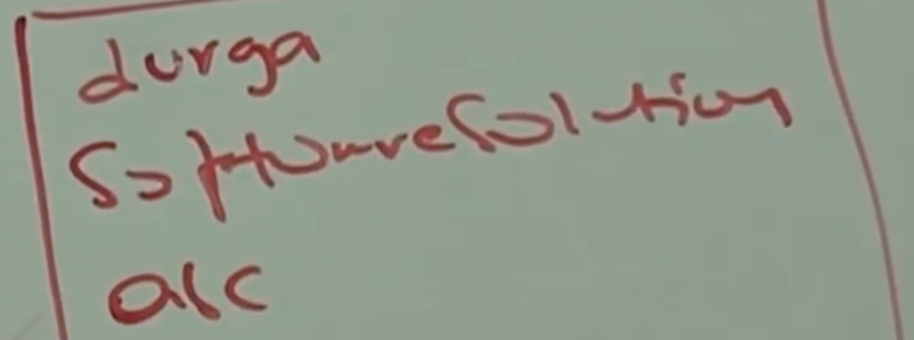

* **Note:**

In the above program FileWriter can perform overriding of existing data. Instead of overriding if we want append operation then we have to create FileWriter object as follows:

FileWrite fw = new FileWriter(“abc.txt”, true);

Note: The main problem with FileWriter is we have to insert line separator “\n” manually, which is varied from system to system. It is difficulty to the programmer. We can solve this problem by using BufferedWriter and PrintWriter classes.