**File IO – Part-04**

* **PrintWriter:**

It is the most enhanced writer to write character data to the file.

The main advantage of PrintWriter over FileWriter and BufferedWriter is we can write any type of primitive data directly to the file.

* **Constructors:**

PrintWriter pw = new PrintWriter(String fileName);

PrintWriter pw = new PrintWriter(File f);

PrintWriter pw = new PrintWriter(Writer w);

Note:

PrintWriter can communicate directly with the file and can communicate via some Writer object also.

* **Methods:**

write(int ch);

write(char[] c);

write(String s);

flush()

open()

print(char ch);

print(int i);

print(double d);

print(boolean b);

print(String s);

println(int i);

println(char ch);

println(double d);

println(boolean b);

println(String s);

Example:

import java.io.*;

class PrintWriterDemo{

public static void main(String[] args) throws IOException{

FileWriter fw = new FileWriter(“abc.txt”);

PrintWriter out = new PrintWriter(fw);

out.write(100);

out.println(100);

out.println(true);

out.println(‘c’);

out.println(“durga”);

out.flush();

out.close();

}

}

Output:

d100

true

c

durga

* **What is the difference between write(100) and print(100)?**

In the case of write of 100, the corresponding ‘d’ will be added to the file. But, in the case of print(100) then int value 100 will be added to the file directly.

* **Note:**

The most enhanced writer to write character data to the file is PrintWriter. Whereas the most enhanced reader to read character data from the file is BufferedReader.

* **Note:**

In general, we can use Readers and Writers to handle character data (Text data), whereas we can use Streams to handle Binary Data (like images, pdf files, video and audio files etc).

We can use OutputStream to write binary data to the file, InputStream to read binary data from the file.

* **Class Hierarchy:**

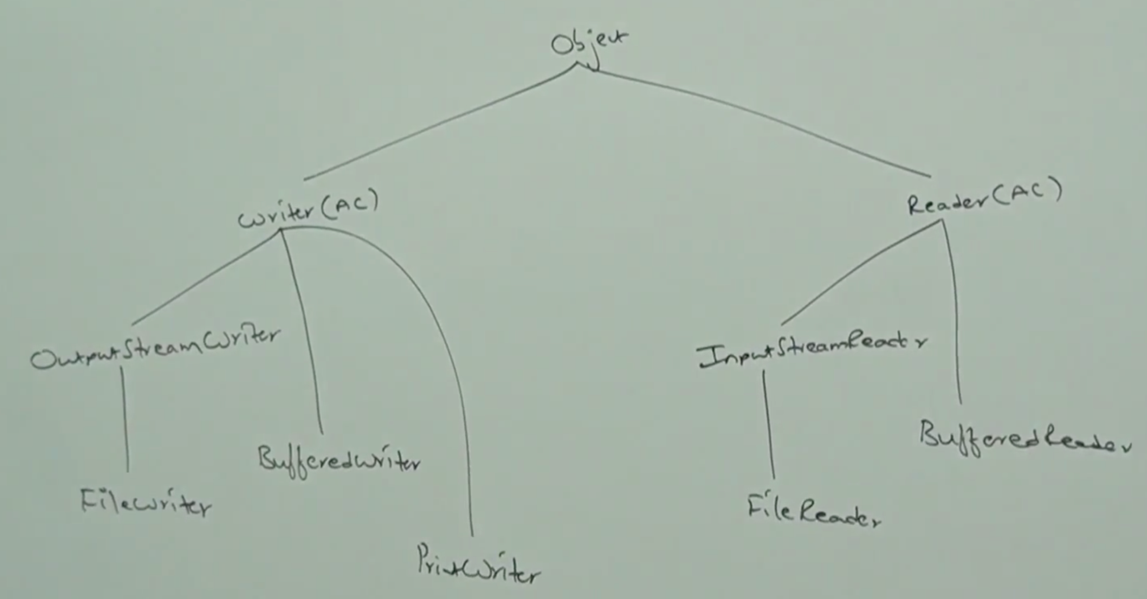

* **Write a program to merge data from two files into a third file.**

import java.io.*;

class FileMerger{

public static void main(String[] args) throws IOException{

PrintWriter pw = new PrintWriter(“file3.txt”);

BufferedReader br = new BufferedReader(new FileReader(“file1.txt”));

String line = br.readLine();

while(line != null){

pw.println(line);

line = br.readLine();

}

br = new BufferedReader(new FileReader(“file2.txt”));

line = br.readLine();

while(line != null){

pw.println(line);

line = br.readLine();

}

br.flush();

}

}

