**Serialization – Part-02**

* **Note:**

We can serialize any number of objects to the file, but in which order we serialized in the same order only we have to deserialize. That is, order of objects is important in serialization.

Example:

Dog d1 = new Dog();

Cat c1 = new Cat();

Rat r1 = new Rat();

FileOutputStream fos = new FileInputStream(“abc.ser”);

ObjectOutputStream oos = new ObjectOutputStream(fos);

oos.writeObject(d1);

oos.writeObject(c1);

oos.writeObject(r1);

FileInputStream fis = new FileInputStream(“abc.ser”);

ObjectInputStream ois = new ObjectInputStream(fis);

Dog d2 =(Dog)ois.readObject();

Cat c2 =(Cat)ois.readObject();

Rat r2 =(Cat)ois.readObject();

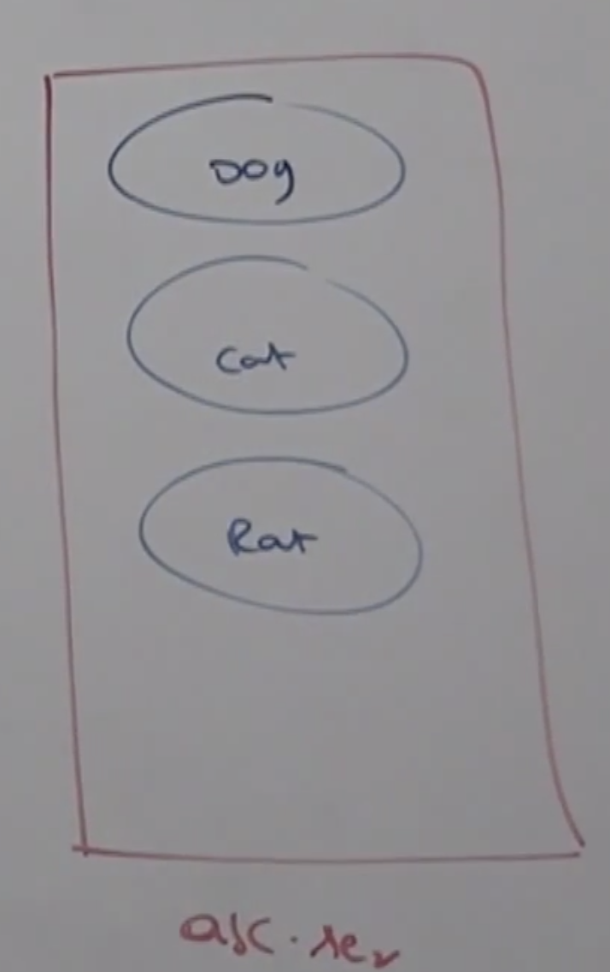

* **If we don’t know order of objects in serialization:**

FileInputStream fis = new FileInputStream(“abc.ser”);

ObjectInputStream ois = new ObjectInputStream(fis);

Object o = ois.readObject();

if(o instanceof Dog){

Dog d2 = (Dog)o;

// do dog specific functionality.

} else if(o instanceof Cat){

Cat c2 = (Cat)o;

// Do cat specific functionality.

} else if(o instanceof Rat){

Rat r2 = (Rat) o;

}

* **Object Graphs in Serialization:**

Whenever we are serializing an object, the set of all objects which are reachable from that object will be serialized automatically. This group of objects is nothing Object Graph.

In object graph every object should be serializable, if at least one object is not serializable then we will get runtime exception saying

NotSerializableException.

Example:

import java.io.*;

class Dog implement Serializable{

Cat c = new Cat();

}

class Cat implements Serializable{

Rat r = new Rat();

}

class Rat implements Serializable{

int j = 0;

}

class SerializeDemo{

public static void main(String[] args) throws Exception{

Dog d1 = new Dog();

FileOutputStream fos = new FileOutputStream(“abc.ser”);

ObjectOutputStream oos = new ObjectOutputStream(fos);

oos.writeObject();

FileInpuStream fis = new FileInputStream(“abc.ser”);

ObjectInputStream ois = new ObjectInputStream(fis);

Dog d2 = (Dog)ois.readObject();

}

}

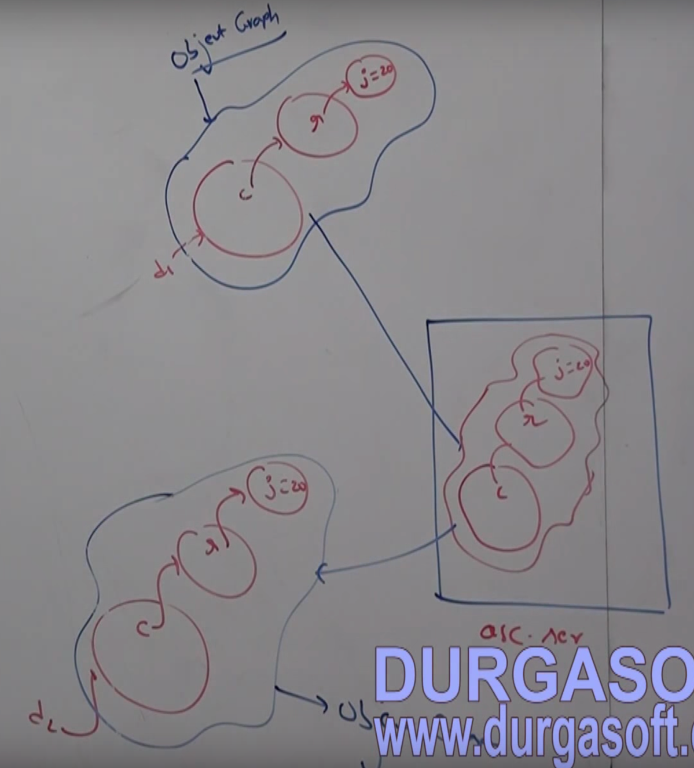

In the above program whenever we are serializing Dog object automatically Cat and Rat objects got serialized because these are part of object graph of Dog object.

Among Dog, Cat and Rat object, if at least one object is not serializable then we will get runtime exception saying:

NotSerializableException