**Concurrent Collection– Part_09**

* **CopyOnWriteArrayList:**

CopyOnWriteArrayList is the thread-safe version of ArrayList.

It is concurrent collection.

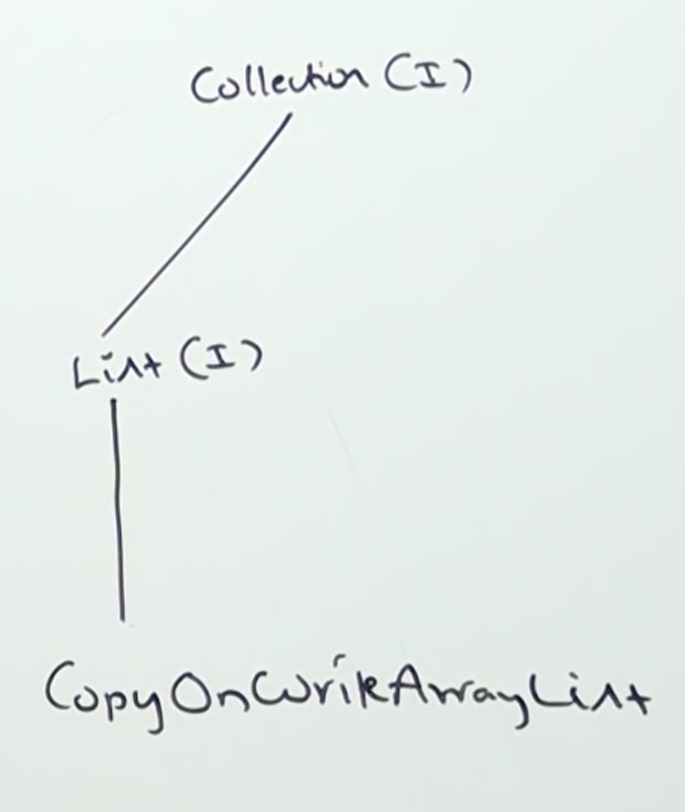

Collection & List 🡪 Comes under java.util package.

CopyOnWriteArrayList 🡪 Comes under java.util.concurrent package.

Read operation will be performed on the original CopyOnWriteArrayList. But for every write and update operation cloned copy will be created and the write or update will be performed on cloned copy of the object, so it will not affect the threads which are doing read operation.

After sometime the cloned copy will be synced with original automatically by JVM.

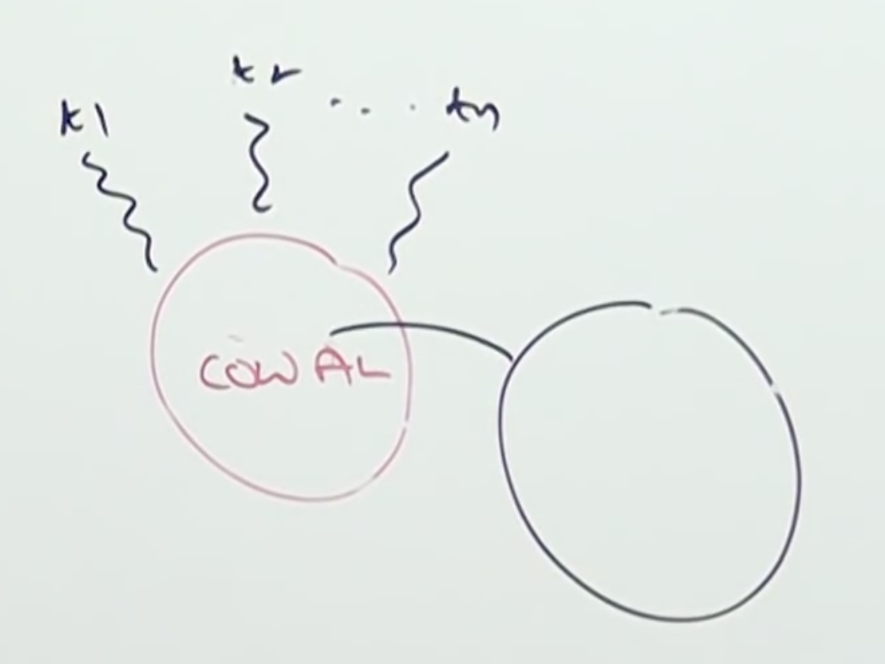

Note:

CopyOnWriteArrayList will create a cloned copy for each and every thread for write or update operation. So, if the requirement is to have more write or update operation, it will impact performance.