**Concurrent Collection– Part_14**

* **Example_03: (For UnsupportedOperationException):**

import java.util.*;

import java.util.concurrent.*;

class CopyOnWriteArrayListDemo{

CopyOnWriteArrayList l = new CopyOnWriteArrayList();

l.add(“A”);

l.add(“B”);

l.add(“C”);

l.add(“D”);

System.out.println(l);

Iterator itr = l.iterator();

while(itr.hasNext()){

String s1 = (String) itr.next();

if(s1.equals(“D”){

itr.remove();

}

}

}

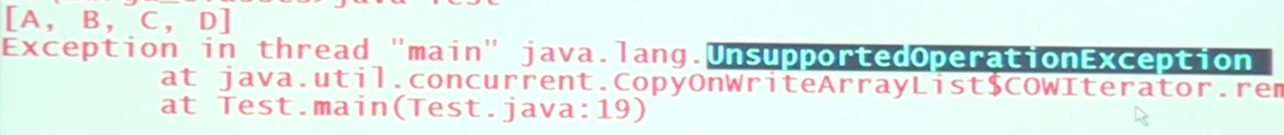

Note:

If we replace CopyOnWriteArrayList with ArrayList, we won’t get the runtime exception.