**Concurrent Collection– Part_18**

* **CopyOnWriteArraySet:**

1. Underlying data structure is CopyOnWriteArrayList.
2. Duplicates are not allowed.
3. Insertion order is preserved.
4. Heterogeneous objects are allowed.
5. We can add null.
6. While one thread iterating the set, another thread allowed to update the set. It will not throw ConcurrentModificationException.
7. Iterator is fail-safe.
8. Iterator can do only read operation, if we try to do remove it will throw UnsupportedOperationException.

* **Class Hierarchy:**

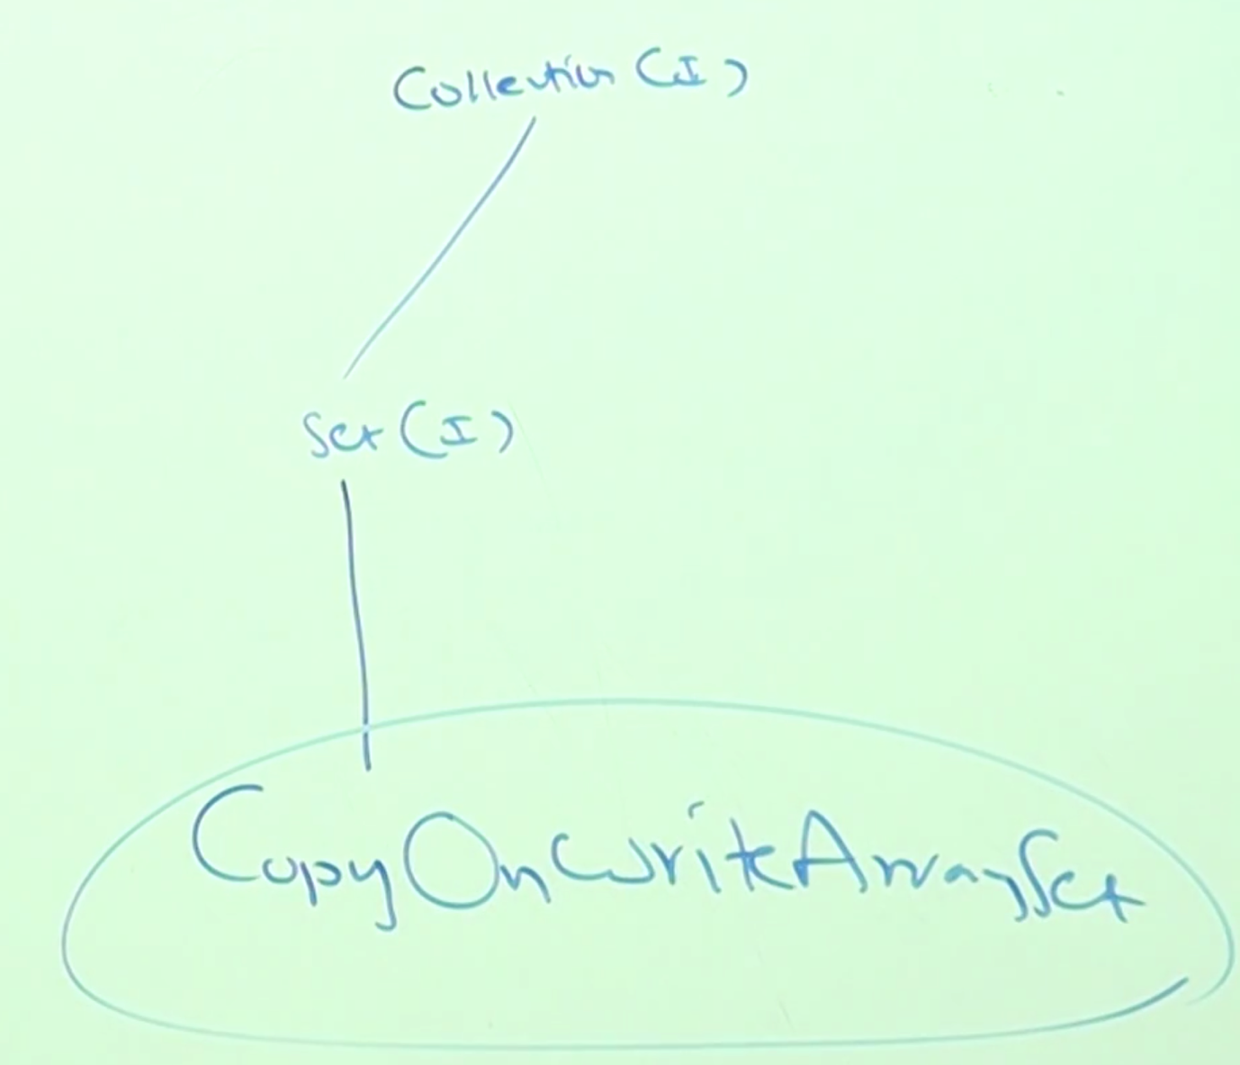

* **Constructors:**

CopyOnWriteArraySet s = new CopyOnWriteArraySet();

CopyOnWriteArraySet s = new CopyOnWriteArraySet(Collection c);

* **Methods:**

This class doesn’t have any new methods, it will inherits the methods of Collection and Set interface methods.

* **Example:**

import java.util.concurrent.*;

class Test{

public static void main(String[] args){

CopyOnWriteArraySet s = new CopyOnWriteArraySet();

s.add(“D”);

s.add(“B”);

s.add(“C”);

s.add(“A”);

s.add(null);

s.add(10);

s.add(“D”);

System.out.println(s); // [D, B, C, A, null, 10]

}

}