**Java-8 – Anonymous Inner Class with Lambda Expression**

* **Anonymous Inner Class VS Lambda Expression – Part1:**

Wherever we use Anonymous inner classes there we can use the Lambda expression.

Example: With Anonymous inner class:

class ThreadsDemo1{

public static void main(String[] args){

Runnable runnable = new Runnable(){

public void run(){

for(int i=0;i<10;i++){

System.out.println(“Child Thread”);

}

}

};

Thread t = new Thread(runnable);

t.start();

for(int i=0;i<10;i++){

System.out.println(“Main Thread”);

}

}

}

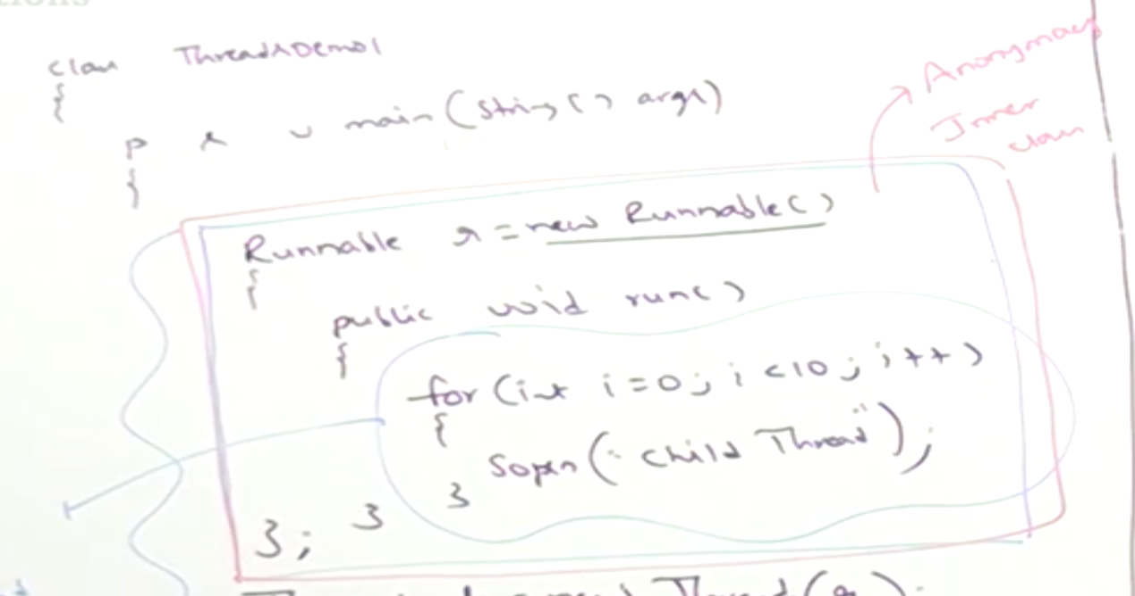

With Lambda Expression:

class ThreadDemo2{

public static void main(String[] args){

Runnable runnable = () -> {

for(int i=0;i<10;i++){

System.out.println(“Child Thread”);

}

};

Thread t = new Thread(runnable);

t.start();

for(int i=0;i<10;i++){

System.out.println(“Main thread”);

}

}

}

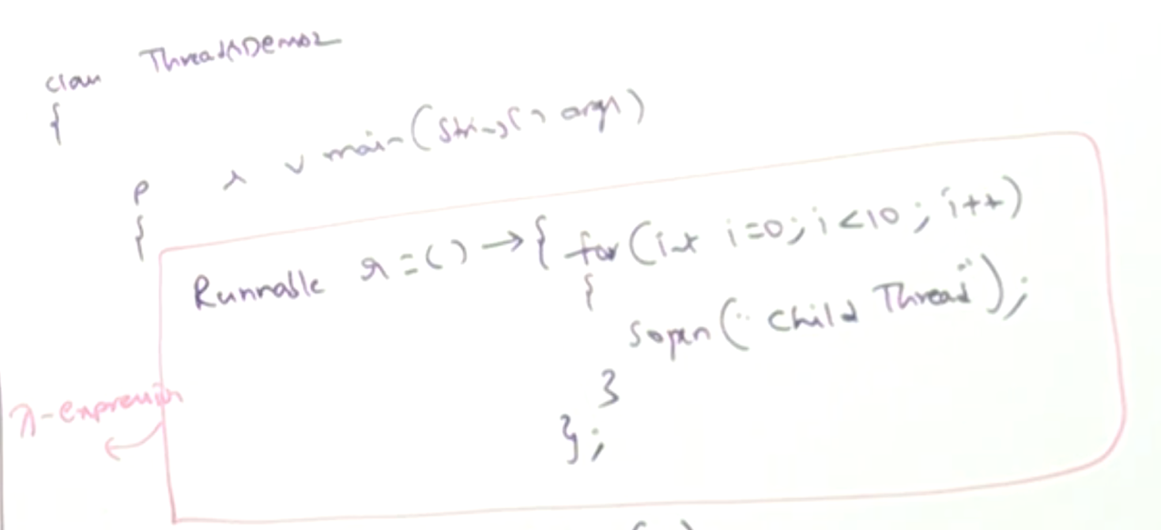

* **Example_02:**

class ThreadDemo2{

public static void main(String[] args){

Thread t = new Thread( () -> {

for(int i=0;i<10;i++){

System.out.println(“Child Thread”);

}

}

);

for(int i=0;i<10;i++){

System.out.println(“Main Thread”);

}

}

}