**Java-8 – Predicate Interface isEqual() method**

* **isEqual():**

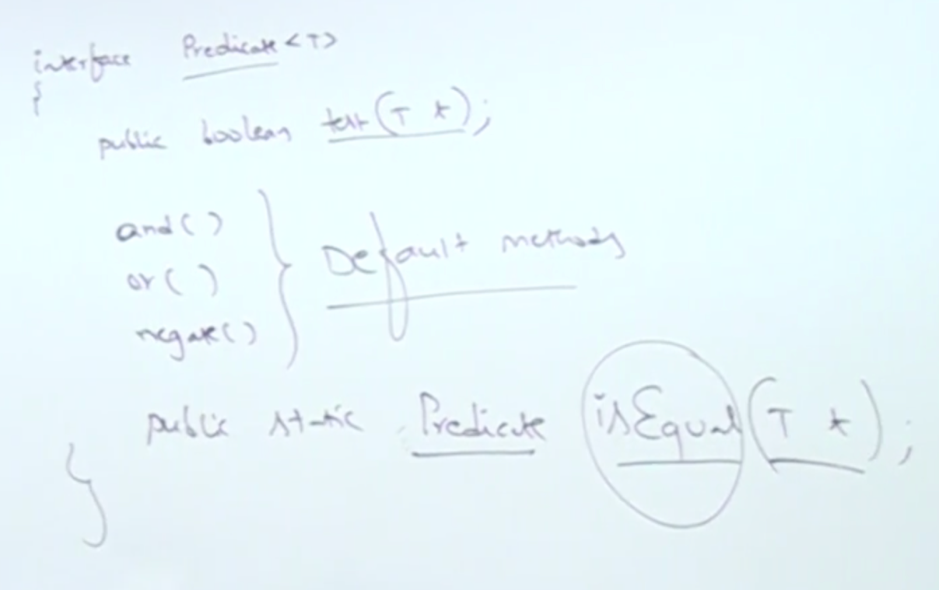

* **Example:**

class Employee{

String name;

String designation;

double salary;

String city;

Employee(String name, String designation, double salary, String city){

this.name = name;

this.designation = designation;

this.salary = salary;

this.city = city;

}

public toString(){

String s = String.format(“(%s,%s,%.2f,%s)”, name, designation, salary, city);

return s;

}

public boolean equals(Object obj){

Employee e = (Employee) obj;

if(name.equals(e.name) && designation.equals(e.designation) && salaray == e.salary){

return true;

} else{

return false;

}

}

}

import java.util.function.Predicate;

class Test{

public static void main(String[] args){

Predicate<String> p = Predicate.isEqual(“DURGASOFT”);

System.out.println(p.test(“DURGASOFT”));

System.out.println(p.test(“MALLIKA”));

Predicate<Employee> isCEO = Predicate.isEqual(new Employee(“Durga”, “CEO”, 30000, “Hyderabad”));

Employee e1 = new Employee(“Durga”, “CEO”, 30000, “Hyderabad”);

Employee e2 = new Employee(“Sunny”, “Manager”, 20000, “Hyderabad”);

System.out.println(isCEO.test(e1);

System.out.println(isCEO.test(e2);

}

}