**Java-8 – Consumer Chaining**

* **Consumer chaining:**

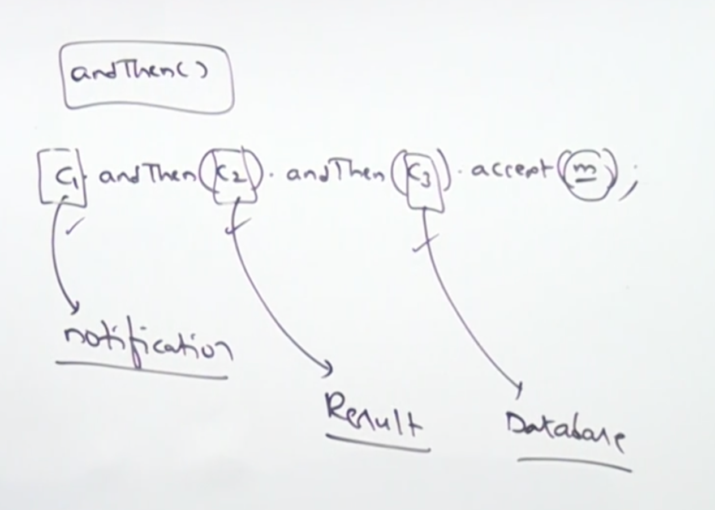

* **Program:**

class Movie {

String name;

String result;

Movie(String name, String result){

this.name = name;

this.result = result;

}

}

import java.util.function.Consumer;

class Test{

public static void main(String[] args){

Consumer<Movie> c1 = m -> System.out.println(“Movie:”+m.name+”is ready to relase”);

Consumer<Movie> c2 = m -> System.out.println(“Movie:”+m.name+”is just released and it is:”+m.result);

Consumer<Movie> c3 = m -> System.out.println(“Movie:”+m.name+”information storing in the database”);

Consumer<Movie> chainedConsumer = c1.andThen(c2).andThen(c3);

Movie m1 = new Movie(“Bahubali”, “Hit”);

chainedConsumer.apply(m1);

Movie m2 = new Movie(“Spider”, “Flop”);

chainedConsumer.apply(m2);

}

}