**Introduction**

* **What do we mean by performance, and what version of Java does this course cover?**

This course is designed to cover, 20% on design time aspects and 80% on runtime aspects.

* **Using different JDK and JVM vendors:**

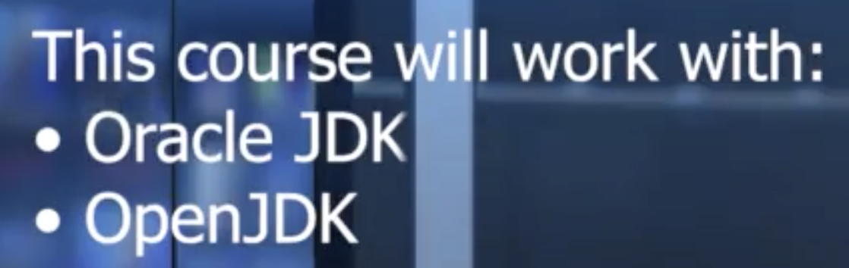

* **Structure of the course:**

