

**Viet Nam National University Ho Chi Minh City,**

**Internation University**

School of Computer Science & Engineering

Major: Data Science

Subject: Principles of Database Management (IT079IU)

Final Project Report of

COLLEGE DATA MANAGEMENT

Project team

| Student name | Student ID | Email Address |
| --- | --- | --- |
| Phạm Huỳnh Thanh Quân | ITDSIU21110 | phamquan26012003@gmail.com |
| Phan Mạnh Sơn | ITDSIU21116 | manhson1995@gmail.com |
| Văn Phú Minh Sang | ITDSIU21112 | sangvpm0212@gmail.com |
| Nguyễn Bá Duy | ITDSIU21014 | baduy3723@gmail.com |
| Phan Danh Đức | ITDSIU21012 | phanduc.ds@gmail.com |

| Seq. | Full name | Student ID | % contribution (total = 100%) | Signature | Score |
| --- | --- | --- | --- | --- | --- |
| 1 | **Phạm Huỳnh Thanh Quân** | **ITDSIU21110** | 20% |  |  |
| 2 | **Phan Mạnh Sơn** | ITDSIU21116 | 20% |  |  |
| 3 | **Văn Phú Minh Sang** | ITDSIU21112 | 20% |  |  |
| 4 | **Phan Danh Đức** | ITDSIU21012 | 20% |  |  |
| 5 | **Nguyễn Bá Duy** | ITDSIU21014 | 20% |  |  |

Dedication

We dedicate this College Database Management System project to all the individuals who have supported and inspired us throughout this journey.

To our esteemed faculty and mentors, thank you for your guidance, knowledge, and expertise. Your patience, encouragement, and constructive feedback have been invaluable in shaping our understanding of database management systems.

To our fellow classmates and friends, thank you for your unwavering support and camaraderie. Your collaboration, discussions, and brainstorming sessions have been instrumental in driving our project forward.

To our family and loved ones, thank you for your unwavering belief in us and for being a constant source of motivation. Your encouragement, understanding, and sacrifices have been the foundation of our success.

We also express our gratitude to the developers and contributors of various open-source tools and frameworks that we utilized in our project. Your hard work and dedication to the open-source community have been instrumental in enabling us to create a robust and efficient College Database Management System.

Last but not least, we dedicate this project to ourselves, for our perseverance, dedication, and hard work in completing this project. It has been a challenging yet rewarding experience, and we are proud of what we have accomplished.

Thank you to everyone who has been a part of this project, directly or indirectly. Your support and encouragement have been invaluable, and we are grateful for your contributions.

**Acknowledgements**

We would like to express our heartfelt gratitude to the following individuals and groups for their contributions to our College Database Management System project:

Our esteemed faculty and mentors for their guidance, expertise, and support throughout the project.

Our classmates and friends for their collaboration, discussions, and encouragement, which helped us shape our ideas and solutions.

Our family and loved ones for their unwavering support and understanding during the project's ups and downs.

The developers and contributors of open-source tools and frameworks that we utilized in our project, for their hard work and dedication in creating these valuable resources.

Our team members for their commitment, hard work, and teamwork in making this project a success.

Thank you to each and every one of you for your invaluable contributions to our College Database Management System project. Your support has been crucial in bringing this project to fruition.

**Requirements for the final college DBMS project**

A university database management system (DBMS) final project typically requires students to design and implement a database management system for an academic institution such as a university. The specific requirements of the project will depend on each specific case, however, generally, the basic requirements include:

**System Requirements Specification:** Students need to understand and define the requirements of the organization, including the features, functions, processes, regulations, and data formats to be managed.

**Database Design:** Students need to design a database based on the requirements of the organization. This includes tables, fields, relationships, and constraints, as well as procedures, functions, and data queries.

**Database Deployment:** After completing the design, students need to deploy the database using database management tools such as MySQL, PostgreSQL, SQL Server, or Oracle.

**Application Development:** Students need to develop a database-driven application designed to manage, retrieve, and process data.

**Testing and Evaluation:** Students need to test the system and evaluate its accuracy, efficiency and stability. If there is an error or problem, students need to fix the problem and improve the system.

**Report Writing:** Finally, students need to write a report on their final project. This report will reflect their system design, implementation and evaluation process, including solutions, challenges and results achieved.

**Executive Summary**

Our College Database Management System project is a comprehensive solution designed to efficiently manage various aspects of a college's data and information. The system is aimed at streamlining and automating processes such as student enrollment, course registration, faculty management, attendance tracking, and result management.

The system offers a user-friendly interface that allows administrators, faculty, and students to easily access and manage relevant data. It provides functionalities such as data entry, data retrieval, data modification, and data reporting, which are essential for effective college administration.

Key features of the system include student enrollment and registration, course management, faculty management, attendance tracking, result management, and reporting. The system is designed to be scalable, secure, and customizable, allowing colleges to adapt it to their specific needs and requirements.

Through the implementation of this College Database Management System, colleges can expect to achieve increased efficiency, accuracy, and transparency in managing their data and information. The system aims to streamline administrative processes, reduce manual efforts, minimize errors, and improve overall data management practices.

In conclusion, our College Database Management System project offers a comprehensive solution for managing college data and information. With its user-friendly interface, key features, scalability, and security, the system is poised to enhance the efficiency and effectiveness of college administration, ultimately benefiting the college, faculty, and students alike.

**Table of contents**

**Dedication.**……………………………………………………………………………………2

**Acknowledgements**…………………………………………………………………………..2

**Requirements for the final college DBMS project**…………………………………………3

**Executive Summary**………………………………………………………………………….3

**Table of contents.**……………………………………………………………………………..4

**Chapter1 Introduction**…………………………………………………………………………………..5

1.1 Background..…………………………………………………………………………..6

1.2 Motivations and Challenges. ………………………………………………………….7

1.3 Goals and Objectives …………………………………………………………………9

1.4 Literature Review/Existing Solutions.……………………………………………….10

1.5 Gap Analysis................................................................................................................11

1.6 Proposed Solution .…………………………………………………………………..12

1.7 Project Plan……………………………......................................................................14

1.7.1 Work Breakdown Structure.. …………………………………………………….14

1.7.2 Roles and Responsibility Matrix.. ……………………………………………….17

1.8 Report Outline....……………………………………………………………………..18

**Chapter2**

**Software Requirements Specifications**………………………..………………………………………………………19

2.1 Introduction……………………………………………………………………………19

2.1.1 Purpose...…………………………………………………………………………….19

2.1.2 Document Coventions……………………………………………………………… 20

2.1.3 Intended Audience and Reading Suggestions….……………………………………21

2.1.4 Product Scope…..……………………………………………………………………22

2.1.5 References….………………………………………………………………………..22

2.2 Overall Description….………………………………………………………………...23

2.2.1 Product Perspective….……………………………………………………………....24

2.2.2 Product Function….……………………………………………………………..…..25

2.2.3 Users Classes and Characteristics….………………………………………………..26

2.2.4 Operating Environment…………………………….……………………………..…27

2.2.5 Design and Implementation Constraints………….…………………………..……..27

2.2.6 User Documentation...…….………………….…………………………………..….27

2.2.7 Assumptions and Dependencies.………...……….……………………………….…29

2.3 External Interface Requirements.………………………………………………….…..30

2.3.1. User Interfaces.………………………………………………………………….…..32

2.3.2 Hardware Interfaces…………………………………………………………………33

2.3.3 Software Interfaces.....................................................................................................34

2.3.4 Communications Interfaces..………………………………………………………..34

**Chapter 3 Use case analysis**………………….....…………………………………………………………….…..35

**Chapter4 System Design.**..…………………………………………………………………37

4.1 Entity relational Diagram with data dictionary……………………………………….37

Chapter 5

**Chapter 1 Introduction**

**Chapter1:** **Introduction**

The college management system is a crucial component of any educational institution, encompassing various tasks and functions. It serves as a comprehensive tool for managing all aspects of college administration. The system allows the administrator to access and modify records pertaining to the college. Additionally, teachers can view and update their personal information. Students can search for their results and access detailed information about the college through the software. The system also provides access to the college's lecture schedule, exam data, fee details, and personal information. Students can easily print their roll number slips with a single click. They can also view the rules and regulations of the college as well as their fee details for previous and current semesters. The system enables students to review their completed and pending courses, as well as repeating courses. Furthermore, students can access the academic calendar and provide feedback through course evaluation forms to enhance the program and educational environment. Teachers are authorized to update results, attendance, and other details of students on a daily basis. Overall, the college management system serves as a vital tool for efficient and effective management of an educational institution.

**1.1 Background**

The college database management system (DBMS) project is an essential software solution designed to streamline and automate various management tasks and functions within a college or educational institution. The background of this project typically involves identifying the need for a robust and efficient system to manage the diverse operations and processes carried out in a college environment.

The current manual or paper-based systems for managing college operations may often be time-consuming, error-prone, and inefficient. These systems may involve manual record-keeping, data duplication, a lack of real-time information, and difficulties in data retrieval and analysis. Additionally, the increasing complexity and scale of college operations, including student admissions, course registrations, faculty management, examinations, result processing, and fee management, necessitate a more efficient and automated approach.

The college DBMS project aims to address these challenges by providing a centralized and integrated system that automates various administrative, academic, and financial processes. This system typically includes modules for student information management, faculty information management, course management, examination management, result processing, fee management, attendance tracking, timetable management, and other relevant functionalities.

The background research for the college DBMS project may involve understanding the existing manual systems and their limitations, conducting a thorough analysis of the requirements and processes of the college, identifying the pain points and challenges faced by the college staff and students, and exploring best practices and industry standards in college management systems.

Based on this research, the project team may define the scope, objectives, and features of the college DBMS project. This may include designing a user-friendly interface, ensuring data security and privacy, incorporating scalability and flexibility to accommodate future growth and changes, and integrating with existing systems or databases. The project team may also establish a timeline, budget, and resources required for the development, implementation, testing, and maintenance of the DBMS project.

The college DBMS project holds significant importance as it can streamline college operations, improve administrative efficiency, enhance student services, facilitate better decision-making through real-time data analysis, and ensure accurate and timely information management. It can also provide a comprehensive platform for communication and collaboration among different stakeholders in the college community, including administrators, faculty, students, and parents, to improve communication, engagement, and transparency.

In conclusion, the background of a college DBMS project involves identifying the need for a modern and efficient system to streamline and automate college operations, conducting thorough research on existing systems, understanding the requirements and challenges of the college, defining the scope, objectives, and features of the project, and establishing a timeline, budget, and resources for its development and implementation. The project aims to provide a robust and integrated solution that enhances administrative efficiency, improves information management, facilitates data-driven decision-making, and promotes collaboration and communication among stakeholders, ultimately contributing to the overall effectiveness and success of the college.

**1.2 Motivations and Challenges**

**Motivations for Implementing a Database Management System (DBMS) in a College**

**Improved Data Management:** A DBMS provides a structured and organized way of managing data, which can help colleges efficiently store, retrieve, and manage large volumes of data related to students, faculty, courses, admissions, finances, and more. It can lead to improved data accuracy, consistency, and integrity, reducing data redundancies and inconsistencies.

**Enhanced Decision-Making:** A DBMS can provide valuable insights by enabling data analysis and reporting, which can support informed decision-making in various areas such as student enrollment, academic performance, resource allocation, and strategic planning. It can help college administrators and staff make data-driven decisions to optimize operations and achieve better outcomes.

**Increased Productivity:** A DBMS can automate routine tasks such as data entry, data updates, and data retrieval, reducing manual effort and increasing productivity. It can streamline processes, eliminate paperwork, and improve data accessibility, leading to time and cost savings for college staff and faculty.

**Enhanced Security:** Data security is crucial in a college environment where sensitive information such as student records, financial data, and intellectual property are stored. A DBMS can provide robust security features such as access controls, authentication, encryption, and audit trails, helping colleges protect data from unauthorized access, data breaches, and other security risks.

**Challenges of Implementing a DBMS in a College**

**Cost and Resource Requirements:** Implementing a DBMS requires significant investments in terms of hardware, software, licenses, and IT resources. Smaller colleges with limited budgets and IT capabilities may find it challenging to implement and maintain a DBMS system effectively.

**Data Integration and Migration:** Colleges may have legacy systems and data stored in different formats and locations, which can make data integration and migration complex and time-consuming. Ensuring data consistency, accuracy, and integrity during the transition to a new DBMS can be challenging.

**Change Management:** Implementing a DBMS may require changes in business processes, data entry procedures, and user roles, which can impact the daily operations of the college. Managing the change and ensuring user adoption of the new DBMS can be challenging, as resistance to change and a lack of training may arise.

**Data Privacy and Compliance:** Colleges need to comply with data privacy regulations such as the Family Educational Rights and Privacy Act (FERPA) in the United States, which governs the privacy and security of student records. Implementing a DBMS that complies with such regulations and ensures data privacy can be challenging and may require additional measures such as data masking, encryption, and consent management.

**System Scalability and Performance:** As colleges grow and data volumes increase, the DBMS must be able to handle the increased workload and provide efficient performance. Ensuring scalability, performance, and availability of the DBMS can be challenging and may require ongoing monitoring, tuning, and optimization efforts.

**User Training and Support:** Training college staff and faculty on how to use the DBMS effectively and providing ongoing user support can be a challenge, as not all users may be proficient in using the technology. Providing adequate training and support resources to ensure user competency and satisfaction can be challenging for the college administration.

**Vendor Selection and Management:** Choosing the right DBMS vendor and managing the vendor relationship can be challenging. Factors such as cost, features, reliability, and vendor support need to be carefully considered to ensure a successful implementation and ongoing maintenance of the DBMS system in the college.

In conclusion, while implementing a DBMS in a college can offer numerous benefits, there are also challenges to be addressed, including cost and resource requirements, data integration and migration, change management, data privacy and compliance, system scalability and performance, user training and support, and vendor selection and management. It is essential for colleges to carefully plan and strategize the implementation of a DBMS, considering these challenges and developing mitigation plans to ensure a successful deployment and effective utilization of the system. Engaging relevant stakeholders, providing adequate training and support, and implementing best practices for data management and security can help colleges overcome these challenges and achieve their motivations for implementing a DBMS in their operations. Regular monitoring, evaluation, and continuous improvement efforts can also ensure that the DBMS remains aligned with the changing needs of the college and its stakeholders. With proper planning, execution, and ongoing management, a DBMS can be a valuable tool for enhancing data management, decision-making, and operational efficiency in a college environment.

**1.3 Goals and Objectives**

The goals and objectives of a College DBMS can vary depending on the specific needs and requirements of the institution. However, here are some common goals and objectives that colleges may aim to achieve with their DBMS:

**Efficient Data Management:** One of the primary goals of a college DBMS is to streamline data management processes and ensure efficient handling of data. This includes data entry, data storage, data retrieval, data update, and data deletion, as well as data integration from various sources. The DBMS should facilitate efficient data capture, storage, retrieval, and management to support college operations and decision-making.

**Data Accuracy and Integrity:** Maintaining accurate and reliable data is crucial for effective decision-making and reporting in a college. A DBMS should have robust data validation, verification, and integrity checks to ensure the accuracy and integrity of data. This includes data consistency, data completeness, data accuracy, and data security.

**Enhanced Reporting and Analysis:** A DBMS should provide comprehensive reporting and analysis capabilities to support data-driven decision-making in a college. This includes generating reports, dashboards, and analytics that provide insights into various aspects of college operations, such as enrollment, student performance, faculty workload, financials, and resource allocation.

**Improved Operational Efficiency:** The DBMS should optimize college operations by automating routine tasks, reducing manual efforts, and eliminating redundant processes. This includes streamlining workflows, automating data entry, generating reports, and improving communication and collaboration among different departments within the college.

**Enhanced Data Security and Privacy:** Colleges handle a vast amount of sensitive data, including student records, financial information, and intellectual property. A DBMS should have robust security measures in place to protect against unauthorized access, data breaches, and data leaks. This includes role-based access controls, data encryption, regular data backups, and adherence to relevant data protection regulations such as GDPR and HIPAA.

**Scalability and Flexibility:** As a college grows and evolves, its data management requirements may change. A DBMS should be scalable and flexible to accommodate changing data volumes, data types, and data sources. This includes the ability to integrate with other systems, support for different data formats, and adaptability to evolving technological advancements.

**User-friendly Interface and Training:** A DBMS should have a user-friendly interface that is easy to navigate and use, even for users with limited technical skills. Additionally, adequate training and support should be provided to college staff to ensure they are proficient in using the DBMS effectively and efficiently.

**Compliance with Regulations:** Colleges need to comply with various regulations related to data management, such as FERPA, GDPR, HIPAA, and others. A DBMS should support compliance with these regulations by providing appropriate data management features, controls, and auditing capabilities.

**Cost-effectiveness:** Colleges typically have budget constraints, and a DBMS should be cost-effective in terms of initial implementation, ongoing maintenance, and total cost of ownership. This includes considering factors such as licensing fees, hardware costs, support and maintenance costs, and potential cost savings from improved efficiency and automation.

**Continuous Improvement:** Lastly, a DBMS should be a tool for continuous improvement. Regular monitoring, evaluation, and feedback from users should be incorporated into the system to identify areas for further enhancement and optimization.

Overall, the goals and objectives of a college DBMS are to enable efficient data management, enhance decision-making, optimize operational efficiency, ensure data security and compliance, and support continuous improvement efforts within the college environment.

**1.4 Literature Review/Existing Solutions**

A literature review of existing solutions for college DBMS reveals that there are various commercial and open-source DBMS options available in the market. Some of the commonly used and well-known DBMS solutions for colleges and universities include:

**Oracle PeopleSoft:** Oracle PeopleSoft is a widely used commercial DBMS solution specifically designed for higher education institutions. It offers a comprehensive suite of applications for managing various aspects of college operations, including student records, enrollment, financials, human resources, and more. PeopleSoft provides robust data management, reporting, and analytics capabilities and is known for its scalability and flexibility.

**Ellucian Banner:** Ellucian Banner is another popular commercial DBMS solution used by many colleges and universities. It provides a wide range of applications for managing student information, financial aid, registration, and other administrative functions. Banner offers integration with other Ellucian products and third-party systems and has a strong focus on data security and compliance.

**Jenzabar:** Jenzabar is a commercial DBMS solution specifically designed for higher education institutions. It offers a comprehensive suite of applications for managing student information, enrollment, financials, and other administrative functions. Jenzabar provides robust reporting and analytics capabilities, along with integration options with other systems.

**Blackbaud CRM:** Blackbaud CRM is a commercial DBMS solution that focuses on advancement and fundraising for higher education institutions. It offers features for managing alumni relationships, donor management, gift processing, and campaign management. Blackbaud CRM provides advanced analytics and reporting capabilities for fundraising efforts and donor engagement.

**OpenEduCat:** OpenEduCat is an open-source DBMS solution designed for educational institutions, including colleges and universities. It offers a wide range of modules for managing student information, enrollment, academic programs, faculty and staff management, and more. OpenEduCat is built on the Odoo platform, which is known for its flexibility and customization options.

**Moodle:** Moodle is a widely used open-source DBMS solution that focuses on learning management system (LMS) functionalities. It provides features for managing course content, assignments, assessments, and student engagement. Moodle also offers integration options with other systems, such as student information systems (SIS) and learning analytics tools.

**Kuali Student:** Kuali Student is an open-source DBMS solution specifically designed for higher education institutions. It offers a modular and customizable platform for managing student information, curriculum management, registration, and other administrative functions. Kuali Student focuses on community-driven development and offers integration options with other systems.

**PowerCampus:** PowerCampus is a commercial DBMS solution designed for small to mid-sized colleges and universities. It offers a range of applications for managing student records, financials, human resources, and other administrative functions. PowerCampus is known for its user-friendly interface and ease of use.

These are just a few examples of the existing solutions for college DBMS. There are numerous other commercial and open-source options available on the market, each with its own features, capabilities, and pricing models. Institutions should carefully evaluate their specific needs, requirements, and budget constraints when selecting a DBMS solution for their college and consider factors such as data management features, scalability, flexibility, reporting and analytics capabilities, data security and compliance, user-friendliness, and cost-effectiveness.

**1.5 Gap Analysis**

A gap analysis for a college DBMS involves identifying the current state of the college's data management system and processes, comparing them to the desired state or ideal system, and identifying the gaps or differences between the two. This analysis helps colleges identify areas where their current DBMS may fall short and where improvements are needed. Here are some key steps for conducting a gap analysis for a college DBMS:

**Define the Desired State:** Start by clearly defining the ideal or desired state of the college's DBMS. This could include identifying the goals, objectives, and requirements of the DBMS system, as well as the expected outcomes and benefits.

Assess the Current State: Evaluate the current state of the college's DBMS by reviewing the existing system, data management processes, and practices. This could involve assessing the strengths, weaknesses, and opportunities for vulnerability (SWOT analysis) of the current DBMS to identify any limitations, deficiencies, or areas for improvement.

**Identify the Gaps:** Compare the analyzed state with the current state to identify the gaps or differences. These gaps could include missing functionalities, inefficient processes, data integrity issues, security vulnerabilities, a lack of integration, or other areas where the current DBMS falls short of meeting the desired state.

**Analyze Impact and Prioritize:** analyze the impact of the identified gaps on the college's operations, goals, and objectives. Prioritize the gaps based on their significance and potential impact on the college's overall data management effectiveness and efficiency.

**Develop an Action Plan:** Develop an action plan to address the identified gaps. This could involve defining strategies, goals, and specific actions to bridge the gaps and move towards the desired state. Consider factors such as resources, budget, timelines, and stakeholders' involvement in the action plan.

**Implement and monitor:** Execute the action plan and implement the necessary changes in the college's DBMS and data management processes. Monitor the progress and track the improvements against the desired state. Regularly review and update the action plan as needed.

**Evaluate Results:** After implementing the changes, evaluate the results against the desired state and measure the effectiveness of the improvements. Identify any further gaps that may have arisen during the implementation and address them accordingly.

A thorough gap analysis for a college DBMS can provide valuable insights into the areas that need improvement and guide the college in making informed decisions to enhance their data management practices, optimize system performance, and achieve their data management objectives.

**1.6 Proposed Solution**

Based on the identified goals, objectives, motivations, challenges, and literature review of existing solutions, a proposed solution for the college DBMS could be to implement a modern, scalable, and flexible cloud-based DBMS solution that meets the unique needs of the college. This proposed solution could incorporate the following key components:

**Cloud-based DBMS Platform:** Leveraging cloud-based technology can offer numerous benefits, such as scalability, flexibility, ease of maintenance, and cost-effectiveness. The proposed solution could involve implementing a cloud-based DBMS platform, such as Amazon Web Services (AWS) RDS or Microsoft Azure SQL Database, which can provide reliable and scalable data storage and management capabilities.

**Modular and Customizable Applications:** The proposed solution could include a suite of modular and customizable applications that can handle various aspects of college operations, such as student information, enrollment, academic programs, faculty and staff management, financials, fundraising, and more. These applications could be built on a modern web-based technology stack, such as Java, Python, or .NET, and could be designed to integrate seamlessly with each other and with other existing systems on campus.

**Robust Reporting and Analytics:** The proposed solution could include robust reporting and analytics capabilities, providing meaningful insights and data-driven decision-making for college administrators. This could include features such as dashboards, ad-hoc reporting, data visualization, and predictive analytics, which can help in monitoring performance, identifying trends, and making informed decisions.

**Data Security and Compliance:** Data security and compliance are critical considerations for any DBMS solution. The proposed solution could prioritize robust data security measures, such as encryption, access controls, authentication, and audit logs, to protect sensitive college data. It could also comply with relevant data protection regulations, such as GDPR or HIPAA, depending on the data types being managed.

**User-Friendly Interface:** The proposed solution could prioritize a user-friendly interface that is intuitive and easy to use for college administrators, faculty, staff, and students. This could involve a modern and responsive user interface, mobile access, and self-service portals that streamline operations and enhance the user experience.

**Integration and Interoperability:** The proposed solution could prioritize integration and interoperability with other existing systems on campus, such as student information systems (SIS), learning management systems (LMS), financial systems, and other relevant systems. This could involve using industry-standard integration protocols, such as RESTful APIs, web services, or middleware, to enable seamless data exchange and process automation across different systems.

**Training and Support:** The proposed solution could include comprehensive training and support for college staff to ensure effective adoption and usage of the DBMS solution. This could involve providing documentation, training sessions, user guides, and a dedicated support system to address any issues or questions that may arise.

**Ongoing Maintenance and Updates:** The proposed solution could involve a plan for ongoing maintenance and updates to ensure the DBMS solution remains up-to-date, secure, and optimized for performance. This could include regular software updates, bug fixes, security patches, and performance tuning.

Overall, the proposed solution for the college DBMS should align with the identified goals and objectives, address the motivations and challenges, leverage existing solutions from the literature review, and provide a modern, scalable, and flexible solution that can meet the unique needs of the college while prioritizing data security, user-friendliness, integration, and support.

**1.7 Project Plan**

**1.7.1 Work Breakdown Structure**

A work breakdown structure (WBS) is a hierarchical decomposition of the work required to complete a project. In the case of a college DBMS implementation project, the WBS could be structured as follows:

**1.Project Management**

Define project scope and objectives

Develop project plan, including timeline, resources, and budget

Establish project communication and reporting mechanisms

Monitor and manage project progress

Conduct project review and lessons learned

**2.Requirements Gathering and Analysis**

Conduct stakeholder interviews and workshops

Define functional and non-functional requirements for the DBMS

Document requirements in a Requirements Specification document

Review and validate requirements with stakeholders

**3.DBMS Design and Development**

Select appropriate cloud-based DBMS platform (e.g., AWS RDS, Microsoft Azure SQL Database)

Design the database schema and data model

Develop database scripts, queries, and stored procedures

Implement data validation and integrity checks

Develop custom applications/modules for different aspects of college operations

Conduct testing and debugging of the DBMS and applications.

**4.Reporting and Analytics**

Design and develop reporting and analytics features, such as dashboards, data visualizations, and predictive analytics

Integrate reporting and analytics capabilities with the DBMS and applications

Test and validate reporting and analytics features for accuracy and reliability.

**5.Data Security and Compliance**

Develop and implement data security measures, such as encryption, access controls, authentication, and audit logs

Conduct vulnerability assessments and penetration testing

Ensure compliance with relevant data protection regulations, such as GDPR or HIPAA

Establish data backup and disaster recovery mechanisms.

**6.User Interface Design and Development**

Design user-friendly interfaces for different user roles, such as college administrators, faculty, staff, and students

Develop responsive and intuitive user interfaces for desktop and mobile devices

Conduct usability testing and incorporate user feedback into interface design

Integrate user interfaces with the DBMS and applications.

**7.Integration and Interoperability**

Define integration requirements with other existing systems on campus, such as SIS, LMS, and financial systems

Develop integration mechanisms, such as RESTful APIs, web services, or middleware.

Test and validate data exchange and process automation between the DBMS and other systems

Troubleshoot and resolve any integration issues

**8.Training and Support**

Develop training materials, such as documentation, user guides, and tutorials

Conduct training sessions for college staff on how to use the DBMS and applications

Provide ongoing support, including addressing user inquiries, issues, and troubleshooting

Update training materials and support documentation as needed

**9.Ongoing Maintenance and Updates**

Establish a maintenance plan for regular software updates, bug fixes, security patches, and performance tuning

Monitor and optimize the performance of the DBMS and applications

Conduct periodic reviews of the DBMS and applications to identify and address any issues or enhancements

Plan and implement upgrades or updates as necessary to keep the DBMS and applications current

**10.Project Closure**

Conduct final testing and validation of the completed DBMS solution

Obtain final acceptance from stakeholders

Complete project documentation, including final reports, lessons learned, and project closure reports

Conduct project review and evaluate project success against defined goals and objectives

Close project accounts, contracts, and administrative tasks.

It's important to note that the specific tasks and activities within each WBS element may vary depending on the size, complexity, and requirements of the college DBMS implementation project. The WBS serves as a guide for organizing and managing the project, and can be used as a reference to track progress, allocate resources, and ensure that all necessary tasks are completed for a successful implementation.

**Front Look**:

The front page of our College Management System contains important information about the college, providing a quick overview of the college's key features and updates.

**Login System**:

Our system has a secure login system that manages the login process for admin, employees, and students. Each user will have their own unique credentials to access their respective accounts.

**Admin System**:

The admin system is designed to perform all administrative functions, providing full control and management of the college system. This includes managing user accounts, overseeing employee details, student details, fee management, exam system, attendance system, and other administrative tasks.

**Employee System**:

The employee system manages the details of all employees working at the college. It includes features such as adding and updating employee information, managing leave applications, and tracking attendance.

**Student System:**

The student system is designed to manage the details of all students enrolled in the college. It includes features such as student registration, maintaining student profiles, tracking academic progress, and managing student records.

**Fee System:**

Our fee system manages the fee payment process for students. It includes features such as generating fee invoices, tracking fee payments, and sending notifications to students and parents regarding fee dues and deadlines.

**Exam System:**

The exam system manages the entire exam process, from creating exam schedules to generating exam results. It includes features such as setting exam dates, managing exam centers, creating question papers, and publishing results.

**Attendance System:**

Our attendance system tracks the attendance of students and employees. It includes features such as marking attendance, generating attendance reports, and sending notifications to students and employees for irregular attendance.

Our College Management System is designed to streamline and automate various administrative processes, making it efficient and effective in managing the day-to-day operations of the college.

**1.7.2 Roles and Responsibility Matrix**

| **Role** | **Responsibilities** |
| --- | --- |
| **System Administrator** | **-** Set up and configure the database server and related systems<br> - Ensure security and access controls<br> - Monitor and optimize system performance<br> - Backup and restore data<br> - Coordinate with database developer for performance tuning |
| **Network Administrator** | - Set up and configure the network infrastructure for the DBMS<br>- Ensure network connectivity and reliability<br>- Troubleshoot and resolve network issues<br>- Coordinate with system administrator for server connectivity |
| **Change Manager** | - Develop and implement change management plans<br>- Coordinate and communicate changes to the DBMS system and processes<br>- Manage user acceptance testing (UAT)<br>- Ensure smooth transition of changes to production environment |
| **Vendor/Supplier Manager** | - Identify and engage with vendors/suppliers for software, hardware, or services<br>- Evaluate and select vendors/suppliers<br>- Negotiate contracts and agreements<br>- Monitor vendor/supplier performance and compliance<br>- Coordinate with procurement for purchasing and payment |
| **Data Analyst** | **-** Analyze and interpret data stored in the DBMS<br>- Develop reports, dashboards, and data visualizations<br>- Conduct data analysis and provide insights<br>- Coordinate with database analyst for data extraction and transformation |
| **Training Coordinator** | - Develop and deliver training programs for end-users<br>- Create training materials and documentation<br>- Coordinate training schedules and logistics<br>- Provide ongoing support and assistance to end-users |
| **Security Specialist** | **-** Develop and implement security measures to protect the DBMS and data<br>- Monitor and detect security threats<br>- Conduct security audits and risk assessments<br>- Ensure compliance with data protection regulations<br>- Coordinate with system administrator for security measures implementation |

It's important to note that the roles and responsibilities mentioned above are indicative and may vary depending on the specific requirements of the college DBMS project, team size, and project scope. It's crucial to have regular communication and collaboration among team members to ensure a successful DBMS project implementation.

**1.8 Report Outline**

**I. Introduction**

Provide an overview of the DBMS project, including its purpose, objectives, and significance for the college.

Describe the scope and limitations of the project.

Provide a brief background on the need for a DBMS in the college.

**II. Project Requirements and Analysis**

Detail the requirements gathering process, including interviews, surveys, and analysis of existing systems.

Present the findings of the requirements analysis, including functional and non-functional requirements.

Describe the data modeling process, including the development of the database schema and entity-relationship (ER) diagrams.

**III. System Design and Implementation**

Provide a detailed description of the system design, including the database schema, data dictionary, and system architecture.

Explain the implementation approach, including the selection of programming languages, frameworks, and tools.

Describe the development process, including coding, testing, debugging, and integration of front-end and back-end components.

**IV. System Features and Functionality**

Provide an overview of the features and functionality of the DBMS system, including user interfaces, data entry and retrieval, data validation, and error handling.

Present screenshots or examples of the system's user interfaces and demonstrate how the system meets the project requirements.

**V. System Testing and Quality Assurance**

Describe the testing process, including functional, performance, and security testing.

Present the results of testing, including any defects identified and their resolution.

Describe the quality assurance measures implemented during the project, including code reviews, documentation reviews, and compliance with coding standards.

**VI. Project Management**

Provide an overview of the project management approach used during the DBMS project, including roles and responsibilities, a project timeline, and communication protocols.

Discuss any challenges encountered during the project and how they were addressed.

Provide an evaluation of the project's success in meeting its objectives and delivering the intended outcomes.

**VII. Conclusion**

Summarize the main findings and outcomes of the DBMS project.

Discuss any recommendations for future improvements or enhancements to the system.

Express gratitude and acknowledgements to team members, stakeholders, and sponsors who contributed to the project's success.

**VIII. Appendices**

Include any supporting documents, such as ER diagrams, data dictionaries, code samples, and screenshots.

**Chapter2 Software Requirements Specifications**

**2.1 Introduction**

The College Database Management System (DBMS) project aims to create a comprehensive and efficient software solution to manage the diverse data and information related to a college or educational institution. The DBMS will provide a centralized platform for storing, retrieving, and managing various types of data, such as student records, faculty information, course details, attendance, and more.

This software requirements specification (SRS) document outlines the key features, functionalities, and performance requirements of the College DBMS project. It serves as a reference guide for the development team, stakeholders, and other relevant parties involved in the project.

**2.1.1 Purpose**

The purpose of the college DBMS project is to streamline and automate the management of data and information related to college operations. The DBMS will provide an efficient and user-friendly interface for managing various aspects of college administration, including student enrollment, course registration, faculty assignments, attendance tracking, grading, and reporting. The main objective of the project is to improve the accuracy, reliability, and accessibility of college data, while reducing manual and paper-based processes.

**2.1.2 Document Coventions**

**1**. **Document Formatting**: The entire document will be formatted using a standard font (e.g., Times New Roman, Arial) and font size (e.g., 12 pt). Headings and subheadings will be appropriately formatted and labeled with appropriate numbering or bullet points for easy readability.

**2.Document Sections**: The document will be organized into sections such as Introduction, Purpose, Scope, Functional Requirements, Non-Functional Requirements, Use Cases, Data Models, User Interfaces, and Test Cases, as applicable. Each section will be clearly labeled and separated for easy reference.

**3.Terminology**: Standard and consistent terminology will be used throughout the document to ensure clarity and understanding. Technical terms or acronyms will be defined when first used and included in a glossary at the end of the document.

**4.Use of Diagrams**: Relevant diagrams, such as flowcharts, entity-relationship diagrams (ERDs), and user interface mockups, will be used to illustrate system functionalities, data models, and user interactions. These diagrams will be labeled with appropriate captions and referred to in the relevant sections of the document.

**5.Use of Tables**: Tables will be used to present data models, system requirements, and other relevant information in a clear and organized manner. Tables will be properly labeled and referenced in the text as needed.

**6.Version Control**: The document will include a version history section to track changes and revisions made to the document over time. Each version will be labeled with a version number, date, and a brief description of changes made.

**7.Review and Approval**: The document will be reviewed by relevant stakeholders, including the development team, project manager, and other relevant parties, to ensure accuracy and completeness. Once reviewed and approved, the document will be formally signed off by the project manager or other designated authority.

8. **Document Distribution**: The final, approved version of the document will be distributed to relevant team members, stakeholders, and other parties involved in the project for reference and implementation.

**2.1.3 Intended Audience and Reading Suggestions**

**1.Project Stakeholders:** This includes college administrators, faculty members, students, and other staff members who have a vested interest in the successful implementation of the DBMS project.

**2.Development Team:** This includes software developers, database administrators, and other technical team members involved in the design, development, and testing of the DBMS project.

**3.Project Manager:** This includes the individual or team responsible for overseeing the overall management and coordination of the DBMS project.

**4.Quality Assurance Team:** This includes individuals responsible for testing and ensuring the quality of the DBMS project.

**5.Other Relevant Parties:** This may include external vendors or consultants who are involved in the DBMS project, or other stakeholders who may need to review and understand the requirements of the project.

**Reading Suggestions:**

**The following reading suggestions are recommended for the intended audience to effectively review and understand the College DBMS project document:**

**1.Start with the Introduction:** Begin by reading the introduction section to get an overview of the project, including its purpose, scope, and objectives. This will provide context for the rest of the document.

**2.Review the Functional and Non-Functional Requirements:** Pay close attention to the functional and non-functional requirements sections, as these outline the features, functionalities, and performance criteria of the DBMS project**.**

**3.Examine Use Cases and User Interfaces:** Review the use cases and user interfaces sections to understand how the system will be used by different stakeholders, including students, faculty, and administrators.

**4.Study Data Models:** Review the data models section to understand the database schema, relationships, and data flow in the DBMS project.

**5.Review Test Cases:** Carefully review the test cases section to understand how the system will be tested for functionality, performance, and usability.

**6.Glossary and Terminology:** Refer to the glossary and terminology sections to understand any technical terms or acronyms used in the document.

**7.Review Document Conventions:** Familiarize yourself with the document conventions, including formatting, sections, tables, and diagrams used in the document, to ensure a clear understanding of the content.

**8.Seek Clarification:** If there are any ambiguities or questions, do not hesitate to seek clarification from the project team or relevant stakeholders to ensure a thorough understanding of the DBMS project requirements.

**2.1.4 Product Scope**

**1.Student Information Management:** The DBMS system may include functionalities to manage student information, such as student registration, enrollment, attendance, academic records, and personal details.

**2.Faculty Information Management:** The DBMS system may include functionalities to manage faculty information, such as faculty profiles, teaching assignments, and evaluations.

**3.Course Management:** The DBMS system may include functionalities to manage courses offered by the college, including course registration, scheduling, and grading.

**4.User Authentication and Authorization:** The DBMS system may include functionalities to authenticate and authorize users based on their roles and permissions, ensuring secure access to the system and data.

**5.Reporting and Analytics:** The DBMS system may include functionalities to generate reports and analytics on student performance, faculty workload, course offerings, and other relevant metrics for decision-making.

**6.Search and Retrieval:** The DBMS system may include functionalities to search and retrieve student, faculty, and course information efficiently.

**7.Communication and Collaboration:** The DBMS system may include functionalities to facilitate communication and collaboration among students, faculty, and administrators, such as messaging, notifications, and discussion forums.

**8.Data Management:** The DBMS system may include functionalities to manage and store data efficiently, including data validation, data integrity, and data backup and recovery.

Product scope for the College DBMS project typically excludes functionalities or features that are beyond the defined boundaries of the project, such as financial management, library management, and other unrelated functionalities.

**2.1.5 References**

**1.College or University Policies and Procedures:** Refer to the existing policies and procedures of the college or university where the DBMS project will be implemented. This may include guidelines on student information management, faculty information management, course management, user authentication and authorization, reporting, and other relevant areas.

**2.College or University Information Systems:** Refer to any existing information systems or databases that are currently in use at the college or university, which may provide insights into the functionalities, features, and data requirements of the College DBMS project.

**3.Industry Standards:** Refer to relevant industry standards related to database management systems, such as the SQL (Structured Query Language) standard, data modeling standards, and security standards, to ensure compliance and best practices in the development of the DBMS project.

**4.DBMS Software Documentation:** Refer to the documentation and manuals of the DBMS software that will be used for the College DBMS project. This may include documentation on software features, functionalities, configuration, and performance guidelines.

**5.Research Papers and Publications:** Refer to relevant research papers, publications, and academic resources related to database management systems, data modeling, and other relevant areas to gather insights and best practices.

**6.Stakeholder Interviews and Feedback:** Conduct interviews and gather feedback from relevant stakeholders, such as college administrators, faculty, students, and other staff members, to understand their requirements, expectations, and feedback on the College DBMS project.

**7.Project Documentation:** Refer to any existing project documentation, such as project proposals, project plans, and other relevant documents, to understand the project context, objectives, and requirements.

**8.Industry Best Practices:** Refer to industry best practices and guidelines related to software requirements specifications, such as the Institute of Electrical and Electronics Engineers (IEEE) standards for software requirements documentation, to ensure adherence to established standards and practices.

**2.2 Overall Description**

The overall description section of the Software Requirements Specifications (SRS) for the College DBMS project provides a high-level overview of the project, including its purpose, goals, and context. It sets the foundation for the requirements that will be outlined in subsequent sections of the SRS. Here is an outline of the key components that could be included in the overall description for the College DBMS project:

**Project Background:** Provide a brief overview of the background and context of the College DBMS project. This may include the motivation behind the project, the problem it aims to solve, and any relevant information about the college or university where the DBMS system will be implemented.

**Project Objectives:** Clearly state the objectives of the College DBMS project. This may include the overall goals and expected outcomes of the project, such as improving student information management, streamlining faculty information management, enhancing course management, and ensuring secure user authentication and authorization.

**Project Scope:** Define the scope of the College DBMS project, including what is included and excluded from the project. This may include the functionalities, features, and boundaries of the DBMS system to be developed, as well as any limitations or constraints.

**Stakeholders:** Identify the key stakeholders involved in the College DBMS project. This may include college administrators, faculty, students, staff members, and other relevant parties who have a stake in the success of the project.

**Project Timeline:** Provide an overview of the project timeline, including the planned start and end dates, milestones, and major deliverables. This gives an understanding of the project timeline and sets expectations for the project schedule.

**Assumptions and Constraints:** Clearly state any assumptions or constraints that may impact the requirements and development of the College DBMS project. This may include technical limitations, resource constraints, or other relevant factors that need to be considered during the project.

**Dependencies:** Identify any dependencies or external factors that may impact the College DBMS project. This may include dependencies on other systems, external APIs, or third-party software that will be integrated into the DBMS system.

**Operational Environment:** Provide an overview of the operational environment of the College DBMS project, including the hardware, software, and network infrastructure that will be used, as well as any security considerations or compliance requirements.

**Project Risks:** Identify potential risks and challenges that may impact the College DBMS project and briefly describe mitigation strategies to address them. This helps in identifying and managing risks effectively throughout the project lifecycle.

**2.2.1 Product Perspective**

The college DBMS will be designed as a standalone system that will function as a centralized database management solution for the college. It will be responsible for managing various data related to students, faculty, courses, and academic records. The system will interact with various stakeholders, including administrators, faculty, students, and support staff, who will use the system for different purposes.

The college DBMS will be developed using modern software development technologies and will be built on top of a relational database management system (RDBMS) to efficiently store and manage the data. The system will provide a user-friendly interface for different types of users to interact with and perform various functions such as student registration, course management, grade tracking, and report generation.

The college DBMS will be an integrated solution that will incorporate all the necessary functionalities required for efficient college administration and academic management. It will be designed to handle a large volume of data, support concurrent users, and provide high performance and reliability.

The college DBMS will be a self-contained system and will not depend on any external systems or services. However, it may require integration with other existing systems within the college, such as student information systems, accounting systems, or learning management systems, to exchange data and perform relevant functions.

The college DBMS will adhere to industry-standard best practices for database management, software development, and information security. It will incorporate appropriate security measures, including authentication, authorization, and data encryption, to protect the confidentiality, integrity, and availability of data.

The college DBMS will be scalable and extensible, allowing for future enhancements and modifications based on changing college requirements and user feedback. It will be developed using modular and maintainable code to facilitate ease of maintenance and future updates.

Overall, the college DBMS will be a comprehensive and efficient database management solution that will streamline college administration and academic management processes, enhance data accuracy and integrity, and provide a user-friendly experience for all stakeholders.

**2.2.2 Product Function**

**Student Registration:** The DBMS should allow students to register for courses, including providing personal information, selecting courses, and confirming registration.

**Course Management:** The DBMS should allow faculty and administrators to manage courses, including adding, modifying, and deleting course information, such as course name, code, credits, prerequisites, and scheduling.

**Grade Tracking:** The DBMS should allow faculty to input and manage student grades for assignments, exams, and other assessments, and provide a reliable and secure way to calculate and store final course grades.

**Attendance Tracking:** The DBMS should allow faculty to track student attendance for classes, labs, and other academic activities, and provide reports and alerts for attendance-related issues.

**Student Information Management:** The DBMS should allow administrators to manage student information, including maintaining accurate and up-to-date student records, managing student accounts, and generating reports related to student data.

**Report Generation:** The DBMS should generate various reports, such as course rosters, student transcripts, enrollment reports, and performance summaries, to assist faculty and administrators in making informed decisions.

**User Management:** The DBMS should provide role-based access control, allowing administrators to manage user accounts and permissions, and ensuring appropriate access to system functionalities based on user roles and responsibilities.

**Communication:** The DBMS should facilitate communication between different stakeholders, such as students, faculty, and administrators, through features such as messaging, notifications, and announcements.

**Data Backup and Recovery:** The DBMS should implement robust data backup and recovery mechanisms to ensure data integrity and availability, and minimize the risk of data loss due to system failures or other unforeseen events.

**System Configuration and Maintenance:** The DBMS should provide configuration options and tools for system administrators to manage system settings, perform maintenance tasks, and troubleshoot issues, ensuring the smooth operation of the system.

**2.2.3 Users Classes and Characteristics**

**1.Student**

**Characteristics:** Student ID, name, date of birth, contact information, enrollment status, program/major, courses enrolled, grades, attendance, billing/payment information, library record, etc.

**Functions:** View course schedule, register/drop courses, view grades and attendance, view billing/payment information, view library record, update personal information, etc.

**2.Faculty**

**Characteristics:** Faculty ID, name, contact information, department, courses taught, office hours, research interests, etc.

**Functions:** View course schedule, assign grades, mark attendance, view student information, update personal information, etc.

**3.Administrator**

**Characteristics:** Administrator ID, name, contact information, role (e.g., registrar, admissions, finance), permissions, etc.

**Functions:** Manage student records, manage faculty records, manage course offerings, manage billing/payment information, manage library records, generate reports, etc.

4.**Staff**

**Characteristics:** Staff ID, name, contact information, role (e.g., librarian, IT support, maintenance), permissions, etc**.**

**Functions:** Manage library records, provide IT support, manage maintenance requests, etc.

**5.Alumni**

**Characteristics:** Alumni ID, name, contact information, graduation year, program/major, etc.

**Functions:** View/update personal information, view alumni events, view alumni directory, etc.

**6.Guest/Visitor**

**Characteristics:** Guest/Visitor ID, name, contact information, purpose of visit, etc.

**Functions:** Request information, attend events, etc.

**2.2.4 Operating Environment**

This website can be used on windows 8 and 10,

SQL Server database

An internet connection is required to browse the website.

Any of the following internet browsers can be used to search the website: Internet Explorer, Google Chrome, Opera, and Firefox.

**2.2.5 Design and Implementation Constraints**

The information of students, teachers, management, and other users will be stored in a SQL Server database. The database will be utilized to store all the details of users. The website will be accessible online 24/7, allowing users to access their accounts from any device or system that meets the website's requirements. Once logged in, students will be able to view, download, or print their required data from the website.

**2.2.6 User Documentation**

**System Overview:**

The College DBMS is a web-based application designed to manage various aspects of a college's operations, including student information, course management, faculty management, and administrative tasks. The system is built using a relational database management system (RDBMS) and offers an easy-to-use interface for managing college data efficiently.

**Features:**

The College DBMS offers the following features:

**a. Student Management:** The system allows administrators to add, edit, and delete student records. It also provides functionalities for managing student details, such as enrollment, attendance, grades, and personal information.

**b. Course Management:** The system allows administrators to manage courses offered by the college, including adding, editing, and deleting courses. It also provides functionalities for managing course details, such as course code, title, credits, and prerequisites.

**c. Faculty Management:** The system allows administrators to manage faculty information, including adding, editing, and deleting faculty records. It also provides functionalities for managing faculty details, such as contact information, courses taught, and experience.

**d. Attendance Management:** The system allows administrators to track and manage student attendance for each course. It provides functionalities for marking attendance, generating attendance reports, and viewing attendance statistics.

**e. Grade Management:** The system allows administrators to manage student grades for each course. It provides functionalities for recording grades, calculating GPA, generating grade reports, and viewing grade statistics.

**f. User Management:** The system provides functionalities for managing user accounts, including adding, editing, and deleting user records. It also offers role-based access control (RBAC) to ensure that only authorized users can perform specific actions in the system.

**g. Reporting:** The system offers various reporting features, including generating reports for student attendance, grades, course enrollment, and faculty details. These reports can be exported in different formats, such as PDF or Excel, for further analysis.

**System Usage:**

**a. User Authentication:** To access the College DBMS, users need to provide their login credentials, including username and password. Upon successful authentication, users will be granted access to the functionalities based on their assigned roles.

**b. Navigation:** The system provides a user-friendly interface with menus, tabs, and buttons for easy navigation. Users can use these options to access different functionalities of the system, such as student management, course management, faculty management, attendance management, grade management, and user management.

**c. Data Entry:** Users can input data into the system by filling out forms or entering data through designated fields. The system may include validation checks to ensure that the data entered is accurate and in the correct format.

**d. Data Retrieval:** Users can retrieve data from the system by using search functionalities or generating reports. The system may offer filters and sorting options to help users retrieve specific data based on their requirements.

**e. Data Modification:** Users with appropriate permissions can edit or delete data in the system. However, caution should be exercised while making changes to the data, as any modifications may affect the integrity and consistency of the system.

**f. System Security:** Users should adhere to the security policies and guidelines set by the system administrators. It is recommended to use strong passwords, log out of the system after each session, and report any suspicious activities to the system administrators.

**Troubleshooting:**

If users encounter any issues or errors while using the College DBMS, they should contact the system administrators for assistance. Users should provide detailed information about the problem, including steps to reproduce the issue, error messages, and any other relevant details. The system administrators will investigate the issue and provide appropriate solutions or fixes.

**Conclusion:**

The College DBMS is a comprehensive system designed to efficiently manage various aspects of a college's operations. It offers functionalities for student management, course management, faculty management, attendance management, grade management, and user management. By following the instructions provided in this documentation and adhering to the system's security policies, users can effectively use the College DBMS to streamline college operations and manage data efficiently.

**2.2.7 Assumptions and Dependencies**

**Technology Platform:** The project assumes that a specific technology platform or programming language will be used to develop the DBMS. For example, it may assume the use of a specific relational database management system (RDBMS) such as MySQL, Oracle, or SQL Server, and a specific programming language or framework such as PHP, Java, or .NET.

**Hardware and Infrastructure:** The project assumes that the necessary hardware and infrastructure, such as servers, networking equipment, and storage, are in place or will be provided to support the deployment and operation of the DBMS. This may include considerations for server capacity, network bandwidth, and storage requirements.

**Data Availability and Integrity:** The project assumes that the necessary data required for the DBMS, such as student information, course details, and faculty records, are available in a consistent and reliable manner. This may involve data migration from existing systems, data integration from various sources, and data validation and cleansing to ensure data integrity.

**User Access and Permissions:** The project assumes that appropriate user access and permissions will be established for the DBMS. This may involve defining user roles, permissions, and authentication mechanisms to ensure that only authorized users can access and perform actions within the system.

**System Integration:** The project assumes that the DBMS may need to integrate with other existing systems or software used in the college, such as learning management systems, student information systems, or financial systems. This may require defining interfaces, data exchange formats, and integration points to enable seamless data flow between systems.

**Regulatory and Compliance Requirements:** The project assumes that the DBMS will comply with relevant regulatory requirements, such as data privacy regulations (e.g., GDPR, HIPAA), security standards (e.g., ISO 27001), and college policies. This may involve implementing appropriate security measures, data encryption, and access controls to ensure compliance with applicable regulations and policies.

**Project Timelines and Resources:** The project assumes that there are defined timelines and resources available for the development, testing, and deployment of the DBMS. This may involve considerations for project scheduling, resource allocation, and budgeting to ensure that the project progresses according to plan.

**User Training and Support:** The project assumes that there will be adequate user training and support provided to ensure that users can effectively use and navigate the DBMS. This may include documentation, training sessions, and ongoing support to address user queries and issues.

**2.3 External Interface Requirements**

**User Interface:** The DBMS should have a user-friendly interface that allows authorized users to interact with the system easily. The user interface should provide functionalities such as login/logout, menu navigation, input forms, data retrieval, data modification, and reporting. It should also comply with accessibility standards to ensure that it is usable by all users, including those with disabilities.

**Authentication and Authorization:** The DBMS should have mechanisms for user authentication and authorization. This may include username- and password-based authentication, multi-factor authentication, and integration with an existing authentication system used by the college, such as LDAP or Single Sign-On (SSO). Authorization mechanisms should ensure that users can only access functionalities and data that they are authorized to view or modify based on their roles and permissions.

**Data Import/Export:** The DBMS should provide functionalities to import data from external sources, such as student information systems or other data management systems. It should also support data export functionalities to generate reports, export data in different formats (e.g., CSV, Excel, PDF), and share data with other systems or stakeholders as needed.

**Integration with External Systems:** The DBMS may need to integrate with other external systems used in the college, such as learning management systems, financial systems, or student information systems. This may involve defining interfaces, data exchange formats, and integration points to enable seamless data flow between systems and ensure data consistency and accuracy.

**APIs and Web Services:** The DBMS may need to provide APIs (Application Programming Interfaces) or web services to allow external systems or applications to interact with it programmatically. These APIs or web services should be well-documented, secure, and follow industry standards to enable easy integration with other systems or applications.

**Reporting and Dashboards:** The DBMS should provide reporting functionalities and dashboards to allow users to generate various reports and visualize data in a meaningful way. Reports may include student performance reports, attendance reports, faculty workload reports, and financial reports, among others. Dashboards may provide real-time or near-real-time insights into key performance indicators (KPIs) and metrics related to college operations.

**Security Interfaces:** The DBMS should have security interfaces to manage user access, permissions, and authentication mechanisms. These interfaces should allow system administrators to define user roles, permissions, and access controls, as well as monitor and audit user activities for security and compliance purposes.

**Error and Exception Handling:** The DBMS should have error and exception handling mechanisms to handle unexpected situations or errors that may occur during system operation. These mechanisms should provide appropriate error messages, log errors for troubleshooting, and handle exceptions gracefully to ensure system reliability and availability.

**Help and Documentation:** The DBMS should provide comprehensive documentation, help resources, and user support to assist users in understanding and using the system effectively. This may include user manuals, online help, tutorials, and FAQs, as well as timely support from system administrators or helpdesk.

External interface requirements are essential to ensure that the college DBMS project can effectively communicate and interact with external entities, providing the required functionalities and services. Proper planning, design, implementation, and testing of these external interfaces will help ensure seamless integration with other systems, smooth user interactions, and overall system usability and reliability.

**2.3.1. User Interfaces**

**Login/Logout Interface:** The login interface allows users to authenticate themselves and gain access to the system. It should include fields for users to input their credentials, such as username and password, and a "Login" button to initiate the authentication process. The logout interface allows users to securely log out of the system, terminating their session and preventing unauthorized access.

**Menu Navigation:** The menu navigation interface provides a hierarchical or categorized menu system that allows users to easily navigate through different functionalities or modules of the DBMS. It should be well-organized, visually appealing, and provide clear labels or icons for each menu item to help users quickly locate and select the desired functionality.

**Input Forms:** Input forms interface allows users to enter or modify data in the DBMS. It should provide fields or controls for users to input data, such as text fields, dropdown lists, checkboxes, radio buttons, and date pickers. The input forms should be intuitive and validate user inputs to ensure data accuracy and integrity.

**Data Retrieval Interface:** The data retrieval interface allows users to search, filter, and retrieve data from the DBMS. It may include search forms, filters, and sorting options to help users easily find and retrieve the desired data. The retrieved data should be presented in a clear and organized manner, such as in tables, lists, or grids, to facilitate data analysis and understanding.

**Data Modification Interface:** The data modification interface allows users to add, edit, or delete data in the DBMS. It should provide functionalities for users to create new records, update existing records, or delete records as needed. Appropriate validation and confirmation mechanisms should be implemented to prevent data errors or accidental data modifications.

**Reporting Interface:** The reporting interface allows users to generate various reports from the DBMS. It should provide functionalities for users to select report parameters, specify report criteria, and generate reports in different formats, such as PDF, Excel, or CSV. The reports should be well-formatted, visually appealing, and provide relevant information for decision-making.

**Dashboard Interface:** The dashboard interface presents key performance indicators (KPIs) and metrics in a visual and interactive manner. It may include charts, graphs, gauges, or other visual elements to provide real-time or near-real-time insights into the performance of the college or specific areas of interest, such as student enrollment, faculty workload, or financial status.

**Help and Documentation Interface:** The help and documentation interface provides users with access to comprehensive documentation, online help, tutorials, and FAQs to assist them in understanding and using the DBMS effectively. It should be easily accessible from the user interface, provide relevant and up-to-date information, and offer user support options, such as contact information for system administrators or helpdesk.

**2.3.2 Hardware Interfaces**

**Server Hardware:** The DBMS may require dedicated server hardware to host the database and handle the processing and storage requirements. The server hardware should meet the system requirements of the DBMS software, including specifications such as CPU, RAM, storage capacity, and network connectivity. The DBMS software may have specific recommendations or requirements for the server hardware, and it is essential to ensure that the hardware is compatible and optimized for the DBMS.

**Storage Devices:** The DBMS may require storage devices, such as hard disk drives (HDDs) or solid-state drives (SSDs), to store the database files and other related data. The storage devices should have sufficient capacity to store the data, provide appropriate performance characteristics (such as read/write speed, latency), and be reliable to ensure data integrity and availability.

**Input/Output (I/O) Devices:** Input/output devices, such as keyboards, mice, monitors, and printers, may be used to interact with the DBMS for tasks such as data entry, data retrieval, and report generation. These devices should be compatible with the DBMS software and provide the necessary functionalities to interact with the system effectively.

**Networking Components:** The DBMS may require networking components, such as switches, routers, and network cables, to enable communication between the DBMS server and client devices. The networking components should be configured correctly to ensure smooth and reliable communication between the DBMS components and users' devices.

**Backup and Disaster Recovery Components:** The DBMS may require backup and disaster recovery components, such as backup servers, backup storage devices, and redundant power supply units, to protect the database and ensure business continuity. These components should be configured and tested to ensure that they can effectively backup and restore the database in case of data loss or system failure.

**Security Components:** The DBMS may require security components, such as firewalls, intrusion detection systems (IDS), and security appliances, to protect against unauthorized access, data breaches, and other security threats. These components should be configured and maintained to ensure the confidentiality, integrity, and availability of the data in the DBMS.

**Mobile Devices:** With the increasing use of mobile devices in educational settings, the DBMS may need to support mobile interfaces, such as mobile apps or responsive web design, to allow users to interact with the system using their smartphones or tablets. The mobile devices should be compatible with the DBMS software and provide appropriate functionalities for mobile access.

**2.3.3 Software Interfaces**

**User Interface (UI):** The user interface is the front-end interface that allows users to interact with the DBMS. It could include features such as login and registration, dashboard, forms for data entry and modification, search and filter options, and reports generation. The UI should be designed to be intuitive, user-friendly, and accessible for different types of users, such as students, faculty, and administrators.

**Admin Interface:** The admin interface is designed for system administrators who manage the DBMS. It could include features such as user management, database backup and restore, system configuration, and security settings. The admin interface should provide robust controls and features to manage the DBMS effectively and securely.

**API (Application Programming Interface):** APIs are interfaces that allow software applications to communicate with each other. In a college DBMS project, APIs could be developed to provide programmatic access to the database for external applications or services. This could include APIs for data retrieval, data modification, and data analysis. APIs could be designed using standard protocols such as REST or GraphQL, and could be secured using authentication and authorization mechanisms.

**Integration Interfaces:** Integration interfaces allow the DBMS to integrate with other software systems or services used in the college. For example, integration with the college's student information system, library management system, or financial system. These interfaces would facilitate data exchange and synchronization between the DBMS and other systems, ensuring consistent and up-to-date data across different applications.

**Reporting Interface:** The reporting interface allows users to generate and view reports based on the data stored in the DBMS. It could include features such as report templates, report customization options, and data visualization tools. The reporting interface should provide meaningful and relevant information to support decision-making and data analysis.

**Mobile Interface:** With the increasing use of mobile devices, a mobile interface could be developed for the college DBMS project. This could be a mobile app or a responsive web design that allows users to access the DBMS from their smartphones or tablets. The mobile interface should be optimized for mobile devices, with a responsive design and features that are tailored for mobile use.

**2.3.4 Communications Interfaces**

**ODBC (Open Database Connectivity):** ODBC is a standard API (Application Programming Interface) for accessing databases. It allows programs to access data in any database using SQL regardless of the type of DBMS being used. ODBC provides a common interface between an application and the database, allowing applications to be easily ported from one DBMS to another.

**JDBC (Java Database Connectivity):** JDBC is a Java-based API that allows Java programs to interact with relational databases. It provides a standard interface for connecting to and accessing data from a wide range of database systems.

**ADO.NET:** ADO.NET is a set of classes that allow .NET applications to interact with databases. It provides a common interface for accessing data from various data sources, including SQL Server, Oracle, and MySQL.

**OLE DB:** OLE DB is a set of COM (Component Object Model) interfaces that provide access to data in a variety of formats. It supports a wide range of data sources, including relational databases, spreadsheets, and text files.

**SOAP (Simple Object Access Protocol):** SOAP is a protocol for exchanging structured information between applications over the internet. It allows applications to communicate with each other using standard XML messages, making it an ideal interface for web-based database applications.

**REST (Representational State Transfer):** REST is a lightweight protocol for accessing web services. It is based on HTTP and allows data to be transferred between applications using simple, standard methods such as GET, PUT, POST, and DELETE.

**JSON (JavaScript Object Notation):** JSON is a lightweight data interchange format that is easy for humans to read and write, and easy for machines to parse and generate. It is commonly used as a data format for web-based database applications.

**Chapter 3 Use case analysis**

**Use Case: Student Registration**

Description: Allows students to register for courses and enroll in classes for the upcoming semester.

Actors: Students, Registrar

Preconditions: Student must be logged into the system, courses must be available for registration.

**Basic Flow:**

Student selects courses from a list of available courses.

Student confirms course selection.

System checks for prerequisites, time conflicts, and availability.

If no conflicts, student is enrolled in the selected courses.

System updates student's enrollment status and sends confirmation to the student.

**Alternative Flows:**

If prerequisites are not met, system displays an error message and prompts the student to choose another course.

If time conflicts occur, system displays a warning and prompts the student to choose another section or resolve the conflict.

If a course is full, system displays a notification and prompts the student to choose another section or join a waitlist.

If the student is on academic hold, system displays a notification and prevents registration until the hold is resolved.

**Use Case: Faculty Grade Submission**

Description: Allows faculty to submit grades for students enrolled in their courses at the end of the semester.

Actors: Faculty, Registrar

Preconditions: Faculty must be logged into the system, semester must have ended.

Basic Flow:

Faculty selects the course for which grades need to be submitted.

Faculty enters grades for each student enrolled in the course.

Faculty reviews and confirms grade submission.

System validates grades for accuracy and completeness.

System updates student transcripts and sends confirmation to the faculty.

**Alternative Flows:**

If grades are not entered for all students, system displays a warning and prompts the faculty to complete the grade submission.

If invalid grades are entered, system displays an error message and prompts the faculty to correct them.

If there are any conflicts, system displays a notification and prompts the faculty to resolve them before submitting grades.

**Use Case: Administrative Reporting**

Description: Allows college administrators to generate reports for various purposes, such as enrollment statistics, course offerings, and student demographics.

Actors: College administrators, Registrar

Preconditions: Administrators must be logged into the system, appropriate permissions must be granted.

Basic Flow:

Administrator selects the type of report to generate.

Administrator specifies the parameters for the report, such as date range, filters, and sorting criteria.

System retrieves data from the database based on the specified parameters.

System generates the report in the desired format, such as PDF or Excel.

System displays the report to the administrator for review and download.

Alternative Flows:

If invalid parameters are entered, system displays an error message and prompts the administrator to correct them.

If the requested data is not available or inaccessible, system displays a notification and prompts the administrator to try again or contact the IT department for assistance.

**Chapter 4 System Design**

**4.1 Entity relational Diagram with data dictionary**

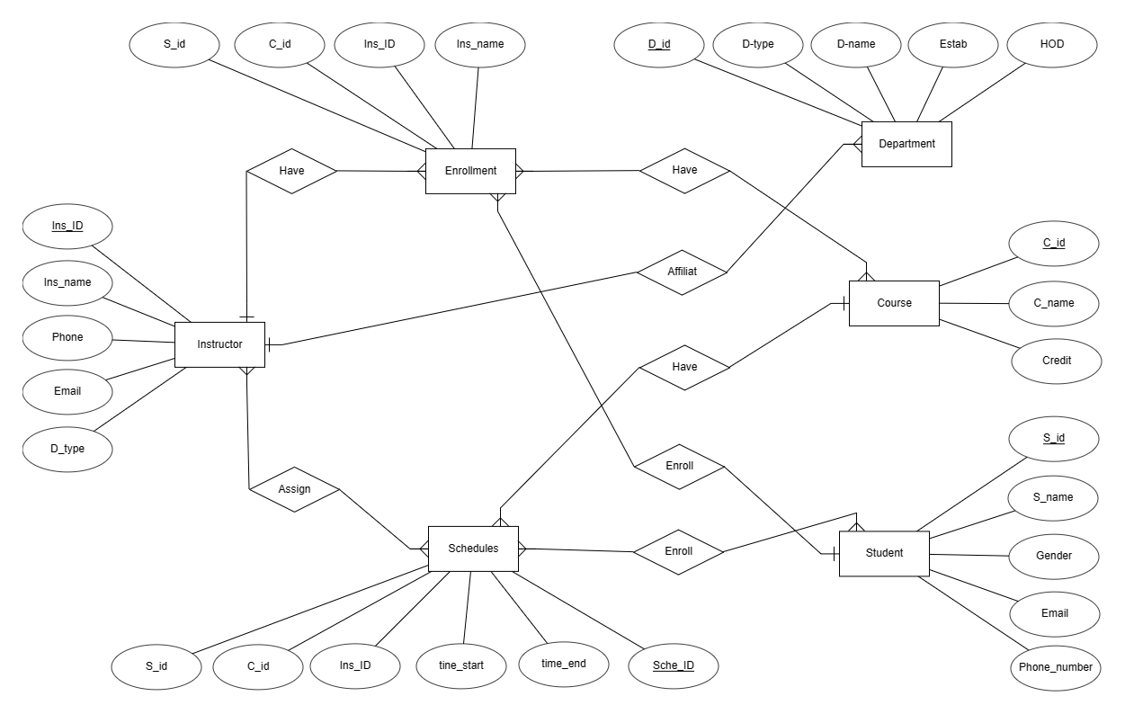

**Chapter 5:Code to Java**

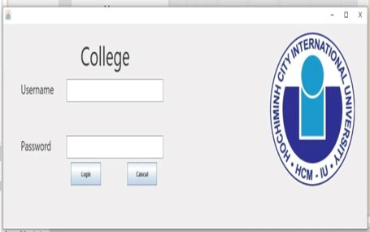

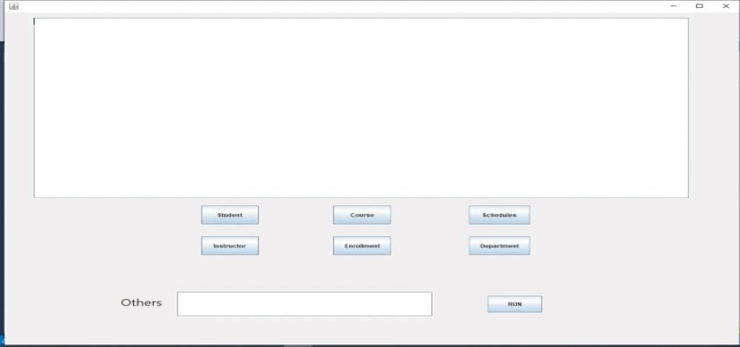

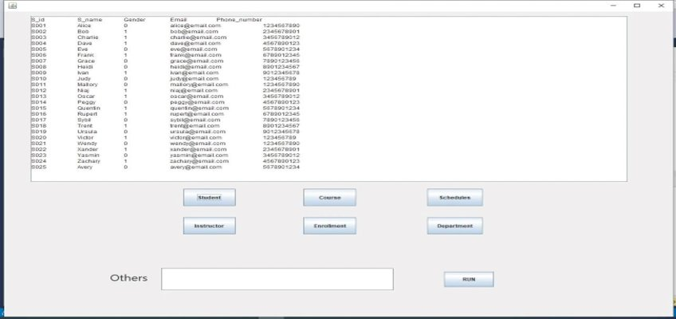

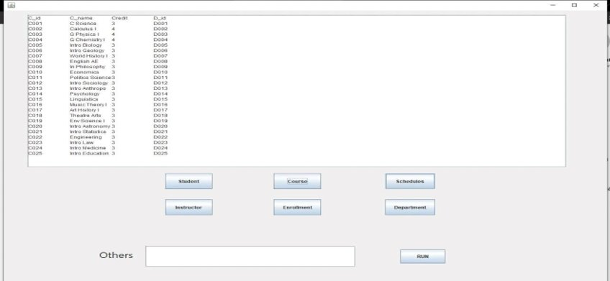

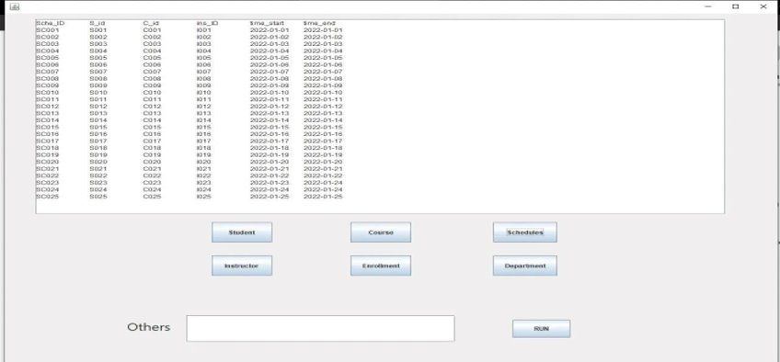

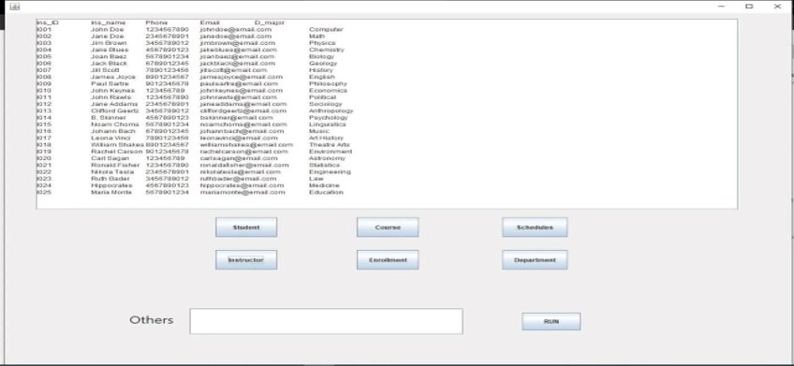

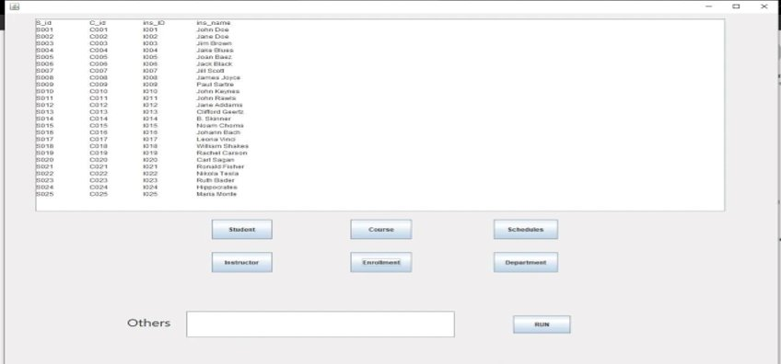

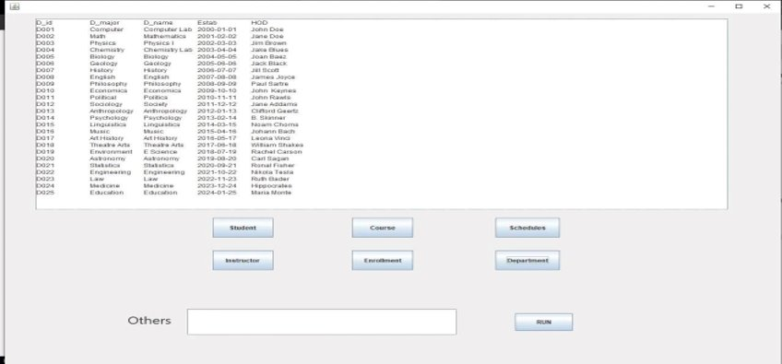

Example



