**Categorical Information Theory**

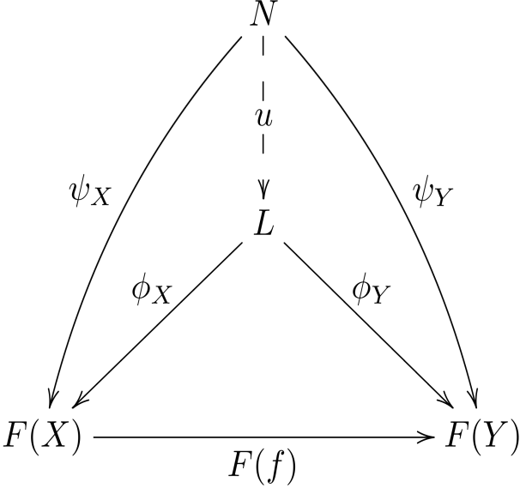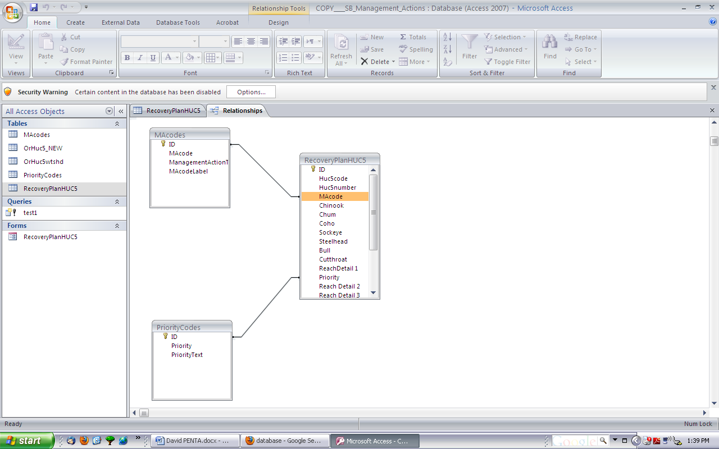

**STATUS QUO**  
There is currently no coherent and qualitative theory of information and communication.

**NEW INSIGHTS**

Category theory is designed to organize complex structures and control the moving parts.

*Figure 2. Diagram comparing objects in different categories.*

*Figure 1. Database schema relating different tables.*

Complex systems have a pressing need to process information eﬃciently, and the Navy is no exception. A group only functions as a unit when all the parts are in good communication. Data from one part of the structure needs to be transferable to and understandable by other parts. Short-term solutions, such as creating links between data sets in an ad hoc manner, will inevitably fail as the system evolves and becomes more complex.

Needed is a more encompassing and foundational viewpoint about how information should be modeled. Category theory not only provides this foundation, it is a powerful tool for organizing information in a way that is flexible, transferable, and scalable.

**END OF PHASE GOAL**

To present a categorical relationship between databases and ontologies, and to formulate a protocol for communication between disparate entities in terms of their respective ontologies.

**QUALITATIVE IMPACT**

Working within the category-theoretic model of information will make the Navy more efficient and accurate when processing and communicating information, both internally and externally.

*Presented by: David I. Spivak*

**Category theory provides a base for reliable information and efficient communication.**