Abstract—Swarm robotics and multilegged-robots require coordination in order move properly. In this paper, we are taking a look at a tripod movement coordination for a hexapod robot and the behavior of swarm robots in an environment with obstacles. All of this will be done independently.
Spider Robot and Swarm: Kumo K.U.M.O
Koralie Porcel, Jimmy Vu

Index Terms—Arduino, multilegged-robot, object recognition, swarm, communication

INTRODUCTION
S WARM robotics is a field of robotics that have a lot of applications. It is used in fields such as agriculture [1], medicine [2], military [3], and even aerospace [4]. When making swarms, engineers are mostly inspired by real life swarms, such as bee swarms or ant swarms. This concept is called biomimicry.
The goal of this project is to replicate the behavior of a real swarm by using robots and Arduino. We are going to build a swarm composed of two robots: a large hexapod which is going to be the chief of a smaller cubic robot. They will have to be coordinated to pick up objects. The chief will send orders and the smaller robot will pick up the objects and return them next to the hexapod.
In this article, we will refer to the small cubic robot as the “Minibot” and the hexapod as the “Spider”, even though it has only six legs.
We are going to present in this article, in the first place the functioning of the Spider robot and in the second place the functioning of Minibot.

The Spider Robot

General form
The Spider is a robot leader who will give the order to Minibot to recover an object of a pre-defined color.
While Minibot is searching and retrieving the object, the Spider will move in 4 directions autonomously while detecting and avoiding obstacles in its path.
When the Minibot has retrieved the object, it will warn the Spider and the latter will order the Minibot to come back and place the object at its leg.

Shape
As we can see with the figure 1, the Spider is a hexapod robot with 18 servomotors TD-8135MG [5]. At each leg there are three 180° servomotors, and each have three axes of rotation.

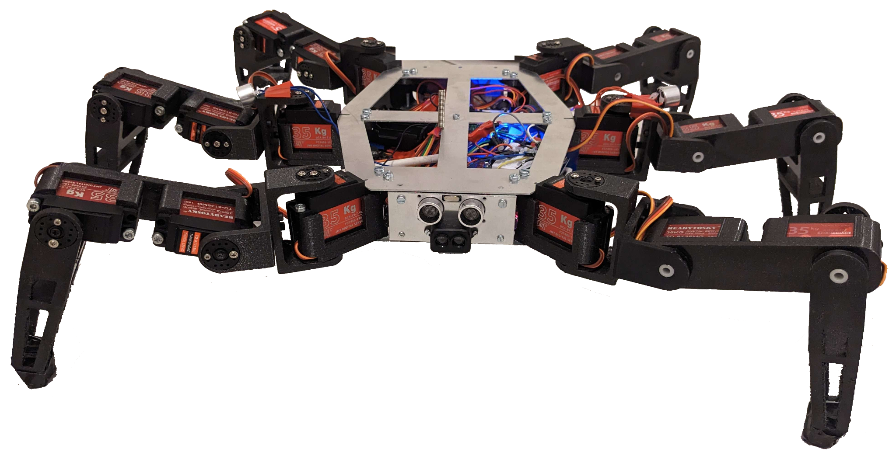
Figure 1: Spider Robot

Figure 1 shows the overall shape of the robot which is a non-regular polygon with 6 sides. This shape was chosen so that the Spider's legs don't get too bothered during movement.
The robot was completely modeled and simulated in 3D on Fusion 360 [6]

Each leg has 5 components that connect the servomotors together.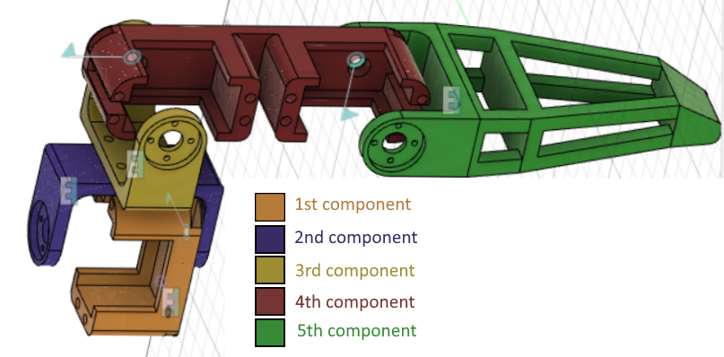
Figure 2: Representation of a leg

On figure 2, the first component is connected to the body of the Spider and allows the fixing of the first servomotor whose axis is horizontal. We add a hole on the other side of the axis of the servomotor to allow a better hold during the rotation. In addition, there are two holes along the entire length to allow the cables of the servomotors to go through.
The second component is connected to the axis of the first servomotor and on the other side of this axis, there is a hole to allow the better hold. The holes in part 1 and 2 are connected by a cylindrical nylon spacer. When this servomotor rotates, this will cause this part to rotate.
The third component is the same as the second one. It is connected to the second piece with screws and to the second servomotor by its axis of rotation and the nylon spacer.
The fourth component is a beam which allows the fixing of the last two servomotors. It has a hole all along to allow the cables of the third servomotor to fit in.
The fifth component allows the rotation of the axis of the third servomotor and contains the end of the leg.

The six legs were printed using a PRUSA 3D printer [7] in PETG [8]. Each leg took 12 hours to be printed.
The body of the Spider is made in aluminium 2mm. There are 4 faces that are holding with metal square and screws. The aluminium was machined using a manual metal shear [9] for exterior cut-outs and a water jet cutter [10] for interior cut-outs. A hacksaw was used to cut the square to size.
There are holes on the top face to allow the robot to be as light as possible.
At the end of each leg, there is an anti-slip material to allow a better adhesion with the ground and therefore not to slip.

Electronic functioning
We use a Mega SSC-32U [11] to control the 18 servo motors.
The Mega board is controlled by an Arduino Uno board [12]. These two cards are connected in series with the RX and TX of the two cards [13].
The Spider has 2 distance sensors: the HC-SR04 [14] module and the LIDAR TF-Luna [15].
The Spider also has a communication module HC-12 [16] that allows it to communicate with the Minibots.
These 3 sensors are controlled by the Arduino board.
There are 2 ultrasonic emitters one on the left middle leg and the other on the right which allow the swarm to return to the Spider. These sensors are just connected to the plus and minus of the Arduino board.
Figure 3 is the electric diagram of a 40 kHz emitter.
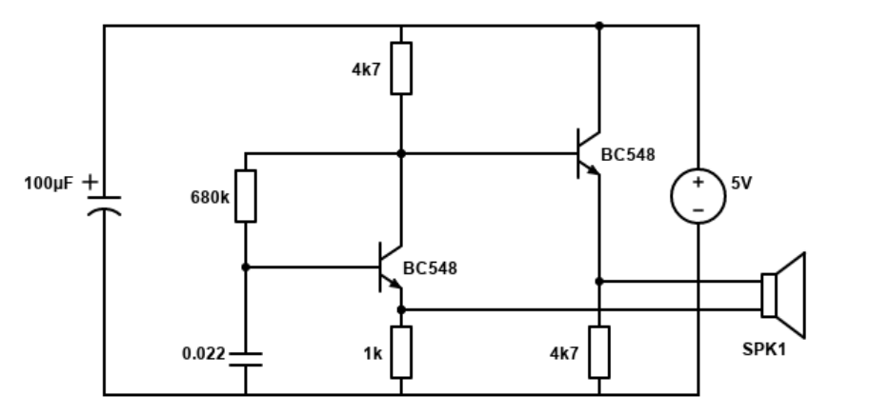
Figure 3 : Electric diagram of a 40 kHz emitter

There are 2 power supplies for the robot:
-The servomotors of the robot are powered with a power supply that outputs 6V and 20A.
-The control cards and the sensor are powered with a 5V battery pack.

Spider movement
The Spider is autonomous, it can move forward, backward, turn left and right [17]. It has a tripod movement. This means that during the movement, the Spider always has 3 points of contact with the ground.
This is not the case with real Spiders which have bipodal movement. However, it is more efficient and more practical for robots to move on a tripod because the legs don’t have enough grip for it to be more optimized and the balance is better.
We use a simulator to understand how the displacement is done [18].
The Spider’s code is made on Arduino [19]. The movement is done using a list that contains all the positions of the angles of the 18 servomotors. Values ​​change to allow the values ​​change to allow to move in the 4 directions using multiple specified conditions. The movement is cut according to what the user wants and at the speed he wants.

Obstacle detection
The Spider uses 2 different distance sensors because they have complementary advantages:
-the HC-SR04 module is an ultrasonic sensor that detects transparent obstacles in dark light but can’t detect complex shapes.
-the TF-Luna LIDAR is an infrared sensor that can detect complex shapes and is more precise than the first sensor but can’t detect transparent obstacles.
The use of 2 sensors makes it possible to compensate for the negative points of the 2 technologies and to have better precision.
Every 6 seconds, the Spider will turn left then right and come back to the middle. During this movement, it will record the distance to the nearest obstacle using the 2 sensors. Then using a case disjunction, depending on whether there is an obstacle on the sides and or in front, it will turn more or less to avoid the obstacle.

The minibot

General form

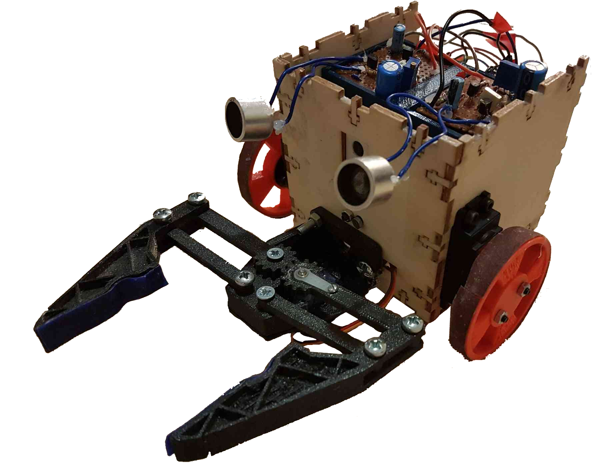

Figure 4: The Minibot

The Minibot’s purpose is to pick up a predetermined object from a list of objects once it has received an order from the Spider. The Minibot is cubic and made of wood, has a gripper to grab its object, a Pixy camera to recognize the object, a communication module using radio waves which is the HC-12, two continuous rotation servomotors and two ultrasonic receivers. All these components are connected to an Arduino Uno.

Shape
The cubic shape of the robot is fabricated using laser cutting technology. We first need to draw the pattern of a cube using MakerCase [20], then laser cut it and assemble it. T-shaped junctions are used to make the body more robust.

Movement
The Minibot moves by using two wheels that can be 3D printed and two continuous rotation servomotors. It can go straight, backwards, turn left and turn right. We glued emery paper onto the wheels to increase friction, thus grip onto the ground.

Gripper
The gripper can be found on Thingiverse [21]. Once the files are downloaded, we use a 3D printer to print the components and assemble it. The gripper needs a servomotor to be able to pick up the object. We use a SG-90 servomotor.

Object recognition
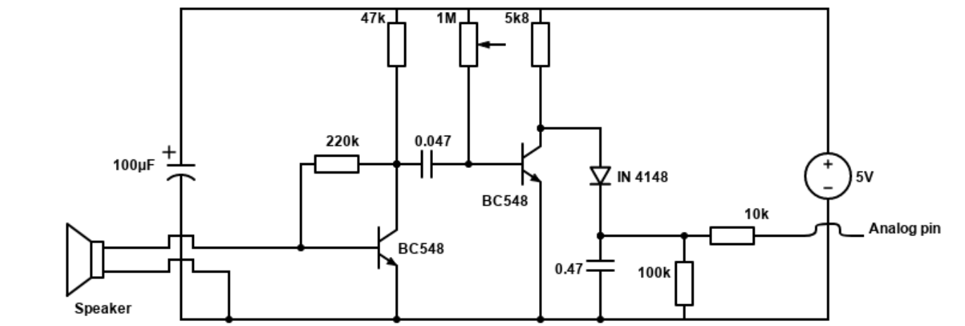
The Pixy camera [22] is used for object recognition. It has a mode that focuses only on the object’s color. We use this mode to teach the Pixy the object we want it to recognize. It is better to use objects that have a strong hue, e.g., a yellow stick glue. Once the Pixy recognizes the object, it can print a lot of useful data: the most important ones are the center of the recognition block with x-coordinates and y-coordinates and the height of the block.
For the Minibot to be able to move towards its object once it is recognized, we split the frame of the Pixy in multiple zones. Each zone has a direction for which the Minibot must go. Thanks to the center of the block, which is a single point in a frame, the Minibot has one and only one action to do for each frame, thus leading to precise movements. The height of the block tells us about the distance between the Minibot and the object. Once the object is centered and the Minibot is at a minimal distance from the object, it can pick up its object with its gripper.
Beware of luminosity variations for they have an influence on the quality of the image, and thus on the performance of the recognition.
Figure 5 is a representation of a sliced frame and a detected object within it.
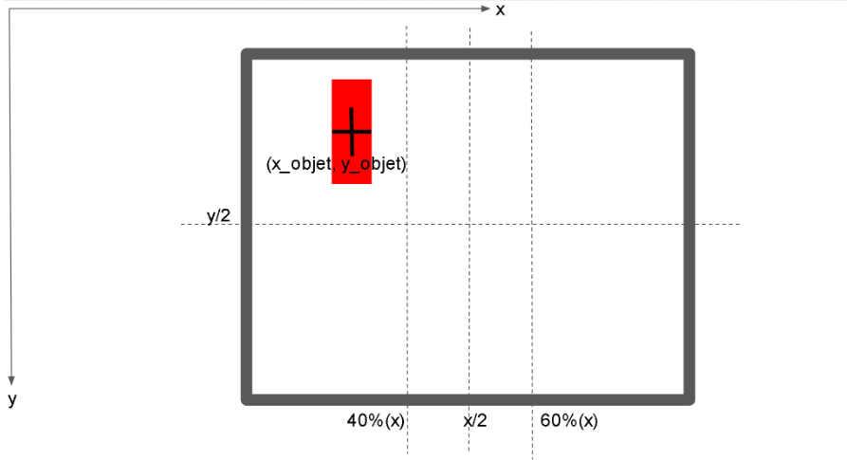
Figure 5: Sliced Pixy frame

Communicating data
The robots can communicate data using an HC-12 module.
The module can send or receive data, but not at the same time [23]. Thus, we need to add a delay which is large enough and small enough to not disrupt the overall behavior of the robots.
Placed on the Minibot, it makes it able to receive orders from the Spider and to send its progress towards its task.

Localization and ultrasonic receivers
In order to come back to the Spider once it has picked up its object, the Minibot must know where the Spider is. The GPS system is not a viable option since it has a 20-meter error, and our robots are not as far as 20 meters. Thanks to the two ultrasonic emitters placed on the Spider and the two receivers on the Minibot, it can slowly move itself towards the Spider which is emitting ultrasonic waves at a 40 kHz frequency. We convert the amplitude of the received signals into an analogic voltage and we compare these voltages. If one voltage drops, the Minibot must take a turn. Once one of the voltages is high enough, the robot can stop and drops its object. The voltage is a function of the inverse of the distance between the Spider and the Minibot: the more the voltage, the less distance there is. Figure 6 is the electric diagram of a receiver [24].
Figure 6 : Electric diagram of a receiver

Conclusion

We have made a hexapod Spider robot with 18 servomotors of 180° of freedom and 3 axes of rotation that can move in 4 directions and can detect obstacles at an angle of 150° in front of the Spider and avoid them using 2 distance sensors.
We also made one cubic robot that moves with a gripper and grabs an object if it matches a specific colour Spider. The Spider orders the cubic robot to find and grabs the object. When he has recovered it, the Spider orders him to come back to her.
It would be even better if there were more robots to retrieve objects, for optimization purposes and if the Spider can help find the object.
Nevertheless, this project is a great introduction to swarm robotics, as the concept is currently expanding around the world. It also introduced the moving of a hexapod Spider in a 3D complex environment.
The project can be found on our GitHub [25].

References
- https://www.swarmfarm.com
- Stefanie Warnat-Herresthal, Hartmut Schultze et al. (2021, 05) Swarm learning for decentralized and confidential clinical machine learning. nature. Available: https://www.nature.com/articles/s41586-021-03583-3
- Ryan Bridley, and Scott Pastor (2022, 08). Military drone swarms and the options to combat them. Small Wars Journal. Available: https://smallwarsjournal.com/jrnl/art/military-drone-swarms-and-options-combat-them#:~:text=A%20swarm%20is%20the%20utilization,own%20swarms%20for%20military%20use
- https://swarm.space
- Servomotor td-8135mg : https://www.racing-power-boat-rc.com/produit/radio-servo/servo/servo-etanche-td-8135mg-35kg/
- Fusion360 : https://www.autodesk.fr/products/fusion-360/overview?term=1-YEAR&tab=subscription
- Prusa printer : https://www.prusa3d.com/fr/categorie/original-prusa-i3-mk3s/
- PETG: https://www.3dnatives.com/plastique-petg-18122019/
- Manual metal shear : https://www.optimachines.com/cisailles-manuelles/9534-cisaille-manuelle-metallkraft-ftbs-1050-10.html
- Water jet cutter: https://www.techniwaterjet.com/how-it-works/#:~:text=Waterjet%20cutting%20is%20simply%20an,object%20in%20place%20for%20cutting.
- SSC-32u : https://www.instructables.com/Controlling-Servos-Using-the-SSC-32-Servo-Controll/
- Arduino uno : https://store.arduino.cc/products/arduino-uno-rev3?gclid=EAIaIQobChMI7OHP-fKS_wIVEsjVCh2ncwSOEAQYASABEgIAy_D_BwE
- RX and TX: https://pecquery.wixsite.com/arduino-passion/la-liaison-serie
- HC-SR04 : https://www.carnetdumaker.net/articles/mesurer-une-distance-avec-un-capteur-ultrason-hc-sr04-et-une-carte-arduino-genuino/
- LIDAR TF-Luna : https://www.lextronic.fr/capteur-de-distance-lidar-tf-luna-59476.html
- HC-12 : https://www.aranacorp.com/fr/utilisation-dun-module-hc-12-avec-arduino/
- YouTube video of our spider movement: https://youtube.com/shorts/W86TozXhF5o
- Simulator : https://github.com/mithi/hexapod-robot-simulator
- Arduino : https://docs.arduino.cc/learn/starting-guide/whats-arduino
- https://fr.makercase.com/#/
- https://www.thingiverse.com/thing:715525
- https://pixycam.com
- https://howtomechatronics.com/tutorials/arduino/arduino-and-hc-12-long-range-wireless-communication-module/
- https://www.pocketmagic.net/detecting-an-ultrasonic-beacon/
- https://github.com/dsprz/Swarm-bots

K. Porcel. Born in Antibes, 2003, enrolled for the CPI at Université Côte d'Azur Polytech Nice and is currently studying robotics at the same school.
J. Vu. Born in Nice, 2003, enrolled for the CPI at Université Côte d'Azur Polytech Nice and is currently studying robotics at the same school.

 K. PORCEL student at Université Côte d'Azur Polytech Nice Robotics and autonomous systems 06410 BIOT ( koralie.porcel@etu.unice.fr) J. VU student at Université Côte d'Azur Polytech Nice Robotics and autonomous systems 06410 BIOT ( jimmy.vu@etu.unice.fr)

