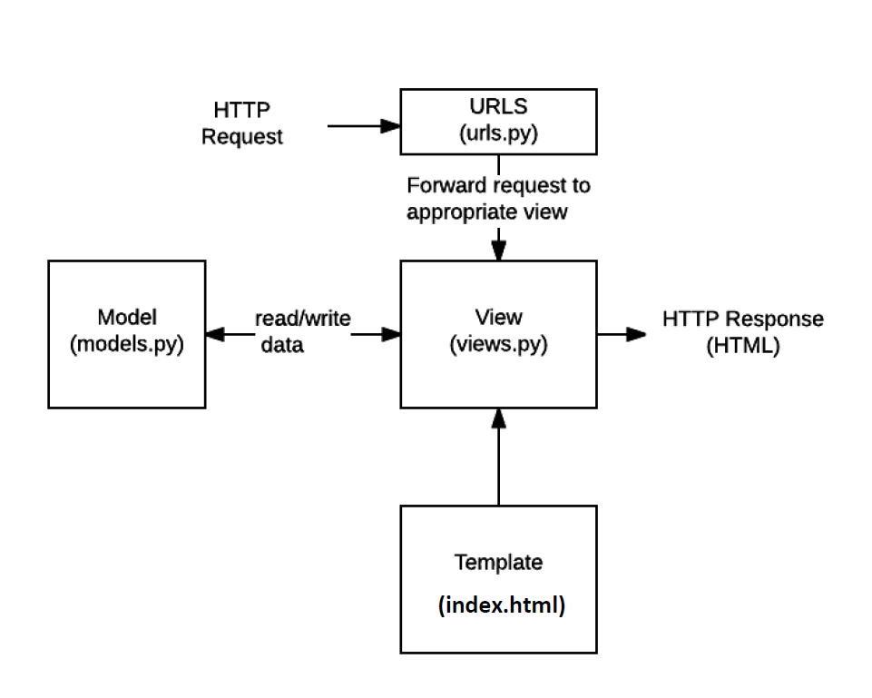

**Django**

**Django REST Framework**

**HTTP Requests**

**+**

**URLS**

**(urls.py)**

**Routers**

**Serializers (serializers.py)**

**read/write data**

**Models (models.py)**

**+**

**View (views.py)**

**Viewsets (api.py)**

**serializes data**