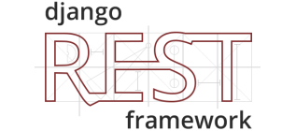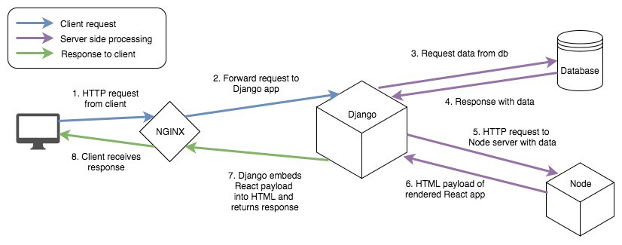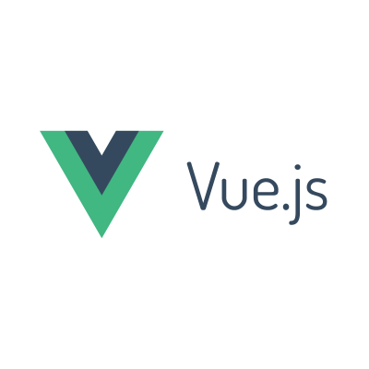

**REST API**

**DjangoREST Framework serializes data from the Django ORM and allows access/updates via a RESTfull API**

**VueJS can GET, POST etc data from the Database via the REST API**

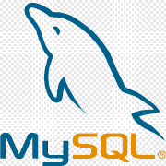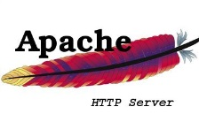C:\Program Files (x86)\Microsoft Office\MEDIA\CAGCAT10\j0205582.wmf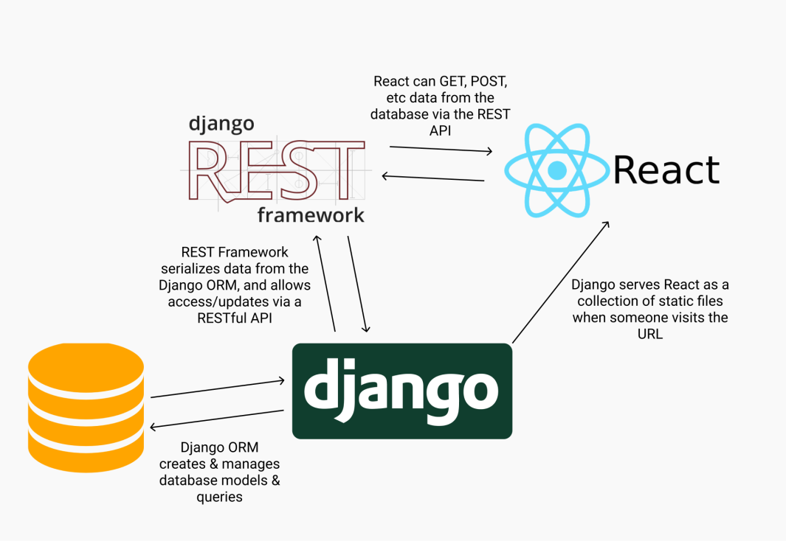

**Django serves VueJs as a collection of static files when someone visits the URL**

**Response with Data**

**Request Data from DB**

**Django embeds VueJs payload into HTML and returns response**

**Forward request to Django App**

**Client receives Response**

**HTTP-Request from Client**