**Pyspark-Shell Output details:**

**PART_1:**  
Task_1_1: Loading Data and take 5 records



Task_1_2:

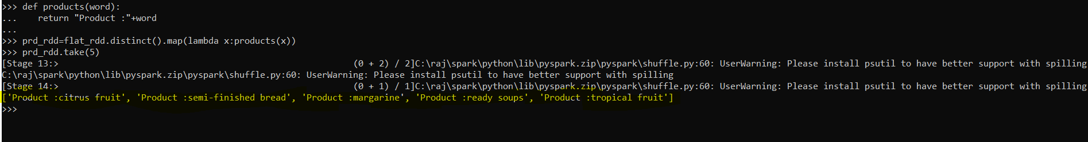

Task_1_2a:

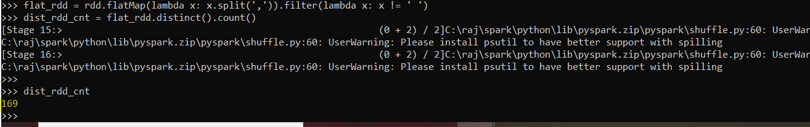

Task_1_3:

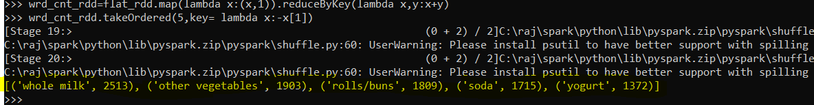

**PART_2:**

Task_2_1:

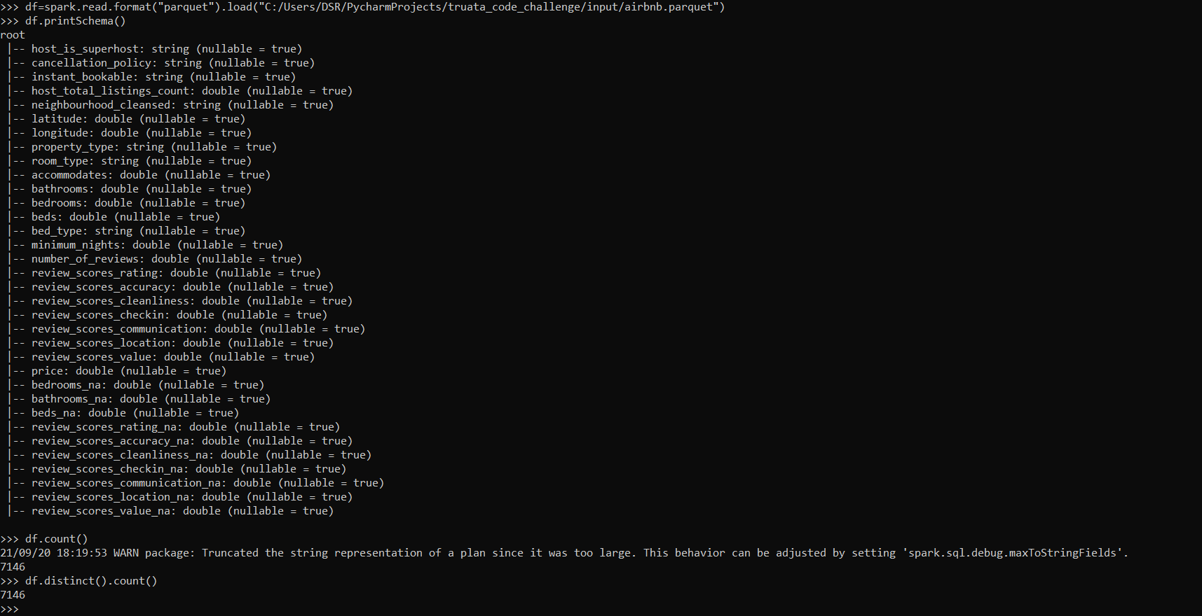

Task_2_2: Multiple Ways

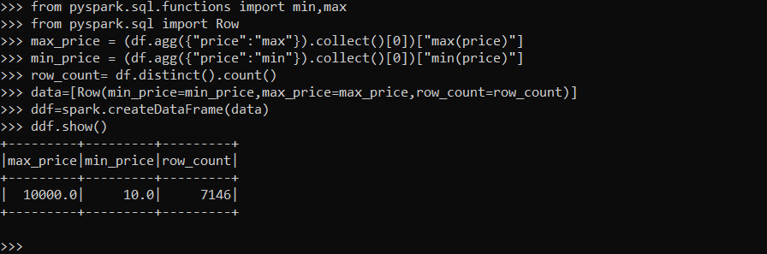

Task_2_3:

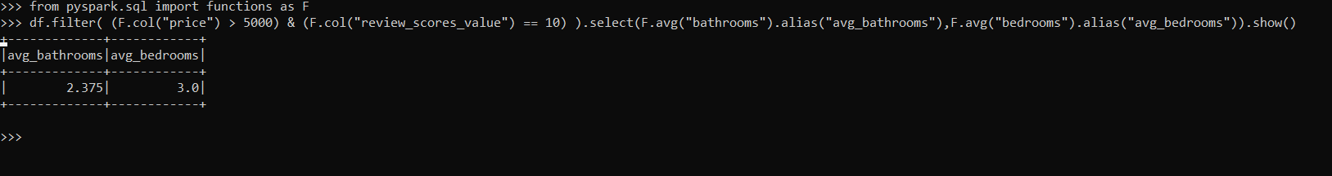

Task_2_4:

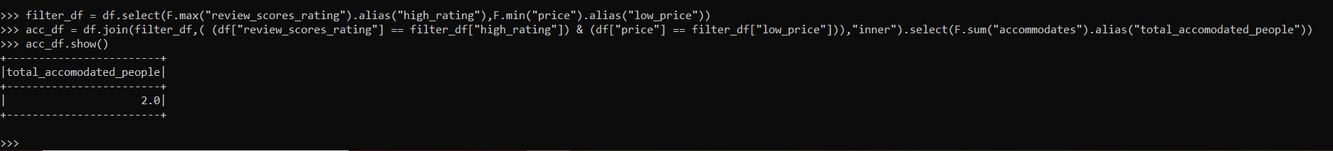

Task_2_5:

Added code snippet to generate the required Airflow DAG

PART3:

Task_3_1 & Task 3_2:

Added the code snippet to work with Spark Mlib as it wasn’t showing the required output.

Note: This needs some external libraries but my windows system was not supporting for that.