### Lab4: Part 1:

Insert these json file into MongoDB: [toi_june2019.json](https://iu.instructure.com/courses/2181613/files/160176562?wrap=1)[Download toi_june2019.json](https://iu.instructure.com/courses/2181613/files/160176562/download?download_frd=1) [database: "news", collection: "june2019"], [tweets.json](https://iu.instructure.com/courses/2181613/files/160176700?wrap=1)[Download tweets.json](https://iu.instructure.com/courses/2181613/files/160176700/download?download_frd=1)[database: "tweetsdb", collection: "tweets"]

JSON insertion snaps:

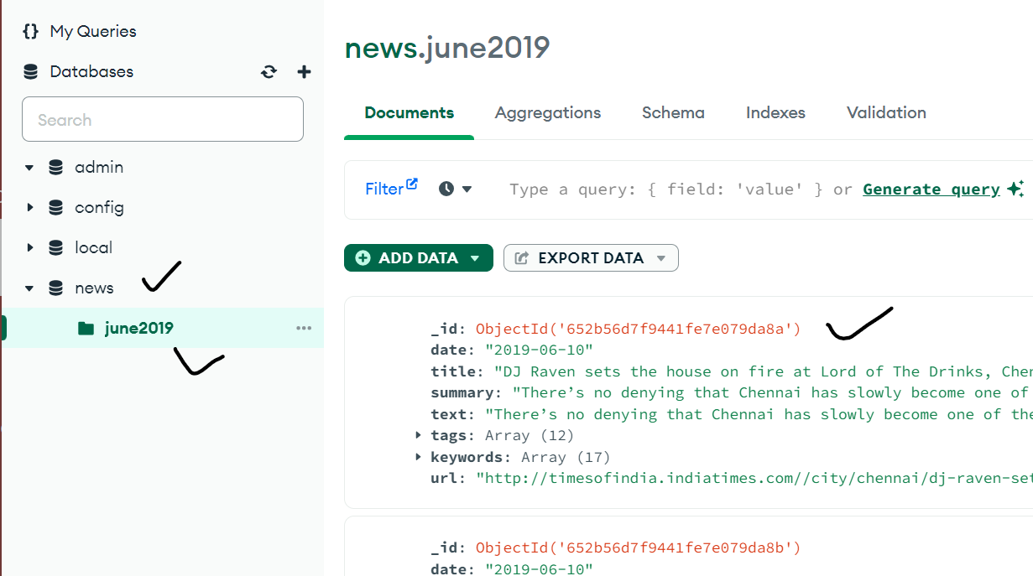

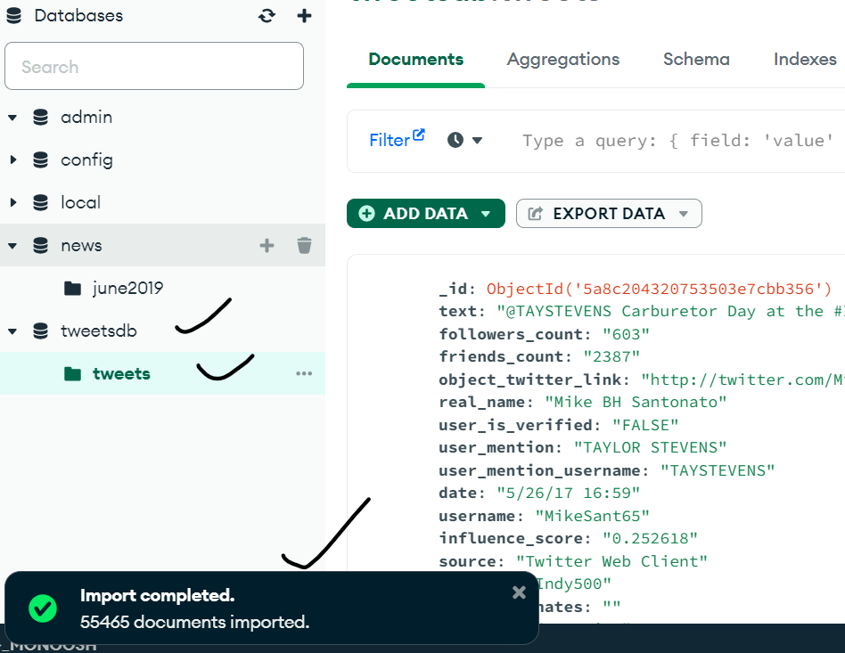

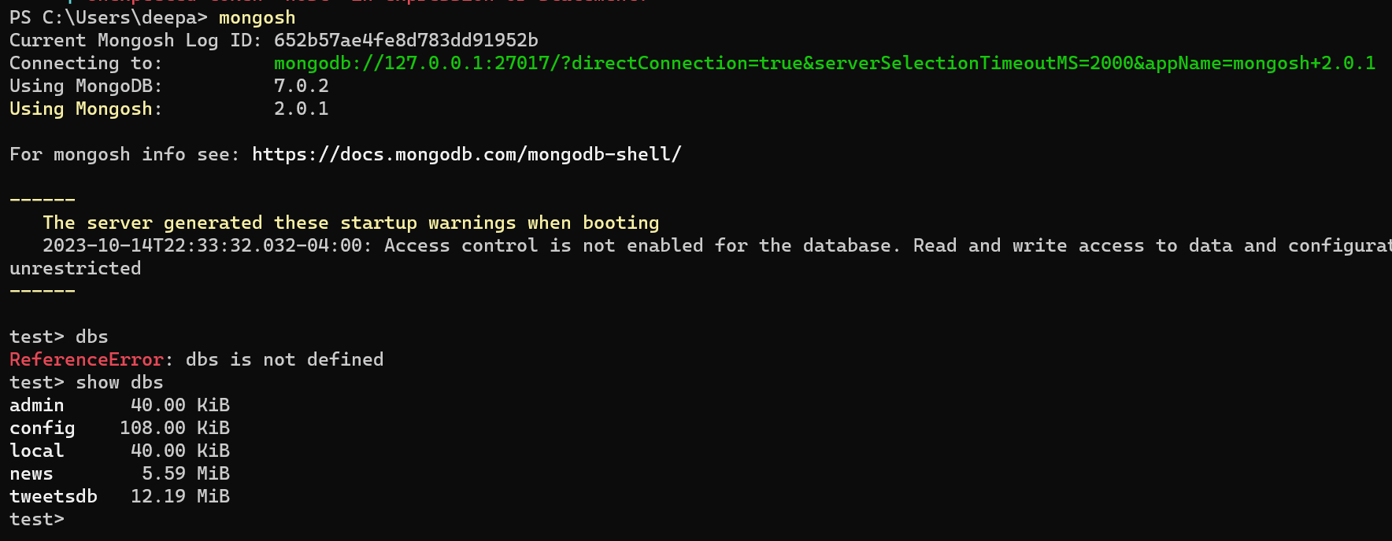

Tasks:

Use pretty() to have a cleaner output

1. List all the "tags" (a field in the documents)

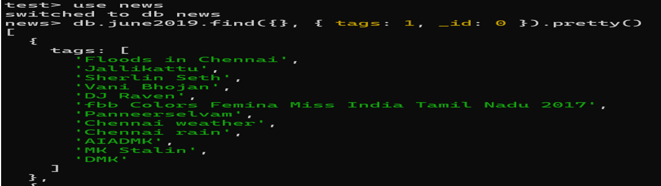

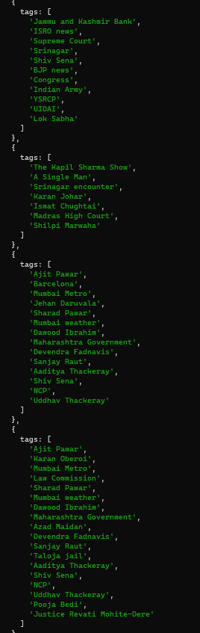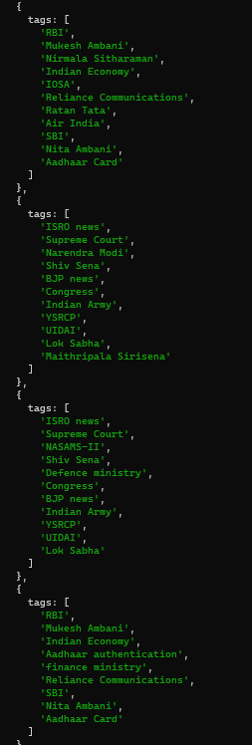

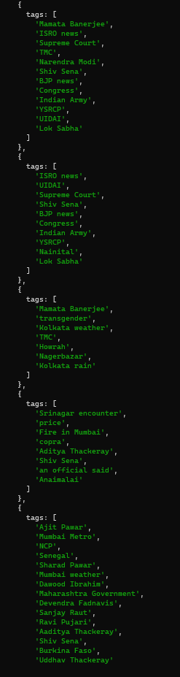

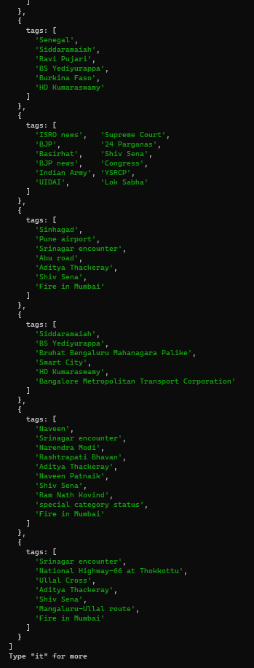

2. List all documents published after June 12 2019 but before June 16 2019 (including those dates)

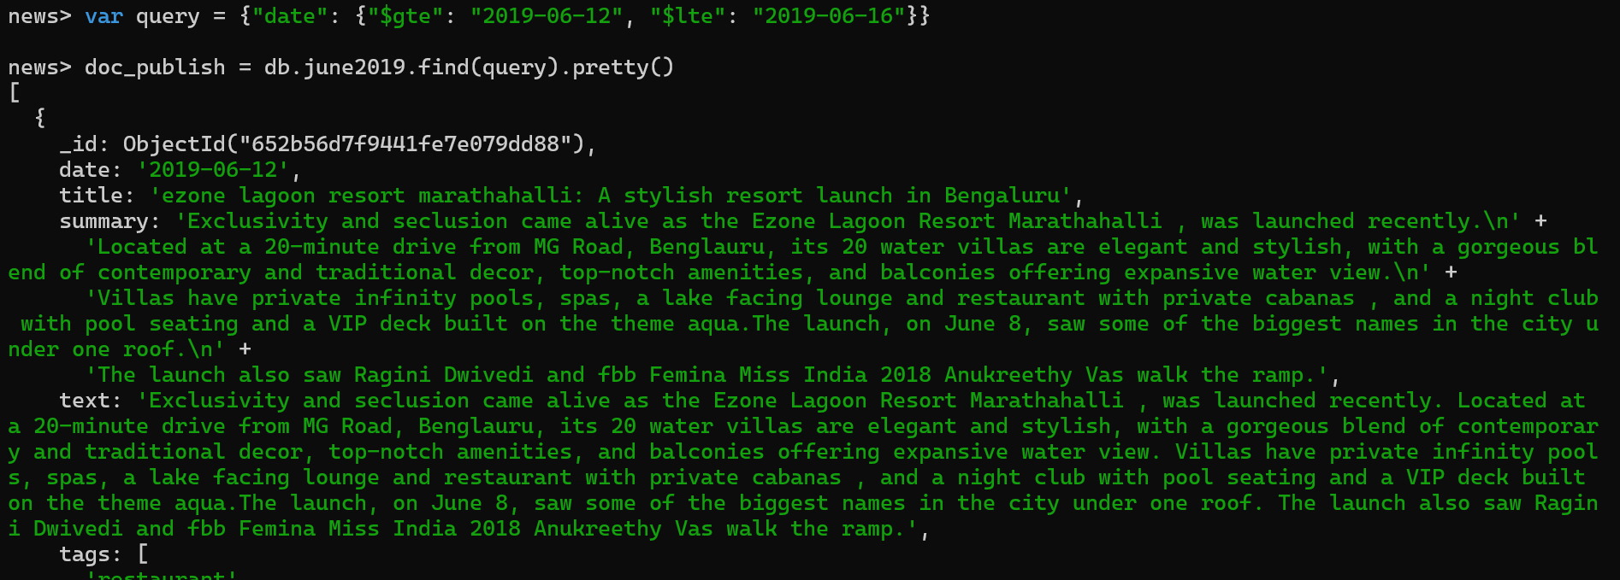

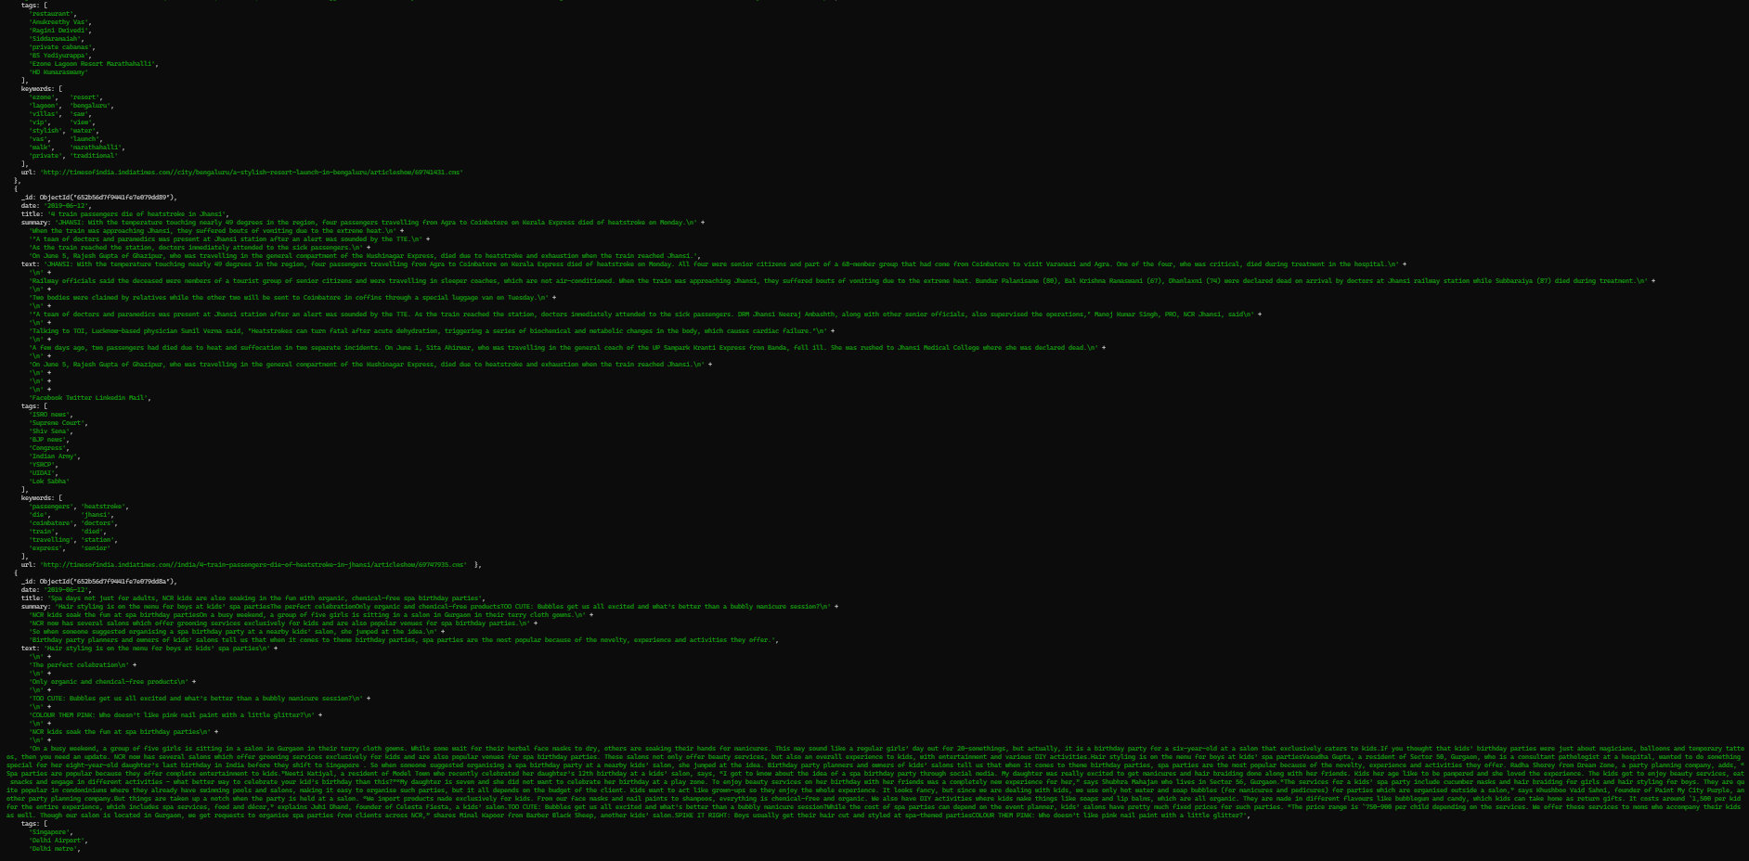

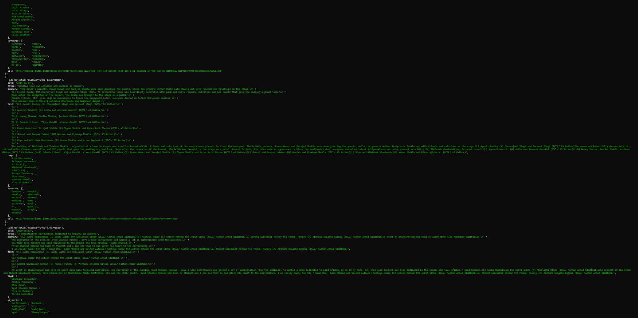

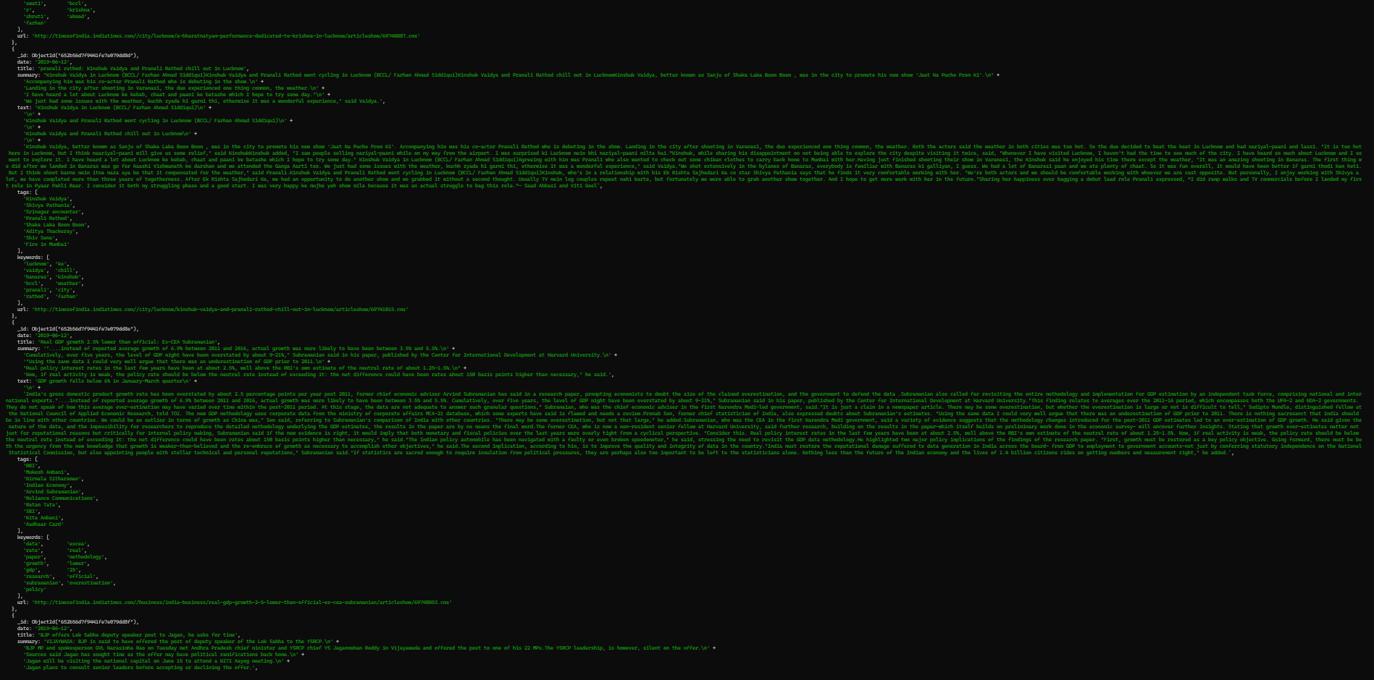

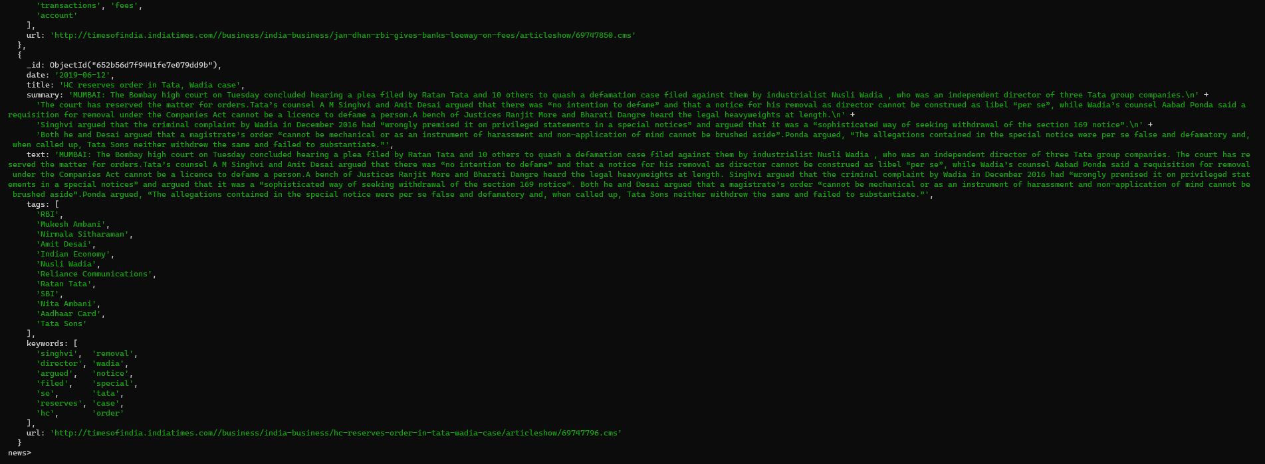

1. List all documents whose "keywords" contain the word "election" (Hint: use regular expression)

