Assignment-01

10 Points

Please follow the below instructions to complete the assignment.

1. Open XCode from the launchpad and click on file and choose new - project.
2. Select the iOS template and click on the App application and click on the next button.
3. Enter the project name as LastName_Assignment01, “nwmsu” for organization identifier, “storyboard” as interface and swift for language.
4. Click on next and select the location for storing the app.
5. In app general setting, select project format to XCode 13.0 compatible and in the minimum deployments section select 15.0.

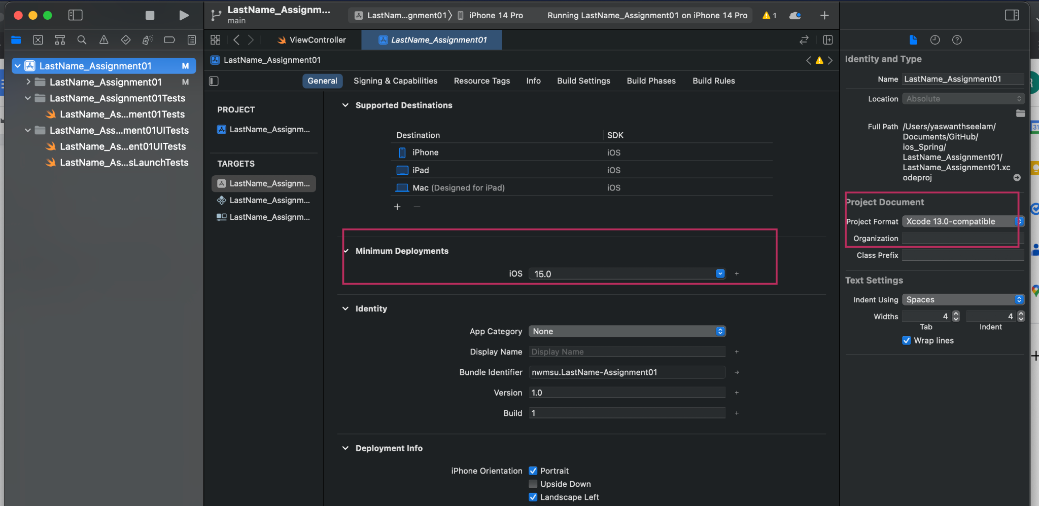

1. From the project navigator click on “Main”. An empty mobile screen will be loaded where we need to add the required fields.

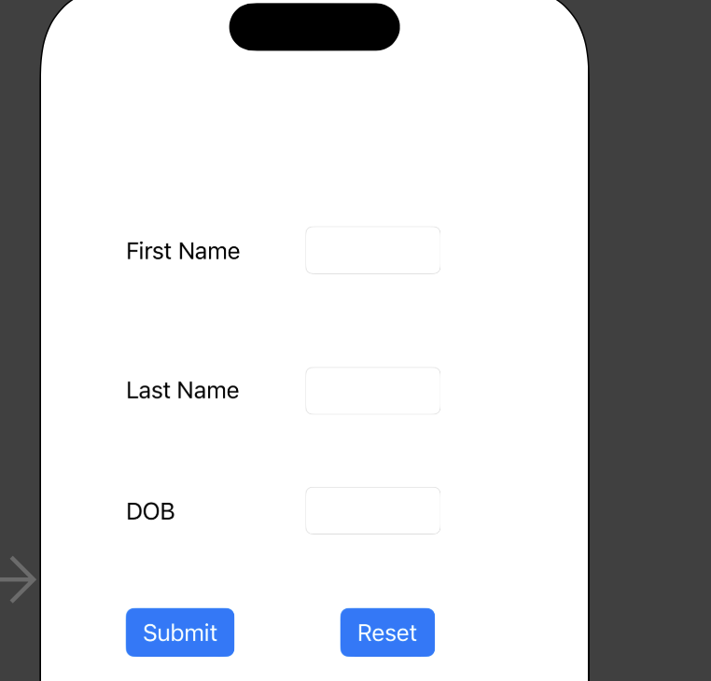

1. We need to add 3 labels by dragging them from the library and name them **First Name**, **Last Name** and **Birth Year** respectively as shown above. Also drag 2 filled buttons and name them **Submit** and **Reset.**
2. On click of the Submit button, we need to display the lastName followed by firstName followed by their initials and then their calculated age.
3. For displaying the details, we need to drag and drop 3 labels from the library and make sure that these are empty initially.

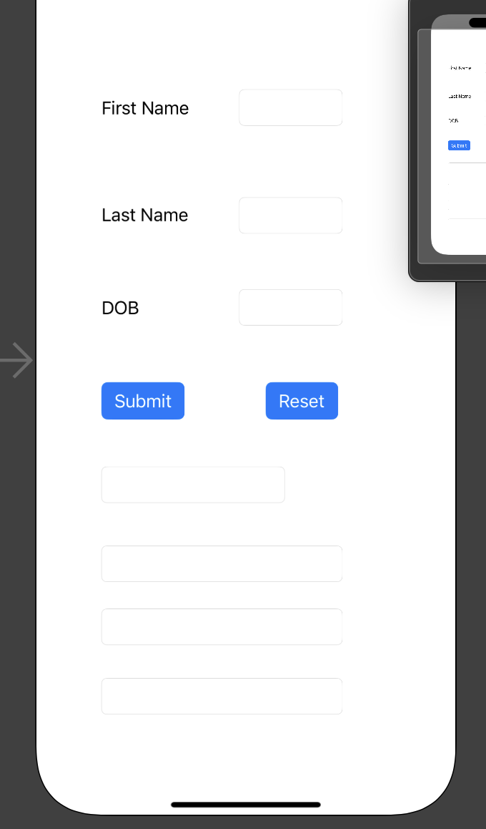

1. On click of the reset button, we need to clear the text entered into the text fields and also the display labels.
2. Now as the UI of the app is completed, we need to provide the connections to the ViewController.
3. Click on the option button and click on the view Controller.
4. Now we will create outlets for first name, last name, year, full name, Initials and age label objects as outlets in the view controller and name them as firstNameOutlet, lastNameOutlet, yearOutlet, fullNameLabel, initialsLabel and ageLabel respectively. To do that, ctrl+click on an object and drag it to the viewcontroller, select the action as an outlet in the popup menu as specified.
5. Now to add the submit and reset actions, we need to ctrl+click on the submit button and drag it to the viewcontroller, in the pop-up menu select the connection as action, type as UIButton and name it as SubmitBTN, follow the same for reset button and name it as ResetBTN.
6. In the function SubmitBTN of the viewController, write code to print the full name (last name followed by first name), then get the initials and also the print the age (calculate it using the give year of birth and current year) and populate the fullNameLabel, initialsLabel and ageLabel respectively.
7. In the function ResetBTN, write code to erase all the details entered and also the details displayed.
8. Set the application background and font styles as per your interest.

**Sample Output:**

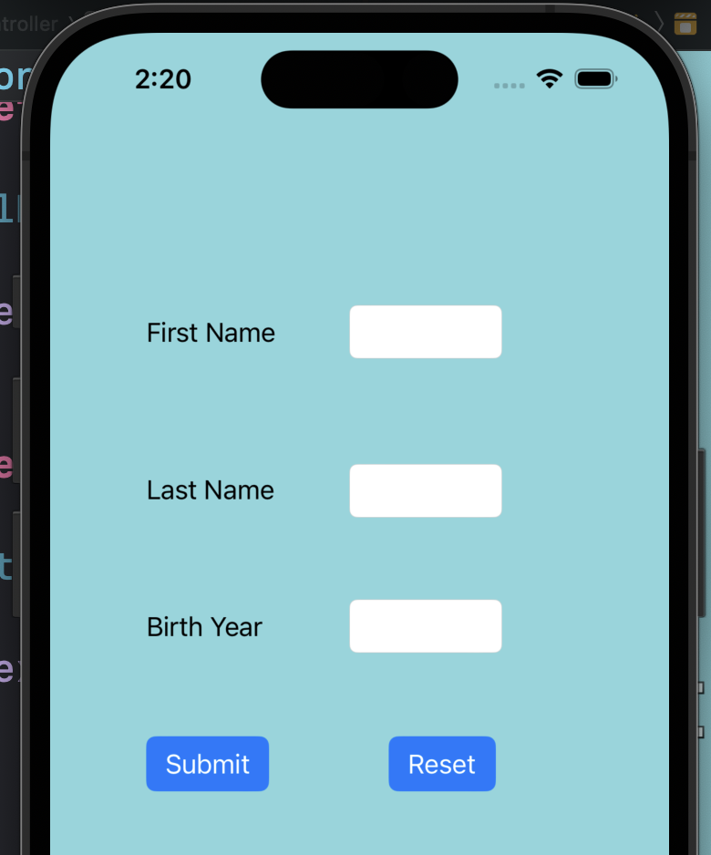

**Click of the Submit button:**

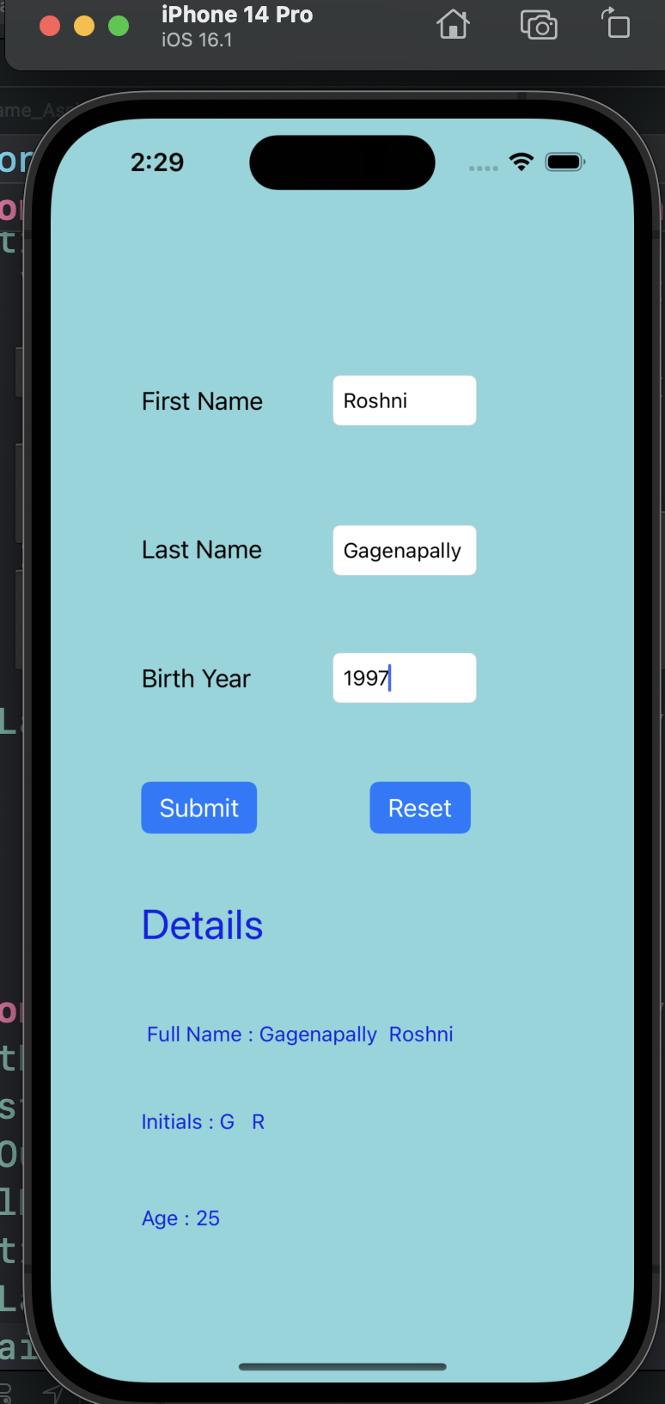

**Click of the Reset button:**

