**Step 0: write git to check if install properly**

**Pwd: present working directory**

**Step 1: Setting up the user and email address.**

**Step 2: Setting up the git repository**

**How to drop the git repository**

**Clone the git repository**

**Git log**

**Press q to quit**

**File tracking**

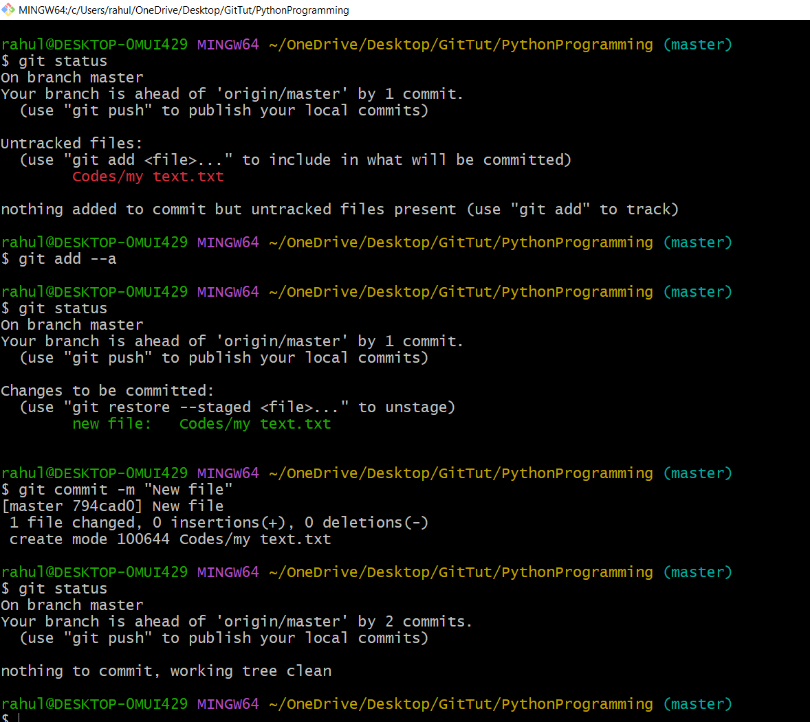

**File both in Staging and modified**

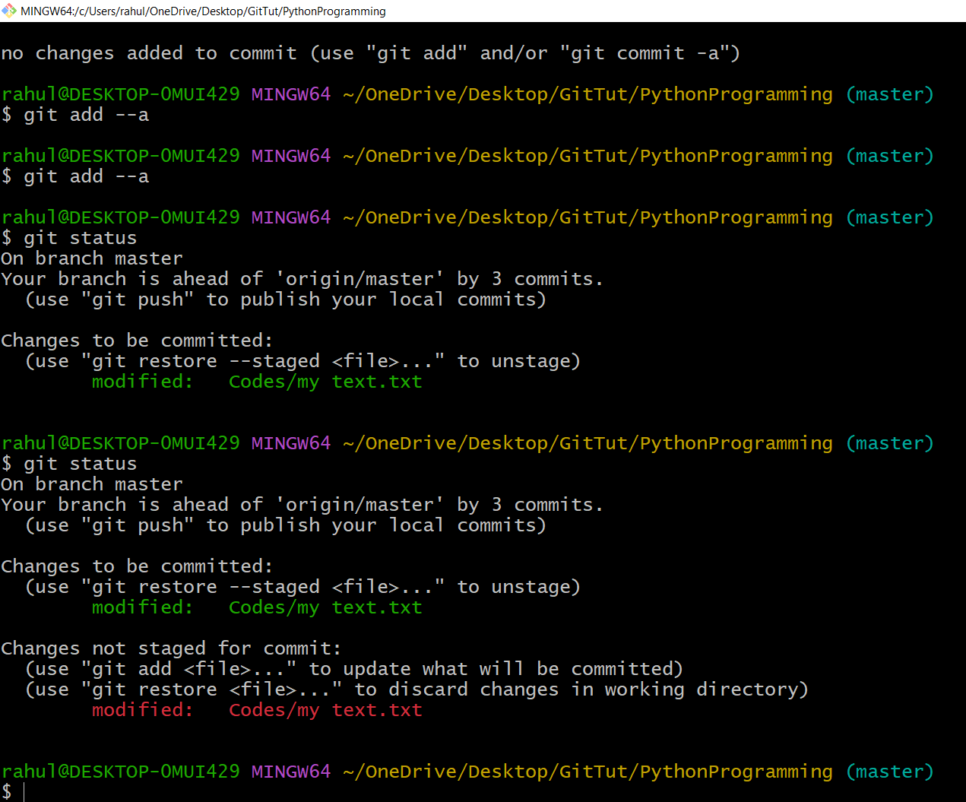

**If you commit now the latest file will not commit old one will commit which are in green.**