Week 4: Exploratory Data Analysis and Feature Engineering
Beauty & wellness customer behavior | Reproducible worked example
Data provenance: simulated, not observed. No source dataset was available in the workspace. The figures and numerical results below are generated from the seeded synthetic data produced by the companion Python script.

1. Executive summary
The reproducible example contains 1,500 simulated customers and 4,511 historical orders dated through 2025-12-31. Simulated total revenue is $174,749.39; Spa Services contributes 38.5% of it. The generated 90-day repeat-purchase rate is 21.9%. On a stratified 25% holdout, engineered customer behavior features produce ROC-AUC 0.855 versus 0.793 for the baseline (difference +0.062). This is a demonstration of the workflow, not evidence of production uplift.

2. Business question and analytical scope
Primary question: which observable purchase-history patterns are useful for identifying customers likely to place another order within 90 days? Secondary questions: how do category mix, discount use, satisfaction, and recency vary across customer groups, and which patterns suggest testable retention or cross-category opportunities?
- Unit of analysis: order line for revenue and category analysis; customer for RFM summaries and the repeat-purchase model.
- Observation cutoff: 2025-12-31. Historical behavior is aggregated at that cutoff; the label is a simulated next-90-day outcome.
- Population: customers with at least one historical order in the synthetic extract; therefore the example does not estimate acquisition or first-purchase conversion.
- Business use: prioritize experiments and customer-service outreach; do not use age, region, or inferred wellness preferences for sensitive decisions without legal, fairness, and privacy review.

3. Data audit and quality checks
Run structural checks before interpreting charts: schema and data types, unique order keys, customer-key referential integrity, missingness, duplicate lines, date range, nonnegative spend, discount bounds, and rating bounds. For real exports, reconcile sales totals with finance and confirm whether refunds, taxes, returns, and canceled orders are included.
Audit item | Observed result
Order rows | 4,511
Customer rows | 1,500
Missing cells: orders / customers | 0 / 0
Duplicate order IDs | 0
Dates outside configured history window | 0
Observed order date range | 2022-02-14 to 2025-12-31

4. EDA workflow and statistical methods

4.1 Univariate and distributional review
Report count, mean, standard deviation, median, IQR, minimum, maximum, and missingness for spend, discount, rating, recency, and order count. Use histograms/KDEs for shape and boxplots for skew and extreme values. Revenue is typically right-skewed, so retain the raw scale for monetary interpretation and use log1p only for suitable model inputs. Flag possible outliers with IQR fences, then verify against business rules rather than deleting automatically.

4.2 Segmentation and relationships
Compare customer spend, frequency, wellness share, and repeat rate by acquisition channel, loyalty status, region, and category. Use median and IQR alongside means. Use Spearman correlation for monotonic relationships between skewed numeric measures; Pearson heatmaps are included here as a screening visualization only. Inspect pair plots on a stratified sample when interactions are suspected.

4.3 Tests and uncertainty
For two independent groups (for example, repeat versus non-repeat customer spend), use Mann–Whitney U when distributional assumptions for a t-test are unsuitable; report group medians and an effect size, not only a p-value. For three or more groups (such as order count by channel), use Kruskal–Wallis, followed by multiplicity-adjusted pairwise tests if significant. For category-by-channel counts, use Pearson chi-square and Cramér's V; combine sparse levels or use an exact/Monte Carlo method if expected cell counts are too small. Predefine comparisons, report confidence intervals, and distinguish exploration from confirmatory inference.

4.4 Worked statistical examples
Worked comparison | Observed groups/check | Test result
Customer spend: repeat vs. non-repeat (Mann–Whitney U) | $159.11 vs. $80.03 | U=289,444; p=<0.001; rank-biserial r=0.506
Order counts across channels (Kruskal–Wallis) | Independent customer groups | H=2.88; p=0.410
Order category by channel (chi-square) | Minimum expected cell=110.9 | chi-square=16.79; p=0.158; Cramér's V=0.035
These tests demonstrate the calculation on seeded simulated data. They do not establish causal effects, and statistical significance does not by itself establish a commercially meaningful difference.

5. Visualization plan and worked results
Use pandas for schema checks, aggregation, and reproducible tables; Matplotlib for explicit axes, labels, and report-ready figures; Seaborn for distribution, categorical, and correlation views; SciPy for nonparametric and contingency-table tests; and scikit-learn for preprocessing pipelines and held-out evaluation.
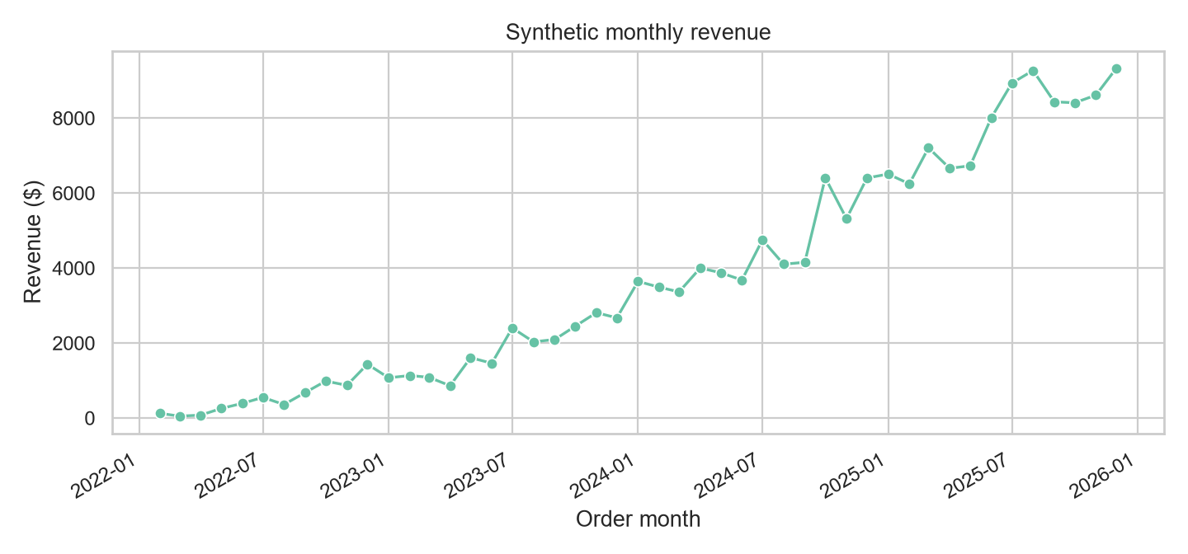
Figure 1. Monthly synthetic revenue. Look for seasonality and abrupt changes; a synthetic curve is not a forecast.
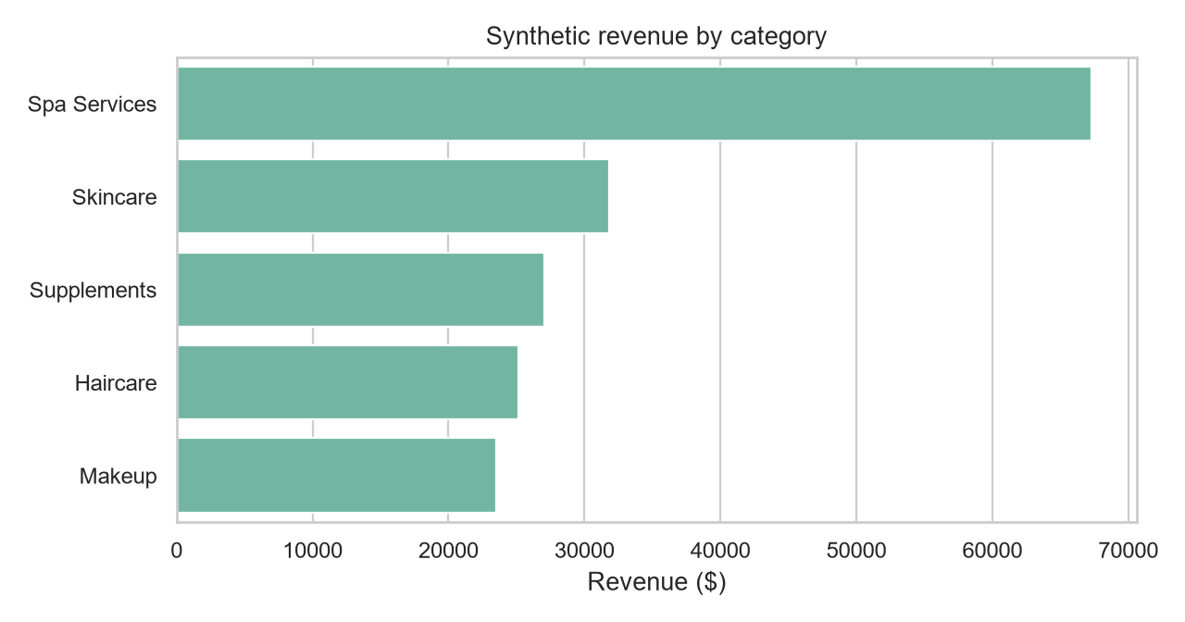
Figure 2. Synthetic revenue by product/service category. Validate returns, price mix, and exposure before interpreting category differences.
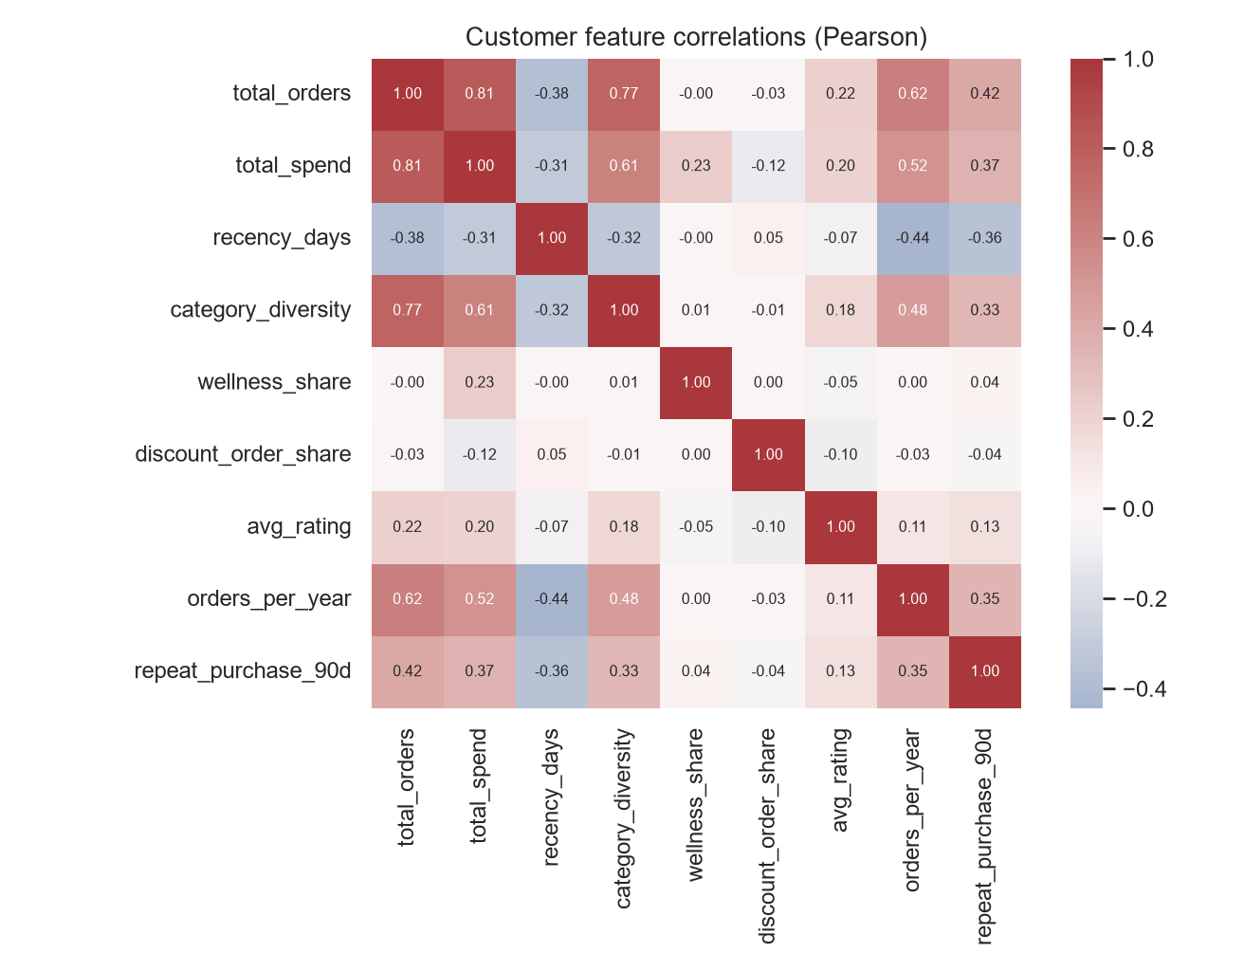
Figure 3. Pearson correlations among customer-level measures. Correlation is descriptive, not causal; correlated features may require regularization.

6. Feature-engineering plan
Feature | Construction | Business signal / caution
Recency | Cutoff date − last order date (days) | Lapse risk and replenishment timing; make cutoff explicit.
Frequency | Distinct orders in trailing 365 days | Engagement cadence; deduplicate order lines.
Monetary / AOV | Net spend sum / distinct orders | Customer value; exclude tax/refunds consistently.
Category diversity | Distinct categories per customer | Breadth of routine; not proof of cross-sell intent.
Wellness share | Supplements and spa order count / all orders | Wellness affinity proxy; validate taxonomy and consent.
Discount-order share | Orders with discount >= 15% / all orders | Promotion reliance proxy; threshold must be tested.
Satisfaction | Mean post-order rating | Experience signal; address missing/non-random survey response.
Order cadence | Orders / observed tenure in years | Normalizes frequency for customer exposure time.
Interaction | Recency × wellness share; discount share × channel | Tests whether recency or promotion response differs by segment.

6.1 Concrete transformations
Example for a customer with 4 orders, $240 spend, 2 wellness orders, and 1 discounted order (at the defined 15% cutoff): AOV = $240 / 4 = $60; wellness share = 2 / 4 = 0.50; discount-order share = 1 / 4 = 0.25. If the cutoff date is 2025-12-31 and the last order was 2025-11-16, recency = 45 days. These calculations are examples of feature definitions, not a claim about any real customer.
For modeling: standardize continuous variables within a training-only Pipeline; use log1p for nonnegative long-tailed monetary/frequency variables after checking zeros; one-hot encode nominal channel and region; keep ordered categories ordinal only when the order has a defensible meaning. Fit imputers, scalers, encoders, and any feature selection on training folds only. Avoid target leakage by computing every feature strictly before the label window.

7. Model comparison and business interpretation
Model | ROC-AUC (higher) | Accuracy at 0.5 | Brier score (lower)
Baseline | 0.793 | 0.795 | 0.137
Engineered | 0.855 | 0.816 | 0.122
The engineered model's held-out ROC-AUC change is +0.062. The outcome was generated partly from engineered behavior signals, so this simulation is intentionally suited to illustrating how richer history can add predictive information. The metric is not a fair estimate of real-world lift. In a real project, use a temporal train/validation/test split, tune thresholds against campaign costs, calibrate probabilities, compare against a simple business rule, and report confidence intervals and segment-level error rates.

Hypothetical decision scenario
A wellness retailer could rank consented customers by predicted 90-day repeat propensity, then run a randomized holdout test of replenishment reminders. Customers with high wellness share and increasing recency could receive routine-specific content; customers whose purchases are discount-heavy could be tested with a value bundle rather than a blanket coupon. Measure incremental contribution margin, opt-outs, and complaints—not clicks alone. The model should support experimentation and resource allocation, not assert why an individual behaves as they do.

8. Limitations and production validation
- All records and relationships are simulated. The generated outcome embeds known feature effects; therefore model performance is illustrative and potentially optimistic.
- The sample omits returns, inventory, product-level ingredients, subscriptions, promotions over time, consent status, and real customer acquisition costs.
- The repeat label is generated probabilistically from history, not observed from a future transaction system; real labels require a mature 90-day outcome window.
- Customers with no recorded orders are excluded. Production use needs explicit cohort definitions and checks for data coverage, survivorship, and channel attribution.
- Before deployment, validate on an out-of-time sample, check calibration and subgroup performance, monitor drift, review privacy and fairness, and test interventions with randomized controls.

9. Proposed 32-hour work plan
Work block | Hours | Output
Data understanding, source definitions, and quality audit | 4 | Data dictionary, key/date/duplicate/missingness checks
Univariate and customer-segment EDA | 6 | Summary tables and distribution plots
Relationships, statistical tests, and uncertainty | 5 | Segment comparisons with effect sizes and caveats
Feature definitions and leakage review | 5 | RFM, routine, wellness, discount, satisfaction features
Reproducible transformations and model comparison | 6 | Pipeline, temporal validation plan, baseline metrics
Business interpretation, report, and QA | 6 | DOCX, charts, reproducibility and limitation review
Total | 32 | Within the requested 30–35 hour workload

10. Reproduction
Install the packages in requirements.txt and run `python eda_feature_engineering.py`. The random seed is 2026. The script writes this report, CSVs, charts, and held-out model metrics to the output directory. Replace the synthetic generator with the authorized preprocessed dataset before presenting results as empirical.

