Predictive Modeling Strategy
Beauty & wellness customer return prediction | Reproducible Python analysis

Executive summary
This run uses a seeded synthetic dataset, not company/customer records.
The business target is whether a customer returns within 60 days of the snapshot. The selected candidate is Logistic regression, chosen by mean five-fold training ROC-AUC. Its held-out ROC-AUC is 0.690, average precision is 0.770, and thresholded recall/precision are 0.965/0.650.

Business problem and target
A salon, spa, skincare clinic, or wellness studio can use a return-risk score to prioritize timely, relevant follow-up. The prediction unit is one customer at a defined snapshot. The target is returned_within_60d (1 if the customer made a subsequent visit within 60 days, otherwise 0). This is a supervised binary-classification task, not a causal estimate of whether a promotion will change behavior.
Features in this worked example are visits in the last 90 days, average ticket in USD, days since the last visit, membership status, share of visits using a discount, satisfaction score (1–5), and service category. Identifiers and post-snapshot data must not be model features.

Data and reproducibility
The dataset contains 3,000 rows; the positive return rate is 61.6%. The split is stratified 2,250/750 (75% training / 25% held-out test, random seed 42). Model selection and threshold tuning use training data only; the test set is used once for final evaluation.
Synthetic-data limitation: generated relationships make this an executable worked example, not evidence of actual business performance. Replace the example with consented, properly time-aligned operational data before making customer-facing decisions.

Candidate algorithms and rationale

1. Logistic regression (interpretable baseline)
A regularized logistic classifier provides a transparent probability baseline. Numeric variables are standardized and categorical variables one-hot encoded in a leakage-safe pipeline. Class weighting addresses unequal class frequencies during fitting. Coefficient direction can describe associations, but it is not causal and can be unstable when features are correlated.

2. Random forest (nonlinear benchmark)
A 300-tree random forest can capture nonlinear effects and feature interactions, such as recency having a different impact for members. The minimum leaf size of eight constrains complexity; balanced subsampling supports the minority class. It is less directly interpretable and may need probability calibration for operational use.
Both candidates use identical stratified folds, hold-out rows, and predictor columns. The candidate with the larger mean five-fold training ROC-AUC is selected automatically; a simple baseline is retained for comparison.

Validation and measured results
Five-fold StratifiedKFold estimates training ROC-AUC and its standard deviation. Out-of-fold training probabilities select an F1-maximizing threshold from 0.10–0.80; the final test set is not used to tune it. The held-out report includes ROC-AUC, average precision (PR-AUC), precision, recall, F1, accuracy, specificity, and Brier score. ROC-AUC measures ranking; PR-AUC emphasizes positive-class retrieval; Brier score measures probability error (lower is better).
Candidate | 5-fold ROC-AUC (mean ± SD) | Test ROC-AUC | Test PR-AUC
Logistic regression | 0.703 ± 0.039 | 0.690 | 0.770
Random forest | 0.685 ± 0.032 | 0.668 | 0.745
Selected model: Logistic regression. Training-only selected threshold: 0.27 (OOF F1=0.773). On the held-out set, precision=0.650, recall=0.965, F1=0.777, specificity=0.167, and Brier=0.219. Confusion counts: TN=48, FP=240, FN=16, TP=446.
Operational reading: at this return-class F1 threshold, the model identified 446 of 462 actual returners, but correctly identified only 48 of 288 non-returners. It labels 686 of 750 test customers as returners. Therefore this threshold is not a ready-made retention-campaign rule. For a re-engagement pilot, rank by lower predicted return probability and choose a contact cutoff using campaign capacity and economics; validate incremental impact with a randomized control group.
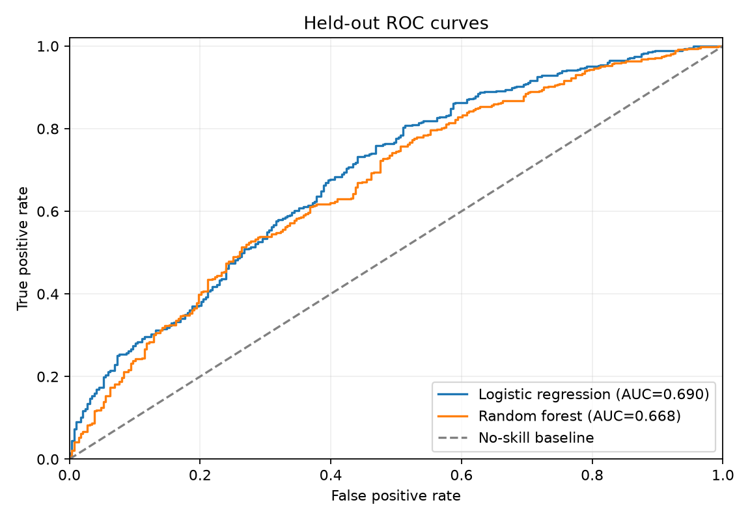

Business interpretation and action
Use scores to rank customers for human-reviewed outreach, for example a service reminder or a relevant rebooking prompt. Start with a small pilot and compare incremental rebooking and margin against a randomized control group: predictive risk alone does not show that an offer works. Choose the operating threshold using the relative cost of missed rebookings, unnecessary contacts, and discount margin; the reported F1 threshold is only a neutral worked-example choice.
Permutation importance on held-out data ranks features by the drop in ROC-AUC when shuffled. The leading example signals are days_since_last_visit (0.085), visits_last_90d (0.032), membership (0.027), satisfaction_score (0.018), service_category (0.010). They indicate predictive association, not causal drivers.
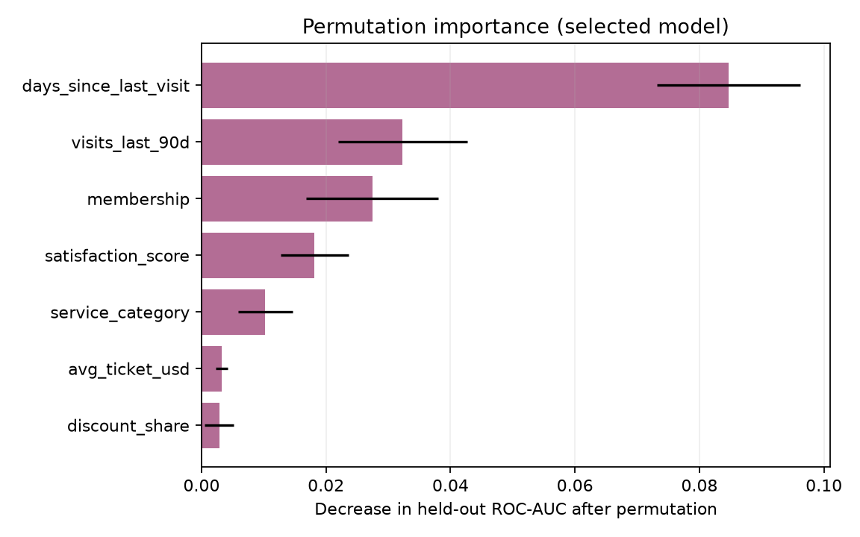

Robustness, pitfalls, and mitigations
- Temporal leakage: construct every feature strictly before the prediction snapshot; use a later time period for a final deployment-style validation.
- Repeated customers: split by customer (and preferably time) when multiple snapshots per person exist so the same person cannot appear in train and test.
- Overfitting: compare training cross-validation with untouched test results, constrain tree leaf size, and tune only within training folds.
- Class imbalance and threshold drift: report PR-AUC and recall/precision, track prevalence, and re-select the threshold using business costs rather than defaulting to 0.50.
- Missingness and inconsistent logging: report data-quality checks, define missing-value treatment from training data, and monitor input distributions.
- Calibration and subgroup performance: check reliability/calibration and precision/recall by relevant service and membership groups before rollout; investigate gaps and avoid discriminatory targeting.
- Concept drift and intervention feedback: monitor performance over time; promotions can change the behavior being predicted, so evaluate campaigns with controlled experiments.

Implementation and next steps
The companion Python script writes the metrics JSON, row-level test predictions, permutation importances, plots, fitted model bundle, and this report. For real deployment, confirm the event window and feature availability, establish a time-based backtest, calibrate probabilities, review privacy/consent and fairness requirements, and monitor drift.

