

SRI LANKA INSTITUTE OF INFORMATION TECHNOLOGY

[**Enterprise Standards and Best Practices for IT Infrastructure**](http://courseweb.sliit.lk/course/view.php?id=137)

**4th Year 2nd Semester 2016**

Name: Reyhart D.S.A

SLIIT ID: IT13064082

Practical Session: Monday

Practical Number: Lab 06

Date of Submission: 16-09-2016

Date of Evaluation : _____________________

Evaluators Signature : _____________________

**vMotion**

**Migration with vMotion**

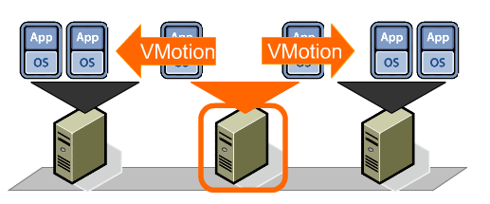

If need to take a host offline for maintenance, can move the virtual machine to another host. Migration with vMotion allows virtual machine processes to continue working throughout a migration.

With vMotion can change the host on which a virtual machine is running, or can change both the host and the datastore of the virtual machine. When migrate virtual machines with vMotion and choose to change only the host, the entire state of the virtual machine is moved to the new host. The associated virtual disk remains in the same location on storage that is shared between the two hosts. When choose to change both the host and the datastore, the virtual machine state is moved to a new host and the virtual disk is moved to another datastore. vMotion migration to another host and datastore is possible in vSphere environments without shared storage.

After the virtual machine state is migrated to the alternate host, the virtual machine runs on the new host. Migrations with vMotion are completely transparent to the running virtual machine. The state information includes the current memory content and all the information that defines and identifies the virtual machine. The memory content includes transaction data and the bits of the operating system and applications that are in the memory. The defining and identification information stored in the state includes all the data that maps to the virtual machine hardware elements, such as BIOS, devices, CPU, MAC addresses for the Ethernet cards, chip set states, registers, and so forth.

**Pre-Requests**

Since vMotion is intervening in an active virtual machine without that virtual machine’s knowledge, certain conditions must be fulfilled so that the process can run without problems or failures:

* CPU compatibility
* vMotion interface (require minimum 1 Gb adapter)
* shared central mass storage
* same naming for virtual port groups
* sufficient resources on the target host
* at least one vSphere Essentials Plus license on the corresponding ESX host

The only point which can sometimes present significant problems is CPU compatibility. In many firms the server infrastructure developed organically and not every server is built on the same hardware components. It is easy to determine if a virtual machine can be migrated between two ESXi servers because in the case of an incompatibility vCenter will issue a warning before the actual migration process begins.

**Virtual Machine Conditions and Limitations for vMotion**

The following virtual machine conditions and limitations apply when you use vMotion:

* The source and destination management network IP address families must match. You cannot migrate a virtual machine from a host that is registered to vCenter Server with an IPv4 address to a host that is registered with an IPv6 address.
* Cannot use migration with vMotion to migrate virtual machines that use raw disks for clustering.
* If virtual CPU performance counters are enabled, you can migrate virtual machines only to hosts that have compatible CPU performance counters.
* Cannot use migration with vMotion to migrate a virtual machine that uses a virtual device backed by a device on the client computer. Disconnect these devices before you migrate the virtual machine.
* Cannot use migration with vMotion to migrate a virtual machine that uses a virtual device backed by a device that is not accessible on the destination host.

**Virtual Machine Advantages for vMotion**

* Not waste cash with upgrades in database integration, submission, implementation, management, and usage performance.
* Development and submission become easier for the vendor; progression for several techniques or physical appearance or delivery is not required.
* With virtual devices, there is no need for additional in-house expertise for implementation and servicing.

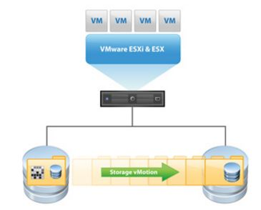**Storage vMotion**

While technically its own separate feature, it works similar to vMotion, except it deals completely with data. As a VM starts to reach its data capacity, the LUN can easily be moved to a larger storage center. This is done without disruption to the users or having to manually reassigning more space to the VM.

**Demonstration of migrating virtual machines between hosts and between different types of storages.**

**[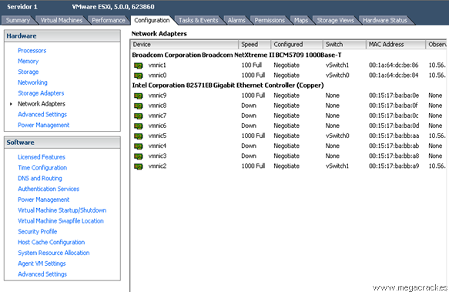](http://en.megacrack.es/wp-content/uploads/2012/10/Vmotion-ESXi-0.png)**

Now we look at the tab **Configuration-> Networking**

**[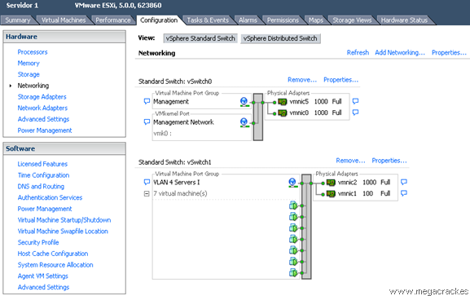](http://en.megacrack.es/wp-content/uploads/2012/10/Vmotion-ESXi-1.png)**

Click on **Add Networking** to create the vSwitch. Select **VMKernel** and click on **Next.**

**[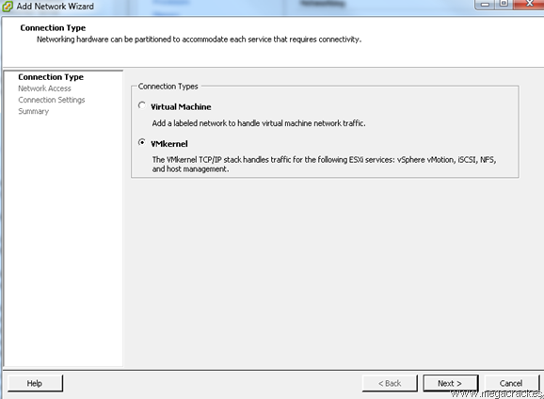](http://en.megacrack.es/wp-content/uploads/2012/10/Vmotion-ESXi-2.png)**

Making a network card or cards that have connected from one server to another (in our case **vmnic9**) and click on **Next**.

**[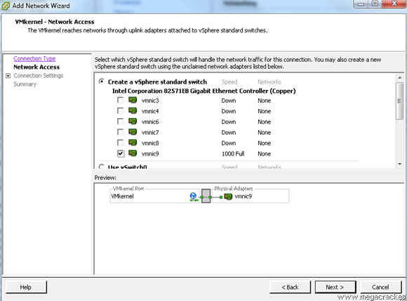](http://en.megacrack.es/wp-content/uploads/2012/10/Vmotion-ESXi-3.png)**

Then set **Use this port group for vMotion.**

Then wrote a **Label Network** different if you want (optional) and click on **Next.**

**[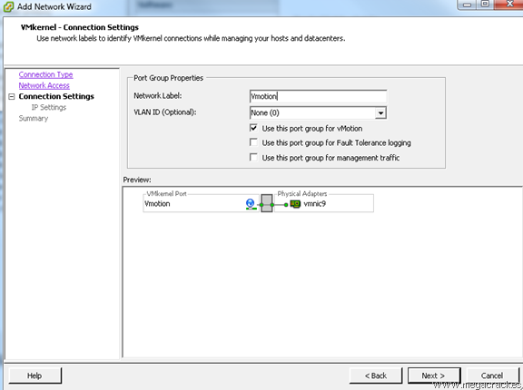](http://en.megacrack.es/wp-content/uploads/2012/10/Vmotion-ESXi-4.png)**

Then set **Use the following IP settings:**

**IP Address: 50.50.50.1**

**Subnet Mask: 255.255.255.252**(Since we will use only 2 ip's).Click on **Next.**

**[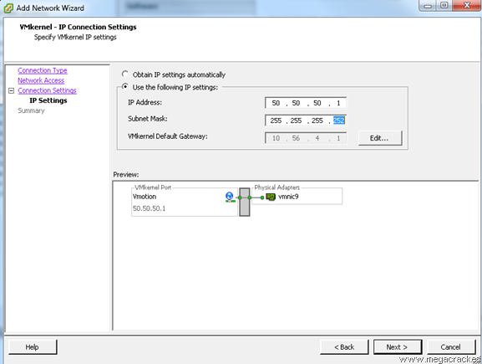](http://en.megacrack.es/wp-content/uploads/2012/10/Vmotion-ESXi-5.png)**

**[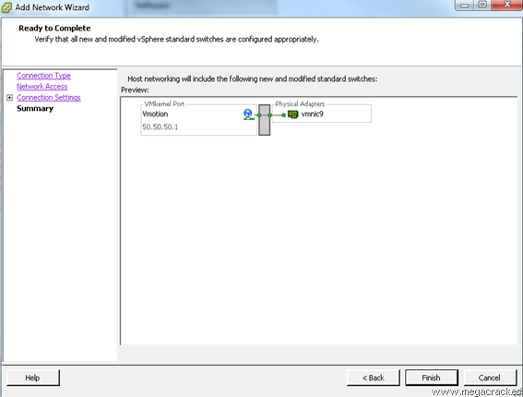](http://en.megacrack.es/wp-content/uploads/2012/10/Vmotion-ESXi-6.png)**Click on **Finish.**

We found that they have created a new virtual switch with Vmotion.

Then connect to another server involved.

**[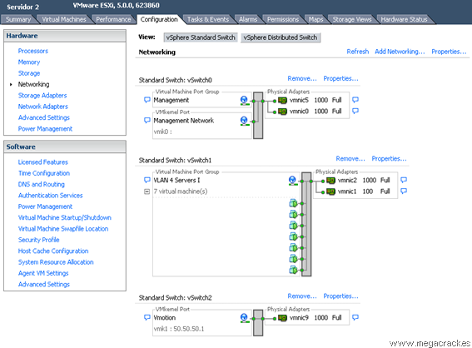](http://en.megacrack.es/wp-content/uploads/2012/10/Vmotion-ESXi-7.png)**

Select the tab **Configuration-> Network Adapters**and we see that we have visibility of the new connections.

**[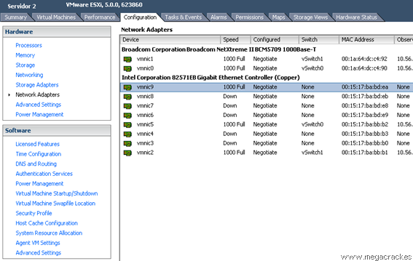](http://en.megacrack.es/wp-content/uploads/2012/10/Vmotion-ESXi-8.png)**

Now we look at the tab **Configuration-> Networking.** Click on **Add Networking** to create the vSwitch.

**[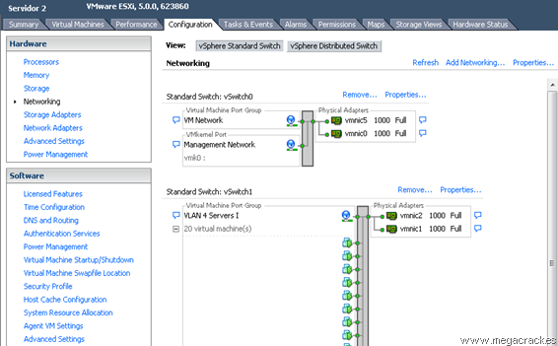](http://en.megacrack.es/wp-content/uploads/2012/10/Vmotion-ESXi-9.png)**

Select **VMKernel** and click on **Next.**

**[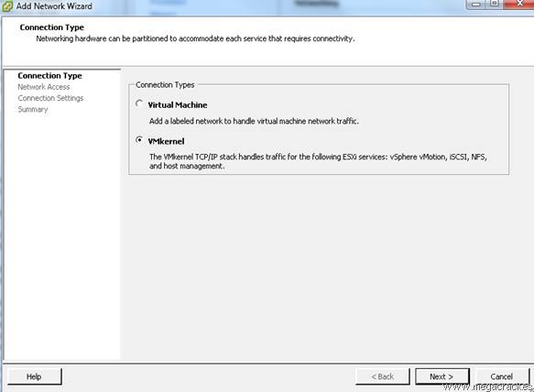](http://en.megacrack.es/wp-content/uploads/2012/10/Vmotion-ESXi-21.png)**

Making a network card or cards that have connected from one server to another (in our case **vmnic9**) And click on **Next**.

**[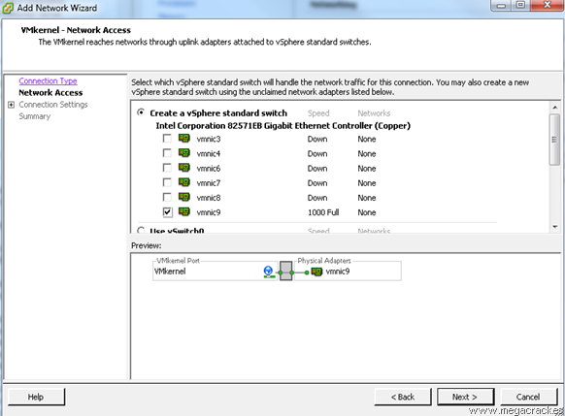](http://en.megacrack.es/wp-content/uploads/2012/10/Vmotion-ESXi-31.png)**

We set **Use this port group for VMotion.**

Then wrote a **Label Network** different if you want (optional) and click on **Next.** We for example we put **Vmotion.**

**[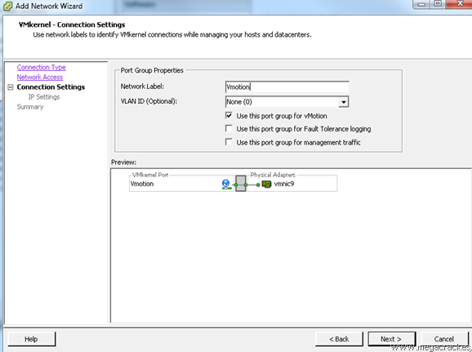](http://en.megacrack.es/wp-content/uploads/2012/10/Vmotion-ESXi-41.png)**

Set **Use the following IP settings:**

**IP Address: 50.50.50.2**(This ip must be different from the server that we configured earlier 1).

**Subnet Mask: 255.255.255.252**(Since we will use only 2 ip's).

Click on **Next.**

**[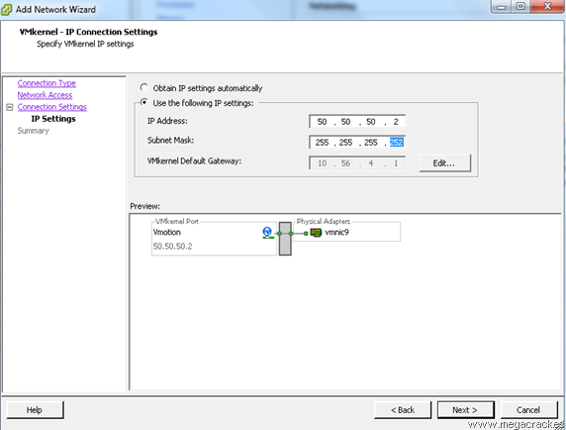](http://en.megacrack.es/wp-content/uploads/2012/10/Vmotion-ESXi-10.png)**

Click on **Finish**.

**[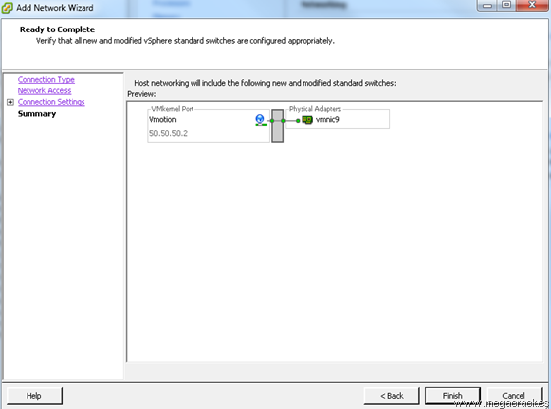](http://en.megacrack.es/wp-content/uploads/2012/10/Vmotion-ESXi-11.png)**

And now what we will do to ensure that the entire system is working properly migrate a VM from one ESXi to the other using Vmotion functionality you just configured.

Press the right mouse button on a virtual machine.

Click on **Migrate.**

**[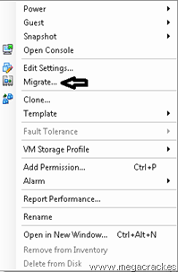](http://en.megacrack.es/wp-content/uploads/2012/10/Vmotion-ESXi-12.png)**

Click on **Next.**

**[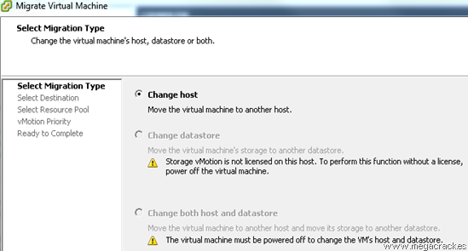](http://en.megacrack.es/wp-content/uploads/2012/10/Vmotion-ESXi-13.png)**

Select the target server where we will move the virtual machine.

**[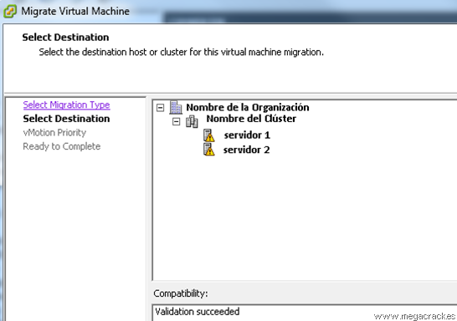](http://en.megacrack.es/wp-content/uploads/2012/10/Vmotion-ESXi-14.png)**

Click on **Next.**

**[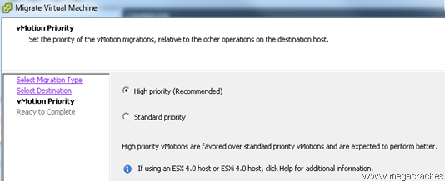](http://en.megacrack.es/wp-content/uploads/2012/10/Vmotion-ESXi-15.png)**

Click on **Next.**

**[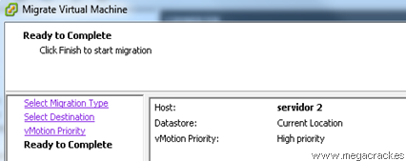](http://en.megacrack.es/wp-content/uploads/2012/10/Vmotion-ESXi-16.png)**

Click on **Finish**to start the migration.

**[ESXi Vmotion 17](http://en.megacrack.es/wp-content/uploads/2012/10/Vmotion-ESXi-17.png)**