Template for a DOCX report in RMarkdown

Author One, author info.[1]

Author Two, author info.[2]

2025-03-26

Abstract

# Abstract

This DOCX template is meant for longer reports with figure and table numbering.

**Keywords:** Word 1, Word 2, Word 3.

Table of Contents

# 1 Establishing the settings for the Rmd document

On a normal Rmd document the setup code tends to be in one(or several) setup code chunk(s) that are not rendered inside the final output file, by using the include = FALSE chunk option. However, here the setup chunks are included in the output document to show there the structure of the Rmd document more explicitly.

The following chunk shows the typical setup chunk of an Rmd document, setting the echo chunk option to TRUEinside the Rmd document. Here I also load the packages I know will be used along the document (e.g. Tidyverse (or specific tidyverse packages), and here),.

knitr::opts_chunk$set(echo = TRUE)  
library(tidyverse)

The following chunk defines a new function for printing data frames within the Rmd document, modifying the default options of the knitr::kable() function. The new data frame printing function needs two objects to work. It requires the data frame to print, which is automatically given to the function when a data frame is printed within the Rmd document, and a caption. The latter has to be defined by storing the caption text in a object called caption, which will be used by the function to produce the table caption.

knit_print.data.frame <- function(x, ...) {  
 res <- paste(c("", "", knitr::kable(x, caption = caption)), collapse = "\n")  
 knitr::asis_output(res)  
}

The chunk below registers the method of the previously defined knit_print.data.frame function under the knit_print function.

registerS3method(  
 "knit_print", "data.frame", knit_print.data.frame,  
 envir = asNamespace("knitr")  
)

# 2 Heading 1

## 2.1 Heading 2

### 2.1.1 Heading 3

#### 2.1.1.1 Heading 4

##### 2.1.1.1.1 Heading 5

Paragraph 1 of normal text, it is extended to two lines in purpose to check the format of the space in between lines of the same paragraph.

Paragraph 2 of normal text, it is extended to two lines in purpose to check the format of the space in between lines of the same paragraph.

Citations can be inserted in text, with ease by using the Zotero citation key(s) (@citation_key) of the source(s) to cite. A citation at the end of the sentence is easily applied with [@citation_key]. For example by citing my own first paper at the end of this sentence (Rodríguez León and López Arévalo, 2019). The previous sentence looks like this **For example by citing my own first paper by the end of this sentence [@rodriguezleonVariacionAbundanciaRelativa2019]** in the RMarkdown document. Meanwhile, a citation as the noun of the sentence can be inserted by using @citation_key. Here, Rodríguez León and López Arévalo (2019) is again an example of this, which looks like this **rodriguezleonVariacionAbundanciaRelativa2019 is again an example of this** in the RMarkdown document.

# 3 Making a table

As we defined and register the function knit_print.data.frame on the setup chunks at the beginning of the document, any data frame that is printed inside the document is printed as a table using the knit_print.data.frame, which is a modifed version of the knitr::kable() function. For example by printing the head of the data frame of the **“cars”** data set.

caption <- "Head of cars dataset data frame"  
cars %>% head

Table 3.1: Head of cars dataset data frame

| speed | dist |
| --- | --- |
| 4 | 2 |
| 4 | 10 |
| 7 | 4 |
| 7 | 22 |
| 8 | 16 |
| 9 | 10 |

# 4 Including figures

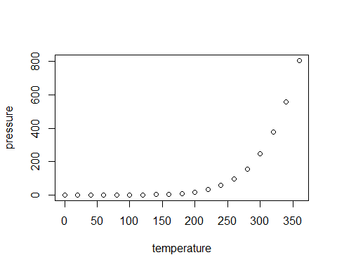

Figure 4.1: Plot of temperature vs pressure

For the bibliography, it is only required to have a last section in the document with the “Bibliography”or “References” title. The bibliography will by automatically inserted from the specified BibTex (.bib) file in the YAML section of the RMarkdown document (e.g. bibliography: references.bib), which should be stored in the same directory folder as the corresponding RMarkdown document file.

# 5 Making a list

* a
  + b
    - c
      * d
        + e

f

# References

Rodríguez León, D.S., López Arévalo, H.F., 2019. Variación de la abundancia relativa de perros en un gradiente de presencia humana en dos reservas privadas (Tabio, Cundinamarca). Acta biol. Colomb. 24, 379–390. <https://doi.org/10.15446/abc.v24n2.70608>

1. author info., [e-mail@example.org](mailto:e-mail@example.org)
2. author info., [e-mail@example.org](mailto:e-mail@example.org)