**Exercise-03: DAF Multilingual User-Interface**

Questions

1. What is the “locale” in the DAF context?

|  |  |  |
| --- | --- | --- |
| a | Location where the Rule Model is deployed |  |
| b | Location where the Rule Model is executed |  |
| c | Browser settings for language |  |
| d | OS settings for language |  |

2. Describe briefly what happens if the DAF Manager (Credit Risk Rating Platform) is switched to another language but a rule model does not provide a key-value pair in this language.

3. Describe the differences and advantages / disadvantages between setting the full message in the rule model vs. using .properties files?

4. How to provide parametized messages in another language?

Task: EU RENT Provide multilingual labels for the basic layout elements

Let your Dynamic Application from the exercise of modeling basic layout elements support a second language.

Steps:

1. Open the DAF Rule Project named EURentApp created in previous exercises.

2. Select the Rule Integration perspective .

3. Select the Language.properties file within the resources folder and you will find out that it is empty. ( # can be used for comments to structure your content in this file.)

4. Open rule START_Layout

5. Replace the value of the attribute labelKey of each UI element with a key like “TAB_car_rental.labelKey”

6. Copy each key to the Language.properties file and assign a translated text.

Example: 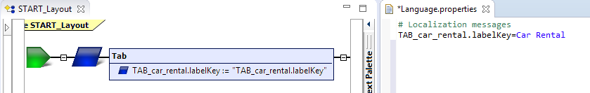

5. Copy Language.properties to Language_de.properties and translate the values.

6. Test your work by redeploying the rule model on the DAF Manager (Credit Risk Rating Platform).

Solution: Questions

1. What is the “locale” in the DAF context?

|  |  |  |
| --- | --- | --- |
| a | Location where the Rule Model is deployed |  |
| b | Location where the Rule Model is executed |  |
| c | Browser settings for language | x |
| d | OS settings for language | x |

2. Describe briefly what happens if the DAF Manager (Credit Risk Rating Platform) is switched to another language but a rule model does not provide a key-value pair in this language.

|  |
| --- |
| * Main Navigation items of the DAF Manager (Credit Risk Rating Platform) are displayed in the language selected by the user * The labels of the application (designed in the rule model) get the fallback version:   + If the rule model has no properties file for this language, the default .properties file (en) is valid.   + If the .properties file does not contain the specific entry or the rule model has no properties files at all, the text assigned in the layout rule is displayed (e.g. “TAB_rental_car.labelKey”) |

3. Describe the differences and advantages / disadvantages between setting the full message in the rule model vs. using .properties files?

|  |
| --- |
| * Within rule model:   (+) Easier traceability, as messages are defined at the according elements within the rule model  (-) Checking the locale in the layout rule is not good style (as you have to make changes to the rule model code, if there are changes in the set of available languages, e.g. a new language is being added, or if a text should be changed)   * Within .properties files:   (+) Messages are saved in central files and therefore are better to maintain  (-) Texts/Messages are harder to find, as they are outside the models |

4. How to provide parametized messages in another language?

Using the localize() function

Solution: Task: EU RENT Provide multilingual labels for the basic layout elements

Project Explorer

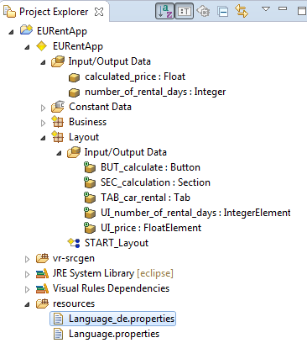

Layout Rule

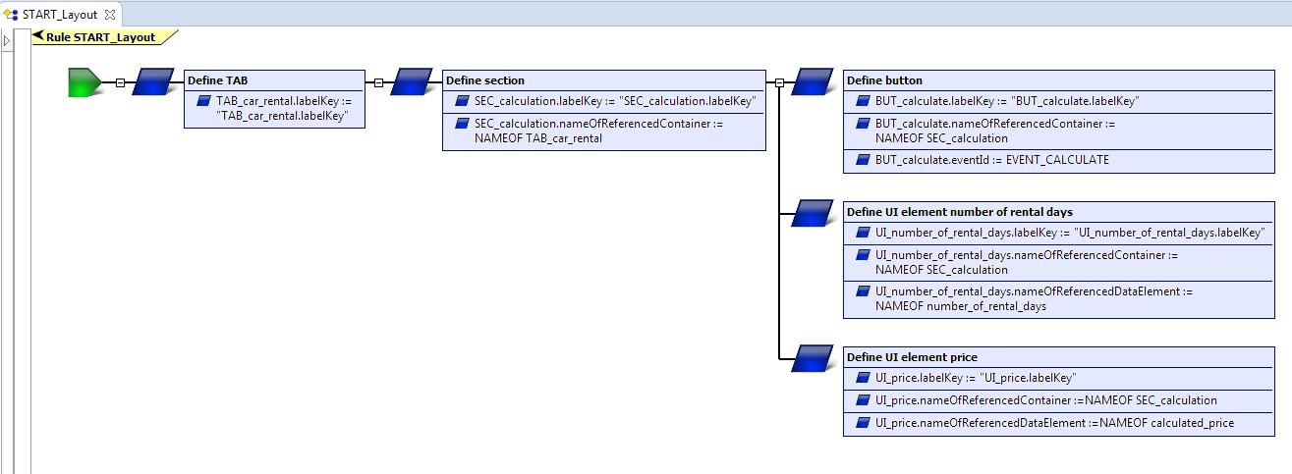

Properties files

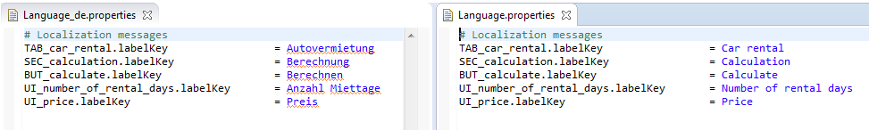

Web Frontend German

