**Exercise-04: DAF Platform Messages in Multilingual User-Interface**

Questions

1. What kind of message can be provided in different languages?

|  |  |  |
| --- | --- | --- |
| a | Labels |  |
| b | Links |  |
| c | Error messages |  |
| d | Flow rule names |  |
| d | Tooltips |  |

2. What severity levels can a message have by default.

|  |  |  |
| --- | --- | --- |
| a | error |  |
| b | note |  |
| c | info |  |
| d | warning |  |
| d | caution |  |

3. Describe how to reference a message to a layout element?

4. Can an exception message (of type GeneralRuleExecutionException) be referenced to a layout element? What is the alternative?

Task 1: EU RENT Provide multilingual tooltip

Create a tooltip to a Layout element.

Steps:

1. Open the DAF Rule Project named EURentApp created in previous exercises.

2. Open rule START_Layout

3. Create the attribute tooltipKey at the element UI_number_of_rental_days (value: "TT_UI_number_of_rental_days.labelKey")

4. Add message key to the .properties files.

Task 2: EU RENT Provide multilingual messages

Create a platform message with multilingual message and dynamic message parameters.

Steps:

1. Open the DAF Rule Project named EURentApp created in previous exercises.

2. Open rule START_Business

3. Create a new action element Create_Message of type CreatePlatformMessage

4. Call this action within the START_Business rule after the price has been calculated

5. Fill attributes of action

a. message: Add a message key which will be copied to the .properties file

b. type: Set type to info

c. messageParameters: Add the in/out parameter which holds the calculated price in order to display the price in the message. *(Hint: As the attribute messageParamters is a list, use {})*

6. Add message key to the .properties files.   
*Hint: Use {0} as a placeholder within the translated text in order to display the value of the calculated price (messageParameter)*

Solution: Questions

1. What kind of message can be provided in different languages?

|  |  |  |
| --- | --- | --- |
| a | Labels | x |
| b | Links | x |
| c | Error messages | x |
| d | Flow rule names |  |
| d | Tooltips | x |

2. What severity levels can a message have by default.

|  |  |  |
| --- | --- | --- |
| a | error | x |
| b | note |  |
| c | info | x |
| d | warning | x |
| d | caution |  |

3. Describe how to reference a message to a layout element?

Action of Type: CreatePlatformMessage provides the parameter nameOfReferencedData

e.g nameOfReferencedData:= NAMEOF UI_TextInputField

4. Can an exception message (of type GeneralRuleExecutionException) be referenced to a layout element? What is the alternative?

The GeneralRuleExecutionException does not provide a nameOfReferencedData parameter by default.

Call an action of type CreatePlatformMessage and set its type parameter to Error, e.g:

nameOfReferencedData:= NAMEOF UI_TextInputField

type:=MessageType.ERROR

Solution Task 1: EU RENT Provide multilingual tooltip

Layout Rule

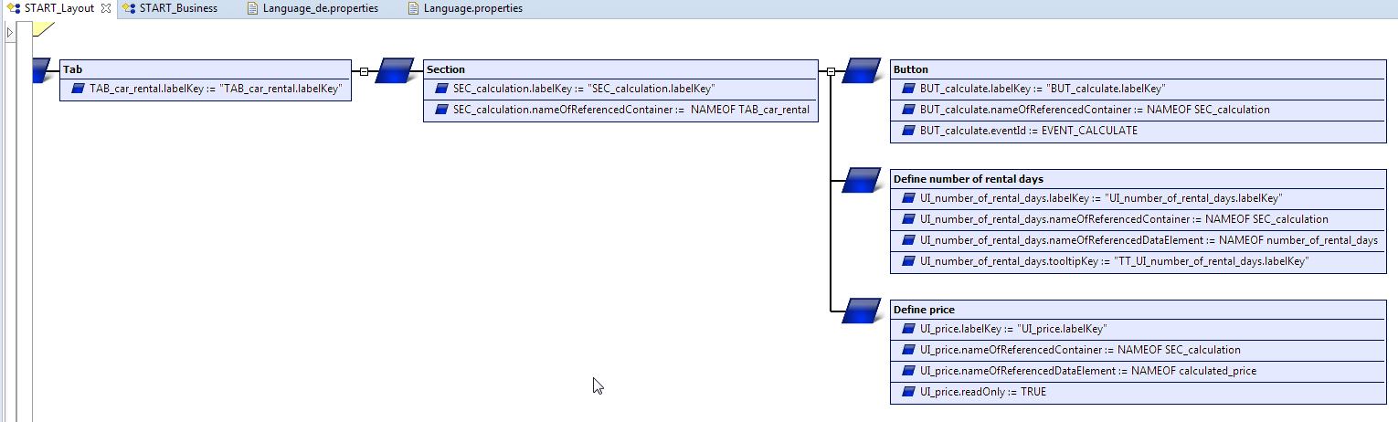

Properties files

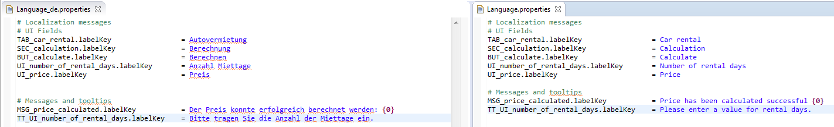

Web Frontend Tooltip

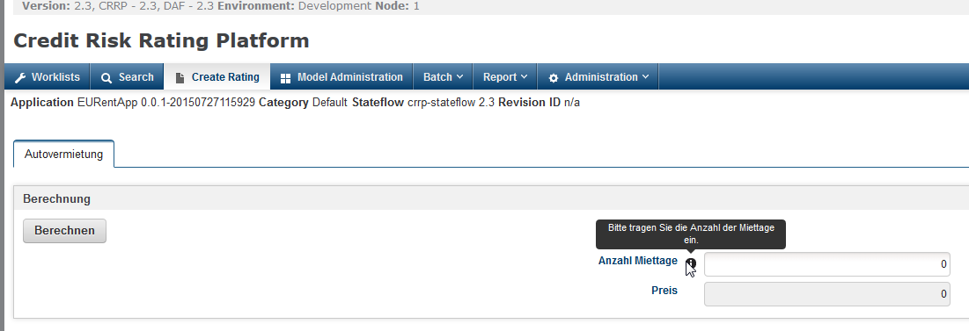

Solution Task 2: EU RENT Provide multilingual messages

Project Explorer

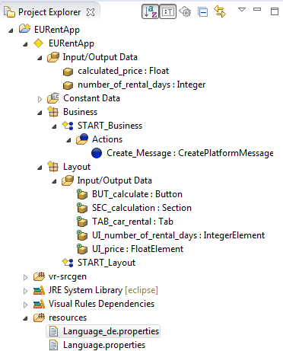

Business Rule

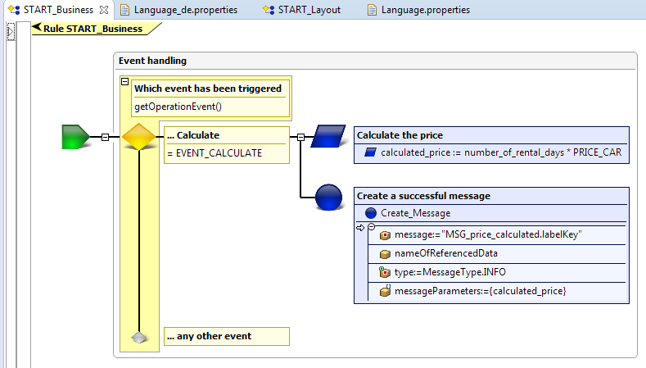

Properties files

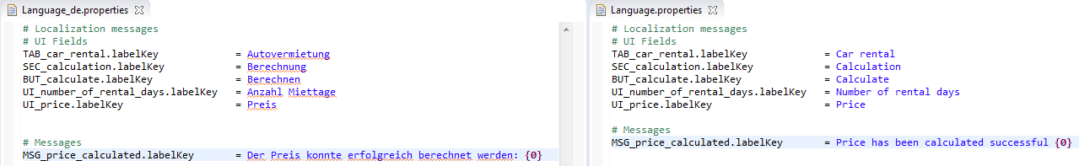

* Web Frontend Message

