**Exercise-05: DAF Quick Refreshing the Layout with Ajax**

Questions

1. What is the type of a root layout element?

|  |  |  |
| --- | --- | --- |
| a | RootElement |  |
| b | Layout |  |
| c | RootLayout |  |

2. Which of the following are attributes of a root layout element?

|  |  |  |
| --- | --- | --- |
| a | root |  |
| b | title |  |
| c | nameOfDefaultAction |  |
| d | changeList |  |
| e | visible |  |

3. Which of the following layout elements do support an eventId attribute?

|  |  |  |
| --- | --- | --- |
| a | Button |  |
| b | Section |  |
| c | LabelElement |  |
| d | OptionElement |  |
| e | BooleanElement |  |

4. Describe the advantages when using the quick refreshing functionality.

Task 1: EU RENT Model calculation of price while leaving input element

Trigger the calculation of the rental price while leaving the input field for number of rental days.

Steps:

1. Open the DAF Rule Project named EURentApp created in previous exercises.

2. Create a new constant data element EVENT_REFRESH_PRICE : String with value “event.refresh_price”

3. Open the rule START_Layout

4. Set the attribute eventId of the UI element UI_number_of_rental_days to the created constant element

5. Create an input/output element root_layout of type Layout at the Layout package

6. Add an assignment at the beginning of START_Layout and reset the changeList attribute at the element root_layout (root_layout.changeList CLEAR)

7. Add a decision and check which event has been triggered at the end of the START_Layout rule

8. If the refresh event has been triggered, add the UI element UI_price to the changeList *(Hint: Use ADD operator)*

9. Open rule START_Business

10. Add another check in the already existing event handling decision for the newly created event

11. Add an assignment in case of the newly created event has been triggered and use the same calculation logic like for calculate event.

12. Test your work by redeploying the rule model on the DAF Manager.

Result

1. What is the type of a root layout element?

|  |  |  |
| --- | --- | --- |
| a | RootElement |  |
| b | Layout | x |
| c | RootLayout |  |

2. Which of the following are attributes of a root layout element?

|  |  |  |
| --- | --- | --- |
| a | root | x |
| b | title | x |
| c | nameOfDefaultAction | x |
| d | changeList | x |
| e | visible |  |

3. Which of the following layout elements do support an eventId attribute?

|  |  |  |
| --- | --- | --- |
| a | Button | x |
| b | Section |  |
| c | LabelElement |  |
| d | OptionElement | x |
| e | BooleanElement | x |

4. Describe the advantages when using the quick refreshing functionality.

Usability

* The user does not need to activate a button in order to have the frontend refreshed.
* Reducing complexity for the user. Forms can display at the beginning only a few fields, other fields appear only if they are relevant.

Result Task 1: EU RENT Model calculation of price while leaving input element

* Project Explorer

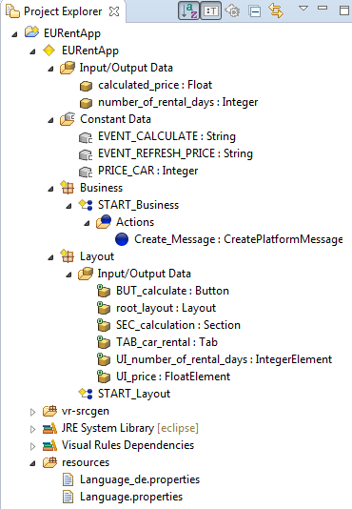

* Layout Rule

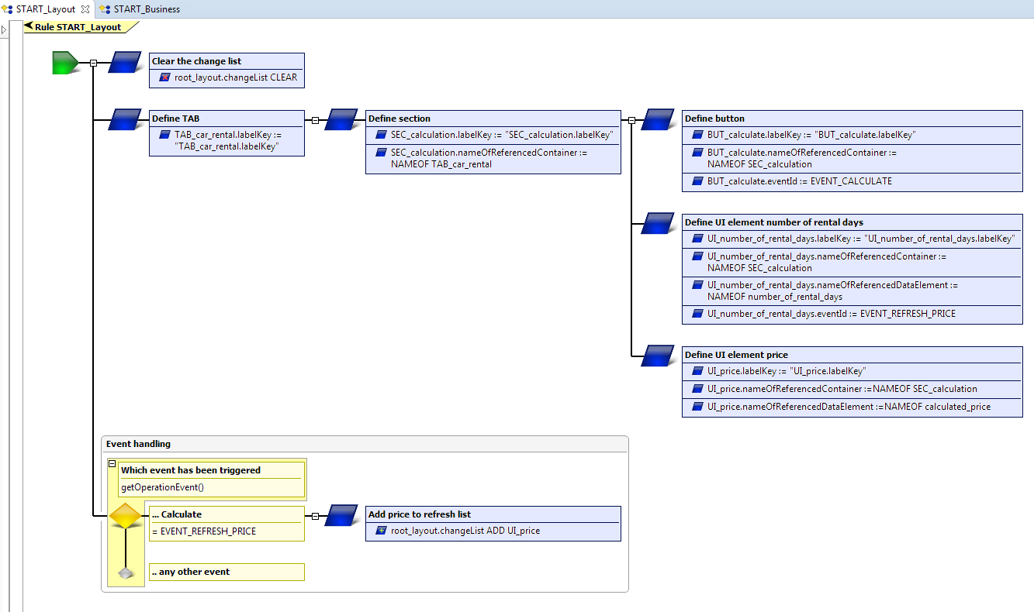

* Business Rule

