Exercise-06.1: DAF Advanced Layout Elements

Modeling: GridElement

Start with a new DAF rule project.

Steps:

1. Create a new DAF Rule Project TestGridElement using the template Application
2. Create a new Structure Person with following attributes:

* firstname : String
* lastname : String
* id : String
* salary : Float
* birthdate : Date

1. Create an in-/output data element persons : Person List on Rule Model level (so it is accessible from both, Business and Layout)
2. In the rule START_Business populate example data to the list persons, if the event “create.rating” (Standard-Event in the DAF) was fired. Follow these steps:

* Create a flow rule called Populate Person Grid Example Data and open it
* Create two persons by using assignments such as this one:

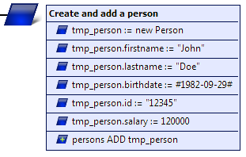

* In the rule START_Business add a decision to check for the triggered event, by calling the function getOperationEvent()
* If the event is “create.rating”, then call the flow rule Populate Person Grid Example Data

1. Create an in-/output data element TABLE_persons : GridElement in the Layout package
2. Since the column headers of our grid won´t change, create a constant data element for each column header (e.g. TH_PERSON_FIRSTNAME : GridHeader) and specify the attributes labelKey and coordinate (the latter being any String serving as the column´s ID)
3. Create a constant data element THS_GRID_PERSON : GridHeader List in the Layout package and use  to add elements to the list. Assign the previously created headers to the elements.

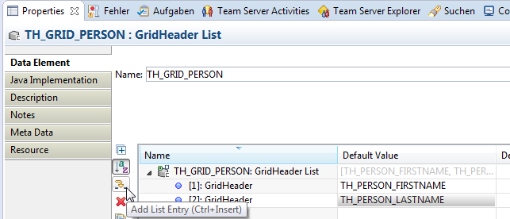

1. Create a new flow rule Populate Grid in the layout package with an output parameter grid_data : GridData
2. Open the rule Populate Grid and populate grid_data with the data from persons. Follow these steps:

* Set the column headers (grid_data.colHeaders = GHS_GRID_PERSON)
* Iterate over the entries in the persons list and for each entry, add a row to the grid, by…
  + …creating a row header and adding it to the grid data  
    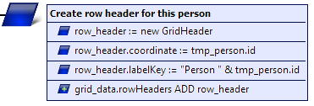
  + …creating cells for each column (filled with respective Layout element) and adding them to the grid data  
    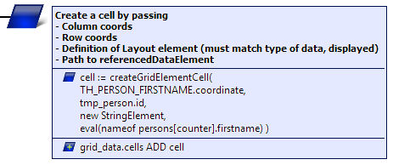

1. In START_Layout call Populate Grid and write the output to Grid_person.gridData
2. Deploy the model and test the result.

Advanced (optional):

1. Create a new Attribute at the Structure Person: gender : Option
2. Create a new constant data element GENDER : Option List with two options “male” and “female”
3. Add example data for gender to Populate Person Grid Example Data
4. Add a respective column header to the grid
5. Populate the gender in Populate Grid.
   * Hint: Using new OptionElement in the createGridElementCell() call won´t work, because information about the option element needs to be specified upfront. Because of this, use an internal data element of type Option. Use it to set up the option and then pass it, when calling createGridElementCell().

Result: Modeling EU RENT Advanced Layout Elements

* Project Explorer

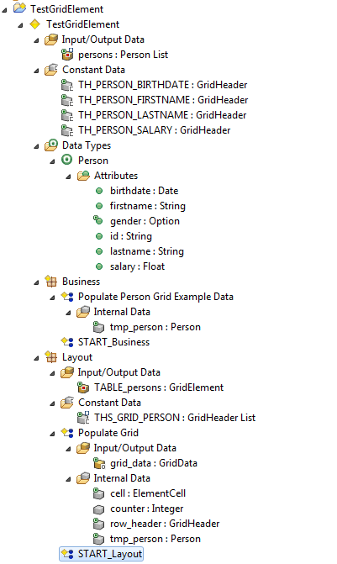

* Business rule START_Business

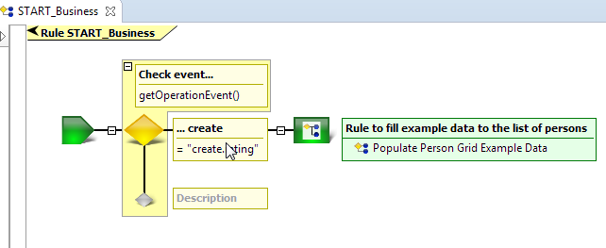

* Business rule Populate Person Grid Example Data

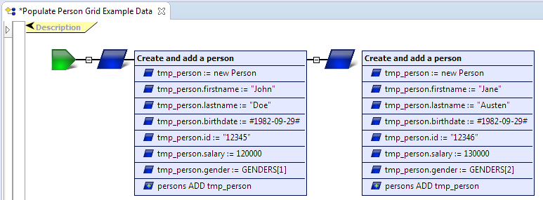

* Layout rule START_Layout

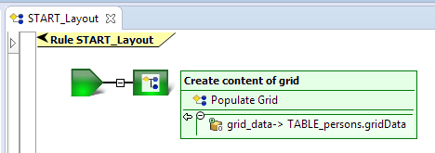

* Layout rule Populate Grid

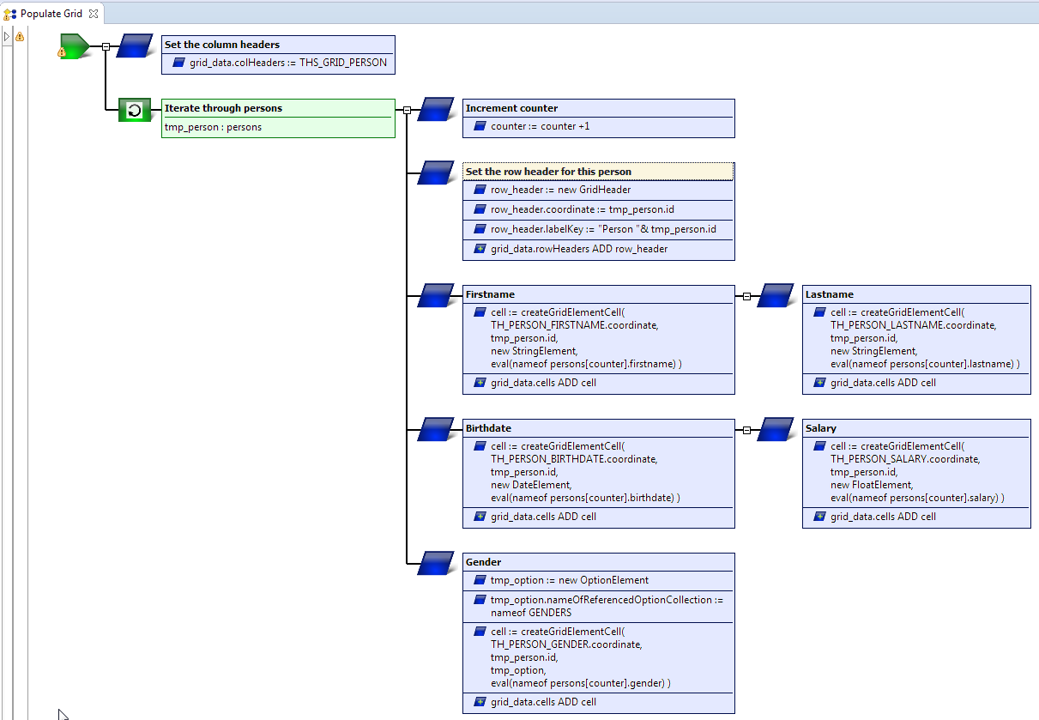

* Web Frontend

