Exercise-06.2: DAF Advanced Layout Elements

Questions

1. Which of the following layout elements does DAF provide?

|  |  |  |
| --- | --- | --- |
| a | SimpleTableElement |  |
| b | VTableElement |  |
| c | LineChartElement |  |
| d | BarChartElement |  |
| e | FileuploadElement |  |
| f | GridElement |  |
| g | RichTextElement |  |

2. Describe in a short manner the process of creating a simple table.

3. Which are the correct steps when creating a GridElement?

|  |  |  |
| --- | --- | --- |
| a | Create row and column headers to coordinate the element position |  |
| b | The attribute “labelKey“ is required |  |
| c | It´s mandatory that the GridElement is designed in the business rules |  |
| d | The type of an ElementCell is IElement |  |

Task: EU RENT Advanced Layout Elements

Extend your DAF rule project EURentApp with a table output of type SimpleTableElement. The table should display the currently rented and calculated car.

Steps:

1. Open your DAF rule model (EURentApp) containing the basic layout elements (e.g. version after adding support for the second language).

2. Create a new section SEC_table. Define the attributes of this section in the rule START_Layout and add it to the TAB_car_rental.

3. Create a table element SimpleTable_rented_cars of type SimpleTableElement to display booked cars.

4. Create a new flow rule in the layout package Populate Simple Table

5. Create an **output** element of this flow rule table_data_booked_cars of type SimpleTableData

6. Define an internal data element for the same rule tmp_current_cell of type SimpleTableCell

7. Open the rule Populate Simple Table. Add an assignment and define a new instance of SimpleTableCell to tmp_current_cell (*Hint: Use new operator*).

8. Set the attributes of tmp_current_cell

* colNumber = 1
* rowNumber = 1
* cellValue = number_of_rental_days (*Hint: As* number_of_rental days *is of type integer you need to cast it to type string. You can use the* toString() *function*)

9. Add the new created cell to the list tableCells which is an attribute of the output element table_data_booked_cars.

10. Repeat step 7 to 9 to create another cell for the calculated_price (*Hint: Increase colNumber to display the calculated price in the next column*).

11. Open the rule START_Layout and call the created rule Populate Simple Table (after the defined section)

12. Assign the output element to the tableData which is an attribute of the UI element SimpleTable_rented_cars

11. Define the attributes for the element UI element SimpleTable_rented_cars

* labelKey to “Booked Cars”
* nameOfReferencedContainer to SEC_table
* columnHeader to {“Rental Days”, “Calculated Price”}

11. Deploy the model and test the result.

Solution: Questions

1. Which of the following layout elements does DAF provide?

|  |  |  |
| --- | --- | --- |
| a | SimpleTableElement | x |
| b | VTableElement | x |
| c | LineChartElement |  |
| d | BarChartElement |  |
| e | FileuploadElement | x |
| f | GridElement | x |
| g | RichTextElement | x |

2. Describe in a short manner the process of creating a simple table.

- Create layout element of type SimpleTableElement

- Define the attributes required for this type of element

- Create business data element of type SimpleTableData

- Instantiate each cell of the table, set the cell attributes and add it to the table data element

3. Which are the correct steps when creating a GridElement?

|  |  |  |
| --- | --- | --- |
| a | Create row and column headers to coordinate the element position | x |
| b | The attribute “labelKey“ is required |  |
| c | It´s mandatory that the GridElement is designed in the business rules |  |
| d | The type of an ElementCell is IElement | x |

Solution Task: EU RENT Advanced Layout Elements

* Project Explorer

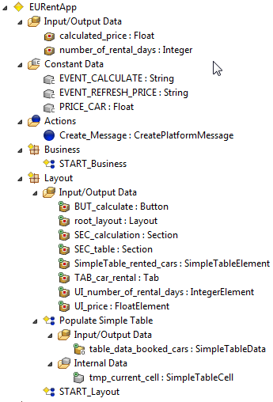

* Layout rule START_Layout

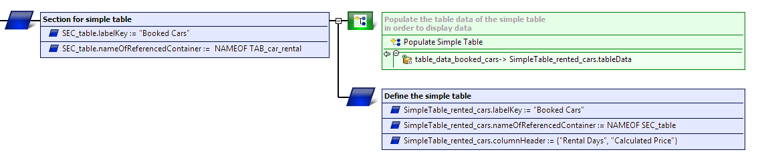

* Layout rule Populate Simple Table

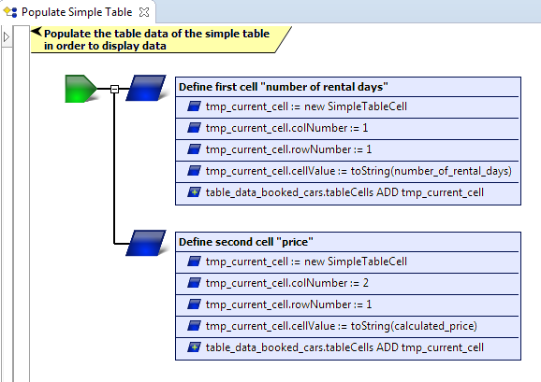

* Web Frontend

