Exercise-07: DAF Modeling Search Rules

Questions

1. What types of fields are available for the search document service?

|  |  |  |
| --- | --- | --- |
| a | Static Fields |  |
| b | Constant Fields |  |
| c | Dynamic Fields |  |

2. What type of conditions can be modeled?

|  |  |  |
| --- | --- | --- |
| a | BetweenCondition |  |
| b | BeyondCondition |  |
| c | EqualCondition |  |

3. Which of the following query causes are required?

|  |  |  |
| --- | --- | --- |
| a | selectClause |  |
| b | sortClause |  |
| c | pageClause |  |

4. Describe in a short manner the process of creating a search rule.

Task: DAF Modeling Search Rules

Create a Search Rule Model to find all documents created after a date.

The search filter should provide at least the date as a filter criteria and a button to start searching.

Steps:

1. Create a new DAF rule model of type "Search" called ModelableSearch.

2. In the package Layout create a Tab, a Section, a DateElement and a Button

3. Initialize the Layout elements in START_Layout

* + Tab labeled “Search Tab”
  + Section labeled “Search Filter” (referenced container is the tab)
  + DateElement labeled “Documents created after” (referenced container is the section, referenced data element must be of type Date and visible for both packages)
  + Button labeled “Search” (referenced container is the section, eventID is “button.search”)

3. Create a second section for the search results presentation.

4. Create a SimpleTableElement UI_date_filter and a corresponding SimpleTableData element that will get the results.

5. Complete START_Layout:

* + The section labeled “Search Results” (referenced container is the tab, the index should be higher than the first section, so it appears on the lower part on the web site)
  + The table’s columnHeader must begin with the Revision ID e.g. {"RevisionID", "Created on"}

6. Check your work. The layout should correspond to following screenshot:

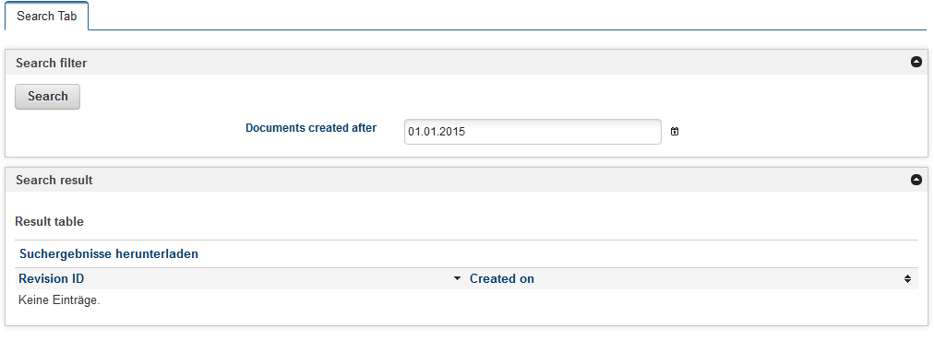

7. Open START_Search to model the search functionality.

8. Create two new Input/Output Data Elements, search_query of type Query and search_result of type ISearchResultSet

9. Call the Service Search Document and set the two created data elements to it

10. Create an assignment to initialize the query at the top of START_Search (use the operator new).

11. Create an element date_condition of type GreaterOrEqualCondition. Create an assignment before the service call to compose the condition parameter for the query. Use the auto complete help and DAF functions to assign the values according to the search logic (which is the static field of the document creation and the value of the date element retrieved as user input) […createGreaterOrEqualCondition(FIELD_REVISION_CREATED_ON,date_filter

Set the condition to the search_query (SearchQuery.condition:=DateCondition)

12. Initialize the page clause for the query (use the operator new). Than assign values to prepare the result beginning with the first page and 10 results per page.

[SearchQuery.pageClause.pageIndex:=1 and SearchQuery.pageClause.pageSize:=10]

13. Create a new assignment after the service call. Pass the SearchResult.totalHits and the query page clause values to the searchParameter. (This is the input/output data element created at the beginning by using the template).

14. In package "Search" create a second rule to fill the table with the search results (e.g. Generate Result Table) and call the rule from START_Search. As table entries are business data, the Generate Result Table rule is located in the Search package and not in the Layout package!

Solution: Questions: DAF Modeling Search Rules

1. What type of fields can be searched?

|  |  |  |
| --- | --- | --- |
| a | Static fields | x |
| b | Constant fields |  |
| c | Dynamic fields | x |

2. What type of conditions can be modeled?

|  |  |  |
| --- | --- | --- |
| a | BetweenCondition | x |
| b | BeyondCondition |  |
| c | EqualCondition | x |

3. Which of the following query causes are required?

|  |  |  |
| --- | --- | --- |
| a | selectClause |  |
| b | sortClause |  |
| c | pageClause | x |

4. Describe in a short manner the process of creating a search rule.

* Define the search criteria
* Define at the layout to retrieve the searched values
* Define at the layout to present the hits (table)
* Call the Search Document Service for the query modeled
* Fill the table with the search results

Solution: Task: DAF Modeling Search Rules

|  |
| --- |
| * Project Explorer      * Layout rule START_Layout      * Search rule START_Search      * Business rule Generate Result Table |