Exercise 1: Modeling Basics

**Requirements:**

The business rules for the calculation of the car – rental project EU RENT have to be modeled.

The prices for the referring vehicle class are the following:

1. Compact class = 50 € / day
2. Full size = 70 € / day

The rental duration of 1-3 days charges the above mentioned prices. In reference to the vehicle class and the amount of rental days, the following discount is taken into consideration:

1. Compact class for a term of lease of more than 3 days: = 5 € discount / day
2. Full size for a term of lease of 4-7 days: = 7 € discount / day
3. Full size for a term of lease of more than 7 days: = 10 € discount / day

**Steps:**

1. Create a new rule project EU Rent.

2. For modeling tasks, create a new flow rule called Rental Calculation.

3. With the help of a decision element, decision_element.png check the vehicle class. Therefore, define variable car\_group (String) as an input data element.

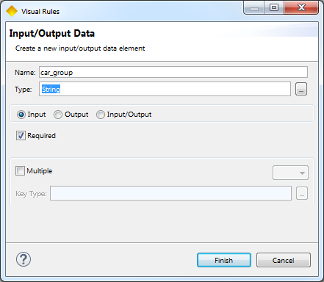

4. Afterwards, check the rental duration of the vehicle (rental\_days, Integer). Create the variable as you just did it.

5. For each decision, calculate the appropriate price per day (price\_per\_day, Float). The price per day is to be defined as an output data element. Further, the discount has to be calculated, as well.

**Hint**: Price per day = price of vehicle class – discount /day.

6. Finally, calculate the overall price for the complete rental duration and assign the result to the data element price (Integer). price is also to be defined as an output data element.

**Prospect**:

The flow rule should be tested. Therefore, perform a right klick on rule Rental Calculation and create a Rule Test (New Element/Rule Test/Finish).

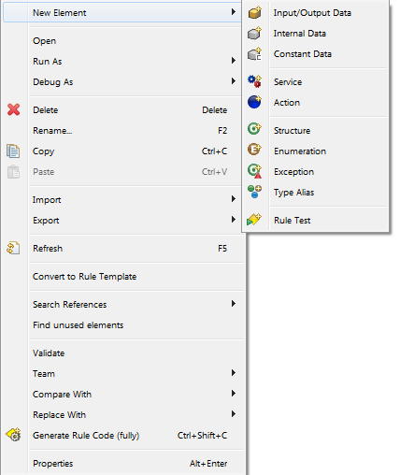

Before being able to run the test, values for the input data elements need to be set like the following:

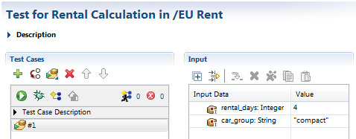

**Note:** Detailed testing will be handled in Exercise 05.

Result: Modeling of EU RENT

Rule Rental Calculation:

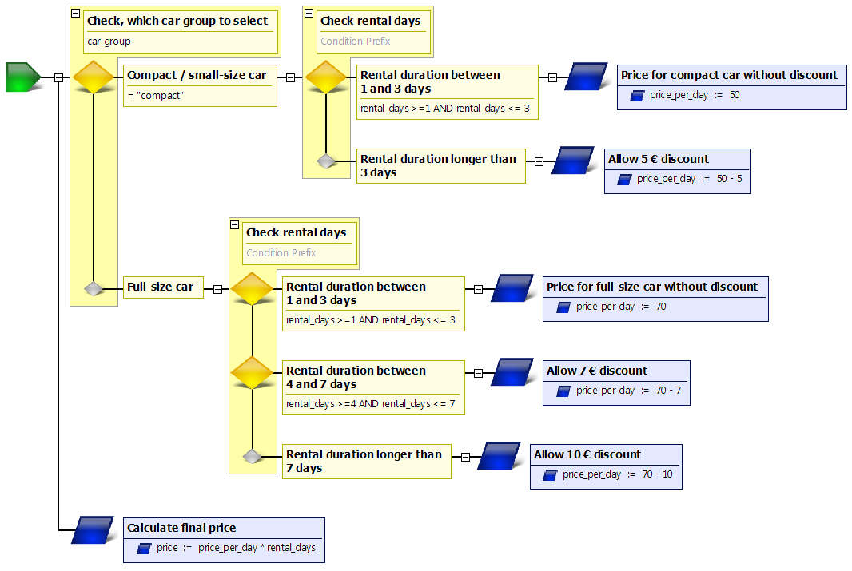

Business Model:

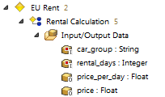

Questions:

1. Which of the following states are correct for rule projects?

|  |  |  |
| --- | --- | --- |
| a | One rule project comprises all resources |  |
| b | A rule project can be renamed |  |
| c | All rule projects are available within the rule explorer |  |
| d | Only one rule project can be set for one Visual Rules instance |  |

2. How can changes be saved within a rule model?

|  |  |  |
| --- | --- | --- |
| a | Executing “Save” button |  |
| b | All changes will be saved automatically |  |

3. Name three different rule elements of Visual Rules:

4. Choose one of the above mentioned rule elements and briefly describe its purpose:

Results

1. Which of the following states are correct for rule projects?

|  |  |  |
| --- | --- | --- |
| a | One rule project comprises all resources | x |
| b | A rule project can be renamed | x |
| c | All rule projects are available within the rule explorer | x |
| d | Only one rule project can be set for one Visual Rules instance |  |

2. How can changes be saved within a rule model?

|  |  |  |
| --- | --- | --- |
| a | Executing “Save” button | x |
| b | All changes will be saved automatically |  |

3. Name three different rule elements of Visual Rules:

1. Decision element
2. Assignment element
3. Action element
4. Start element

4. Choose one of the above mentioned rule elements and briefly describe its purpose:

Decision element:

1. Defines „if-then-rules“
2. Identifies the part of the rule to be executed
3. Has two or more decision cases
4. Allows single- or multiple matches