Exercise 1: Data structure

Use the rule project EU Rent (Exercise 4) of the Basic Rule Modeling training as a template for the following exercises.

**New requirements:**

Define the structures for the input data elements and replace all data elements in the rule model with the attributes of the new structures.

**Steps:**

1. Get familiar with the rule model Rental Calculation and try to understand all included rules.
2. Create a new structure Reservation on the level of Rental Calculation with the following attributes:

rental_days : Integer with default value 8  
car_group : String with default value „full-size”

date_of_rental : Date with default value #2015-07-28#  
date_of_reservation : Date with default value #2015-07-02#

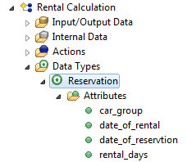

1. Create a new input data element („required“ = false) for the rule Rental Calculation which uses the newly created structure:  
   current_reservation : Reservation
2. In every rule, replace the data elements car_group, rental_days, date_of_rental and date_of_reservation with the attributes of the new structure.   
     
   **Hint:** Use the dot notation to access attributes of the structure: current_reservation.rental_days



1. Delete the data elements car_group, rental_days, date_of_rental and date_of_reservation from the input/output data on the level of Rental Calculation. They will be replaced by the new structures.

Delete the elements in the test cases, also.

1. Now, start the flow rule: Right – click on rule Rental Calculation > Run as > 1 Visual Rules Test

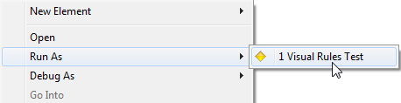

Result: Modeling of EU RENT

Business data model:

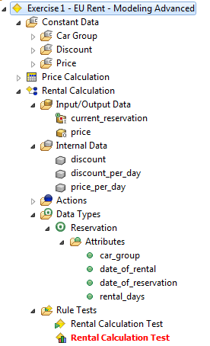

Rule Rental Calculation:

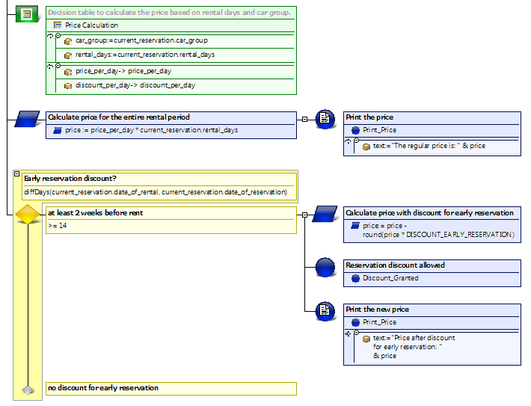

Questions:

1. Which of the following statements are correct for structures?

|  |  |  |
| --- | --- | --- |
| a | A data type of the kind of „structure“ will be assigned like other data types |  |
| b | The attributes of the structure must be created manually in the data element |  |
| c | Every data type can be used for an attribute |  |
| d | Attributes of the structure can be changed directly at the data element |  |

2. How to access the attributes of a structures data element? Name an example.

Results:

1. Which of the following statements are correct for structures?

|  |  |  |
| --- | --- | --- |
| a | A data type of the kind of „structure“ can be assigned like other data types | x |
| b | The attributes of the structure must be created manually in the data element |  |
| c | Every data type can be used for an attribute | x |
| d | Attributes of the structure can be changed directly at the data element |  |

2. How to access the attributes of a structures data element? Name an example.

You can access the attributes of a structured data element with the dot notation.

Example:

Access to car group via the data element customer of the type customer with the attribute

current_reservation of the type rental car:

customer.current_reservation.car_group