Exercise 2: Data Basics

**New requirements:**

Optimize your model by using adequate data types for elements. Like that, your model is easier to maintain, to test and to read.

**Steps:**

1. Decide between input-/output data elements and elements which are just used internally. Convert the affected element accordingly respectively create new ones in terms of optimization:  
   Internal used element: price_per_day, discount (Float), discount_per_day (Float)

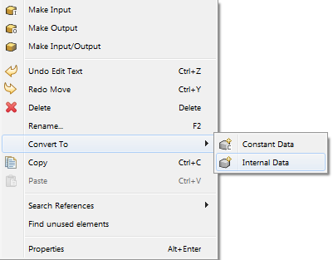

1. Define the following constant data elements for prices like the following:PRICE_COMPACT : Float (default value = 50)PRICE_FULLSIZE : Float (default value = 70)

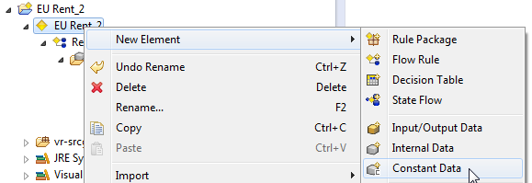

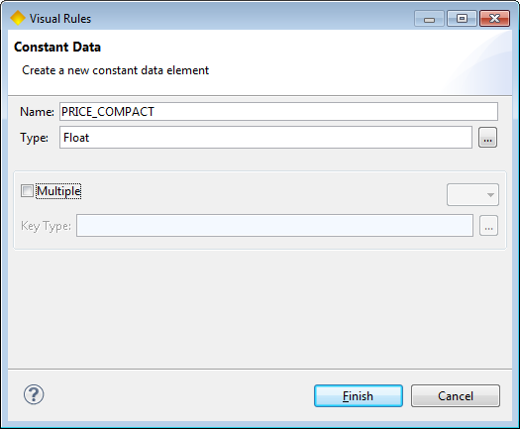

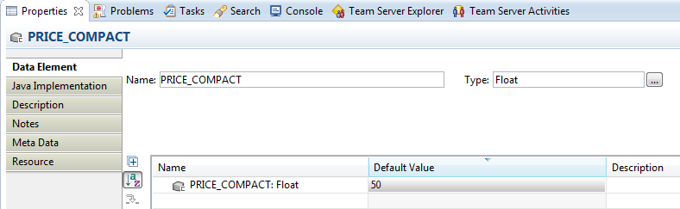

1. Further, define the constant data elements for discounts like the following:DISCOUNT_COMPACT_SHORT: Float (default value = 5)  
   DISCOUNT_FULLSIZE_SHORT: Float (default value = 7)DISCOUNT_FULLSIZE_LONG: Float (default value = 10)
2. Additionally, define the constant data elements for vehicle classes like the following:CAR_GROUP_COMPACT: String „compact“CAR_GROUP_FULLSIZE: String „full-size“
3. Now, group those constant data elements by creating accordant groups. Then, move the constant data elements within the project explorer to the correspondent group. For grouping, a structure like the following is suggested:

* Car Group
* Price
* Discount

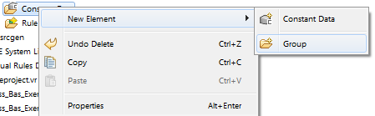

1. Use the constant data elements in order to assign the price calculation.
2. Now, change your rule by setting price_per_day and discount_per_day: at the end of the rule, add an assignment element and calculate price and discount for the complete rental duration. Afterwards, subtract both values from each other in order to get the final price.
3. Adjust the rule test by using one of the constant data elements for the car group and execute the test again.

Result: Modeling of EU RENT

Business model:

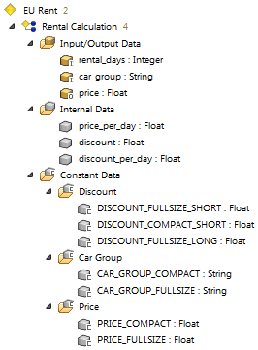

Rule Rental Calculation:

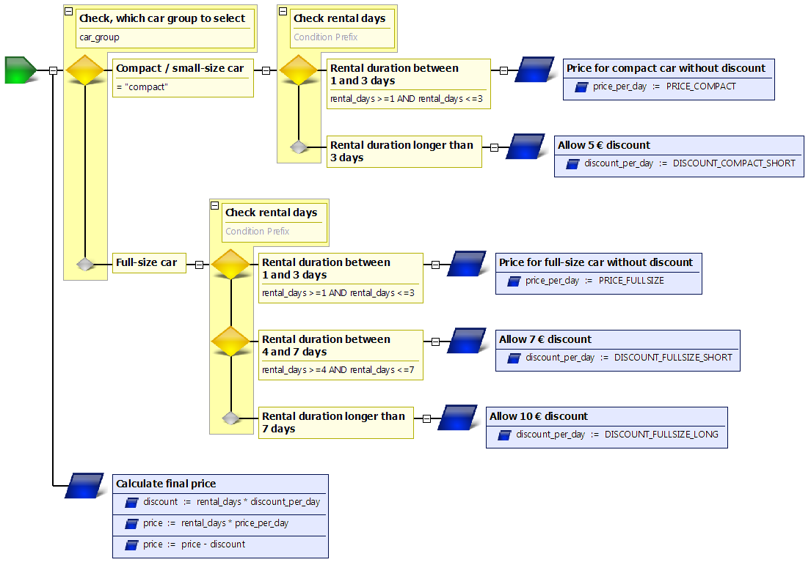

Questions:

1. Which of the following data types exist in Visual Rules?

|  |  |  |
| --- | --- | --- |
| a | Time |  |
| b | Any |  |
| c | Boolean |  |
| d | Null |  |
| e | String |  |

2. Name three different data elements existing in Visual Rules.

3. Now, describe the purpose of the above mentioned data elements.

Results:

1. Which of the following data types exist in Visual Rules?

|  |  |  |
| --- | --- | --- |
| a | Time | x |
| b | Any | x |
| c | Boolean | x |
| d | Null |  |
| e | String | x |

2. Name three different data elements existing in Visual Rules.

* Input-/output data element (parameter)
* Internal data element (variable)
* Constant data element (constants)

3. Now, describe the purpose of the above mentioned data elements.

