Exercise 3: Extended actions

**New requirements:**

Write the results of the rule execution in a CSV-file to get an overview of rentals and prices. The file should contain customer ID, rental term, car group, rental date, price and date of calculation (6 fields).

Optionally, you can create a database connection and use it in the rule model. The task is independent from the exercise EU Rent and should be created in an own rule project.

**Steps:**

1. Create a new action Write_Result_To_Excel of type „Write CSV File“ and insert all action settings within tab “Properties”.
2. Define the columns of the CSV file: Customer ID, Rental Days, Car Group, Rental Date, Actual Price and Calculation Date.

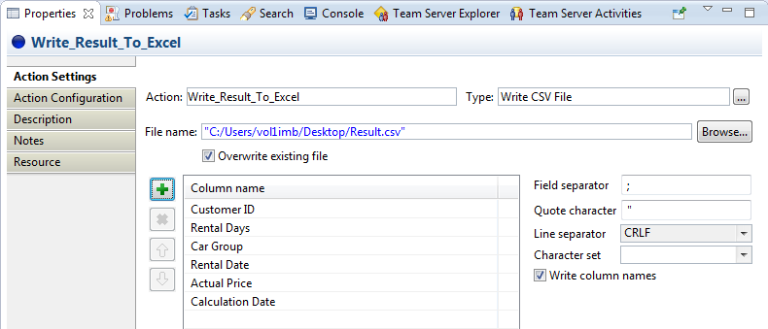

1. Use the action in the rule and write the execution result for the current customer to the CSV file „Result.csv“.
2. Execute the rule and analyze the re-created CSV file.

Result: Modeling of EU RENT

Business Data model:

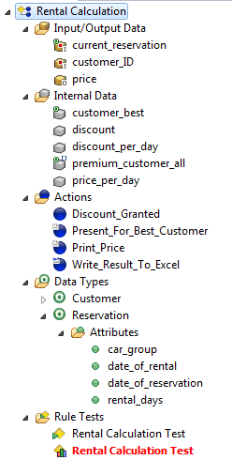

Properties of „Fire action“-element:

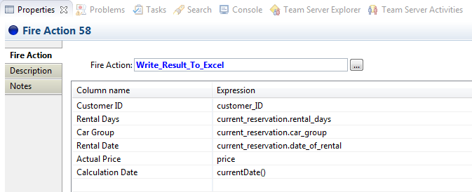

Rule Rental Calculation:

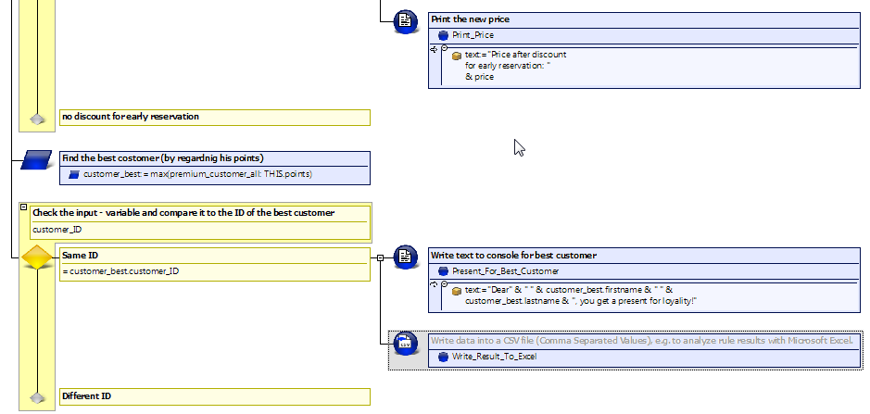

CSV – file („Result.csv“):



Questions:

1. Which properties can be specified while using the action type “Write CSV file”?

|  |  |  |
| --- | --- | --- |
| a | File name of the CSV file which shall be filled |  |
| b | Standard editor to open the CSV file |  |
| c | Column names |  |
| d | Overwriting of existing files |  |
| e | Field separator |  |

2. Briefly describe the steps for the usage of actions in rules.

Results:

1. Which properties can be specified while using the action type “Write CSV file”?

|  |  |  |
| --- | --- | --- |
| a | File name of the CSV file which shall be filled | x |
| b | Standard editor to open the CSV file |  |
| c | Column names | x |
| d | Overwriting of existing files | x |
| e | Field separator | x |

2. Please describe briefly the steps for the usage of actions in rules.

* Create a new action
* Specify the action properties
* Specify the usage of the action with the fire action element
* Specify the properties for the fire action element