Exercise 3: Expressions and Actions

**New requirements:**

An “early bird” discount is supposed to be introduced:

If the difference between the reservation date and the rental date is at least 14 days, a discount of 5 % will be granted. The resulting price is to be rounded to two decimal places and afterwards displayed on the console.

Information needed for the “early bird” discount will be introduced by creating a new input element for the rule.

**Steps:**

1. Create an action element called print_price of type „Output message“:

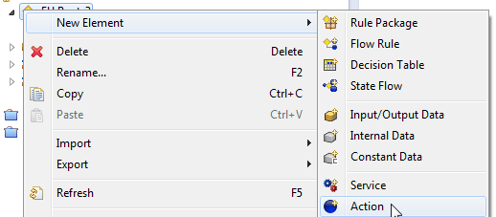

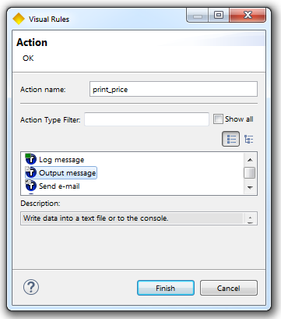

1. Use the just created action element in order the display the price on the console.
2. Further, create two new input data elements like the following:

- date_of_rental: date with default value #2015-02-15#  
- date_of_reservation: date with default value #2015-01-21#

1. Due to structural reasons, create a new group called Reservation Information for input-/ output elements. Move the following data elements to group Reservation Information:

* date_of_rental
* date_of_reservation
* rental_days
* car_group

1. Create a new constant data element within group Discount:  
   DISCOUNT_EARLY_RESERVATION: Float (default value: 0.05)
2. Use a Visual Rules – function in order to calculate the difference between the reservation- and rental date.

**Hint**: Use function diffDays(Date date1, Date date2) in order to calculate the intermediate days.

1. If there are at least 14 days lying in between the date of reservation and the date of rental, an additional “early bird” discount will be granted (to be implemented at the end of the rule).  
     
   **Hint**: In order to calculate the discount, manipulate the price with the value of the constant data element DISCOUNT_EARLY_RESERVATION and round the result to two decimal places by using the function round(Float value, Integer precision).
2. Create a new action element (type: Standard) called discount_granted, which only will be fired if the “early bird” discount is granted:

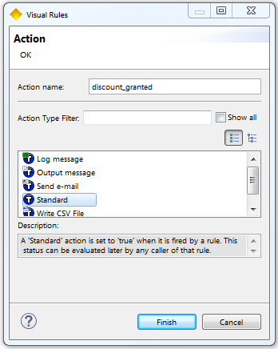

1. Again, use the action element print_price, in order to display it on the console after it has been granted.
2. Adjust the rule test according to the new input data elements and execute the test again.

Result: Modeling EU RENT

Business model:

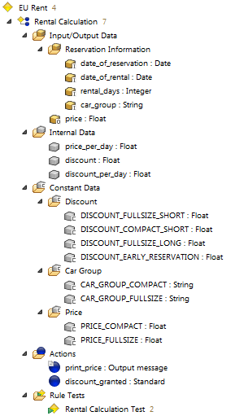

Rule Rental Calculation:

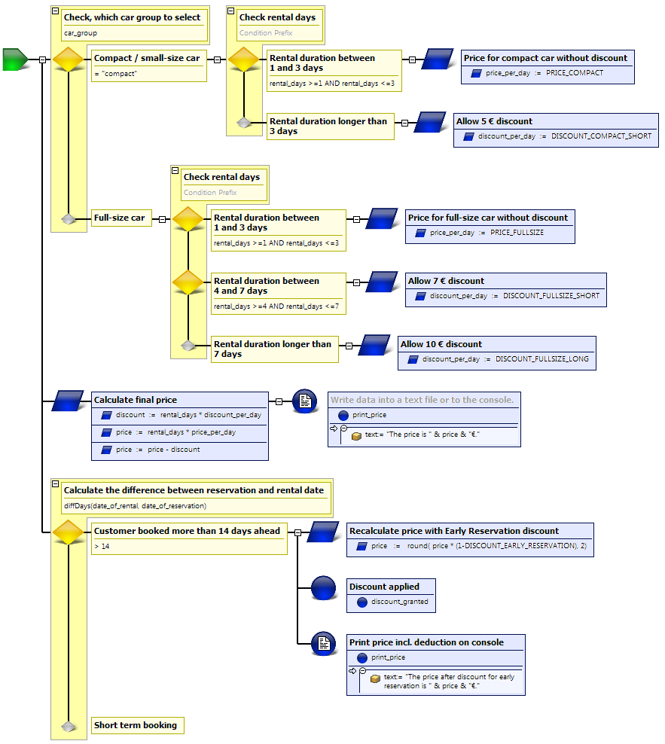

Questions:

1. Which of the following expressions are valid within Visual Rules?

|  |  |  |
| --- | --- | --- |
| a | (5 + 10) * 3 |  |
| b | ((5 + 10) * 3 |  |
| c | (5 + 10) * 3 > 10 |  |
| d | (5 + 10) * 3 > 10 AND 100 = 100 |  |
| e | (5 + 10) * “3” |  |

2. Name three different types of action elements in Visual Rules.

3. Which result values of the rule will be returned for the following input data values?

a) rental_days := 2 b) rental_days := 1

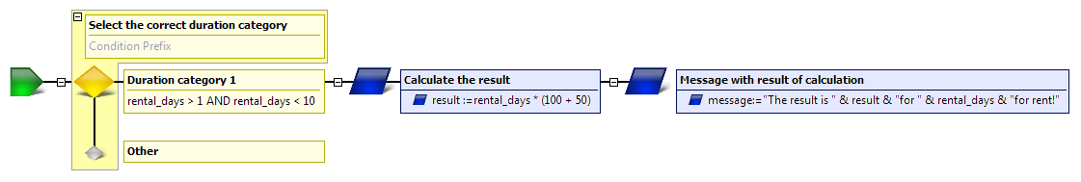

a) Data values of the …

result = ___________________________________________

message = “_________________________________________”

b) Data values of the …

result = ___________________________________________

message = “_________________________________________”.

Results:

1. Which of the following expressions are valid within Visual Rules?

|  |  |  |
| --- | --- | --- |
| a | (5 + 10) * 3 | x |
| b | ((5 + 10) * 3 |  |
| c | (5 + 10) * 3 > 10 | x |
| d | (5 + 10) * 3 > 10 AND 100 = 100 | x |
| e | (5 + 10) * “3” |  |

2. Name three different types of action elements in Visual Rules:

- Standard

- Log message

- Output message

3. Which result values of the rule will be returned for the following input data values?

a) rental_days := 2 b) rental_days := 1



a) Data values of the …

result = 300

message = “The result is 300 for 2 days rent!”

b) Data values of the …

result = 0

message = “” (empty String)