Exercise 4: Decision Tables

**New requirements:**

The existing rule is supposed to be extended by a decision table. Like that, a part of the logic within the rule will be stored in the decision table, instead. As well, all constant data elements, defined in earlier exercises (“Car Group”, “Discount”, “Price”) should be defined globally.

**Steps:**

1. Via “Drag-and-Drop”, move the constant data elements directly under rule project “EU Rent” in order to use them globally like the following:

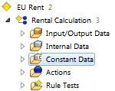 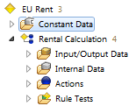

1. Deactivate the existing decision element (including all branches) „Check, which car group to select“ (executing a right – click on the topmost left decision element) in the rule:

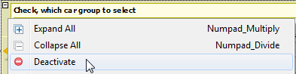

1. Create a new decision table called Calculate Price:

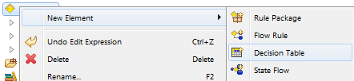

1. Move all constant data elements which have been applied for the rule in previous exercises to the topmost level of the rule model. Like that, those elements are visible for the newly created decision table, as well.
2. For the decision table, create new input-/output data elements like the following:

* car_group : String (input)
* rental_days : Integer (input)
* price_per_day : Float (output)
* discount_per_day : Float (output)

1. Insert the input elements car_group and rental_days as a decision element to the data table. As an assignment, the output elements price_per_day and discount_per_day should be used. Now, reproduce the logic from the rule within the decision table.

**Hint:** Deactivate descriptions in the decision table. So, readability is much improved:

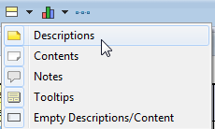

1. In order to check the logic, execute the rule test, again.

Result: Modeling of EU RENT

Business Model:

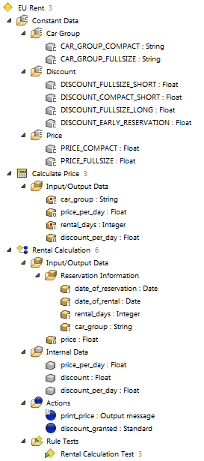

Decision Table Calculate Price:

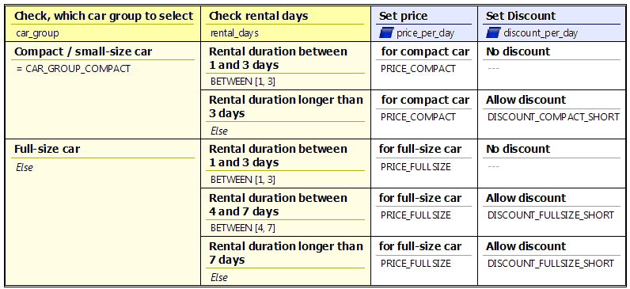

Rule Rental Calculation:

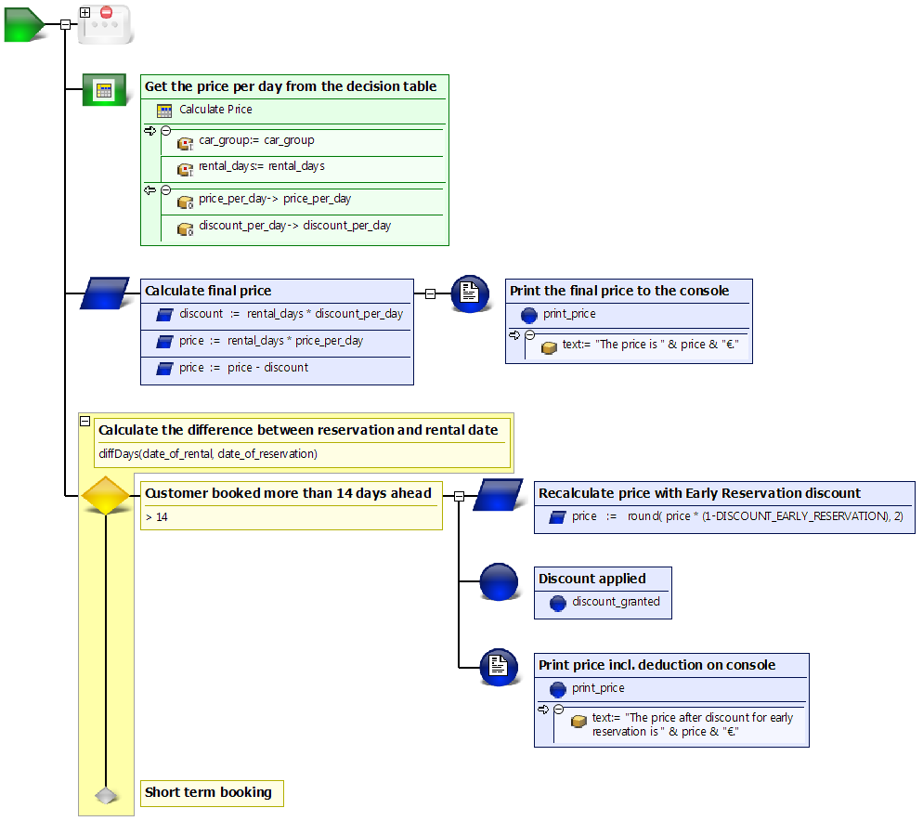

Questions:

1. Which of the following use cases suits the use of a decision table?

|  |  |  |
| --- | --- | --- |
| a | Rules with many decisions only based on few input data elements |  |
| b | Rules with only few decisions based on many input data elements |  |
| c | Rules with many decisions based on many input data elements |  |

2. Where can decisions be inserted?

|  |  |  |
| --- | --- | --- |
| a | Only within lines |  |
| b | Only within columns |  |
| c | Within both, rows and columns |  |

3. How can assignments be specified?

|  |  |  |
| --- | --- | --- |
| a | Only line by line |  |
| b | Only column by column |  |
| c | Both, line by line and column by column |  |

Results:

1. Which of the following use cases suits the use of a decision table?

|  |  |  |
| --- | --- | --- |
| a | Rules with many decisions only based on few input data elements | x |
| b | Rules with only few decisions based on many input data elements |  |
| c | Rules with many decisions based on many input data elements |  |

2. Where can decisions be inserted?

|  |  |  |
| --- | --- | --- |
| a | Only within lines |  |
| b | Only within columns |  |
| c | Within both, rows and columns | x |

3. How can assignments be specified?

|  |  |  |
| --- | --- | --- |
| a | Only line by line |  |
| b | Only column by column | x |
| c | Both, line by line and column by column |  |