Exercise 4: Exceptions

**New requirements:**

It should be checked whether the customer ID is valid or not.

**Steps:**

1. At the beginning of the rule Rental Calculation insert a new decision element which checks whether the customer ID (customer_id) is 0, or not.
2. If the customer ID is 0, an exception element should be triggered. Proceed as the following:
   1. Create a new exception data type Customer_ID_Invalid_Exception.
   2. Create a new internal data element customer_id_invalid_ex of the just created type.
   3. In the corresponding decision branch, trigger the exception of type “Return Exception“ and enter a meaningful text for the error message.
3. The exception is to be handled at the end of the rule with an adequate error message to be displayed on the console (therefore, choose type “Handle Exception” from the palette and insert it to the rule start - element). Further, create a new action Write_Exception_To_Console for the console - output.

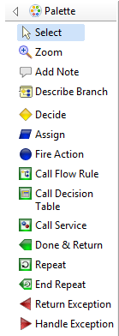

1. Test the rule: use value 0 for the customer ID within the test environment in order to check the exception handling.

Result: Modeling of EU RENT

Triggering of the exception in rule Rental Calculation:

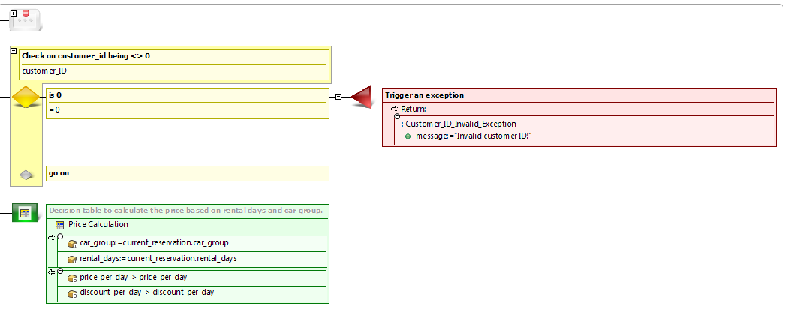

Exception handling:

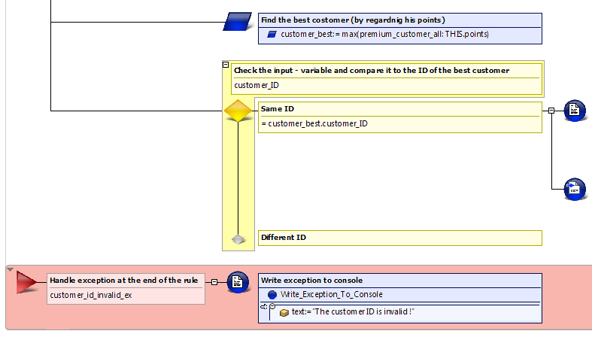

Business data model:

