Exercise 6: Getting connected to the team server and publish projects

Connect the rule project “EU Rent” (e.g. use the one from the last exercise) with the team server.

**Steps:**

1. Get connected to the team server - therefore, use the following settings:

**Connection name:   
Server-URL:** http://REPLACETHIS:PORT/Team Server  
**Name*:** XX   
**Password*:** YY  
**Tenant:** DEFAULT

* Replace XX and YY with your user name and the team server’s password

1. Extend the project’s name “EU Rent” with your name and member code (EU Rent name / member code). Afterwards, share your project on the team server. Therefore, select the repository being assigned to your user.
2. Add another rule to you rule model called “Testregel 1” and publish it on the team server, as well.

Result: Getting connected to the team server and publish projects

Settings for the actual team server connection:

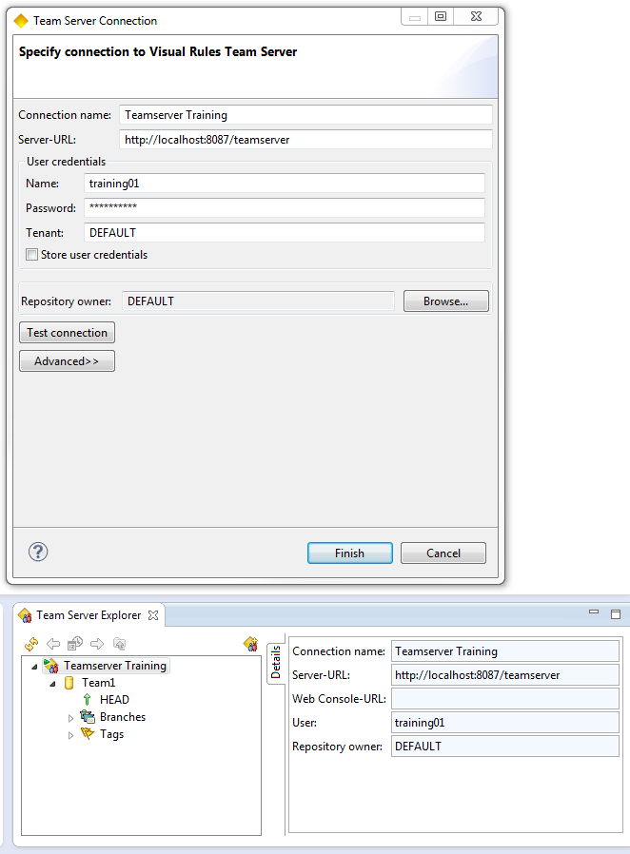

Business data model:

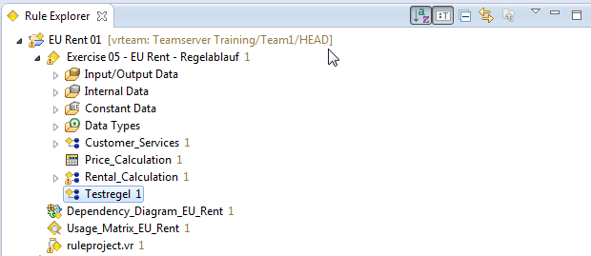

Publishing test rule:

