Exercise 6: Important tools to use in Visual Rules

**New requirements:**

In previous exercises, business rules have been modeled and tested. Now, information about advanced tooling in Visual Rules will be given, additionally.

A dependency – diagram, as well as a usage – matrix is to be created for the existing rule model. The logic modeled within rules is supposed to be saved as pictures. A Visual Rules - documentation has to be created, additionally.

**Steps:**

1. A dependency – diagram called Dependency Diagram EU Rent is to be created for the rule project.

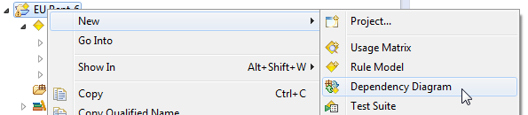

1. A usage – matrix called Usage Matrix EU Rent is to be created for the rule project, as well.

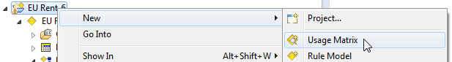

1. Save flow rules and decision tables as pictures (e.g. pictures can be saved on the desktop).

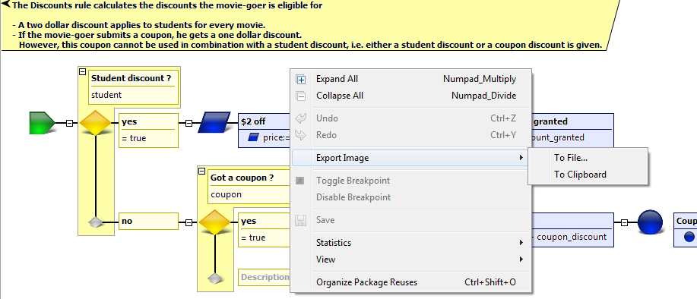

1. Now, a documentation for the rule model has to be created (it is recommended to test different output formats like PDF, HTML, WORD).

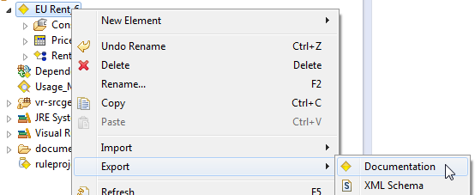

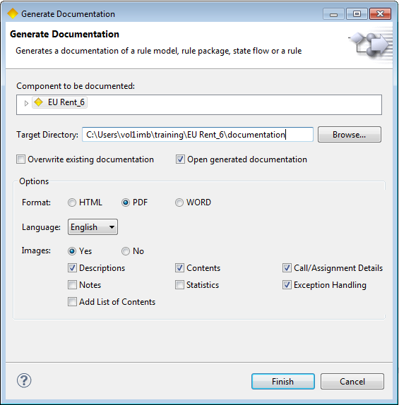

Result: Modeling EU RENT

Dependency - diagram:

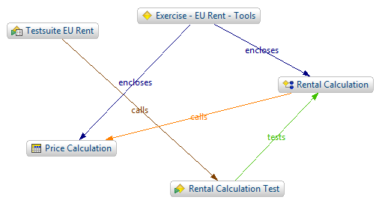

Usage - matrix:

