Exercise 7: Working together on the team server

Do changes within a different rule project “EU Rent“ (not in your own workspace):

Use the existing rule project “EU Rent” in order to get familiar the team server – usage.

**Hint**:

You need to get synchronized with another user being connected to the repository, as well.

**Steps**:

1. Load rule project “EU Rent“ from another user with the team server explorer’s help into your own workspace.
2. Now, do several changes within rule “Testrule” of the other user’s rule project “EU Rent“ by creating diverse assignments, attributes and finally use a decision element (be reminded that those changes are not meant to make sense).
3. Publish your changes on the team server and meanwhile add a meaningful description.
4. Manually block a different rule within the other user’s rule project “EU Rent“.
5. All changes another user is performing in your own project due to this exercise can be traced within the “Team Server Activities“ view.

Carefully check, how the Visual Rules Modeler is handling your activities when you try to add some changes to the already blocked rule.

1. Due to this exercise, changes have been done within your own project “EU Rent“ by another user: step-by-step, check on those changes by using the compare – view. Finally, retrieve the changes from the team server.

Result: Working together on the team server

Both rule models are now located within your workspace:

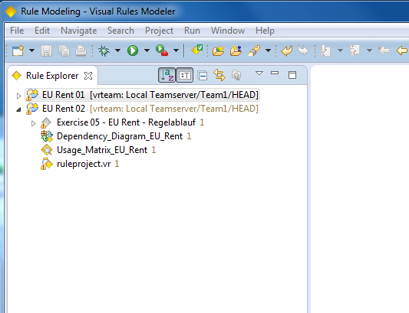

“Team Server Activities“ is showing all (outgoing) changes referring to the blocked resources you are working on, as well as blocked resources others are performing (incoming) changes on:

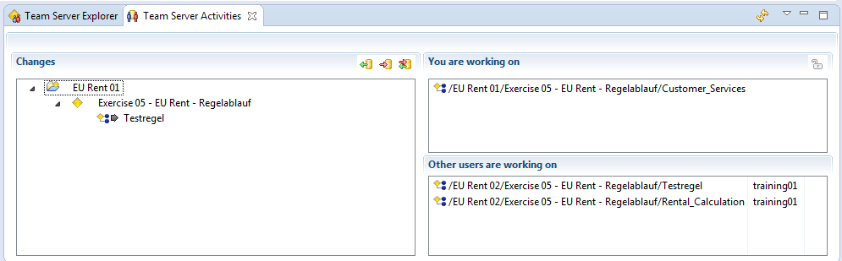

Error message will be shown, when trying to work on rules other users are blocking:

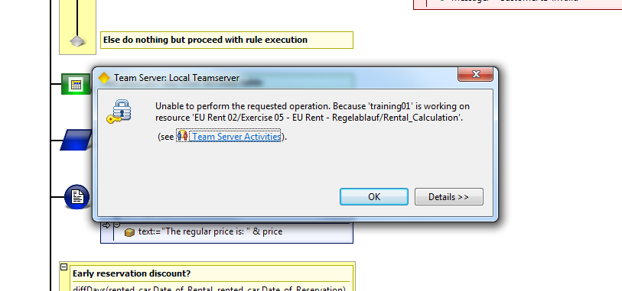

Incoming changes within the compare – view (from training02’s point of view):

