Exercise 8: Create team server conflicts and resolve them

Creating team server conflicts and resolve them:

Use the existing rule project “EU Rent” in order to get familiar the team server – usage.

**Hint**:

You need to get synchronized with another user being connected to the repository, as well. Before getting connected to the server again, it is recommended to wait until the other user has finished and published his changes on the team server, first.

**Steps:**

Within the model “EU Rent“:

1. Disconnect “EU Rent“ from team server.
2. Execute the beneath described steps (…) within “EU Rent“ of the second user. This is the user, you’re sharing your repository with.
3. Reconnect your rule model with the team server.
4. Now, examine the conflicts having been created by the changes of the rule model and finally, resolve them.
5. Analyze revisions and audit logs within the team server explorer view.

Within the model “EU Rent“ of the other user using the repository:

1. Change diverse rules and publish these changes.
2. Resolve blockings created by these random changes.

Result: Create team server conflicts and resolve them

Reconnect with the already existing rule project on the team server:

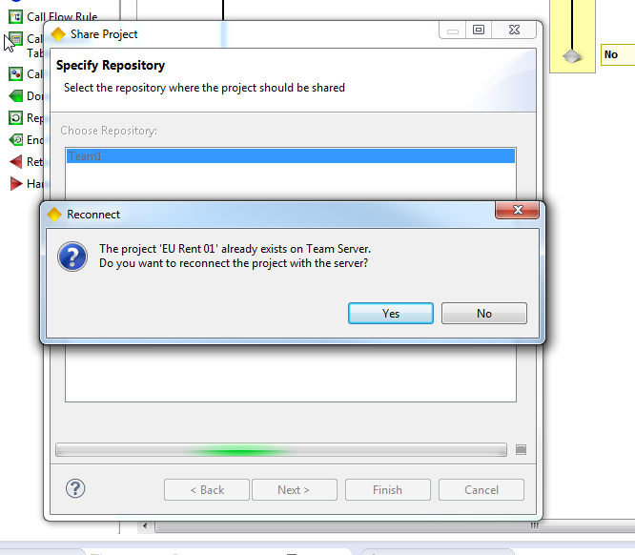

Displaying conflicts within “Team Server Activities“:

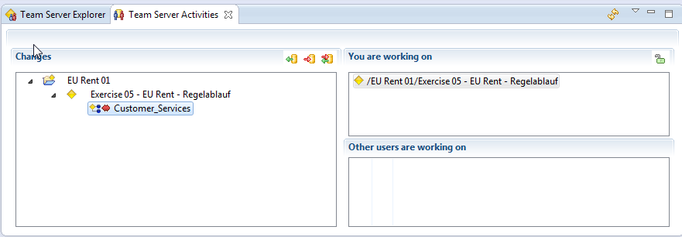

Audit Log within the view “Team Server Explorer”:

