**1. GIT-HOL**

**After installing git:**

91891@BUNNY MINGW64 ~

$ git config --global user.name "Sruthi"

91891@BUNNY MINGW64 ~

$ git config --global user.email [dsruthi2005@gmail.com](mailto:dsruthi2005@gmail.com)

**Git configuration:**

91891@BUNNY MINGW64 ~

$ git config --global --list

filter.lfs.clean=git-lfs clean -- %f

filter.lfs.smudge=git-lfs smudge -- %f

filter.lfs.process=git-lfs filter-process

filter.lfs.required=true

user.name=Sruthi

user.email=dsruthi2005@gmail.com

core.autocrlf=true

**Integrating notepad++.exe to Git and make it a default editor:**

91891@BUNNY MINGW64 ~

$ git config --global core.editor "'C:/Program Files/Notepad++/notepad++.exe' -multiInst -nosession"

91891@BUNNY MINGW64 ~

$ git config --global -e

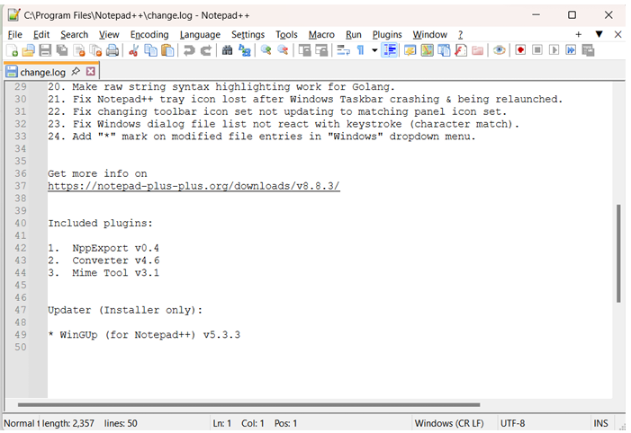

**Adding a file to source code repsoitory:**

91891@BUNNY MINGW64 ~/OneDrive/Desktop/HANDSON_6314262/Week8 (main)

$ mkdir GitDemo

91891@BUNNY MINGW64 ~/OneDrive/Desktop/HANDSON_6314262/Week8 (main)

$ cd GitDemo

91891@BUNNY MINGW64 ~/OneDrive/Desktop/HANDSON_6314262/Week8/GitDemo (main)

$ git init

Initialized empty Git repository in C:/Users/91891/OneDrive/Desktop/HANDSON_6314262/Week8/GitDemo/.git/

91891@BUNNY MINGW64 ~/OneDrive/Desktop/HANDSON_6314262/Week8/GitDemo (master)

$ ls -a

**.**/ **..**/ **.git**/

**Creating a file “welcome.txt” and verifying it:**

91891@BUNNY MINGW64 ~/OneDrive/Desktop/HANDSON_6314262/Week8/GitDemo (master)

$ echo "Welcome to GitDemo" > welcome.txt

91891@BUNNY MINGW64 ~/OneDrive/Desktop/HANDSON_6314262/Week8/GitDemo (master)

$ ls

welcome.txt

**Verifying the content of “welcome.txt”:**

91891@BUNNY MINGW64 ~/OneDrive/Desktop/HANDSON_6314262/Week8/GitDemo (master)

$ cat welcome.txt

Welcome to GitDemo

**Checking the git status:**

91891@BUNNY MINGW64 ~/OneDrive/Desktop/HANDSON_6314262/Week8/GitDemo (master)

$ git status

On branch master

No commits yet

Untracked files:

(use "git add <file>..." to include in what will be committed)

welcome.txt

nothing added to commit but untracked files present (use "git add" to track)

**Staging the file “welcome.txt” and commiting changes to git:**

91891@BUNNY MINGW64 ~/OneDrive/Desktop/HANDSON_6314262/Week8/GitDemo (master)

$ git add welcome.txt

warning: in the working copy of 'welcome.txt', LF will be replaced by CRLF the next time Git touches it

91891@BUNNY MINGW64 ~/OneDrive/Desktop/HANDSON_6314262/Week8/GitDemo (master)

$ git commit

[master (root-commit) 382c852] Add welcome.txt

1 file changed, 1 insertion(+)

create mode 100644 welcome.txt

91891@BUNNY MINGW64 ~/OneDrive/Desktop/HANDSON_6314262/Week8/GitDemo (master)

$ git remote add origin https://github.com/dsruthi17/GitDemo

91891@BUNNY MINGW64 ~/OneDrive/Desktop/HANDSON_6314262/Week8/GitDemo (master)

$ git push -u origin master

Enumerating objects: 3, done.

Counting objects: 100% (3/3), done.

Writing objects: 100% (3/3), 236 bytes | 236.00 KiB/s, done.

Total 3 (delta 0), reused 0 (delta 0), pack-reused 0 (from 0)

To https://github.com/dsruthi17/GitDemo

* [new branch] master -> master

branch 'master' set up to track 'origin/master'.

**Status after commiting changes to git:**

91891@BUNNY MINGW64 ~/onedrive/desktop/handson_6314262/week8/GitDemo (master)

$ git status

On branch master

Your branch is up to date with 'origin/master'.

nothing to commit, working tree clean

**Verifying all existing commits:**

91891@BUNNY MINGW64 ~/onedrive/desktop/handson_6314262/week8/GitDemo (master)

$ git log

commit 382c85268f26ba95df96b880f771d5bad74f34c6 (**HEAD** -> **master**, **origin/master**)

Author: Sruthi <dsruthi2005@gmail.com>

Date: Sat Aug 9 20:41:28 2025 +0530

Add welcome.txt

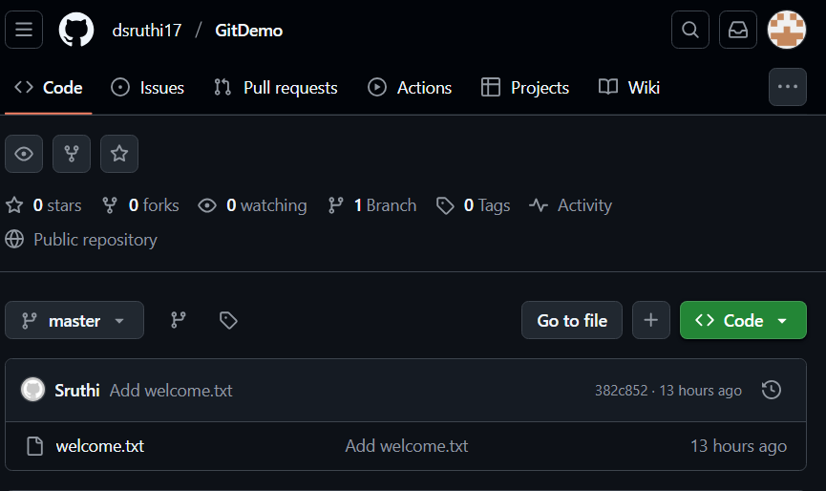

**2. GIT-HOL**

**Creating a log file “error.log”**

91891@BUNNY MINGW64 ~/onedrive/desktop/handson_6314262/week8  
$ echo “This is a log file.” > error.log

**Creating a directory “log” in working directory**

91891@BUNNY MINGW64 ~/onedrive/desktop/handson_6314262/week8  
$ mkdir log

91891@BUNNY MINGW64 ~/onedrive/desktop/handson_6314262/week8  
$ echo "Sample log content" > log/info.txt

**Creating a file “.gitignore”**

91891@BUNNY MINGW64 ~/onedrive/desktop/handson_6314262/week8  
$ notepad .gitignore

**Status after creating “.gitignore” file**

91891@BUNNY MINGW64 ~/onedrive/desktop/handson_6314262/week8 (main)

$ git status

On branch main

Your branch is up to date with 'origin/main'.

Changes not staged for commit:

(use "git add <file>..." to update what will be committed)

(use "git restore <file>..." to discard changes in working directory)

(commit or discard the untracked or modified content in submodules)

modified: gitignore-demo (untracked content)

no changes added to commit (use "git add" and/or "git commit -a")

**Staging the “.gitignore” file**

91891@BUNNY MINGW64 ~/onedrive/desktop/handson_6314262/week8 (main)

$ git add .gitignore

**Commiting the change done**

91891@BUNNY MINGW64 ~/onedrive/desktop/handson_6314262/week8 (main)

$ git commit -m “Added .gitignore to ignore .log files and log folder”



91891@BUNNY MINGW64 ~/onedrive/desktop/handson_6314262/week8 (main)

$ git add debug.log

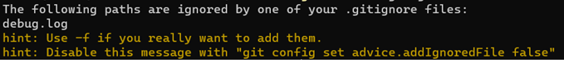

91891@BUNNY MINGW64 ~/onedrive/desktop/handson_6314262/week8 (main)

$ git push origin main

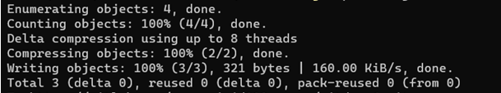

**3. GIT-HOL**

**Branching:**

**🡪Creating a new Branch**

git branch GitNewBranch

git branch -a

* GitNewBranch

main

remotes/origin/main

**🡪Switch to the newly created branch and adding files**

91891@BUNNY MINGW64 ~/onedrive/desktop/handson_6314262/week8

$ git checkout GitNewBranch

91891@BUNNY MINGW64 ~/onedrive/desktop/handson_6314262/week8 (GitNewBranch)

$ echo "This is a test file for branching" > branchfile.txt

91891@BUNNY MINGW64 ~/onedrive/desktop/handson_6314262/week8 (GitNewBranch)

$ git add branchfile.txt

**🡪Commiting the changes to the branch**

91891@BUNNY MINGW64 ~/onedrive/desktop/handson_6314262/week8 (GitNewBranch)

$ git commit -m "Added branchfile.txt in GitNewBranch"

[GitNewBranch 2bc8eb1] Added branchfile.txt in GitNewBranch

1 file changed, 1 insertion(+)

create mode 100644 Week8/branchfile.txt

**🡪checking the status**

91891@BUNNY MINGW64 ~/onedrive/desktop/handson_6314262/week8 (GitNewBranch)

$ git status

On branch GitNewBranch

Untracked files:

(use "git add <file>..." to include in what will be committed)

GitDemo/

gitignore-demo/

nothing added to commit but untracked files present (use "git add" to track)

**🡪switch to the main**

91891@BUNNY MINGW64 ~/onedrive/desktop/handson_6314262/week8 (main)

$ git switch main

Already on 'main'

Your branch is up to date with 'origin/main'.

**🡪Differences between trunk and branch**

91891@BUNNY MINGW64 ~/onedrive/desktop/handson_6314262/week8 (main)

$ git diff main GitNewBranch

**diff --git a/Week8/branchfile.txt b/Week8/branchfile.txt**

**new file mode 100644**

**index 0000000..2746078**

**--- /dev/null**

**+++ b/Week8/branchfile.txt**

@@ -0,0 +1 @@

+This is a test file for branching

**🡪Using P4MergeTool**

91891@BUNNY MINGW64 ~/onedrive/desktop/handson_6314262/week8 (main)

$ git difftool main GitNewBranch

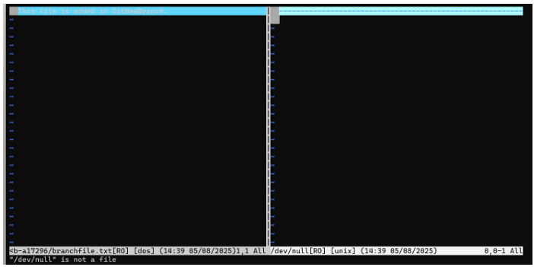

**🡪Merging**

91891@BUNNY MINGW64 ~/onedrive/desktop/handson_6314262/week8 (main)

$ git merge GitNewBranch

Updating b2dc53c..2bc8eb1

Fast-forward

Week8/branchfile.txt | 1 +

1 file changed, 1 insertion(+)

create mode 100644 Week8/branchfile.txt

91891@BUNNY MINGW64 ~/onedrive/desktop/handson_6314262/week8 (main)

$ git log --oneline --graph --decorate

* 2bc8eb1 (**HEAD** -> **main**, **GitNewBranch**) Added branchfile.txt in GitNewBranch

* b2dc53c (**origin/main**) Week7 Added

* 8cc24f4 Added week1 folder

* 311ea88 Delete cohorttracker directory

* 8846a2d Delete studentapp directory

* f3364c5 Delete scorecalculatorapp directory

* 8e50b97 Delete myfirstreact directory

* 93d4379 Delete blogapp directory

* bbd416f Initial commit

|\

| * 570f620 initial commit

| * a004de7 Create ReadME.md

| * b84f2c3 Delete Week 5/MicroServices

| * 0400ede Add files via upload

| * 5d604b8 Create MicroServices

| * a48ba97 Add files via upload

| * 260aedb Delete Week4/4

| * 63131a0 Add files via upload

| * 1e8daa2 Create 4

| * 835ba6f Add files via upload

| * 826d2e9 Create Demo

| * 0667ae2 Add files via upload

| * 55438af Add files via upload

| * 498f338 Create EXERCISE1.sql

| * ff00e17 Resolve merge conflicts

| |\

| | * 81ee287 Delete ecommercesearch directory

| * | 271f842 Add week1 module

| |/

| * 448c17c Add ecommercesearch module

| * 54b1f86 first commit

| * 51cd01a first commit

| * 2b9e5e1 first commit

| * 2880177 Add singletonpattern folder with Java files

| * 2c632b2 Add singletonpattern folder with Java files

| |**\**

| | * d449ce8 Initial commit

| * 9bae7eb Initial commit: Add singletonpattern folder with Java files

* 3edd8c2 Initial commit

**🡪Deleting the branch**

91891@BUNNY MINGW64 ~/onedrive/desktop/handson_6314262/week8 (main)

$ git branch -d GitNewBranch

Deleted branch GitNewBranch (was 2bc8eb1).

91891@BUNNY MINGW64 ~/onedrive/desktop/handson_6314262/week8 (main)

$ git status

On branch main

Your branch is ahead of 'origin/main' by 1 commit.

(use "git push" to publish your local commits)

Untracked files:

(use "git add <file>..." to include in what will be committed)

GitDemo/

gitignore-demo/

nothing added to commit but untracked files present (use "git add" to track)

**4. GIT-HOL**

91891@BUNNY MINGW64 ~/onedrive/desktop/handson_6314262/week8 (main)

$ git status

On branch main

Your branch is ahead of 'origin/main' by 1 commit.

(use "git push" to publish your local commits)

Untracked files:

(use "git add <file>..." to include in what will be committed)

GitDemo/

gitignore-demo/

nothing added to commit but untracked files present (use "git add" to track)

**Creating a branch “GitWork”**

91891@BUNNY MINGW64 ~/onedrive/desktop/handson_6314262/week8 (main)

$ git branch GitWork

**Switching to GitWork branch**

91891@BUNNY MINGW64 ~/onedrive/desktop/handson_6314262/week8 (main)

$ git switch GitWork

Switched to branch 'GitWork'

**Creating a file “hello.xml”**

91891@BUNNY MINGW64 ~/onedrive/desktop/handson_6314262/week8 (GitWork)

$ echo "<message> Hello from GitWork branch </message>" > hello.xml

91891@BUNNY MINGW64 ~/onedrive/desktop/handson_6314262/week8 (GitWork)

$ git add hello.xml

warning: in the working copy of 'Week8/hello.xml', LF will be replaced by CRLF the next time Git touches it

**Updating contents of “hello.xml”**

91891@BUNNY MINGW64 ~/onedrive/desktop/handson_6314262/week8 (GitWork)

$ echo "<update> Branch-specific change</update>" >> hello.xml

**status after updating “hello.xml”**

91891@BUNNY MINGW64 ~/onedrive/desktop/handson_6314262/week8 (GitWork)

$ git status

On branch GitWork

Changes to be committed:

(use "git restore --staged <file>..." to unstage)

new file: hello.xml

Changes not staged for commit:

(use "git add <file>..." to update what will be committed)

(use "git restore <file>..." to discard changes in working directory)

modified: hello.xml

Untracked files:

(use "git add <file>..." to include in what will be committed)

GitDemo/

gitignore-demo/

91891@BUNNY MINGW64 ~/onedrive/desktop/handson_6314262/week8 (GitWork)

$ git commit -m "Added and updated hello.xml in GitWork"

[GitWork fb47e73] Added and updated hello.xml in GitWork

1 file changed, 1 insertion(+)

create mode 100644 Week8/hello.xml

91891@BUNNY MINGW64 ~/onedrive/desktop/handson_6314262/week8 (GitWork)

$ git switch main

error: Your local changes to the following files would be overwritten by checkout:

Week8/hello.xml

Please commit your changes or stash them before you switch branches.

Aborting

91891@BUNNY MINGW64 ~/onedrive/desktop/handson_6314262/week8 (GitWork)

$ echo "<message> Hello from main branch </message>" hello.xml

<message> Hello from main branch </message> hello.xml

**Staging the file “hello.xml”**

91891@BUNNY MINGW64 ~/onedrive/desktop/handson_6314262/week8 (GitWork)

$ git add hello.xml

warning: in the working copy of 'Week8/hello.xml', LF will be replaced by CRLF the next time Git touches it

**commiting the changes done**

91891@BUNNY MINGW64 ~/onedrive/desktop/handson_6314262/week8 (GitWork)

$ git commit -m "Added hello.xml in main with different content"

[GitWork f1c43ca] Added hello.xml in main with different content

1 file changed, 1 insertion(+)

**Visual representation of log**

91891@BUNNY MINGW64 ~/onedrive/desktop/handson_6314262/week8 (GitWork)

$ git log --online --graph --decorate --all

fatal: unrecognized argument: --online

91891@BUNNY MINGW64 ~/onedrive/desktop/handson_6314262/week8 (GitWork)

$ git diff main GitWork

**diff --git a/Week8/hello.xml b/Week8/hello.xml**

**new file mode 100644**

**index 0000000..0856250**

**--- /dev/null**

**+++ b/Week8/hello.xml**

@@ -0,0 +1,2 @@

+<message> Hello from GitWork branch </message>

+<update> Branch-specific change</update>

**Checking differences using Git diff tool**

91891@BUNNY MINGW64 ~/onedrive/desktop/handson_6314262/week8 (GitWork)

$ git difftool main GitWork

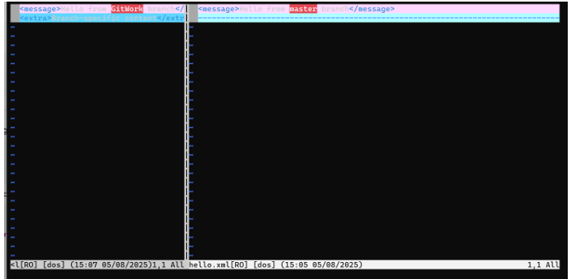

**Merging “Gitwork” branch to “main” branch**

91891@BUNNY MINGW64 ~/onedrive/desktop/handson_6314262/week8 (main)

$ git merge GitWork

Auto-merging Week8/hello.xml

CONFLICT (content): Merge conflict in Week8/hello.xml

Automatic merge failed; fix conflicts and then commit the result.

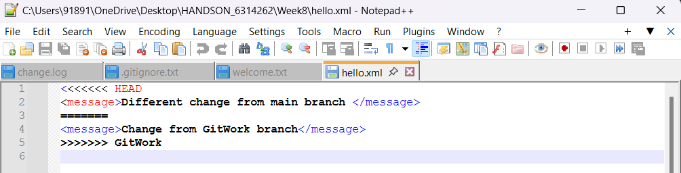

**Using 3-way merge tool**

91891@BUNNY MINGW64 ~/onedrive/desktop/handson_6314262/week8 (main|MERGING)

$git mergetool GitWork

**Commiting the changes**

91891@BUNNY MINGW64 ~/onedrive/desktop/handson_6314262/week8 (main|MERGING)

$ git commit -m "Resolved merge conflict for hello.xml"

[main 7c3fa69] Resolved merge conflict for hello.xml

91891@BUNNY MINGW64 ~/onedrive/desktop/handson_6314262/week8 (main)

$ git status

On branch main

Your branch is ahead of 'origin/main' by 6 commits.

(use "git push" to publish your local commits)

Untracked files:

(use "git add <file>..." to include in what will be committed)

GitDemo/

gitignore-demo/

hello.xml.orig

hello_BACKUP_1314.xml

hello_BASE_1314.xml

hello_LOCAL_1314.xml

hello_REMOTE_1314.xml

nothing added to commit but untracked files present (use "git add" to track)

**Creating a “.gitignore” file**

91891@BUNNY MINGW64 ~/onedrive/desktop/handson_6314262/week8 (main)

$ echo "*.orig" >> .gitignore

**Staging the “.gitignore” file**

91891@BUNNY MINGW64 ~/onedrive/desktop/handson_6314262/week8 (main)

$ git add .gitignore

warning: in the working copy of 'Week8/.gitignore', LF will be replaced by CRLF the next time Git touches it

**Commiting the changes**

91891@BUNNY MINGW64 ~/onedrive/desktop/handson_6314262/week8 (main)

$ git commit -m "Updated .gitignore to ignore merge backup files"

[main 7f1bd7a] Updated .gitignore to ignore merge backup files

1 file changed, 1 insertion(+)

create mode 100644 Week8/.gitignore

**Listing all branches**

91891@BUNNY MINGW64 ~/onedrive/desktop/handson_6314262/week8 (main)

$ git branch -a

GitWork

* main

remotes/origin/main

**Deleting the merged branch**

91891@BUNNY MINGW64 ~/onedrive/desktop/handson_6314262/week8 (main)

$ git branch -d GitWork

Deleted branch GitWork (was e7c63b0).

**Final log check**

91891@BUNNY MINGW64 ~/onedrive/desktop/handson_6314262/week8 (main)

$ git log --oneline --graph --decorate

* 7f1bd7a (**HEAD** -> **main**) Updated .gitignore to ignore merge backup files

* 7c3fa69 Resolved merge conflict for hello.xml

|\

| * e7c63b0 Changed hello.xml in GitWork

* | 7460df1 Changed hello.xml in main

|/

* f1c43ca Added hello.xml in main with different content

* fb47e73 Added and updated hello.xml in GitWork

* 2bc8eb1 Added branchfile.txt in GitNewBranch

* b2dc53c (**origin/main**) Week7 Added

* 8cc24f4 Added week1 folder

* 311ea88 Delete cohorttracker directory

* 8846a2d Delete studentapp directory

* f3364c5 Delete scorecalculatorapp directory

* 8e50b97 Delete myfirstreact directory

* 93d4379 Delete blogapp directory

* bbd416f Initial commit

|\

| * 570f620 initial commit

| * a004de7 Create ReadME.md

| * b84f2c3 Delete Week 5/MicroServices

| * 0400ede Add files via upload

| * 5d604b8 Create MicroServices

| * a48ba97 Add files via upload

| * 260aedb Delete Week4/4

| * 63131a0 Add files via upload

| * 1e8daa2 Create 4

| * 835ba6f Add files via upload

| * 826d2e9 Create Demo

| * 0667ae2 Add files via upload

| * 55438af Add files via upload

| * 498f338 Create EXERCISE1.sql

| * ff00e17 Resolve merge conflicts

| |**\**

| | * 81ee287 Delete ecommercesearch directory

| * **|** 271f842 Add week1 module

| **|/**

| * 448c17c Add ecommercesearch module

| * 54b1f86 first commit

| * 51cd01a first commit

| * 2b9e5e1 first commit

| * 2880177 Add singletonpattern folder with Java files

| * 2c632b2 Add singletonpattern folder with Java files

| **|\**

| **|** * d449ce8 Initial commit

| * 9bae7eb Initial commit: Add singletonpattern folder with Java files

* 3edd8c2 Initial commit

**5. GIT-HOL**

91891@BUNNY MINGW64 ~/onedrive/desktop/handson_6314262/week8 (main)

$ git switch main

Already on 'main'

Your branch is ahead of 'origin/main' by 7 commits.

(use "git push" to publish your local commits)

**Verifying if master is in a clean state**

91891@BUNNY MINGW64 ~/onedrive/desktop/handson_6314262/week8 (main)

$ git status

On branch main

Your branch is ahead of 'origin/main' by 7 commits.

(use "git push" to publish your local commits)

Untracked files:

(use "git add <file>..." to include in what will be committed)

GitDemo/

gitignore-demo/

hello_BACKUP_1314.xml

hello_BASE_1314.xml

hello_LOCAL_1314.xml

hello_REMOTE_1314.xml

nothing added to commit but untracked files present (use "git add" to track)

**List out all the available branches(local & remote)**

91891@BUNNY MINGW64 ~/onedrive/desktop/handson_6314262/week8 (main)

$ git branch -a

* main

remotes/origin/main

**Pulling the remote Git repository to the main**

91891@BUNNY MINGW64 ~/onedrive/desktop/handson_6314262/week8 (main)

$ git pull origin main

From https://github.com/dsruthi17/Java-FSE-DeepSkilling-6314262

* branch main -> FETCH_HEAD

Already up to date.

**Pushing changes to remote repository**

91891@BUNNY MINGW64 ~/onedrive/desktop/handson_6314262/week8 (main)

$ git push origin main

Enumerating objects: 29, done.

Counting objects: 100% (29/29), done.

Delta compression using up to 12 threads

Compressing objects: 100% (23/23), done.

Writing objects: 100% (28/28), 2.59 KiB | 882.00 KiB/s, done.

Total 28 (delta 8), reused 0 (delta 0), pack-reused 0 (from 0)

remote: Resolving deltas: 100% (8/8), completed with 1 local object.

To https://github.com/dsruthi17/Java-FSE-DeepSkilling-6314262.git

b2dc53c..7f1bd7a main -> main

91891@BUNNY MINGW64 ~/onedrive/desktop/handson_6314262/week8 (main)

$ git add .

warning: adding embedded git repository: Week8/GitDemo

hint: You've added another git repository inside your current repository.

hint: Clones of the outer repository will not contain the contents of

hint: the embedded repository and will not know how to obtain it.

hint: If you meant to add a submodule, use:

hint:

hint: git submodule add <url> Week8/GitDemo

hint:

hint: If you added this path by mistake, you can remove it from the

hint: index with:

hint:

hint: git rm --cached Week8/GitDemo

hint:

hint: See "git help submodule" for more information.

hint: Disable this message with "git config set advice.addEmbeddedRepo false"

warning: adding embedded git repository: Week8/gitignore-demo

91891@BUNNY MINGW64 ~/onedrive/desktop/handson_6314262/week8 (main)

$ git commit -m "Completed Git-T03-HOL_002 lab"

[main 13c9155] Completed Git-T03-HOL_002 lab

6 files changed, 11 insertions(+)

create mode 160000 Week8/GitDemo

create mode 160000 Week8/gitignore-demo

create mode 100644 Week8/hello_BACKUP_1314.xml

create mode 100644 Week8/hello_BASE_1314.xml

create mode 100644 Week8/hello_LOCAL_1314.xml

create mode 100644 Week8/hello_REMOTE_1314.xml

91891@BUNNY MINGW64 ~/onedrive/desktop/handson_6314262/week8 (main)

$ git push origin main

Enumerating objects: 8, done.

Counting objects: 100% (8/8), done.

Delta compression using up to 12 threads

Compressing objects: 100% (5/5), done.

Writing objects: 100% (6/6), 738 bytes | 738.00 KiB/s, done.

Total 6 (delta 1), reused 0 (delta 0), pack-reused 0 (from 0)

remote: Resolving deltas: 100% (1/1), completed with 1 local object.

To https://github.com/dsruthi17/Java-FSE-DeepSkilling-6314262.git

7f1bd7a..13c9155 main -> main