# ***UPFC Model Documentation***

**Report generated by Davis Montenegro Martinez**

**Student Intern at EPRI**

**Aug-10-2015**

The Universal Power Flow Controller (UPFC) model developed for EPRI’s OpenDSS corresponds to an equivalent representation for applications on Distribution Systems (DS), where the aim is to regulate voltage for a part of the system and to compensate reactive power to fix a desired power factor (PF).

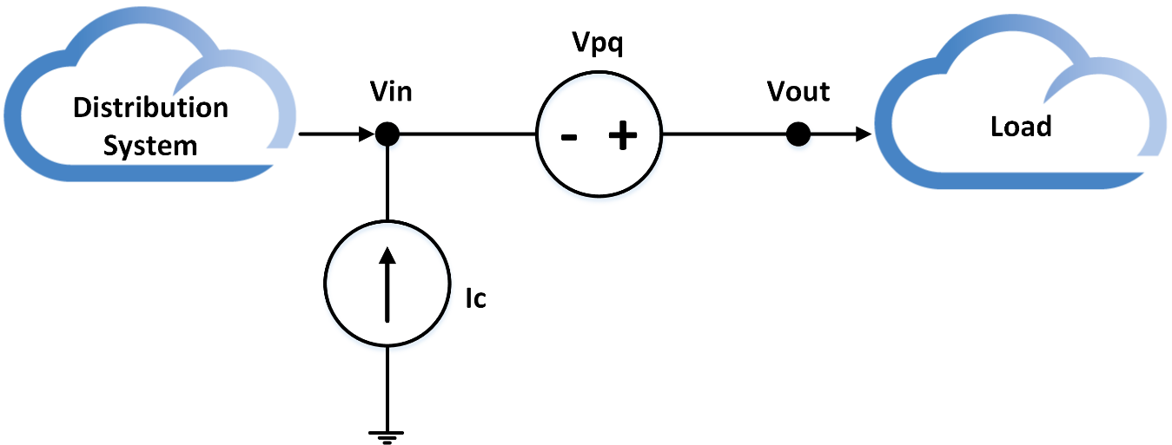

Figure 1. General architecture of the UPFC device

This model is a steady state model and can be used for simulations in sequential-time mode. The variables defined to configure this device allows to configure the set point in terms of the output voltage and PF. Additionally, this generalized model allows to specify the maximum rating for the compensating voltage source (Vpq) and the losses behavior as a function of the input voltage by using XY curves. These variables are described as follows:

|  |  |
| --- | --- |
| **Bus1 =** | Name of bus to which the UPFC's first terminal (input terminal *“Vin”*) is connected. Remember to specify the node order if the terminals are connected in some unusual manner. |
| **Bus2 =** | Name of bus to which the UPFC's second terminal (output terminal *“Vout”*) is connected. Remember to specify the node order if the terminals are connected in some unusual manner. |
| **RefkV =** | The set point in kV for the voltage regulation controller. The default value is 0.24 |
| **PF =** | The desired power factor to be compensated by the UPFC. The default value is 1. |
| **Frequency =** | Frequency of the system. Defaults to circuit fundamental frequency. |
| **Phases =** | Number of phases of the device, the default value is 1. |
| **Xs =** | Impedance in ohms of the series transformer of the UPFC (2πfL). By default is 0.745 Ω (2mH – 60Hz) |
| **Tol1 =** | Corresponds to the desired tolerance for the control algorithms of the UPFC, the default value is 0.02 (2%) |
| **Mode =** | Number (integer) specifying the operation mode. The UPFC has 4 modes of operation:  0: The controllers are turned off, this means that the UPFC will behave as a series impedance with value Xs for all the phases.  1: Voltage regulation mode. In this mode the UPFC only regulates the output voltage; however, there is no reactive compensation. The set point is the one specified in the property RefkV.  2: Reactive power compensation. In this mode the UPFC will compensate reactive power and try to fix the PF programmed in the property PF. There will be no voltage regulation.  3: Dual control mode. In this mode the UPFC performs voltage regulation and reactive power compensation. Both controllers will follow the set points programmed in the properties RefkV and PF. |
| **VpqMax =** | Is the maximum voltage (in Volts) that the series voltage source (Vpq) can provide. By default is 24 V. |
| **LossCurve =** | Is the name of the XY curve that describes the losses as a function of the input voltage. |
| **BaseFreq** = | Base Frequency for impedance specifications. Default is 60 Hz. |
| **enabled =** | {Yes|No or True|False} Indicates whether this element is enabled |
| **Like** = | Name of an existing UPFC object on which to base this one. |
| **VHLimit =** | High limit for the voltage at the input of the UPFC, if the voltage is above this value the UPFC turns off. This value is specified in Volts (default 300 V) |
| **VLLimit =** | Low limit for the voltage at the input of the UPFC, if voltage is below this value the UPFC turns off. This value is specified in Volts (default 125 V)’; |
| **CLImit =** | Current Limit for the UPFC, if the current passing through the UPFC is higher than this value the UPFC turns off. This value is specified in Amps (Default 265 A) |

## ***The losses curve***

The losses curve of the UPFC is a XY curve where the losses are defined as a function of the input voltage. The values for the voltage (X) must be specified in pu and the values for the power (Y) must be specified in percentage. In the case of the power, the quantities must be specified considering the base power, this is, suppose that the load power is 50kW and the desired losses at 0.9 Vpu are the 1%, in this case, the couple of values will be 0.9 (X) and 1.01 (Y). For example, consider the losses curve shown in Figure 2. This curve corresponds to the losses of the UPFC when connected to a load of 50kW.

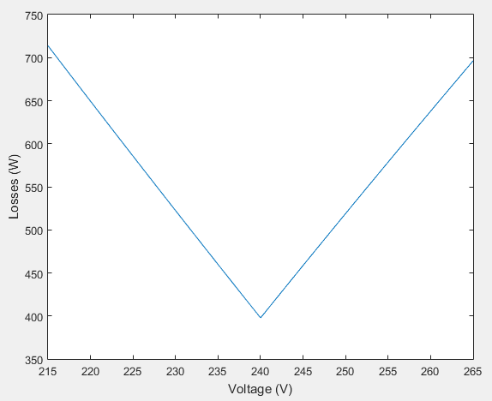

Figure 2. Losses curve for the UPFC with a 50kW load connected (example)

In Figure 2, the minimum value of losses is 397.76W and the maximum 713.76W, both values correspond to the 0.8% and 1.43% of the load. In this case, the XY curve object must be defined I OpenDSS as follows:

*New XYCurve.UPFCLoss npts=3 xarray=[0.9 1 1.1] yarray=[1.0143 1.008 1.0143]*

## ***Mathematical model of the UPFC***

The mathematical model of the UPFC is defined considering the problem formulation proposed in OpenDSS to solve the circuit’s power flow. This way, the model proposed in Figure 1 is transformed into an equivalent based on current sources. This equivalent is shown in Figure 3.

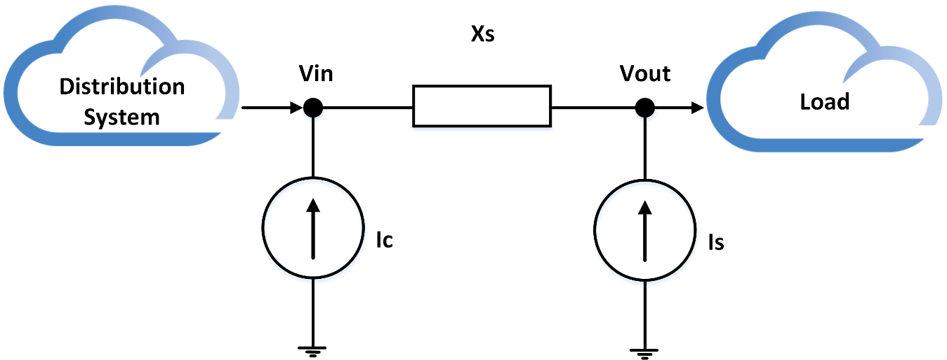

Figure 3. Equivalent circuit for the UPFC model

The equations that rules the control routines of the UPFC in steady state depends on the control mode selected. In these equations *Vin* and *Vout* correspond to the input and output voltages (as complex numbers) measured at the UPFC terminals. These equations are described as follows:

### *Control Mode 0 (Mode=0)*

In this control mode both controllers (voltage regulation and reactive power compensator) are turned off. As a consequence, the UPFC will be behave as a series impedance representing the series transformer impedance.

### *Control Mode 1 (Mode=1)*

In this control mode the voltage regulation controller regulates the voltage at the output of the UPFC device. In this mode, the controller used to perform the reactive power compensation will not perform any control action.

The voltage regulation is made considering a Thevenin series equivalent of a voltage source, where the parallel impedance is given by the impedance of the series transformer Xs. Then, the value of the current source *Is* will be given by:

Where *Vdiff1* is the calculated as follows:

And *Is[z-1]* is a shift register containing the value of the current source *Is* calculated in the previous iteration. Equations (3) and (4) are used to calculate the value of the current source until reach convergence, which is calculate considering the tolerance defined in the property Tol1. When the convergence is reached, the value of *Is* will be equal to *Is[z-1]*.

On the other hand, the value for the current source *Ic* is calculated by using the following expression:

In (5), *Losses* corresponds to the losses programmed in the XY curve (Y axis) when the input voltage acquires certain value respect to the RefkV property (pu).

### *Control Mode 2 (Mode=2)*

In this mode the controller designed for reactive power compensation will take the power factor to the desired set point (variable PF). However, the voltage regulation function will take no effect, which means that the current source *Is* will be off (Zero).

Then, to calculate the percentage of reactive power that must be compensated by this controller the power flowing through the UPFC must be calculated, which is performed using the following expression:

Using the power calculated in (6) the reactive power to compensate will be given as follows:

Then, using (7) and the input voltage it is possible to calculate the compensating current source *Ic* as follows:

### *Control Mode 3 (Mode=3)*

In control mode 3 there are two controllers interacting to take the system to the programmed set points in terms of voltage and power factor. In this mode, both controllers are combined and synchronized by using flags. The operation of both controllers is made sequentially: the voltage regulation controller operates and then, the reactive power compensator performs the compensation using the information previously provided by controller the voltage controller.

The value for the current source *Is* are calculated exactly in the same way that in control mode 1; however, in this mode an extra variable is added called the synchronism flag. This Boolean flag will be *false* until the controller converges into the programmed value in the property RefkV, then, the flag will be set as *True*.

The routine for calculating the value of the current source *Ic* is equal to the sum of the current sources calculated in the control modes 1 and 2 as follows:

Nevertheless, this calculation process takes place until the synchronism flag is true AND if the latest value of *Ic* is lower than the one currently calculated. Additionally, because of the effect when adjusting the output voltage of the UPFC the power in (6) must be calculated by removing this value. AS a consequence, the power in this control mode will be calculated as follows:

## *Behavior of the model*

The model typically converge in 5 iterations (tolerance 0.5%); however, this behavior can change depending on the tolerance programmed by the user when declaring the UPFC. Figures 4 and 5 shows the evolution of the voltage and PF until reach convergence (tol1=0.02).

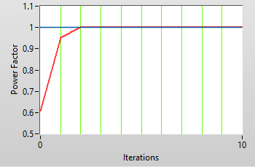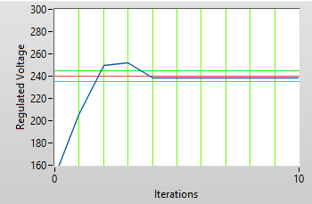

Figure 4. a) Voltage evolution until reach convergence (set point 240 V) b) Power factor evolution until reach convergence (Set point PF=1.0)

Figures 5 to 11 show the voltage and power factor values obtained as functions of the voltage incoming to the UPFC when simulating in OpenDSS. In these tests the property VpqMax=24.

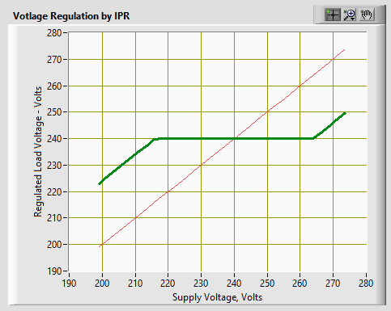

Figure 5. Voltage regulated as a function of the input voltage (set point 240 V)

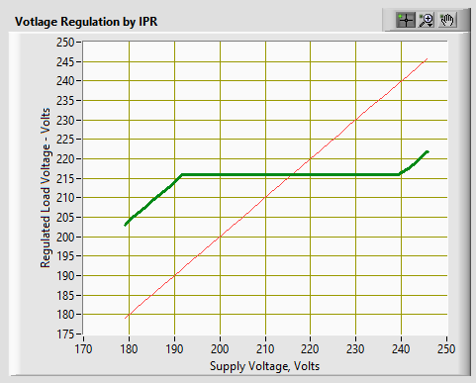

Figure 6. Voltage regulated as a function of the input voltage (set point 216 V)

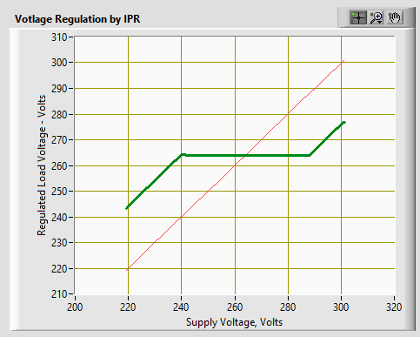

Figure 7. Voltage regulated as a function of the input voltage (set point 264 V)

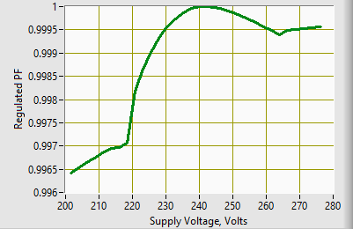

Figure 8. Compensated reactive power (set point PF=1)

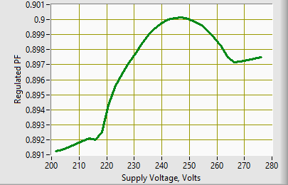

Figure 9. Compensated reactive power (set point PF=0.9)

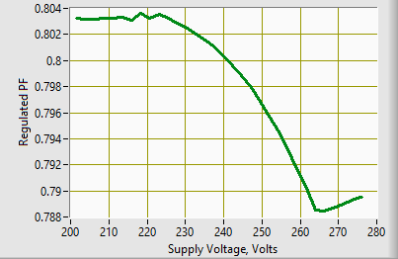

Figure 10. Compensated reactive power (set point PF=0.8)

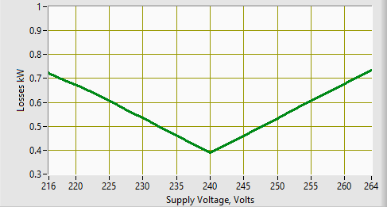

Figure 11. Losses obtained for a 50kW load