**Voltage Source Element (VSource and Circuit)**

Celso Rocha, Andres Ovalle

# 1 Purpose

To describe the modelling and main parameters of the Vsource and Circuit elements. Relevant concepts commonly covered in power systems basic courses are utilized such as symmetrical components and single-phase and three-phase short-circuit calculations. Sample code are presented at the end of this document.

**2 Why?**

The main purpose of a voltage source – also known as Slack Bus – in distribution system modeling is to represent any linear system seen from a bus in the electrical system, typically as a voltage source behind an impedance. Practically speaking, it can represent, for example, the bulk system as seen from a primary substation when modeling a primary substation with its supplied feeders. It can also represent both a primary substation system and the bulk system when modeling one or more feeders without detailed representation of the primary substation.

This concept can be better understood through Figure 1, which represents a fictitious system constituted by two subsystems, *S*1 e *S*2, connected to each other through node *A*. Suppose, for example, that it is of interest to study system *S*2 only. In this case, supposing that system *S*1 is linear, the voltage source element can be utilized to represent *S*1 system entirely, as depicted in Figure 2.

*S*

1

*S*

2

*A*

Figure 1: Fictitious Power System

˙

*E*

¯

*Z*

˙

*I*

*A*

*S*

2

Figure 2: Thevenin Equivalent of System *A*

Observation: Every circuit model in OpenDSS **must** contain at least one voltage source element.

Only the first of these elements (and only the first!) **must** be specified with type “Circuit” (e.g., *New Circuit.MyVoltageSource*) while other elements must be specified with type “Vsource”. The “Circuit” element is utilized for initialization of the circuit topology and other internal initializations within OpenDSS, and it can be seen as the “main” voltage source of the circuit model. Voltage source is utilized throughout this document to reference both the unique Circuit element that must be defined, but also the Vsource element. Both have the same representation. In fact, the circuit element is internally mapped to a Vsource element with name “Source”.

# 3 Modeling

Figure 3 shows the voltage source modeling in OpenDSS. Note that it is a two-terminal element (like lines and transformers), where the second terminal is connected to node 0, which is always grounded, of the same bus of the first terminal for all phases.

∆*V*˙*A*

Bus

1

2

3

0

˙

*E*

*A*

¯

*Z*

*AA*

˙

*I*

*A*

˙

*E*

*B*

¯

*Z*

*BB*

˙

*I*

*B*

˙

*E*

*C*

¯

*Z*

*CC*

˙

*I*

*C*

¯

*Z*

*AB*

¯

*Z*

*BC*

¯

*Z*

*CA*

˙

*V*

*A*

˙

*V*

*B*

˙

*V*

*C*

Terminal2

Terminal1

Figure 3: Electrical Model of the Voltage Source Element

By default, this element corresponds to a 3-phase symmetric voltage source, i.e., three sinusoidal single-phase voltage sources with the same magnitude and phase angles shifted by 120°. Furthermore, the self series impedance at each phase and the mutual series impedance between phases are equal, as shown in expressions (1) and (2), where *Z*¯*s* and *Z*¯*m* are defined as self and mutual impedance, respectively.

|  |  |
| --- | --- |
| *Z*¯*s* = *Z*¯*AA* = *Z*¯*BB* = *Z*¯*CC* | (1) |
| *Z*¯*m* = *Z*¯*AB* = *Z*¯*BC* = *Z*¯*CA* | (2) |

Observation: OpenDSS doesn’t support a perfectly ideal voltage source, but, for all practical effects, this can be accomplished by setting (1) the source impedances to a very low value or (2) or by setting its “model” property to “ideal”, which essentially assigns a tiny impedance to the source.

*Z*¯*s* and *Z*¯*m* impedances are not commonly utilized to specify voltage source impedances in power flow tools. One of three different ways are utilized instead: sequence impedances, short-circuit powers or short-circuit currents. In the next sections, it is demonstrated how to obtain those parameters and the relation between them.

## 3.1 Sequence Impedances Computation from Series and Mutual Impedances of a Voltage Source

The sequence impedances can be utilized as input parameters to *Vsource* element. The computation of sequence impedances from phase impedances is presented next.

Observing Figure 3, it is possible to write KVL equations for each phase to obtain Equation 3.

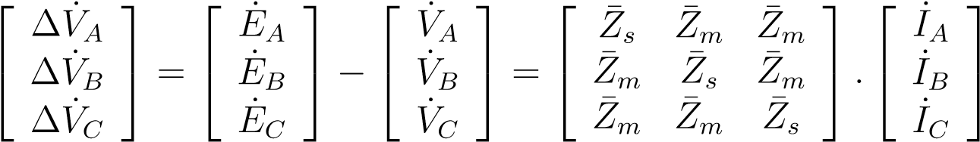 (3)

where the 3 × 3 phase impedance matrix is represented by *Z*¯.

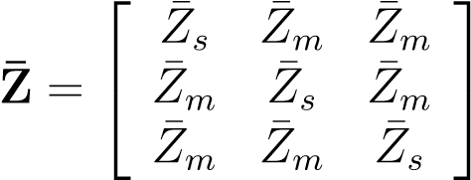 (4)

Equation 5 presents the mathematical relation between the series impedances in the phase domain and in the symmetrical components domain.

### Z¯012 = A−1 × Z¯ × A (5)

where,

**A** 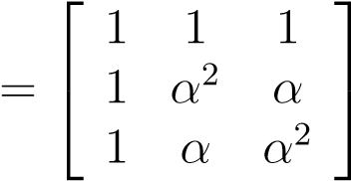 (6)

|  |  |
| --- | --- |
| and |  |
| *α* = 1 120°  Applying (4), (6) and (7) in (5), one can obtain: | (7) |

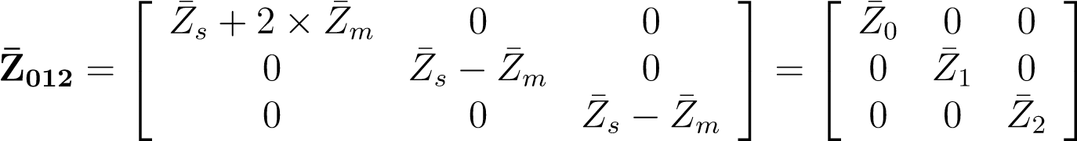 (8)

*Z*¯0, *Z*¯1 and *Z*¯2 are the zero, positive and negative sequence impedances, respectively. Note that, in this particular case, *Z*¯1 equals *Z*¯2.

These values can be directly utilized to specify the *Vsource* element, as shown in section 4.1.1.

## 3.2 3-Phase Short-Circuit Power and Current Calculation

In addition to sequence impedances, the pair 3-phase and 1-phase short-circuit powers, *S*¯*sc*3 and *S*¯*sc*1, or the pair 3-phase and 1-phase short-circuit currents, *I*˙*sc*3 and *I*˙*sc*1, can also be utilized to define the voltage source element.

In this section, *S*¯*sc*3 and *I*˙*sc*3 are calculated considering that the voltage source element is at a 3-phase short-circuit condition, as presented in Figure 4.

˙

*E*

*A*

¯

*Z*

*s*

˙

*I*

*A*

=

˙

*I*

*sc*

3

*A*

˙

*E*

*B*

¯

*Z*

*s*

˙

*I*

*B*

*B*

˙

*E*

*C*

¯

*Z*

*s*

˙

*I*

*C*

*C*

¯

*Z*

*m*

¯

*Z*

*m*

¯

*Z*

*m*

∆

˙

*V*

*A*

*SC*

Figure 4: *Vsource* Element at a 3-phase Short-Circuit Condition

The 3-phase short-circuit current and the line-to-line voltage between phases *A* and *B* are as follows.

|  |  |
| --- | --- |
| *I*˙  √ *sc*3 = *I*˙*A*  *E*˙*AB* = *E*˙*A* − *E*˙*B* = 3 × *E*˙*A*30°  Applying KVL on phase *A*, one can obtain Equation 11.  ∆*V*˙*A* = *E*˙*A* − 0 = *Z*¯*s* × *I*˙*A* + *Z*¯*m* × *I*˙*B* + *Z*¯*m* × *I*˙*C* | (9)  (10) |
| *E*˙*A* = *Z*¯*s* × *I*˙*A* + *Z*¯*m* × (*I*˙*B* + *I*˙*C*)  Applying KCL to node *SC*,  *I*˙*A* + *I*˙*B* + *I*˙*C* = 0 | (11) |
| *I*˙*B* + *I*˙*C* = −*I*˙*A* | (12) |

By applying (12) in (11) and also considering that *Z*¯1 = *Z*¯*s*−*Z*¯*m*, as presented in (8), one can obtain:

*E*˙*A* = (*Z*¯*s* − *Z*¯*m*) × *I*˙*A* = *Z*¯1 × *I*˙*A* (13)

From Equation 13, it is possible to obtain the magnitude of the 3-phase short-circuit current as function of the positive sequence impedance, as presented below:

*I*˙*A* = *I*˙*sc*3 = *E*˙*A* = *E*˙*AB* −30° (14)

¯

*Z*

1

√

3

×

¯

*Z*

1

|

˙

*I*

*A*

|

=

|

˙

*E*

*AB*

|

√

3

×|

¯

*Z*

1

|

(15)

Since the voltage source is symmetric, the 3-phase short-circuit power is defined as three times the power provide by each phase, as shown in Equation 16.

 (16)

From (14) and (16) it is possible to obtain the magnitude of the 3-phase short-circuit power as function of the positive sequence impedance, as shown in Equation 18.

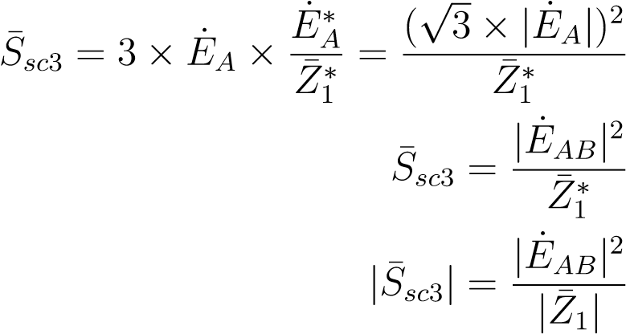(17)

(18)

## 3.3 Single-Phase Short-Circuit Power and Current Calculation

In this section, *S*¯*sc*1 and *I*˙*sc*1 are calculated considering that the *Vsource* element is at a single-phase short-circuit condition in phase *A*, as shown in Figure 5.

The single-phase short-circuit current can be defined with (19).

|  |  |
| --- | --- |
| *I*˙*sc*1 = *I*˙*A*  From Figure 5, applying KVL on phase *A*, one can obtain:  ∆*V*˙*A* = *E*˙*A* − 0 = *Z*¯*s* × *I*˙*A* + *Z*¯*m* × 0 + *Z*¯*m* × 0 | (19) |
| *E*˙*A* = *Z*¯*s* × *I*˙*A* | (20) |

˙

*E*

*A*

¯

*Z*

*s*

˙

*I*

*A*

=

˙

*I*

*sc*

1

*A*

˙

*E*

*B*

¯

*Z*

*s*

˙

*I*

*B*

=0

*B*

˙

*E*

*C*

¯

*Z*

*s*

˙

*I*

*C*

=0

*C*

¯

*Z*

*m*

¯

*Z*

*m*

¯

*Z*

*m*

∆

˙

*V*

*A*

Figure 5: *Vsource* Element at a Single-Phase Short-Circuit Condition

From Equation 20, it is possible to obtain the single-phase short-circuit current magnitude as function of the magnitude of the self-impedance, as shown in Equation 22.

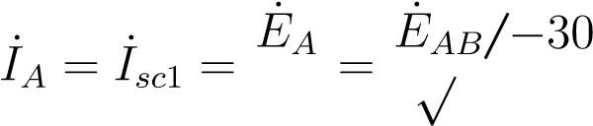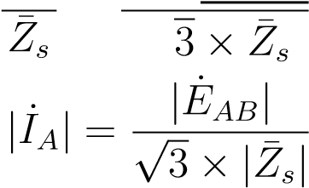°

(21)

(22)

The single-phase short-circuit power is defined as follows.

 (23)

Applying (21) into (23), the single-phase short-circuit power magnitude can be obtained as function of the magnitude of the self-impedance, as shown in Equation 25.

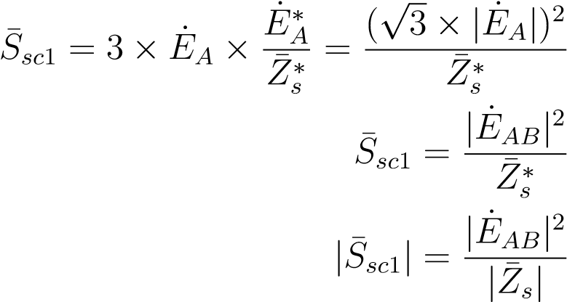(24)

(25)

To obtain *S*¯*sc*1 and *I*˙*sc*1 as function of *Z*¯0 e *Z*¯1, the relation between *Z*¯*s* and the pair *Z*¯0 and *Z*¯1 suffice, as shown in Equation 26, derived from the relations found in (8).

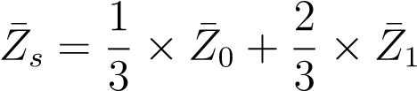 (26)

## 3.4 Relations between Obtained Parameters

In this section, the relation between the pairs of parameters that can be utilized to define the *Vsource* element are presented. As previously mentioned, the pairs are: *S*¯*sc*1 and *S*¯*sc*3; *I*˙*sc*1 and *I*˙*sc*3; *Z*¯0 and *Z*¯1. Note that it is not possible to utilize the pair *Z*¯*s* and *Z*¯*m* to define this element.

Equation 27 presents the relation between *S*¯*sc*1, *I*˙*sc*1 and *Z*¯*s*, where *E*˙*AB* corresponds to the line-to-line nominal voltage of the element and *Z*¯*s* relates to *Z*¯0 and *Z*¯1 through Equation 26.

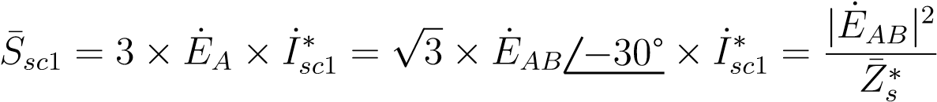 (27)

Equation 28 presents the relation between *S*¯*sc*3, *I*˙*sc*3 and *Z*¯1.

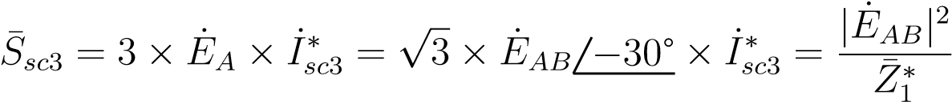 (28)

# 4 Examples

In this section, the different parameters are utilized to define the main voltage source element in OpenDSS, as presented in Figure 6, where the connections to nodes 4 and 0 of bus A may vary in each example. The codes snippets shown here are also available in your local OpenDSS installation folder in the folder “Examples\VsourceTechNote”.

Source Model

*A*

1

2

3

4

0

Figure 6: *Vsource* Element Connection

## 4.1 Example 1

Assume that the *Vsource* element presents the following parameters:

* Name: *TheveninEquivalent*
* Nominal Voltage: |*E*˙*AB*| = 13*.*8 *kV*
* Operating Voltage: |*e*˙*A*| = 1*.*1 *pu*
* Connection Bus: *A*
* Connection Configuration: *Y g*
* Zero Sequence Impedance: *Z*¯0 = 0*.*025862916 + *j* × 0*.*077588748 Ω
* Positive Sequence Impedance: *Z*¯1 = 0*.*023094242 + *j* × 0*.*092376969 Ω

**4.1.1 Definition from Impedances** The code snippet below presents the circuit element definition with such parameters:

|  |
| --- |
| Clear  New Circuit.TheveninEquivalent bus1=A pu=1.1 basekv=13.8  ~ Z0=[0.025862916, 0.077588748] Z1=[0.023094242, 0.092376969]  Set voltagebases=[13.8] Calcvoltagebases  Solve |

### 4.1.2 Definition from Short-Circuit Powers

It is assumed that only the short-circuit powers are known. To assume the same voltage source as in example 4.1.1, the short-circuit powers are first calculated from equations (17), (24) and (26) considering the same source characteristics as in the previous example.

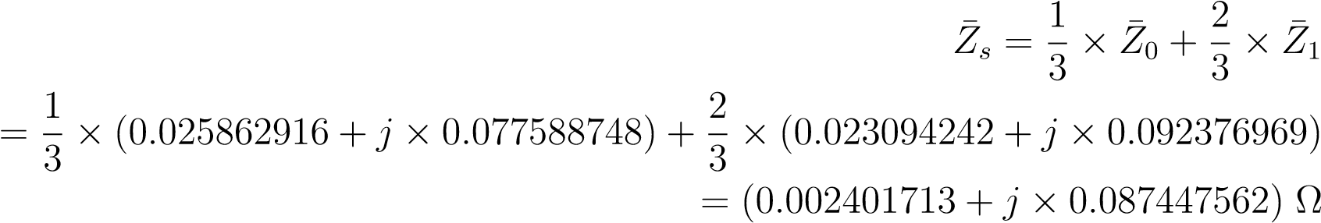

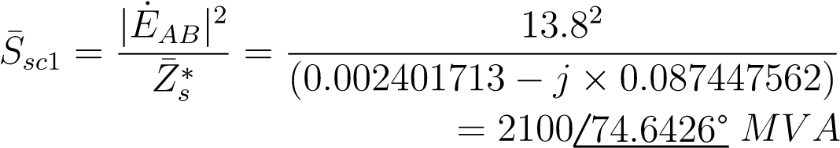

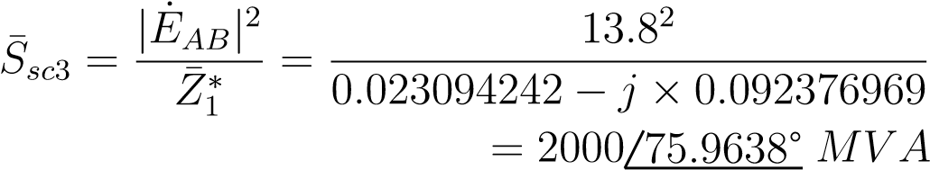

It is important to note that OpenDSS only takes the magnitude of the short-circuit powers as input parameters. The angles must be entered indirectly through the *x*1*r*1 parameter, which represents the  ratio, where *R*1 and *X*1 are the positive sequence resistance and reactance, respectively.

With that, the positive sequence impedance and the three-phase short-circuit power can be written as follows.

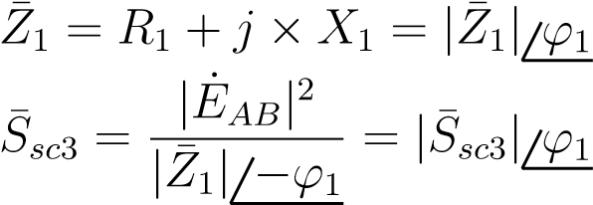

Thus, the three-phase short-circuit power angle can be specified through *x*1*r*1 following Equation 29.

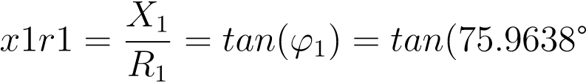) = 4 (29)

To enter the single-phase short-circuit power angle, *x*0*r*0 property is utilized, which represents ratio, where *R*0 and *X*0 are the zero sequence resistance and reactance, respectively.

*Z*¯0 can be calculated from the short-circuit powers. First, *Z*¯1 is calculated through Equation 30.

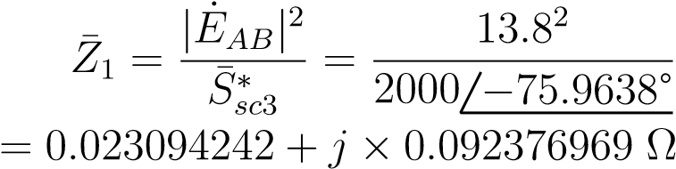 (30)

Second, *Z*¯*s* is calculated with Equation 31.

(31)

*S*¯*sc*1 2100 −74*.*6426°

¯

*Z*

*s*

=

|

˙

*E*

*AB*

|

2

∗

=

13

*.*

8

2

= 0*.*002401713 + *j* × 0*.*087447562 Ω

With *Z*¯1 and *Z*¯*s*, *Z*¯0 can be calculate through Equation 32, which is the result of the manipulation of Equation 26.

*Z*¯0 = 3 × *Z*¯*s* − 2 × *Z*¯1 (32)

= 0*.*025862916 + *j* × 0*.*077588748 Ω

Finally, the relation is calculated following Equation 33.

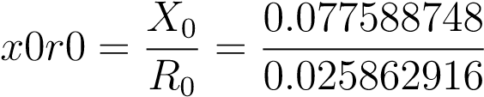= 3 (33)

The magnitude of the short-circuit powers and the ratios  and are utilized to define the circuit element as follows:

|  |
| --- |
| Clear  New Circuit.TheveninEquivalent bus1=A pu=1.1 basekv=13.8  ~ MVAsc3=2000 x1r1=4 MVAsc1=2100 x0r0=3  Set voltagebases=[13.8] Calcvoltagebases  Solve |

### 4.1.3 Definition from the Short-Circuit Currents

To define the same element but the short-circuit current parameters, those can be obtained from (27) and (28).

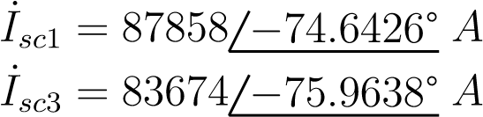(34)

(35)

As in the short-circuit powers case, the short-circuit currents magnitude and  and  ratios are utilized. With the short-circuit currents data *I*˙*sc*1 and *I*˙*sc*1, the short-circuit powers are calculated with (27) and (28) and, therefore, the method for obtaining  and  presented in example 4.1.2 can be utilized. The source definition with the short-circuit currents data is presented below:

|  |
| --- |
| Clear  New Circuit.TheveninEquivalent bus1=A pu=1.1 basekv=13.8  ~ Isc3=83674 x1r1=4 Isc1=87858 x0r0=3  Set voltagebases=[13.8] Calcvoltagebases  Solve |

## 4.2 Example 2

This example shows how to define a voltage source with different connections.

### 4.2.1 Delta-Connected

A voltage source can be specified as delta-connected by setting the terminal connections with the full node order bus specification, and appropriately assigning the adjacent nodes for each phase. In the example below, the bus order specification A internal.1.2.3 for the 1st terminal and A internal.2.3.1 for the 2nd terminal indicates that the first phase of the three-phase voltage source is connected to nodes 1 and 2 of bus A, whereas the second phase is connected between nodes 2 and 3, and so on.

Since the impedances are connected in series with the ideal voltage source in each phase, the impedances in the *VSource* element must be set to a very low value, while the actual impedances of the source must be modeled with a separate element, for example, a reactor, as shown in Figure 7. Note that an auxiliary bus was added between the√ *VSource* and the reactor. Also note that the

*basekv* parameter must be multiplied by√ 3 because a wye connection is assumed by default, i.e.,

*basekv* is divided by 3 internally to determine the rated voltage in each phase.

*A internal A*

1

2

3

0

˙

*E*

*AB*

˙

*E*

*BC*

˙

*E*

*CA*

¯

*Z*

*m*

¯

*Z*

*m*

¯

*Z*

*m*

1

2

3

0

¯

*Z*

*s*

¯

*Z*

*s*

¯

*Z*

*s*

Figure 7: 3-Phase Delta-Connected *Vsource* Element

|  |
| --- |
| Clear  New Circuit.TheveninEquivalent bus1=A_internal.1.2.3 bus2=A_internal.2.3.1 pu=1.1  ~ basekv=(13.8 3 sqrt *) Z0=[0.000001, 0.000001] Z1=[0.000001, 0.000001]  New Reactor.SourceImpedance bus1=A_internal.1.2.3 bus2=A.1.2.3  ~ Z0=[0.025862916, 0.077588748] Z1=[0.023094242, 0.092376969]  Set voltagebases=[13.8] Calcvoltagebases  Solve |

### 4.2.2 Wye-Connected, with a grounding impedance

A voltage source with a grounding impedance might be useful when considering a Wye-connected transformer’s winding as the voltage source of the model where the winding is grounded with an impedance. In this case, all is needed is to connect all phases of the 2nd terminal to a separate node, which is also connected to the element modeling the grounding impedance, as shown in Figure 8. In the example below, a reactor is utilized for that purpose.

*Z*¯*s A*1

2

3

4

0

˙

*E*

*A*

˙

*E*

*B*

˙

*E*

*C*

*R*

*g*

¯

*Z*

*m*

¯

*Z*

*m*

¯

*Z*

*m*

¯

*Z*

*s*

¯

*Z*

*s*

Figure 8: 3-Phase Wye-Connected *Vsource* Element Grounded through Impedance

|  |
| --- |
| Clear  New Circuit.TheveninEquivalent bus1=A bus2=A.4.4.4 pu=1.1 basekv=13.8  ~ Z0=[0.025862916, 0.077588748] Z1=[0.023094242, 0.092376969]  New Reactor.Rg bus1=A.4 bus2=A.0 phases=1 ~ R= 10 ! 10 Ohms grounding resistance  Set voltagebases=[13.8] Calcvoltagebases  Solve |

## 4.3 Example 3 - Unbalanced Voltage Source

In order to model an unbalanced voltage source, three independent single-phase voltage sources are required. Those must be connected appropriately to represent the desired connection configuration. Since the voltage sources are independent, the source impedance must be modeled with a separate element to preserve the mutual coupling between phases. In the example below, a reactor is used for that purpose. Note that, in this case, if the desired configuration is Wye, the *basekV* parameter must be specified as a line-to-neutral voltage.

*A*

*internal*

1

2

3

0

*A*

1

2

3

0

ThA

˙

*E*

*A*

ThB

˙

*E*

*B*

ThC

˙

*E*

*C*

¯

*Z*

*m*

¯

*Z*

*m*

¯

*Z*

*m*

¯

*Z*

*s*

¯

*Z*

*s*

¯

*Z*

*s*

Figure 9: 3-Phase Wye Grounded-Connected Unbalanced *Vsource* Element

|  |
| --- |
| Clear  New Circuit.ThA bus1=A_internal.1 phases=1 pu=1.1 basekv=7.97 ~ Z0=[1e-6, 1e-6] Z1=[1e-6, 1e-6]  New Vsource.ThB bus1=A_internal.2 phases=1 pu=1.1 basekv=7.97 ~ Z0=[1e-6, 1e-6] Z1=[1e-6, 1e-6]  New Vsource.ThC bus1=A_internal.3 phases=1 pu=1.1 basekv=7.97  ~ Z0=[1e-6, 1e-6] Z1=[1e-6, 1e-6]  New Reactor.SourceImpedance bus1=A_internal.1.2.3 bus2=A.1.2.3  ~ Z0=[0.025862916, 0.077588748] Z1=[0.023094242, 0.092376969]  Set voltagebases=[13.8] Calcvoltagebases  Solve |

# 5 References

1. W. Stevenson, *Elements of power system analysis*, ser. McGraw-Hill series in electrical engineering: Power and energy. McGraw-Hill, 1982.
2. P. Radatz and C. Rocha, “Elemento circuit (vsource) do opendss,” Grupo de Usua´rios do OpenDSS - Brasil, Nota T´ecnica, Agosto 2018.