# Harmonics Modeling in OpenDSS

OpenDSS is generally considered a power flow analysis tool for distribution system capacity planning because that is the most common problem addressed by OpenDSS users. However, its circuit modeling techniques actually are from distribution system harmonics analysis tools. Thus, harmonics analysis is a natural part of the program. This document will describe how to use the OpenDSS harmonics analysis capabilities.

While OpenDSS is mostly utilized for power flow, Quasi-Statice Time Series (QSTS) simulations, and dynamic analysis these days, its circuit modeling methods evolved from a series of power system harmonics analysis programs that were originally developed in the late 1970’s. These harmonic solvers use very detailed multiphase, multi-voltage circuit models because many of the more significant harmonics problems first appeared in medium- and low-voltage industrial and utility systems. It is necessary to model these systems in precise detail to accurately represent the system response to harmonic sources on the power system. In 1997 this capability was exploited to create the Distribution System Simulator (DSS) with extraordinary circuit modeling capabilities for power flow analysis of the typical unbalanced North American distribution system with distributed generation.

C:\Users\prdu001\OpenDSS\Training\Oncor2014\Network Model.wmf

Figure 1‑1. Overall Circuit Model in OpenDSS

Figure 1‑1 shows the basic circuit model concept that OpenDSS uses for both harmonics analysis and power flow analysis of distribution systems. In fact, it uses this circuit model for all of the solution modes currently implemented in OpenDSS, including Dynamics mode. A nodal admittance matrix, YSYSTEM, is constructed to represent all the linear elements in the circuit. In OpenDSS, these are called the *power delivery* elements of the circuit. The nonlinear elements are modeled as current sources outside the part of the circuit covered by YSYSTEM. For power flow analysis, *power conversion* elements (PC Elements) such as Load and Generator usually have a nonlinear characteristic with respect to voltage and are represented as a combination of current sources and shunt linear impedances (a Norton equivalent). For harmonics analysis, the nonlinear circuit elements are the sources of the distortion and are likewise represented by current sources of multiple frequencies, i.e., harmonic current sources.

In OpenDSS, you will find current-carrying circuit elements segregated into two classes: Power Delivery (PD) elements and Power Conversion (PC) elements. PD elements are completely defined by their linear “primitive” Y matrix. That is, a nodal admittance matrix written for that element alone. PC elements may be represented by various formulations where the current injected into the network is computed as a function of the voltage. There may be linear and non-linear components to PC elements.

Harmonic analysis of distribution systems is often very labor intensive. We wanted the DSS to be a tool that could seamlessly incorporate harmonics analysis into the power flow analysis without requiring the distribution system modelers to laboriously enter nonlinear device models.

We also recognized that we would need at least a simple dynamics analysis for DG interconnection evaluation. Simple dynamics models are presently built into the program and this feature continues to be developed.

## Introduction to Power System Harmonics Analysis

A good assumption for most utilities in the United States is that the sine-wave voltage generated in central power stations is very good. In most areas, the voltage found on transmission systems typically has much less than 1.0 percent distortion. However, the distortion increases closer to the load. At some loads, the current waveform barely resembles a sine wave.

While there are a few cases where the distortion is random, most distortion is *periodic*, and results in a harmonic profile that is an integer multiple of the power system fundamental frequency. That is, the current waveform is nearly the same cycle after cycle, changing very slowly, if at all. Such periodic waveforms can be decomposed into a sum of sinusoids of harmonic frequencies. This is a technique involving the Fourier Transform that is commonly taught to electrical engineering students early in their classwork. Thus, it is very familiar to most electrical power engineers. This has given rise to the widespread use of the term harmonics to describe periodic distortion of the waveform in the power system.

To some, harmonic distortion is still the most significant power quality problem. It is not hard to understand how a distribution engineer faced with a difficult harmonics problem can come to hold that opinion. Harmonics problems run counter to many of the conventional rules of distribution system design and operation that consider only the fundamental frequency. Therefore, the distribution planner is faced with unfamiliar phenomena that require unfamiliar tools to analyze and unfamiliar equipment to solve.

Although harmonic problems are of great concern, they are not statistically very numerous on utility distribution systems. Only a few percent of utility distribution feeders in the United States have a sufficiently severe harmonics problem to require intervention. In contrast, voltage sags and interruptions are nearly universal to every feeder and represent the most numerous and significant power quality deviations.

The utilization sector downline from the load service transformer typically suffers more from harmonic problems than does the utility power delivery sector. Industrial users with adjustable-speed, or variable-frequency, drives (ASDs or VFDs), arc furnaces, induction furnaces, and the like are much more susceptible to problems stemming from harmonic distortion. This is particularly true if there are power factor correction capacitors in the circuit. This can yield severe harmonic resonance.

Harmonic distortion is not a new phenomenon on power systems. Concern over distortion has waxed and waned over the history of ac electric power systems. A problem would arise – usually with the introduction of new technology – and then a solution would be implemented by the industry and the concern would wane until the next technology is introduced. In the 1930s and 1940s, there were many technical papers on power system harmonics. At that time the primary source of harmonic distortion was the excitation characteristic of distribution transformers and a key problem was inductive interference with open-wire telephone lines. The forerunners of modern arc lighting were also being introduced and were causing quite a stir because of their relatively large harmonic content—not unlike the stir caused by electronic power converters in the 1980’s.

Fortunately, if the system is properly sized to handle the power demands of the load, there is a low probability that harmonic currents will cause a problem with the power distribution system. They may still cause problems with low power circuits such as telecommunications and computer systems in the vicinity of the power system.

Harmonic *problems* in the electric power system arise most frequently when the *capacitance* in the system results in *resonance* at a critical harmonic frequency. This dramatically increases the distortion above normal amounts.

While these resonances occur to some degree on utility power distribution systems, the more severe cases are usually found in industrial power systems because of the higher degree of resonance experienced. There is proportionately less resistance at the point of connection to power factor correction capacitors and the “Q” of the resonant circuit is much greater than is typically found on the utility distribution system. The relatively low Q of the MV distribution system tends to keep the more serious effects suppressed.

The standard that governs harmonic distortion on the power system is IEEE Std 519-2014 - *IEEE Recommended Practice and Requirements for Harmonic Control in Electric Power Systems.* The standard breaks the problem into two parts:

* Limiting the amount of harmonic current that a load may inject into the power system.
* Limiting the voltage distortion on the power system.

Distribution planners usually do not have much control over the harmonic currents a consumer may inject into the distribution system other than including references to IEEE Std 519-2014 limits in the interconnection agreement. It is always a good idea for planners to investigate the types of loads that commercial and industrial customers are proposing to connect to the system even if it is not explicitly the planner’s responsibility.

Distribution planners have more control over the harmonic voltage distortion that results from the harmonic currents that originates in consumer loads. Part of that control comes from designing the system with enough capacity to absorb the harmonic currents without harm. However, in North America most utilities apply capacitor banks on distribution systems to reduce losses and increase power delivery capacity. The introduction of capacitance into a mostly inductive circuit will always result in a resonance at some frequency. The challenge to the distribution planner is to keep the system out of resonance at a harmonic frequency present in the load currents. Usually, the *odd harmonics* are the more prevalent with resonance problems.

This document deals with the essential harmonic analysis a distribution planner should perform to complement the power flow analysis for capacity planning studies.

## Power System Harmonics Fundamentals

The ideal ac power system service voltage is a perfect sine wave – of one frequency – that has constant magnitude and frequency. The sine-wave voltage measured at central power station generators for most utilities in the United States is very nearly ideal. As the power flows from the generator to the load the voltage gets distorted due to serving loads that produce harmonic currents. The voltage found on transmission systems is often less than 1% distorted. Some areas have higher distortion, but it seldom exceeds 2% on the transmission grid. The distortion increases as the current flows through the distribution system and low-voltage system on its way to the load. At some load points, the current waveform barely resembles a sine wave.

Harmonic distortion is caused by *nonlinear* devices in the power system. A nonlinear device is one in which the current magnitude and shape is not proportional to the magnitude and shape of the applied voltage. This is the source of the most significant harmonic distortion in power system voltages and currents.

The theory of how a distorted waveform is decomposed into harmonics of the fundamentals is well-documented and is basic electrical engineering science. The reader is referred to standard textbooks on power system harmonics. Here, we will assume the existence of harmonics and focus on how a distribution planner must deal with them

As Figure 1‑2 shows, voltage distortion is the result of distorted load currents passing through the linear, series impedance of the power delivery system. Assuming that the source bus is a pure sinusoid, there is a nonlinear load that draws a distorted current. The harmonic currents passing through the impedance of the system cause a voltage drop for each harmonic. This results in a harmonically-distorted voltage appearing at the load bus. The amount of voltage distortion depends on the impedances and the currents. Assuming the load bus voltage distortion stays within reasonable limits (e.g., less than 5 percent), the amount of harmonic current produced by the load is nearly constant.

While the load current harmonics ultimately cause the voltage distortion, it should be noted that load has virtually no control over the voltage distortion. That is a function of impedance of the power delivery system.



Figure 1‑2. Voltage Distortion is Due to Distorted Current Passing Through the System Impedance

Note: Most of the harmonic currents flow in the opposite direction of the fundamental frequency load current – from the load back to the utility source. (Direction is relative to the voltage at the point of measurement.) Therefore, the distorting loads are often considered a source of harmonic currents. Tracing the active power flow at harmonic frequencies will often lead to the primary source of the harmonic distortion.

A major function of OpenDSS in harmonic analysis is representing the network of lines, capacitors, transformers, and reactors at each harmonic frequency. This is represented in the system nodal admittance matrix that models the linear part of the system.

## Sources of Current Distortion

The key elements in harmonics analysis on power systems are

1. The sources of harmonic currents (nonlinear power conversion elements),
2. The response of the power system to those currents.

Nonlinear elements on electric power systems that are well-known for producing distorted currents include:

* Arcing devices such as arc furnaces, welders, and arc lighting.
* Electronic power converters such as rectifiers, adjustable-speed motor drives, inverters, and induction furnaces.
* Ferromagnetic devices such transformers.

Ferromagnetic devices were quite important harmonic current producers early in the history of US power systems. Single-phase transformers produced a significant amount of 3rd and 9th harmonic currents that were notorious for producing telephone interference when the predominant type of telephone line was an open-wire construction. Today, telephone interference is much less of a problem and other sources of harmonic currents swamp out the transformer contribution. Transformers produce harmonic currents at a level of approximately 1% of the rated current of the transformer. This is still significant because there are so many transformers. A typical 10-MVA distribution feeder in the US may have over 20 MVA of distribution service transformers connected, which is roughly the equivalent of 200 kVA of distorting power.

Historically, the next class of harmonic-producing load to cause problems on the power system was arc lighting. In particular, the application of sodium-vapor arc lighting for street lighting and other area lighting application resulted in a flurry of papers in the AIEE Transactions on harmonics in power distribution systems. Fluorescent lighting has similar harmonic content in the current as do arc furnaces. Of course, arc furnaces are very large loads with quite volatile current characteristics and continue to be difficult to handle even today. Arcing loads produce harmonic current magnitudes on the order of 20-30% or rated current – considerably more than what transformers produce.

Power distribution engineers learned to cope with harmonics from ferromagnetic and arcing devices. Then came electronic power converters with the potential for nearly an order of magnitude higher magnitudes of harmonic currents.

Electronic power converters can chop the current into seemingly arbitrary waveforms. Figure 1‑3 shows the typical “rabbit ear” current waveform from a 3-phase variable-frequency drive, which will have a schematic circuit diagram similar to Figure 1‑4. The “ears” come from the current pulses generated from charging the dc bus capacitor. The magnitude and duration of the pulses will depend on the equivalent source impedance. When the impedance is low, distortion can exceed 100%. One of the difficult issues with serving this type of load is that the *displacement power factor* – the fundamental frequency power factor – is near unity while the *true power factor* including all harmonics is very low. This requires the supply system to be overbuilt with larger conductors and transformers to support this kind of load. Power factor correction capacitors will often not help because they act on the fundamental frequency power factor, which is already near unity. In fact, if the application of capacitors results in harmonic resonance, capacitors will exacerbate the problem.

When such power converters were first installed in large numbers in the late 1970s, utility engineers became quite concerned about the ability of the power system to accommodate the harmonic distortion. Many dire predictions were made about the fate of power systems if these devices were permitted to exist. These concerns have proven to be somewhat overstated and the power delivery system has proven remarkably robust in the presence of this distortion. A statement that is frequently made about this observation is:

*Without resonance, if the power system is built with sufficient kVA capacity to supply the load kVA demand, the harmonic voltage distortion will generally be in the acceptable range.*

This is part of the basis for the harmonic limits stated in IEEE Std. 519-2014. The current limits were established assuming normal power delivery system capacity. Exceptions to this statement are where the system capacity for serving the load is marginal. Then one can get excessively distorted voltages even without resonance.

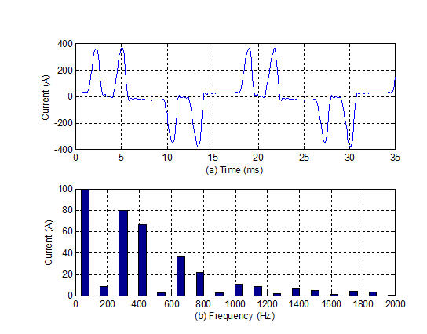

Figure 1‑3. Current waveform from a variable-frequency drive and its corresponding harmonic spectrum.

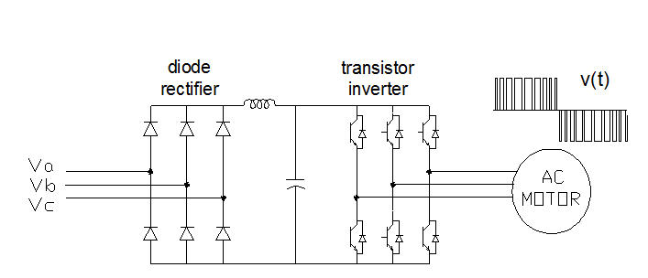

Figure 1‑4. Schematic of a 3-phase pulse-width modulated variable-frequency drive. .

To perform network analysis at harmonic frequencies, most power system harmonic analysis computer software tools take the approach illustrated in Figure 1‑5. The linear impedances of the system are adjusted for frequency and the nonlinear, harmonic-producing loads are nominally replaced by harmonic current sources. Then a separate solution is performed for each frequency of interest. The magnitude and phase angles of the harmonic current source is determined from a fundamental frequency power flow solution. A measured, or assumed, harmonic spectrum is used to determine the magnitude of the current source at harmonic frequencies. Some tools assume that the current source is constant while others iterate and adjust the current for the voltage distortion. Either approach is generally acceptable for planning purposes.



Figure 1‑5. Replace the harmonic-producing device with a current source in the model.

The concept of replacing the nonlinear loads with a current source will work in most cases for computing the harmonic flows in a power distribution system, but not all. The exceptions involve resonance.

Capabilities of an adequate harmonic analysis tool for distribution planning include:

* Solving at frequencies other than fundamental power frequency.
* Performing a solution at individual harmonics or interharmonics with multiple harmonic sources simultaneously to estimate total harmonic distortion.
* Performing a frequency-response scan at a small frequency interval (e.g., 5 Hz) to identify resonances.
* Producing graphs and tables of multi-frequency analyses.
* Automatically adjusting the impedances of lines, transformers, capacitors, etc. for frequency.
* Adjusting phase angles of current sources by the base power flow and by frequency.
* Modeling all transformer connections because different connections have different responses to each harmonic.
* Modeling multi-phase coupled lines. This is important where there are multiple circuits sharing the same right-of-way and the same neutral conductor. Triplen harmonic currents tend to flow in the neutrals and can couple different circuits.
* Modeling frequency-dependence of line and transformer impedances.
* Has models for filters.
* Modeling large networks of at least several hundred nodes
* Allows both current-source and voltage-source models of harmonic sources.

## Modeling Nonlinear Loads When Resonance is Present

As suggested in Figure 1 it is common for harmonic analysis of power systems in the frequency domain to replace nonlinear harmonic-producing elements with a current source at each harmonic of interest. This is possible because for most distorting elements the harmonic currents are relatively constant so long as the power system voltage remains in narrow limits with less than 10% variation. This is the default model in most power system harmonic analysis tools. However, when the system is near resonance, a simple ideal current source model can give an excessively high prediction of voltage distortion.

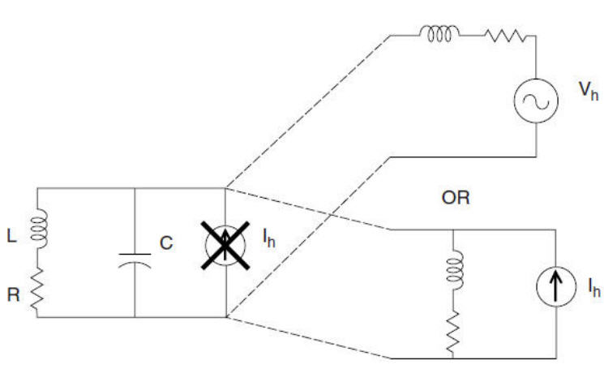

Figure 1‑6. Replacing Simple Current Source Models with Thevenin or Norton Equivalents to Get Better Answers for Simulations at Resonant Frequencies.

As depicted in Figure 1‑6, a simple current source would try to inject a constant current into a parallel resonant circuit that has a high impedance at its resonant frequency, which is not a valid representation of reality. Our experience has shown that once the voltage distortion exceeds approximately 15%, the nonlinear load changes and no longer injects the same current.

Sometimes the simple current source is adequate for planning purposes if the planner does not try to justify the predicted voltages. The knowledge that the system is in resonance is often sufficient to justify seeking a remedy. Once the resonance is eliminated by changing a capacitor size or adding a filter, the simple current-source model will give a reasonable answer.

For the cases where a more accurate estimate of distortion is required during resonant conditions, a more sophisticated model must be used. For many power system devices, a Thevenin or Norton equivalent as shown in Figure 1‑6 will be needed. The additional impedance moderates the response of the parallel resonant circuit. By default the OpenDSS program assumes the Norton equivalent model with a shunt admittance derived from the characteristics of the nonlinear circuit element.

## Norton Equivalent Load Model for Harmonic Analysis

A simple load model commonly used in harmonics analysis is a Norton equivalent as shown in Figure 1‑7. The current source in the model is set to the value of the fundamental current, *Ifund*, determined from a power flow solution and the multiplier for the harmonic spectrum assumed for the load at each frequency. The load equivalent admittance, *G + jB*, may also be represented in the model as shown with only the susceptance, *B,* adjusted for frequency.

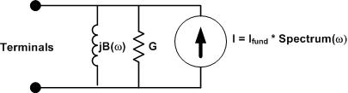

Figure 1‑7. Simple Norton Equivalent Model of a Load for Harmonics Analysis

This model of a load may be derived directly from the typical power flow load model specified by active and reactive load values, P and Q. *G* and *B* would be determined from P and Q typically at rated voltage.

Where,

*V* = 100% rated voltage magnitude in volts

*P* = Load active power in watts

*Q* = Load reactive power in vars

Admittances for models in harmonics analysis on distribution systems are typically used directly in units of actual siemens. Per-unit values are not commonly used in unbalanced multiphase harmonics analysis due to increased possibilities for errors.

One side effect of this approach to load modeling is that loads that are highly resistive may provide significant damping of harmonic resonance if they are large enough. Whether or not this is desirable depends on the motivation of the analysis. This will produce lower estimates of the voltages and currents resulting from the resonance.

For frequencies where the system is not in resonance, most of the current produced by the current source in the model flows back into the power system. The short circuit impedance of the typical power system looking into it from a load is usually less than 5% of the load’s equivalent impedance. Therefore, very little current is siphoned off into the shunt admittance branch of the Norton model.

At frequencies where the system is near resonance, the driving-point impedance looking into the system can be very high. A significant portion of the harmonic current is bled off into the shunt admittance branch of the model. This keeps the predicted voltage distortion more reasonable than an ideal current source, but it may also provide excessive damping. Engineering judgement based on experience with actual measurements of harmonics is helpful.

### A More Detailed Load Model

The present load model in the OpenDSS program was modified in 2015 per user requests to have more control over the amount of damping caused by the load model at resonant frequencies. Figure 1‑8 shows the revised model schematic diagram.

A series R-X branch was added to the existing parallel G-B branch. The program’s user can specify the percentage split between the two branches. The default split is to assume half the load is represented by each branch. The impedance of the series branch behaves differently than the parallel branch. It becomes more inductive and provides less damping to resonance as frequency increases. It also tends to shift the resonant frequency slightly higher. The inductive part of the parallel G-B branch becomes a high impedance at the higher frequencies, resulting in the branch appearing more resistive.

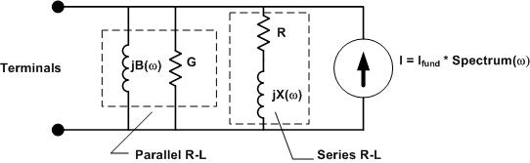

Figure 1‑8. Load model with both series and parallel branches

Many analysts prefer to represent motor load as a series branch for harmonic analysis and the OpenDSS program provides a special model for motor load as do other harmonic analysis tools. Instead of determining R and X from the load P and Q, it is estimated from the equivalent blocked rotor impedance. This results in a lower impedance at lower harmonics that rises with frequency to be mostly inductive at the higher harmonics.

## Set Mode=Harmonics or Solve Mode=Harmonics

This command sets the solution mode to Harmonics and initializes any required variables. It must be preceded by a converged power flow solution so that the various harmonics sources can be initialized to the actual phase angles throughout the circuit. Instead of an iterative power flow solution, a direct-mode, or linear, solution is also acceptable to initialize the phase angles. This is sometimes necessary for circuits where the model fails to converge for the normal power flow solution. The direct-mode solution with always give a reasonable answer allowing the harmonics analysis to proceed.

The current sources for the PC elements are set to the present solution magnitude and the phase angle adjusted for each harmonic represented in the Spectrum object associated with the Load, Generator, or other PCElement-class model.

The basic usage is intended to be:

1. **Solve ! power flow**
2. **Solve Mode=Harmonics ! Yields a reasonable harmonics solution**

Thus, the user could do an analysis of adding a capacitor bank and very quickly get an estimate of how that will affect the harmonic resonances of the system.

Loads are converted to harmonic current sources (Norton equivalents) and are initialized based on the power flow solution according to the Spectrum object associated with each Load. Generator objects are converted to a voltage source behind *subtransient* reactance with the voltage spectrum specified for each generator. Harmonics from synchronous generators are due to slot harmonics and imperfect windings. These are better represented by voltage sources than current sources (Note: internally, OpenDSS converts these Thevenin equivalent models to Norton equivalents before the solution takes place.)

Each kind of PC element can have its own special algorithm for initializing harmonics mode.

Once initialized, a Direct-mode solution is performed for each harmonic frequency (more precisely, non-power frequency – it doesn’t have to be a harmonic frequency). The system Y matrix is built for each frequency and solved with the defined injections from all harmonic sources. A solution is performed for each frequency found to be defined in every Spectrum object active in the circuit. This solution gives an estimate of the expected harmonic distortion for the present loading condition.

## Spectrum Objects

Each PC element has a link to a harmonic spectrum object that is used for harmonics analysis. The elements of a Spectrum object are:

|  |  |
| --- | --- |
| **Property** | **Description** |
| NumHarm | Number of frequencies in this spectrum. (See CSVFile) |
| %mag | Array of magnitude values, assumed to be in PERCENT. You can also use the syntax  %mag = (file=filename) !for text file one value per line %mag = (dblfile=filename) !for packed file of doubles %mag = (sngfile=filename) !for packed file of singles |
| angle | Array of phase angle values, degrees.You can also use the syntax  angle = (file=filename) !for text file one value per line angle = (dblfile=filename) !for packed file of doubles angle = (sngfile=filename) !for packed file of singles |
| harmonic | Array of harmonic values. You can also use the syntax  harmonic = (file=filename) !for text file one value per line harmonic = (dblfile=filename) !for packed file of doubles harmonic = (sngfile=filename) !for packed file of singles |
| CSVFile | File of spectrum points with (harmonic, magnitude-percent, angle-degrees) values, one set of 3 per line, in CSV format. If fewer than NUMHARM frequencies found in the file, NUMHARM is set to the smaller value. |

Since a harmonic spectrum my have many points, there are alternate ways to enter the arrays that define the Spectrum object once it is loaded into memory. The basic way to enter an array in DSS text script is to enclose the elements in one of the string quoting methods in DSS:

[..], (..), “..”, ‘..’’

Examples

NumHarm = 10

Harmonics = (1, 3, 5, 7, 9, 11, 13, 15, 17, 19, )

%mag = “100, 1.2, 33.6, 1.6, 0.4, 8.7, 1.2, 0.3, 4.5, 1.3, “

Angle = [-75, 28, 156, 29, -91, 49, 54, 148, -57, -46, ]

Or, as indicated in the table above, you may put the numbers in a file and redirect the DSS processor to that file as indicated. (DSS standard syntax for defining arrays in files.) See Scan Spectrum example below.

## Frequency Scan (or Frequency Sweep)

The OpenDSS solves for each frequency presently defined for any of the harmonic-producing circuit elements (these are all presently Power Conversion-class elements – PC Elements). Users may also specify which harmonics are to be computed (see the next topic). Monitors are placed around the circuit to capture the results.

Another useful analysis is to perform a frequency scan of the network to identify possible resonances. To perform a *frequency scan* of a circuit, you would define a Spectrum object with a small frequency increment and assign it to either an *Isource* or *Vsource* object, as appropriate. A common technique is to define a 1.0 A current source at each frequency. Thus, the voltage solution will be the driving-point impedance at the bus where the current source is attached or the transfer impedance to another bus.

All other harmonic sources must be set to zero so they don’t interfere with the frequency scan. Since all *Load* objects have a default Spectrum assigned, one common error is to leave these in the circuit. I all Load objects have the “DefaultLoad” spectrum assigned, a quick way to negate its effect is to issue change the number of points in that spectrum to 1:

Spectrum.DefaultLoad.NumHarm=1

This will define all Loads with only a fundamental frequency value. Another method is to disable all Spectrum objects and re-define the scan spectrum.

BatchEdit Spectrum..* enabled=NO

Edit Spectrum.ScanSpectrum …

The user defines a Spectrum object containing values for the frequencies (expressed as harmonics of the fundamental) of interest and assigns them to appropriate voltage or current sources. Three-phase sources may be defined to perform the frequency sweeps in three different ways:

1. Positive Sequence: Phasors in 3-phase sources are assumed to maintain a positive-sequence relationship at all frequencies. That is, all three voltages and currents are equal in magnitude and displaced by 120 degrees in normal ABC, or 123, rotation.
2. Zero Sequence: All three voltages or currents are equal in magnitude and in phase.
3. No sequence: Phasors are initialized with the power flow solution and are permitted to rotate independently with frequency. If they are in a positive sequence relationship at fundamental frequency, they will be in a negative sequence relationship at the 2nd harmonic, and a zero-sequence relationship at the 3rd harmonic, etc. In between integer harmonics, the phasors will be somewhere in between (the difficulty will be deciding what that means!).

It is also possible to use 1-phase Isource and Vsource elements to perform frequency sweeps in cases where that makes more sense. Sweeping on just one phase will sometimes reveal significant resonances that were not exposed by 3-phase sources.

OpenDSS will solve these frequency sweeps very quickly. So it is imperative to use Monitor objects to capture the results after each frequency. Then the contents of a monitor may be copied into Excel or some other program for further processing.

## Set Harmonics = […] Command

This command tells the program which harmonics of the base power frequency are to be solved. You can specify ALL or a list of harmonics in OpenDSS array format. For example

Set Harmonics=(1 5 7 11 13)

Set Harmonics = ALL (**this is the default**)

If you specify ALL, the program will go to each PC element and tabulate all the harmonics defined. These will be sorted from lowest to highest and a solution performed at each frequency. This is the default harmonics-mode behavior of OpenDSS.

The other example above will solve only at harmonics 1, 5, 7, 11, and 13. If a PC element does not have one or more of these harmonics defined, it will be assumed that its value is zero at that harmonic. This is a common harmonic sequence for a circuit where zero-sequence harmonics are not expected to be significant. Thus, harmonics 3 and 9 are omitted.

## Example Script for a Frequency Scan

**// CHANGE THIS PATH TO MATCH WHERE YOU HAVE THE 123 BUS IEEE TEST FEEEDER**

**Redirect "\OpenDSS\Distrib\IEEETestCases\123Bus\IEEE123Master.dss"**

**// THIS SCRIPT WILL RUN A FREQUENCY SCAN ON THE IEEE 123 BUS TEST CASE**

**! Solve executes the solution for the present solution mode, which is "snapshot".**

**solve**

**Buscoords Buscoords.dat ! load in bus coordinates (must be local file)**

**Spectrum.DefaultLoad.NumHarm=1 ! This effectively gets rid of LOAD harmonics**

**// Define a spectrum for the scan source**

**New spectrum.Scanspec numharm=1000 csvfile=ScanSpectrum.csv**

**// Put a Monitor to capture the results**

**New Monitor.Mscan Line.l84 1**

**// Define a positive-sequence (the default) 1-A 3-ph current source**

**New Isource.scansource bus1=83 amps=1 spectrum=scanspec**

**solve ! solve the power flow**

**// add a marker to the circuit plot to show the Isource location**

**ClearBusMarkers !...Clears any previous bus markers**

**AddBusMarker Bus=83 code=15 color=Red size=4**

**// Create the circuit plot**

**Plot Circuit Power Max=1000 dots=n labels=n C1=Blue 1ph=3**

**solve mode=harmonics ! do the harmonic solutions**

**show mon mscan ! show the results**

**Export monitors mscan**

**// You can plot the Monitor, but Excel or Matlab might be better**

**Plot monitor object= mscan channels=(1 3 5 )**

Snippet from ScanSpectrum.CSV (5 Hz increments)

<Harmonic> <pct magnitude> <Phase angle>

**1.083333333,100,0**

**1.166666667,100,0**

**1.25,100,0**

**1.333333333,100,0**

**1.416666667,100,0**

**1.5,100,0**

**1.583333333,100,0**

**1.666666667,100,0**

**1.75,100,0**

**1.833333333,100,0**

**1.916666667,100,0**

**2,100,0**

**2.083333333,100,0**

**2.166666667,100,0**

**2.25,100,0**

**2.333333333,100,0**

**2.416666667,100,0**

**2.5,100,0**

**2.583333333,100,0**

**2.666666667,100,0**

**2.75,100,0**

**2.833333333,100,0**

**2.916666667,100,0**

**3,100,0**

**3.083333333,100,0**

**3.166666667,100,0**

**3.25,100,0**

**3.333333333,100,0**

**3.416666667,100,0**

**<SNIP>**

This frequency scan yields the results shown in Figure 9 for the three phases of the voltage at the current source site (Bus 83 in this case). Since the source is defined as a unit source of 1.0 A, this plot is the volts per ampere injected, or the driving-point impedance. This clearly shows a resonance close to 180 Hz, the 3rd harmonic of 60 Hz. This can be problematic if the harmonic-producing loads on the system produce significant amounts of the 3rd harmonic and the transformer connections allow the flow of zero-sequence harmonics. On 3-phase systems, this will depend on the nature of the source and the connection of the service transformer.



Figure 9. Results of a frequency scan from 65 Hz to 1000 Hz in 5 Hz increments

### Rms and Power Values

Much of distribution planning revolves around accounting for the power flow through the circuit elements. It is important to understand how power is computed in the presence of harmonic distortion.

There are three standard quantities associated with power:

1. *Apparent power* S [voltampere (VA)]. The product of the rms voltage and current.
2. *Active power* P [watt (W)]. The average rate of delivery of energy.
3. *Reactive power* Q [var (var)]. The portion of the apparent power that is out of phase, or in quadrature, with the active power.

The apparent power S applies to both sinusoidal and nonsinusoidal conditions. The apparent power can be determined as follows:

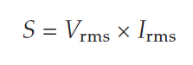

For the sinusoidal condition, P resolves to the familiar form,

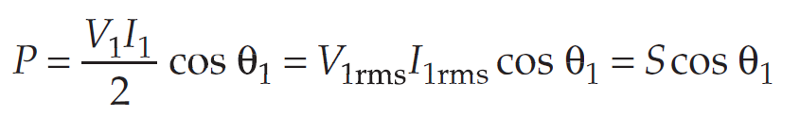

Where θ1 is the phase angle between the fundamental-frequency voltage and current.

For the distorted, or non-sinusoidal, condition, the rms quantities are computed by the square-root of the sum of the squares of the individual harmonic components:

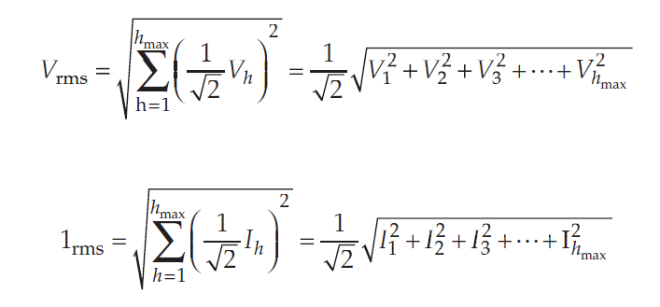

## Determining Capacity with Distorted Currents

There is some disagreement among harmonics analysts on how to define the “reactive power” Q in the presence of harmonic distortion. If it were not for the fact that many utilities measure Q and compute demand billing from the power factor computed by Q, it might be a moot point. It is more important to determine P and S; P defines how much active power is being consumed, while S defines the capacity of the power system required to deliver P. Q is not actually very useful by itself. However, Q1, the traditional reactive power component at fundamental frequency, could be useful in sizing shunt capacitors.

The reactive power component when distortion is present has another interesting peculiarity. In fact, it may not be appropriate to call it reactive *power*. The concept of “var flow” in the power system is deeply ingrained in the minds of most electric power engineers. What many do not realize is that this concept is valid only in the sinusoidal steady state.

When distortion is present, the component of S that remains after P is taken out is not conserved—that is, it does not sum to zero at a node. For planning studies, power quantities are presumed to flow around the system in a conservative manner.

This does not imply that P is not conserved or that current is not conserved because the conservation of energy and Kirchoff’s current laws are still applicable for a waveform of any shape. The reactive components actually sum in quadrature (square root of the sum of the squares). This has prompted some analysts to propose that Q be used to denote the reactive components that are conserved and introduce a new quantity for the components that are not.

Some analysts call this quantity D, for distortion power or, perhaps more correctly, distortion voltamperes. It has units of voltamperes, but it may not be strictly appropriate to refer to this quantity as power, because it does not flow through the system as power is assumed to do. In this concept, Q consists of the sum of the traditional reactive power values at each frequency. D represents all cross products of voltage and current at different frequencies, which yield no average power.

P, Q, D, and S are related as follows, using the definitions for S and P given previously as a starting point:

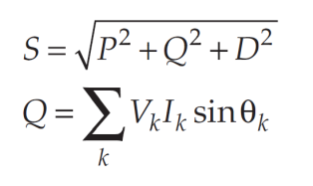

Therefore, D can be determined after S, P, and Q by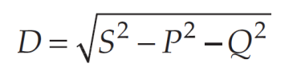

Some prefer to use a three-dimensional vector chart to demonstrate the relationships of the components as shown in Figure 1‑10. P and Q contribute the traditional sinusoidal components to S, while D represents the additional contribution to the apparent power by the harmonics.

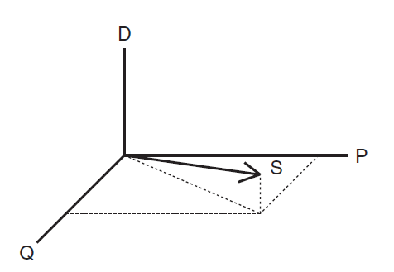

Figure 1‑10. The Components Of Power For Non-Sinusoidal Currents

Power factor (PF) is a ratio of useful power to perform real work (active power) to the power supplied by a utility (apparent power), i.e.,

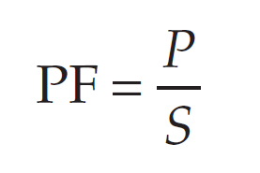

Many devices such as switch-mode power supplies and PWM VFDs have a near-unity *displacement power factor –* the power factor at *fundamental frequency* due to the phase angle displacement between the voltage and current. However, the *true power factor* may be 0.5 to 0.6. The poor power factor is almost entirely due to the *D* term.

A power factor correction capacitor will do little to improve the true power factor in this case because *Q1* is nearly zero. In fact, if it results in harmonic resonance, the distortion may increase, causing the true power factor to decrease. The true power factor indicates how large the power delivery system must be built to supply a given load. In this example, using only the displacement power factor would give a false sense of security that all is well.

The bottom line is that distortion results in additional current components flowing in the system that do not yield any net energy except that they cause losses in the power system elements they pass through. This requires the system to be built to a slightly larger capacity to deliver the power to the load than if no distortion were present. To supply a load with significantly distorted load current, the system current-carrying capacity must be larger than for a sinusoidal current.

## Resonance and Harmonic Distortion Problems

The electric power system is remarkably robust. When it is mostly inductive and planned with sufficient capacity to deliver the fundamental frequency power to the load the harmonic distortion generally remains within bounds. *Problems* in the electric power system with harmonic distortion are most frequently due to *resonance* of some form when the *capacitance* in the system results in resonance at one, or more, critical harmonic frequencies. This dramatically increases the distortion above normal amounts.

Utility distribution planners usually do not have much control over the harmonic currents a consumer may inject into the distribution system other than including references to IEEE Std 519-2014 limits in the interconnection agreement. Distribution planners have more control over the harmonic voltage distortion that results from the harmonic currents originating in consumers’ load equipment. The planners’ basic responsibility is to design the system with sufficient capacity to supply the load kVA demand at fundamental frequency. As mentioned previously, this is sufficient for accommodating most typical harmonic-producing loads. The introduction of capacitance into a mostly inductive circuit will always result in a resonance at some frequency. The challenge to the distribution planner to meet the utility’s responsibility in IEEE Std. 519-2014 is to keep the system out of resonance at a harmonic frequency present in the load currents.

Thus, the responsibilities in meeting IEEE Std. 519-2014 boil down to the follow two:

1. Consumers operate their loads so that the amount of harmonic current injected into the power supply system is less than the current limits in the standard. Filters are applied if necessary.
2. Utilities build the power delivery system with sufficient capacity to supply the load with typical margins and operate the system to keep it out of harmonic resonance. Filters and detuning devices are applied if necessary.

## Sharpness of Resonance on the Power System

While resonance problems can occur anywhere on utility power distribution systems, the most severe cases are usually found in industrial power systems because of the sharper resonance that occurs. Power factor correction capacitors are typically applied at the secondary bus and there is proportionately less equivalent resistance at the point of connection. Capacitors installed in utility substations are subject to the same considerations. Engineers often describe the sharpness of the resonance in terms of the “Q” factor. The *Q* of the resonant circuit is much greater at a transformer location than is typically found when capacitors are placed on the distribution system lines.

Q is typically defined for power systems harmonics resonance problems as:

Where

*XL* = reactance of the equivalent inductance of the circuit at the resonant frequency, and

*R* = resistance in the resonant circuit.

When Q is very high – as it is for a capacitor located on a transformer bus – the harmonic resonance is very sharp and devices in the resonant circuit are more prone to failure. The *X/R* of a substation transformer or a large industrial service transformer might be 20 at fundamental frequency. If the transformer-capacitance combination is resonant at the 5th harmonic – which is common – the Q might be approaching 100.

In contrast, the X/R on a distribution line might be approximately 2-to-4 and Q at the resonant frequency being less than 10. Load damping effects will further reduce the Q. Thus, distribution engineers typically can place feeder capacitor banks anywhere they are needed without concern for harmonic resonance. Resonance problems can arise, but they are generally less extreme than for capacitors connected to transformers.

Figure 1‑15 illustrates this sharpness of the resonance by plotting the magnitude of the impedance of a parallel resonant circuit for different values of Q. Figure 1‑16 shows the same data in another way more pertinent to power system planning – the magnification of the injected current in the inductive element (the transformer) for different values of Q.



Figure 1‑15. Illustrating the effect of increasing the apparent resistance (decreasing the Q) of a resonant circuit.



Figure 1‑16. Magnification factor: Amps through transformer per amp injected.

### Modeling Transformer Impedance Variation with Frequency

Generally, the resistance in a power system has a minor effect on the flow of harmonic currents when the system is not in resonance. However, the damping of harmonic resonance by resistance of loads, lines, and transformers can have a significant effect. Loads are not the only elements in the power system that have significant impedance variation with frequency. Substation transformers and larger transformers supplying industrial consumers have a relatively high X/R ratio of 10 or greater at fundamental power frequency and this contributes to sharp resonances. Distribution service transformers such as those that serve residential loads can have a much lower X/R. A 25 kVA transformer would have an X/R ratio only slightly greater than 1.0. In either case, there is a question about what to assume for the variation of the equivalent resistance for harmonic frequencies.

If no adjustment to the winding resistance for frequency is made, the equivalent X/R will increase in proportion to the harmonic. Such a model predicts very little damping at harmonic frequencies and excessively sharp resonances. For example, if a substation transformer has an X/R ratio of 10 at fundamental, the model will have an X/R of 50 at the 5th harmonic, which generally results in an unrealistically high-Q circuit model with highly exaggerated predictions of voltage distortion.

The apparent resistance of transformers increases with frequency at a rate that is dependent on its design. The chief component of the increase comes from the *stray eddy current losses* and can be quite significant in transformers that have conductors with large cross-sectional areas. Also, designs with conductors in parallel can have circulating currents within the windings that yield an effective increase in resistance.

Utility distribution planning engineers do not have time to measure the frequency response of each transformer, but they should know that the apparent resistance of the transformer increases with frequency and helps to hold system resonances in check. A typical assumption of harmonics analysts when no other data are available is to assume that the X/R ratio at fundamental frequency remains constant over the frequency range of interest. This approximates what happens in larger power transformers. It is not a good fit for some transformers, but at least it adds some damping to the model to compensate for the exaggerated high voltages and impedances that would otherwise be predicted.

Adjusting the resistance model of small utility distribution transformers in the frequency range up to the 13th harmonic is generally not critical. The windings are constructed with wire having a small cross section and the stray eddy losses do not generally increase as rapidly as for large power transformers. The typical low X/R of these transformers tends to contribute to the damping of resonance in any case, yielding results that are only moderately conservative.

## Combined Effect of Load and Transformer Modeling

Figure 1‑20 shows the effect of the various load and transformer modeling assumptions we’ve discussed on the magnitude of the impedance looking into a typical parallel resonant circuit. The all-parallel simple Norton equivalent yields the greatest damping and will be overdamped for some cases. It is interesting to note that this model often matches well with measurements when the capacitor banks are mostly on distribution lines rather than in substations. The likely explanation is that the low X/R of distribution feeders damps resonance similarly.

Figure 1‑20. Comparing the impact of different load and transformer modeling assumptions on resonance

Assuming the X/R of the transformer is constant drops the magnitude of the driving point impedance at the capacitor location by approximately 20% compared to the model that has no load and no extra damping. This can be important in many cases where there is a sharp resonance in a substation.

Assuming the impedance branch in the load model is all series RL shifts the frequency higher and provides a little damping at the resonant frequency. Note that if this model is incorrect it could shift the resonance either into or out of a troublesome harmonic frequency. This is sometimes the reason that models predict a high resonance that is not observed in measurements.

The default 50/50 split in the load model admittance branch is often a good compromise when no better data are available. It will clearly show the resonance and will generally not exaggerate the voltage distortion that would occur.

Figure 1‑21 shows a one-line diagram of the OpenDSS REACTOR model. The model is nominally a series, multiphase R-L branch with user-defined properties of R and X. In addition to scalar values, R and X may also be defined as matrices. A feature of the model that, perhaps, is seldom used is the parallel resistance, *Rp*, that is connected around the entire branch. Its default value is infinite (open) so that it does not enter into the calculations. However, it can be employed to model frequency dependence of R-L elements, including transformers. This requires a separate REACTOR element to be added in series with the transformer and defined with an appropriate value so that the total impedance through the transformer is correct. Users may also define curves for the resistance, R, and inductance, L, as a function of frequency when *Rp* is not defined.

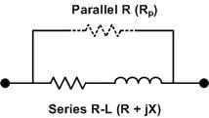

Figure 1‑21. One-Line Diagram of the OpenDSS REACTOR Object

## Avoiding Resonance

The simplest way to solve problems with harmonic resonance is to try to avoid resonance at any of the critical odd harmonics such as 5, 7, 11, and 13. When planning for the addition of a capacitor bank one should always check the resonant frequency that will result when it is installed. One quick way for most power engineers to estimate the resonant frequency when installing a capacitor immediately downline from a transformer is to use the available short circuit kVA (*kVASC*) and the capacitor kvar rating:

If *kVASC*is not supplied by any other means such as a short circuit study, it can be estimated from the transformer kVA rating and percent reactance, %*X*, at the base kVA rating, *kVATR*:

The actual harmonic value will be lower than given by this formula because there will be impedance in the power supply to the transformer. One common approach is to use 90% of this value when more accurate information is not available.

While special computer programs are generally required due to the complexity of many distribution system circuit models, one circuit appears frequently in simple industrial systems that is tractable by manual calculations (Figure 1‑22). It is basically a one-bus circuit with one capacitor. Two things may be done relatively easily:

1. *Determine the resonant frequency.* If the resonant frequency is near a potentially damaging harmonic such as the 5th or 7th, either the capacitor must be changed or a filter designed.
2. *Estimate the Voltage distortion at each frequency.* The voltage across the potentially parallel resonant circuit can be computed by a relatively simple formula.

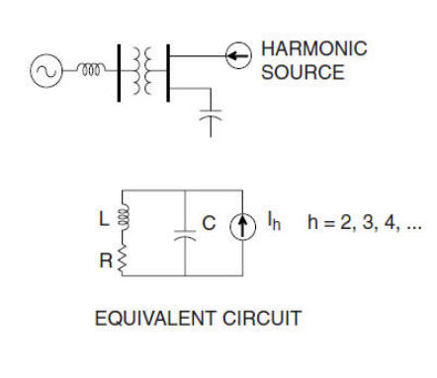

Figure 1‑22. A simple circuit that can be analyzed by manual calculations

The formula for estimating the voltage magnitude at each harmonic, *h*, is given below. Note that this formula includes the effect of the resistance, *R*.

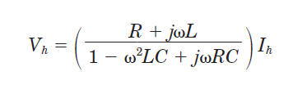

If the resonant frequency is not near a significant harmonic and the projected voltage distortion is low, the application will probably operate successfully without resonance. Planners should avoid applications where the resonant frequency is near the 5th or 7th harmonic especially. Tuning near even harmonics like the 8th are often successful unless there are significant amounts of *interharmonics* due to loads such as induction furnaces and cycloconverters.Tuning at the 6th runs a greater risk of accentuating both the 5th and the 7th, so this application should be designed with great care.

Adding just one more L-C loop to this circuit makes it very difficult to analyze by manual calculations. Typical distribution systems with power factor correction capacitor banks may have dozens or even hundreds of such loops. There will be not just one resonant frequency but several. This will require software such as OpenDSS that can handle network harmonic analysis.

## Harmonic Studies

Harmonic studies in combination with measurements play an important role in characterizing and understanding the extent of harmonic problems in power systems. Harmonic studies are performed for the following purposes:

1. Finding a solution to an existing harmonic problem
2. Installing large capacitor banks on utility distribution systems or industrial power systems
3. Installing large nonlinear devices or loads
4. Designing a harmonic filter
5. Converting a power factor capacitor bank to a harmonic filter

Harmonic studies are very important when the conditions exist for harmonic resonance. Without resonance, most power systems with sufficient capacity to serve the load demand can also handle typical distorting loads without excessive harmonic distortion. Harmonic studies are often neglected because distribution engineers, in particular, can usually apply capacitor banks where needed for loss reduction, voltage profile improvement, or power factor correction without concern for resonance. The main reason is that capacitor banks distributed on distribution lines are in locations where the X/R ratio of the equivalent short-circuit impedance is relatively low. Thus, resonance is heavily damped for the majority of the installations. However, harmonic studies should always be performed when applying large capacitor banks at or near transformers. The transformer X/R is much higher than power lines and dangerous harmonic resonance can easily occur.

Harmonic studies range from relatively simply resonant frequency calculations to quite complicated simulations of large networks requiring sophisticated computer models. The studies provide a means to evaluate various possible solutions and their effectiveness under a wide range of conditions before implementing a final solution.

## Harmonic Study Procedure

The ideal procedure for performing a power systems harmonics study can be summarized as follows:

1. Determine the objectives of the study. This is important to keep the investigation on track. Objectives could include identifying resonances and correcting the system frequency response.
2. Make a preliminary computer model to identify likely resonance situation.
3. Make measurements of the existing harmonic conditions, characterizing sources of harmonic currents and system bus voltage distortion.
4. Calibrate the computer model using the measurements.
5. Study the new circuit condition or existing problem.
6. Develop solutions (filter, detuning options, etc.) and investigate possible adverse system interactions. Also, check the sensitivity of the results to important variables.
7. After the installation of proposed solutions, perform monitoring to verify the correct operation of the system.

It is not always possible to perform each of these steps ideally. The most often omitted steps are one, or both, of the measurement steps due to the cost of engineering time, travel, and equipment charges. An experienced analyst may be able to solve a problem without measurements, but it is strongly recommended that the initial measurements be made if at all possible because there are often surprises when performing harmonics analysis of power systems.

If the subject power system is complex, it is often economical to make an initial computer model prior to making measurements using the best information available. Harmonic simulation technology in tools such as OpenDSS is now sufficiently advanced that models can often make good predictions without measurements. Measurements are very beneficial but are very expensive in terms of labor, equipment, and possible disruption to plant operations. It will generally be economic to have a good idea what the likely problems will be and where to look before beginning the measurements. Then the investigation team can take the monitoring equipment directly to the likely problematic locations.

## Modifying System Frequency Response

There are a number of methods to modify system frequency response when resonance occurs at significant harmonic frequencies:

1. Change the capacitor size. This is often the least expensive options for both utilities and industrial customers. Simply move the resonance frequency away from a harmonic.
2. Add a shunt filter. Not only does this shunt a major troublesome harmonic current off the system, but it completely changes the system response. When properly designed the change is beneficial
3. Add a reactor to detune the system. Harmful resonances generally occur between the system inductance and shunt power factor correction capacitors. The reactor must be added between the capacitor and the supply system source. One method is to simply put a reactor in series with the capacitor to move the system resonance without actually tuning the capacitor to create a filter. Another is to add reactance in the line.
4. Move a capacitor to a location on the system with a different short-circuit impedance or higher losses. This is also an option for utilities when a new bank causes telephone interference—moving the bank to another branch of the feeder may very well resolve the problem. This is frequently not an option for industrial users because the capacitor cannot be moved far enough to make a difference.
5. Remove the capacitor and simply accept the higher losses, lower voltage, and power factor penalty. If technically feasible, this could be an economic choice.

The X/R ratio of a utility distribution feeder is generally low. Therefore, the magnification of harmonics by resonance with feeder banks is usually minor in comparison to what might be found at an industrial facility or for capacitors installed in a substation. Utility distribution engineers are accustomed to placing feeder banks where they are needed for voltage and capacity issues without concern for harmonics. When problems do occur, the usual strategy is to first attempt a solution by moving the offending bank or changing the capacitor size or neutral connection.

Harmonic problems on distribution feeders often exist only at light load. The voltage rises, causing the distribution transformers to produce more harmonic currents while at the same time there is less load to damp out resonance. Switching the feeder capacitors off at this time frequently solves the problem.

When harmonic currents from widely-dispersed sources require filtering on distribution feeders, one approach is to distribute a few single-tuned filters toward the ends of the feeder. With the ends of the feeder “nailed down” by filters with respect to the voltage distortion, it is more difficult for the voltage distortion to rise above limits elsewhere.

When harmonic resonance is suspected in an industrial load facility, the first step is to confirm that the main cause is resonance with power factor capacitors in the facility. This is done by measuring the current in the capacitors and looking for the telltale waveform of a harmonic sinusoid riding on top of the fundamental waveform. One should first attempt a simple solution by using a different capacitor size.

Some automatic power factor controllers with multi-step capacitors may have control logic that allow them to avoid the capacitance values that causes resonance. In other cases, there will be so many capacitors switched at random with various loads that it will be nearly impossible to avoid resonant conditions. Filtering will be necessary, possibly with broadband filters.

Resonance problems are often less severe in factories when capacitors are located out on the plant floor on motors and in motor control centers. This assumes that the cables are sufficiently long to introduce enough resistance into the circuit to dampen the resonance. In plants with short cables, it may not be possible to achieve significant harmonic reduction benefit by distributing the capacitors.

## Filters

When simple changes are not feasible, harmonic filters can be added to the system to alter the frequency response, either moving or damping the resonance. Figure 1‑24 shows some commonly-applied filter topologies.



Figure 1‑24. Common harmonic filter topologies

The most commonly-applied is the single-tuned resonant shunt. It is generally the least expensive and the most efficient. The main intent with this filter is create a low impedance for a troublesome harmonic current and short-circuit it off the system. This filter also changes the overall system frequency response, which could cause problems at other frequencies. Figure 1‑25 shows what happens when an existing capacitor that was causing a resonance at the 9th harmonic was converted to a 5th harmonic filter. It is usually good practice to design the filter for one of the lower harmonics on the system because the filter creates a new, sharp resonance below the notch frequency. This resonance should be designed for a frequency where it is not likely to cause a problem. In this case, the new resonance occurs near the 4th and there is generally little excitation of this resonance unless the system is serving cyclo-converter type loads.

The other two filters in Figure 1‑24 introduce intentional resistance. Resistance helps to damp out resonance so this can be quite useful if the losses are affordable. The 1st-order high pass filter simply inserts a resistance into the resonant circuit sufficient to suppress the resonance. This is of course quite lossy. However, there are applications where the heat off the resistor can be used effectively and this simple filter works effectively. The 2nd-order high pass is a little more sophisticated. It is typically applied in smaller sizes for 11th harmonic and higher where the fundamental frequency voltage across the inductor is relatively low.

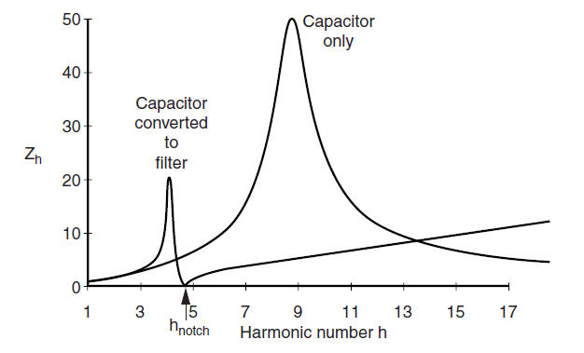

Figure 1‑25. Converting an existing capacitor bank to a single-tuned filter

An increasingly popular filter is the C Filter (Figure 1‑26). This yields a frequency response similar to the 2nd-order filter, but can be tuned to a low harmonic such as the 3rd without suffering the high losses of the 2nd-order filter. It does an excellent job of suppressing all frequency above its main tuning frequency. The key feature is the series-tuned combination of *Lm* and *Ca* tuned to the fundamental frequency that shorts the resistance, *R,* at the fundamental, thus avoiding many of the losses.



Figure 1‑26. C Filter configuration.

The frequency-scan response of a C Filter is illustrated in Figure 1‑27. It is tuned to the 5th harmonic where the notch occurs. It presents a high impedance to fundamental frequency but has a low impedance with resistive damping above the notch frequency. This can be effective in filtering the higher frequency components of harmonic-producing loads.



Figure 1‑27. C-Filter Characteristic

A final type of filter to consider for controlling resonance is the broadband filter (Figure 1‑28). The application for this would be where there are multiple resonances and, perhaps, cyclo-converter type loads that produce varying interharmonics such that it is almost impossible to avoid a resonant condition. The main idea is to use a relatively large inductance to keep all harmonic currents on the right-hand side of the diagram by forcing them through the capacitor. The filter is thus tuned to a low frequency such as near the 2nd or 3rd harmonic. A significant voltage rise at power frequency occurs at the capacitor due to the size of the capacitor relative to the short circuit strength of the system. Therefore, a tap changing transformer is often employed to control the voltage level. Such devices are available for industrial low-voltage applications and are effective in minimizing the distortion over a wide range of frequencies. Such filters could also be constructed on utility distribution systems using transformers for the inductance and voltage regulators to control the overvoltage.



Figure 1‑28. Broadband Filter Schematic

Figure 1‑29 shows a broadband filter current magnification frequency response – the current observed on the source side of the filter per ampere of current on the load side. The harmonic current source sees a typical parallel resonance characteristic with a high impedance at the tuning frequency. However, at higher frequencies the impedance approaches the impedance of the capacitor which shunts the current off the system and strongly attenuates the currents about 300 Hz in this case (the magnification factor is less than one). This is a useful characteristics for loads that produce harmonic and interharmonic currents that are constantly shifting frequencies. Obviously, the tuning frequency must be lower than the lowest harmonic produced by the load.



Figure 1‑29. A Broadband Filter Characteristic