Counts + Rates

Table of Contents

This reports stores the drafts of the visualizations generated from the combined data set produced by ./manipulation/4-combiner.R script.

# Set the scene

Describe the working environment.

# Attach these packages so their functions don't need to be qualified  
library(magrittr) # pipes  
library(dplyr) # disable when temp lines are removed  
library(ggplot2) # graphs  
library(ggpubr) # documents

# Call `base::source()` on any repo file that defines functions needed below.   
base::source("./scripts/common-functions.R")

path_file_input <- "./data-unshared/derived/9-combined.rds"  
html_flip <- FALSE  
baseSize <- 10  
  
  
age_group_order <- c(  
 "less_than_1"  
 ,"1_4"   
 ,"5_9"   
 ,"10_14"   
 ,"15_19"   
 ,"20_24"   
 ,"25_34"   
 ,"35_44"   
 ,"45_54"   
 ,"55_64"   
 ,"65_74"   
 ,"75_84"   
 ,"85_plus"   
)

#Put code in here. It doesn't call a chunk in the codebehind file.

dto <- readRDS(path_file_input)  
dto %>% pryr::object_size(); dto %>% class(); dto %>% names()

16.1 MB

[1] "list"

[1] "granularity_gls" "granularity_population"

# to collapse into a single data frame  
ds <- dto[["granularity_population"]] %>%   
 Reduce(function(a , b) dplyr::left_join( a, b ), . )  
  
ds %>% explore::describe_all()

variable type na na_pct unique min mean max  
1 county chr 0 0.0 67 NA NA NA  
2 year chr 0 0.0 17 NA NA NA  
3 sex chr 0 0.0 2 NA NA NA  
4 race chr 0 0.0 2 NA NA NA  
5 ethnicity chr 0 0.0 3 NA NA NA  
6 age_group chr 0 0.0 13 NA NA NA  
7 population_count dou 0 0.0 14511 0 2926.53 144791  
8 peer_group dou 1612 1.5 25 1 32.85 81  
9 resident_deaths dou 97718 90.5 40 1 3.30 41  
10 region chr 101972 94.4 4 NA NA NA  
11 community dou 104156 96.4 35 8 491.19 3764  
12 professionals dou 102388 94.8 45 4 95.89 1161  
13 county_gls log 101972 94.4 2 1 1.00 1

# to help us filter out those counties that had programming  
counties_gls <- ds %>%   
 distinct(county,region) %>% # those who have region had programming  
 na.omit() %>%  
 dplyr::distinct(county) %>%   
 as.list() %>% unlist() %>% as.character()  
  
  
# to view the total programming delivered (between 2015 and 2017)  
ds %>%   
 dplyr::filter(county %in% counties_gls) %>%   
 dplyr::distinct(county, year, community, professionals ) %>%   
 # na.omit() %>%   
 dplyr::group_by(county) %>%   
 dplyr::summarize(  
 community = sum(community, na.rm= T)  
 ,professionals = sum(professionals, na.rm= T)  
 ) %>%   
 dplyr::arrange(desc(professionals))

# A tibble: 23 x 3  
 county community professionals  
 <chr> <dbl> <dbl>  
 1 Orange 8182 1605  
 2 Saint Lucie 1068 830  
 3 Volusia 2170 432  
 4 Seminole 2400 419  
 5 Lake 206 290  
 6 Palm Beach 935 241  
 7 Duval 0 235  
 8 Saint Johns 250 210  
 9 Brevard 1126 166  
10 Hernando 115 131  
# ... with 13 more rows

ds <- ds %>%   
 dplyr::rename(  
 "deaths_by_suicide" = "resident_deaths" # to remind what we count  
 ) %>%   
 dplyr::mutate(  
 # to have a standardized measure / put counties on the same scale  
 suicide_rate_per100k = (deaths_by_suicide / population_count) *100000  
 # to have a single variable describing racial background  
 ,racethnicity = paste0(race," + ", ethnicity)  
 # to aid in graph production ( note the spaces at the end of "NE ")  
 ,rgn = car::recode(  
 region,  
 "  
 'central' ='CN'  
 ;'southeast'='SE'  
 ;'northeast'='NE '  
 "  
 )  
 ) %>%   
   
 dplyr::select(county, year, sex, age_group, race, ethnicity, racethnicity, # context  
 region, rgn, # support for graphing and grouping  
 population_count, deaths_by_suicide, suicide_rate_per100k, #measures  
 community, professionals # treatment  
 )  
  
ds %>% explore::describe_all()

variable type na na_pct unique min mean max  
1 county chr 0 0.0 67 NA NA NA  
2 year chr 0 0.0 17 NA NA NA  
3 sex chr 0 0.0 2 NA NA NA  
4 age_group chr 0 0.0 13 NA NA NA  
5 race chr 0 0.0 2 NA NA NA  
6 ethnicity chr 0 0.0 3 NA NA NA  
7 racethnicity chr 0 0.0 6 NA NA NA  
8 region chr 101972 94.4 4 NA NA NA  
9 rgn chr 101972 94.4 4 NA NA NA  
10 population_count dou 0 0.0 14511 0.00 2926.53 144791.00  
11 deaths_by_suicide dou 97718 90.5 40 1.00 3.30 41.00  
12 suicide_rate_per100k dou 97718 90.5 8395 0.83 63.70 7142.86  
13 community dou 104156 96.4 35 8.00 491.19 3764.00  
14 professionals dou 102388 94.8 45 4.00 95.89 1161.00

# to remind out how to aggregate   
# the most granular level includes (6):  
# county, year, sex, age_group, race, ethnicity  
d1 <- ds %>%   
 # apply filters to better understand the structure of the data  
 # dplyr::filter(county %in% c("Orange") ) %>%  
 # dplyr::filter(year %in% c("2015") ) %>%  
 # dplyr::filter(sex %in% c("Male") ) %>%  
 # dplyr::filter(age_group %in% c("15_19") ) %>%  
 # dplyr::filter(race %in% c("White") ) %>%  
 # dplyr::filter(ethnicity %in% c("Non-Hispanic") )%>%  
 # dplyr::filter(ethnicity %in% c("Hispanic","Non-Hispanic") )%>%  
 dplyr::group_by(county, year, sex, age_group, race, ethnicity) %>% # no aggregation  
 # to exemplify useful aggregates:  
 # dplyr::group_by(county, year ) %>%  
 # dplyr::group_by(county, year, sex ) %>%  
 # dplyr::group_by(county, year, sex, age_group ) %>%  
 # dplyr::group_by(county, year, sex, racethnicity ) %>%  
 dplyr::summarize(  
 population_count = sum(population_count, na.rm = T)  
 ,deaths_by_suicide = sum(deaths_by_suicide, na.rm = T)  
 ,professionals = sum(professionals, na.rm = T)  
 ,community = sum(community, na.rm = T)  
 )   
# use the code for preparing data for custom graphs  
# d1 %>% glimpse(60)  
# d1 %>% explore::describe()

# I Exposition

# II. Development

## Population Counts

### p0

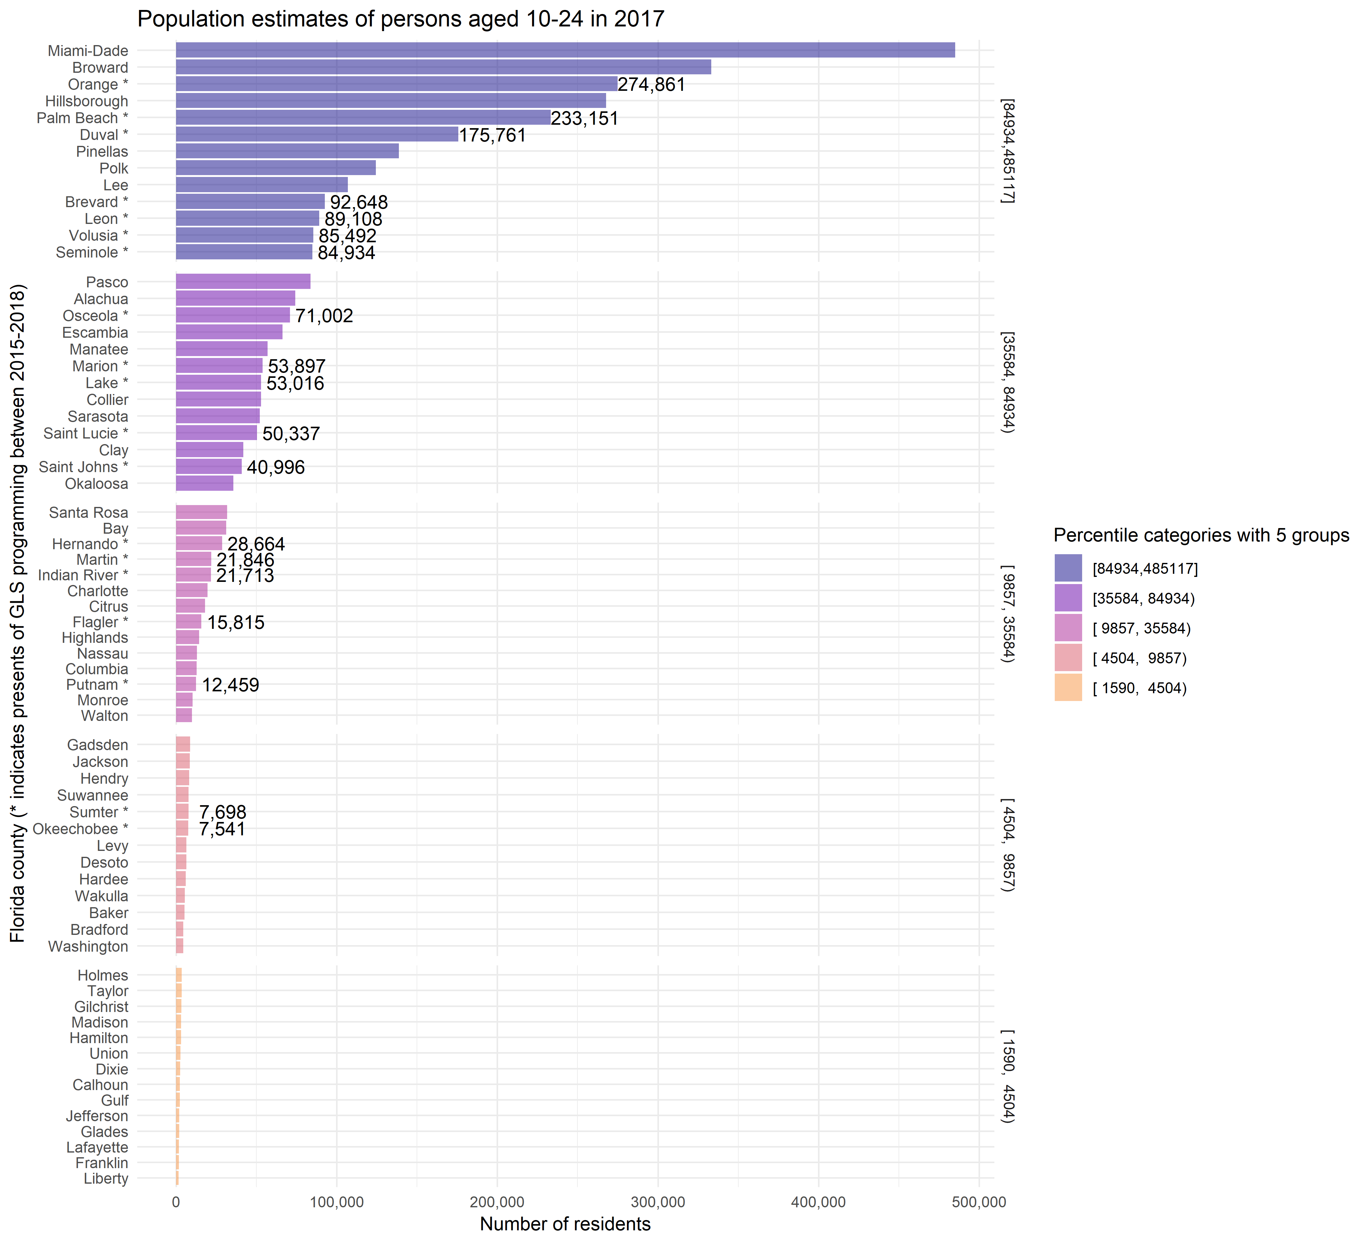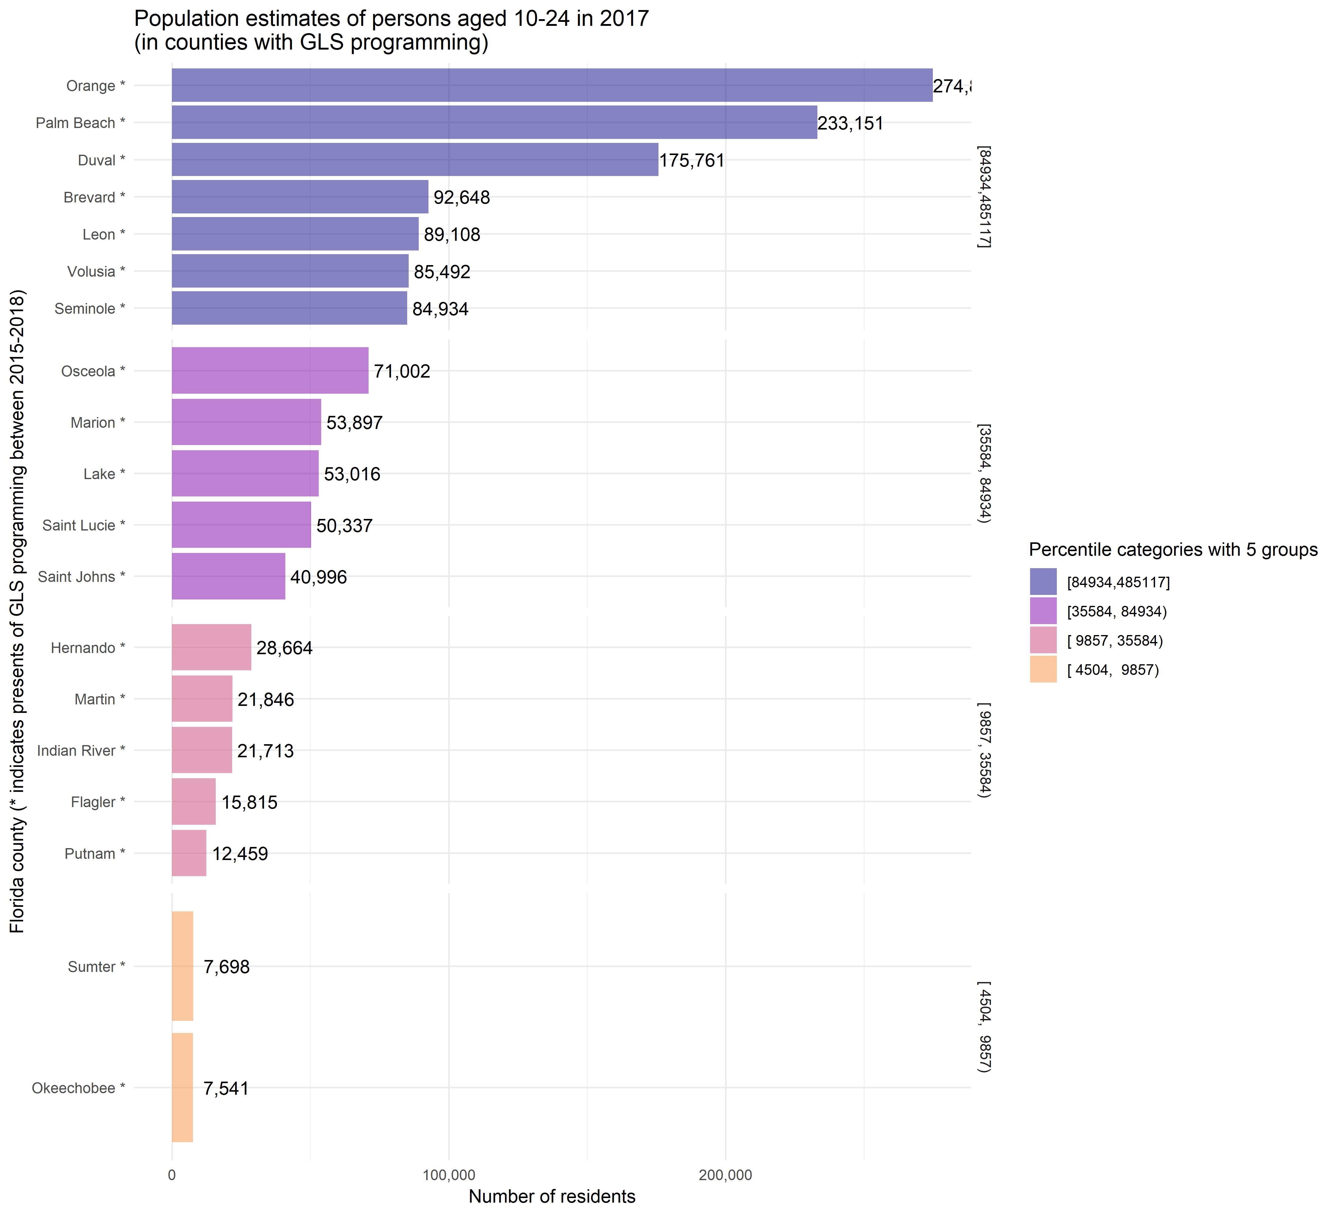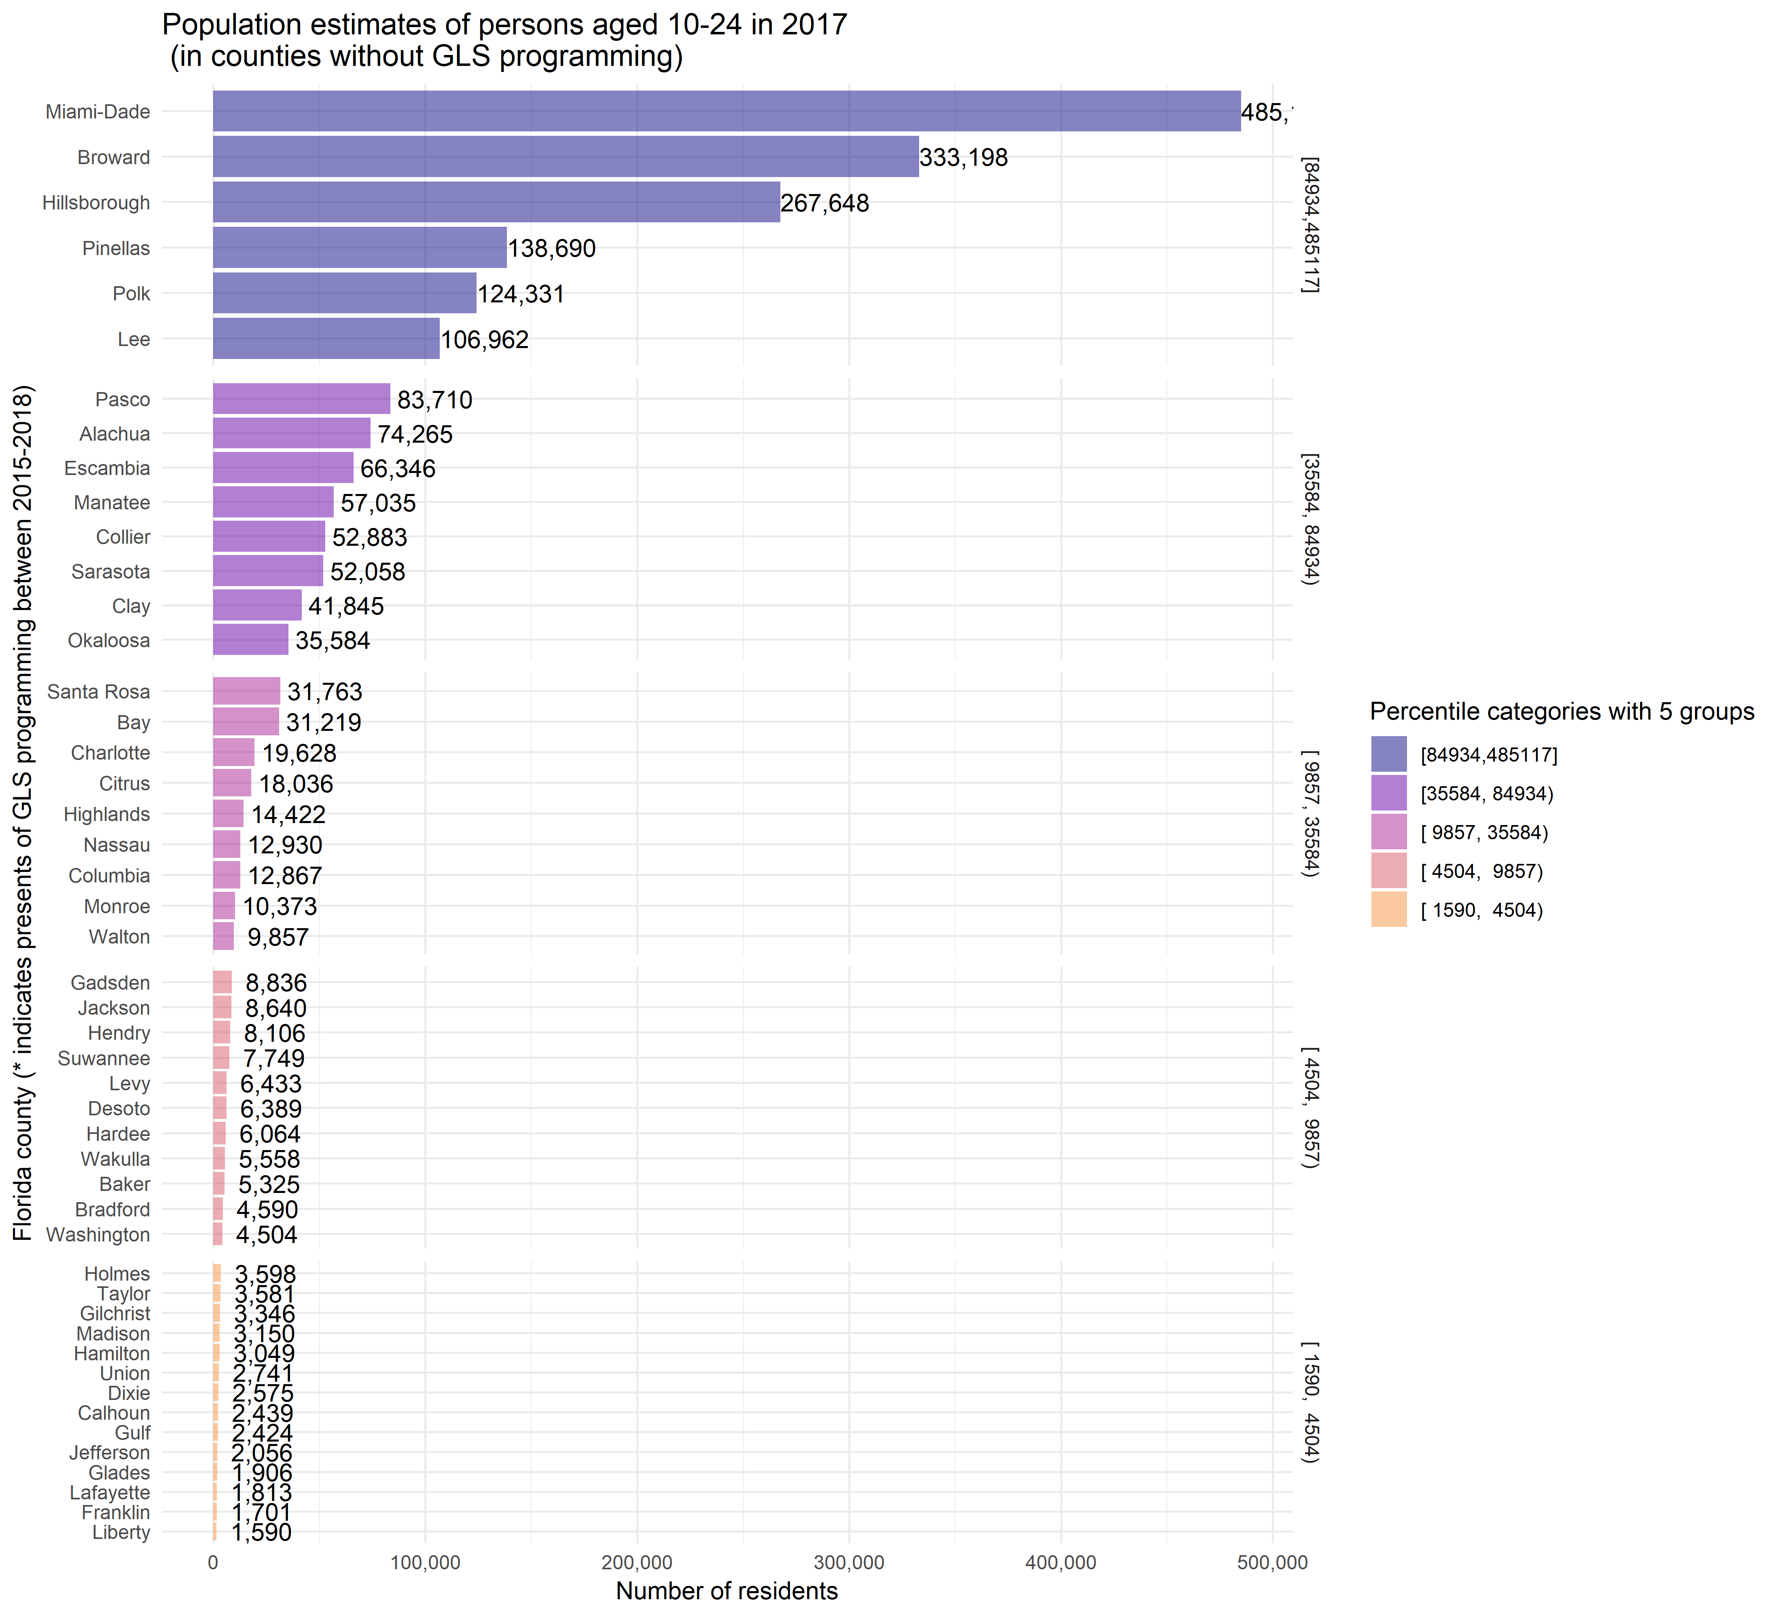

### p1

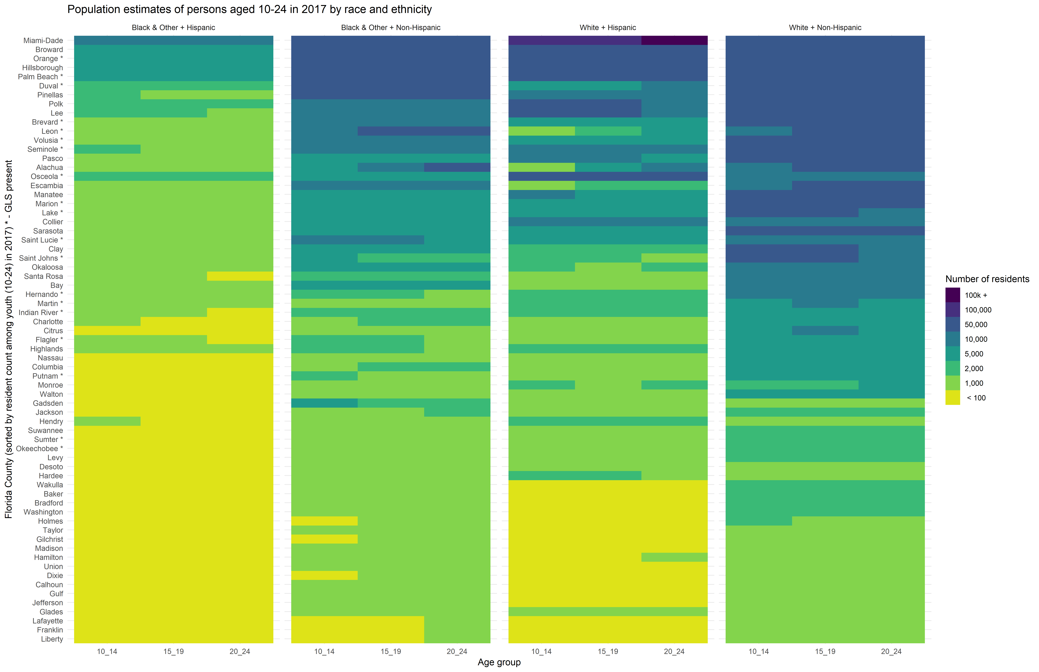

### p2

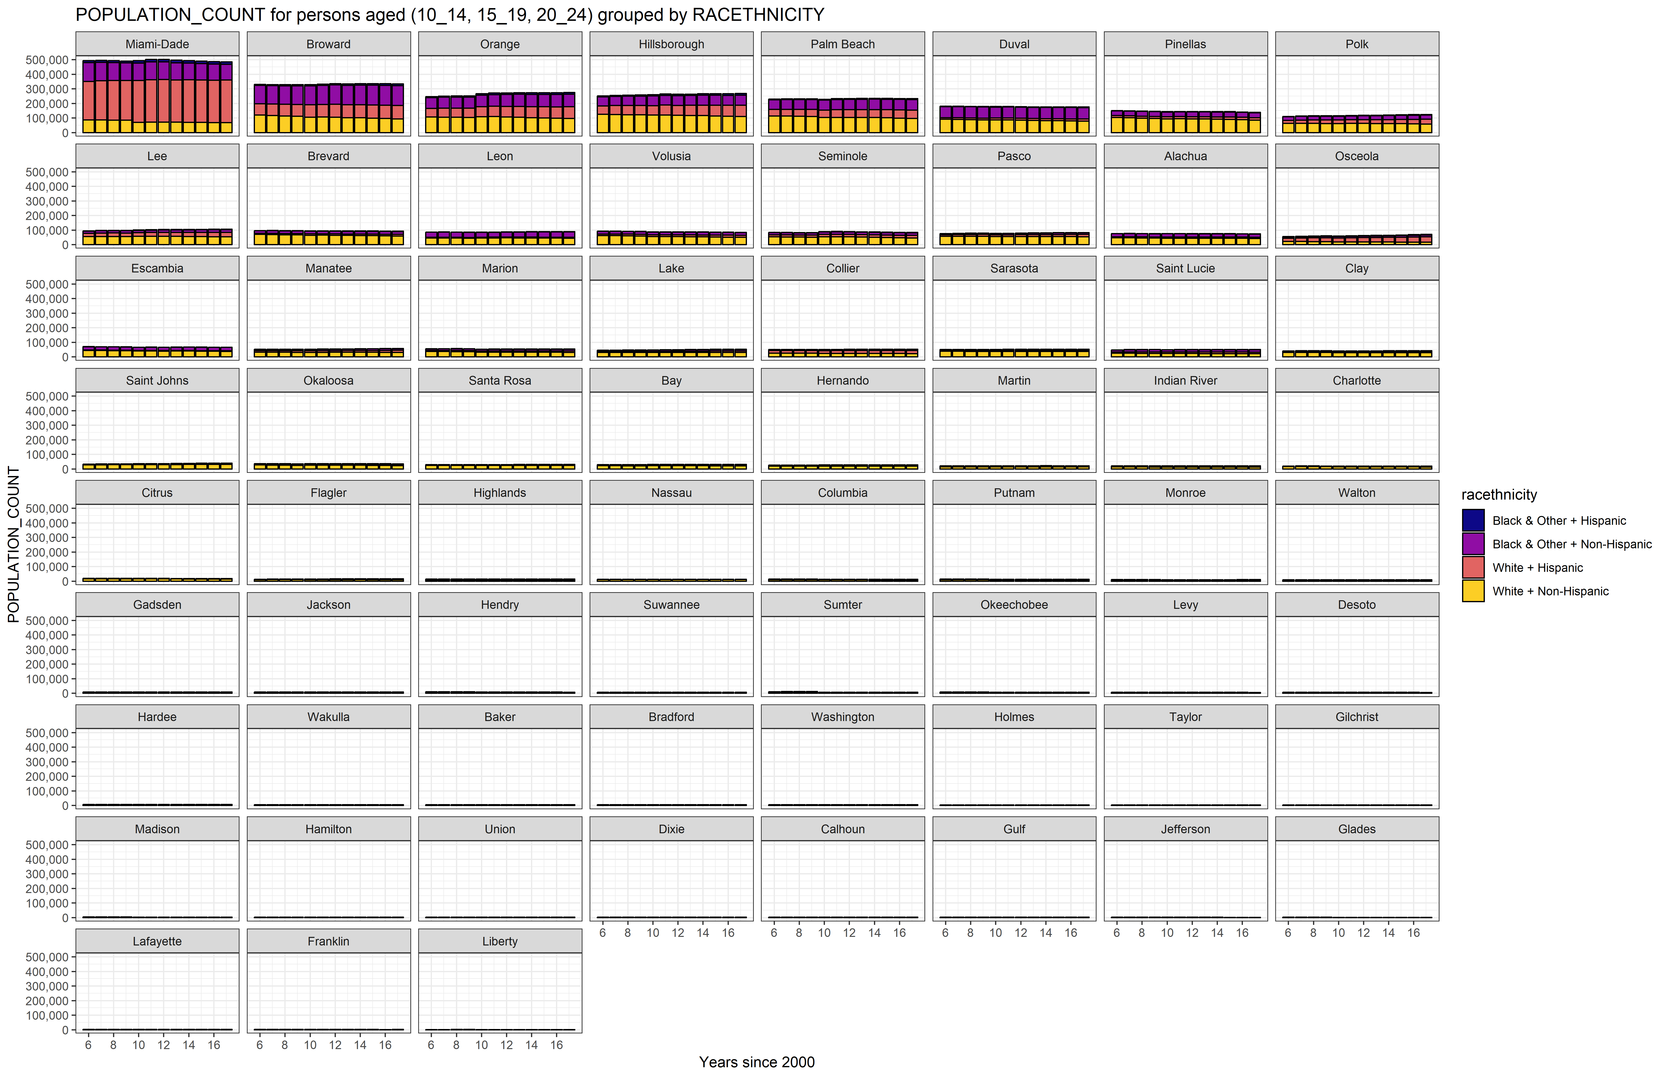

### p3

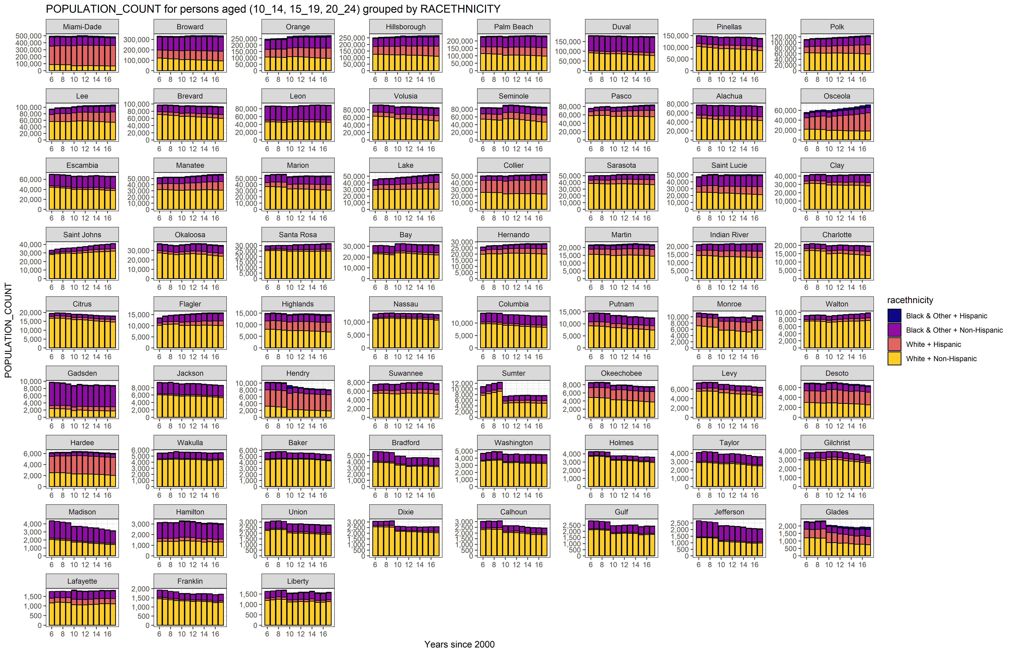

## Suicides Counts

### p4

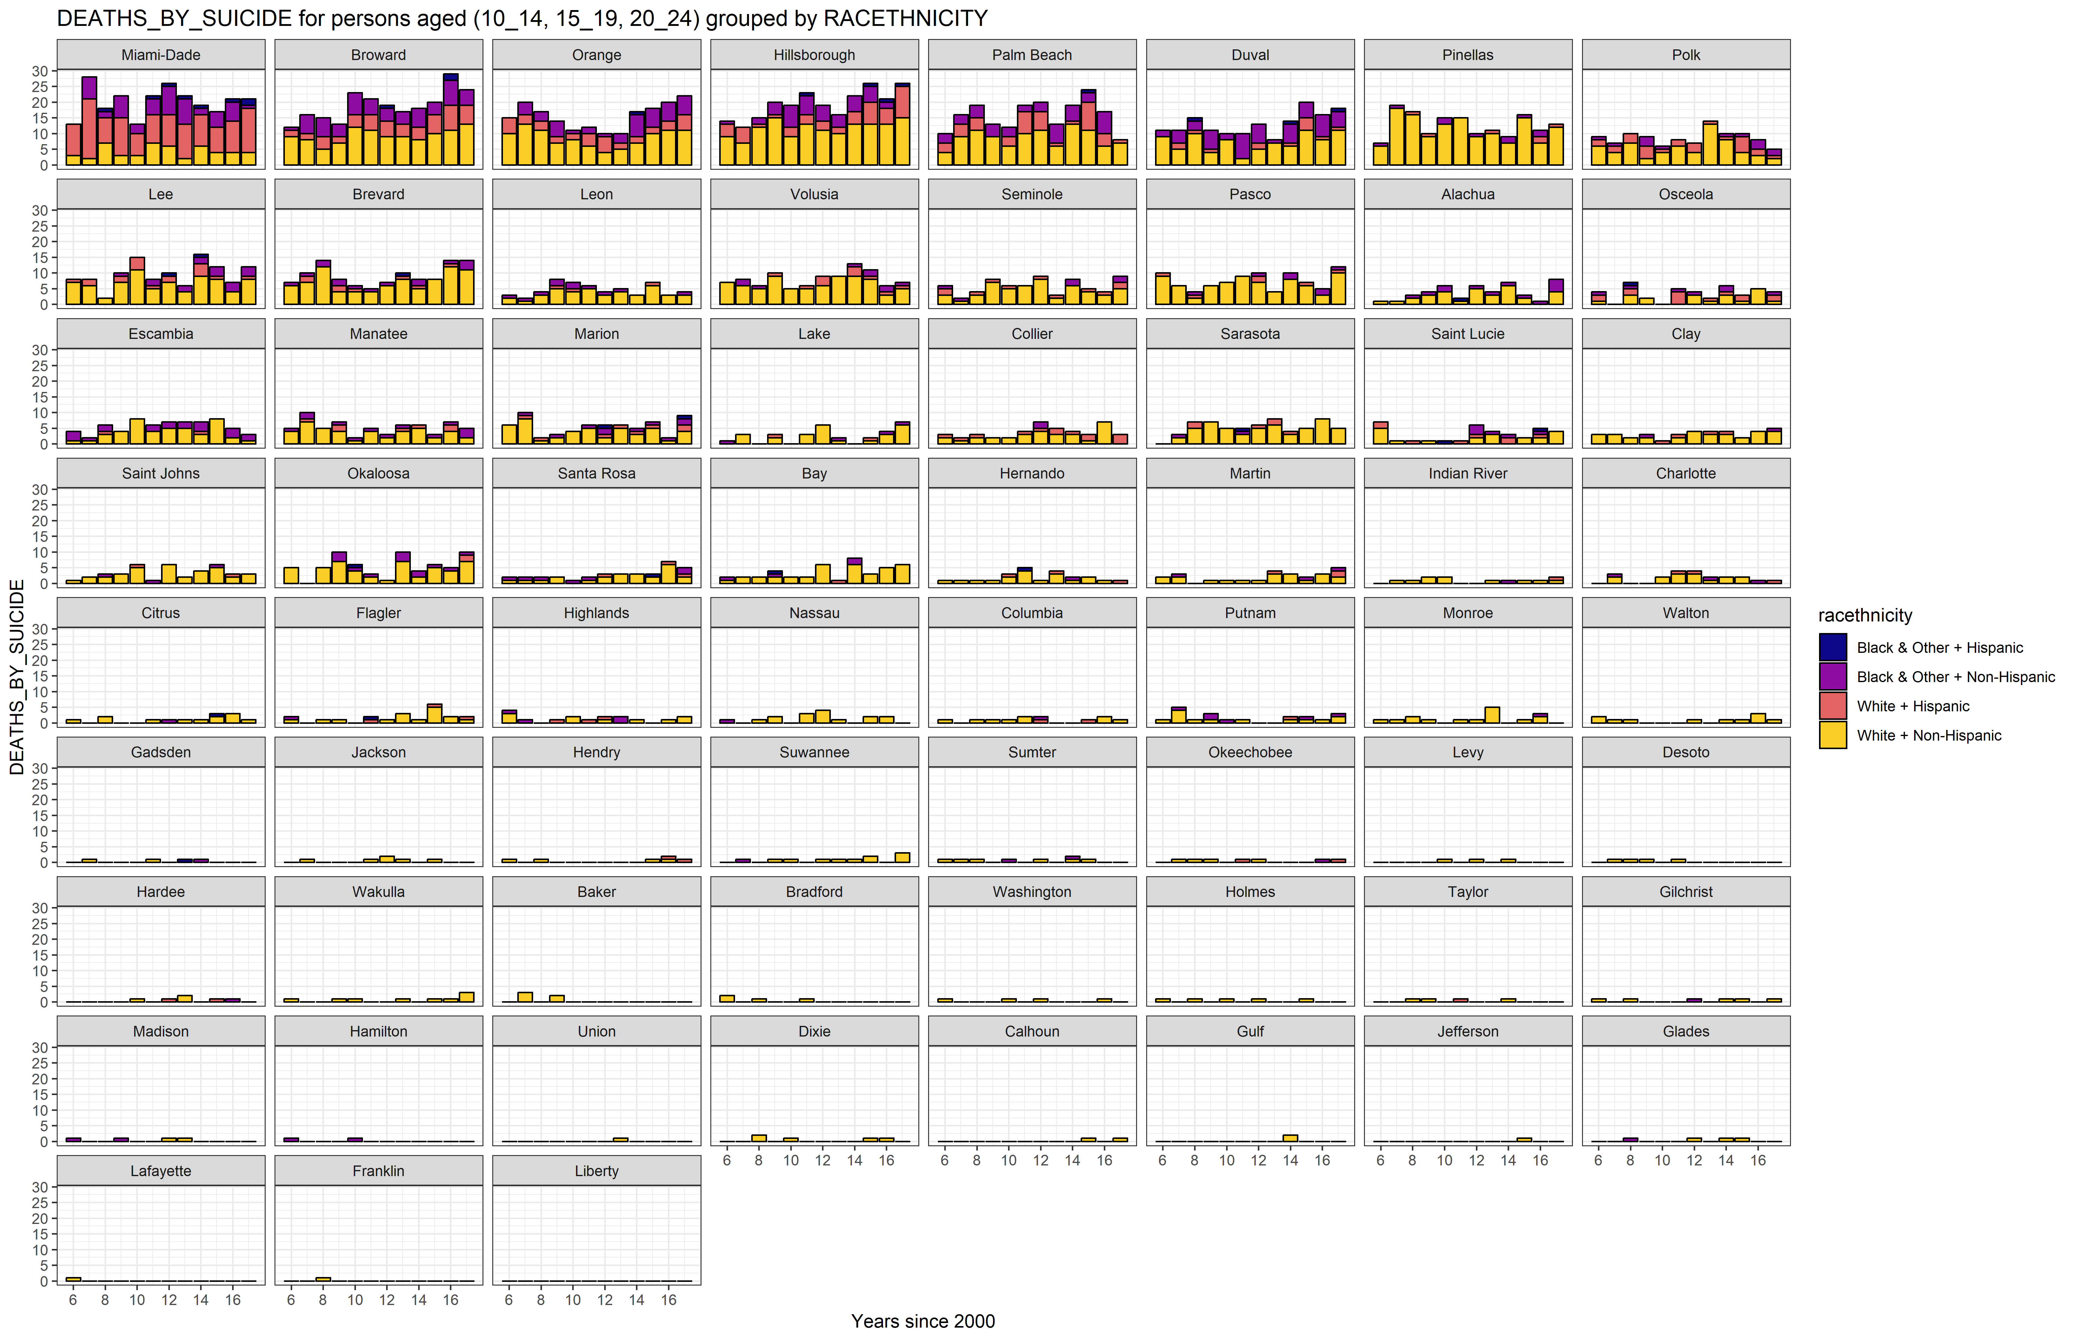

### p5

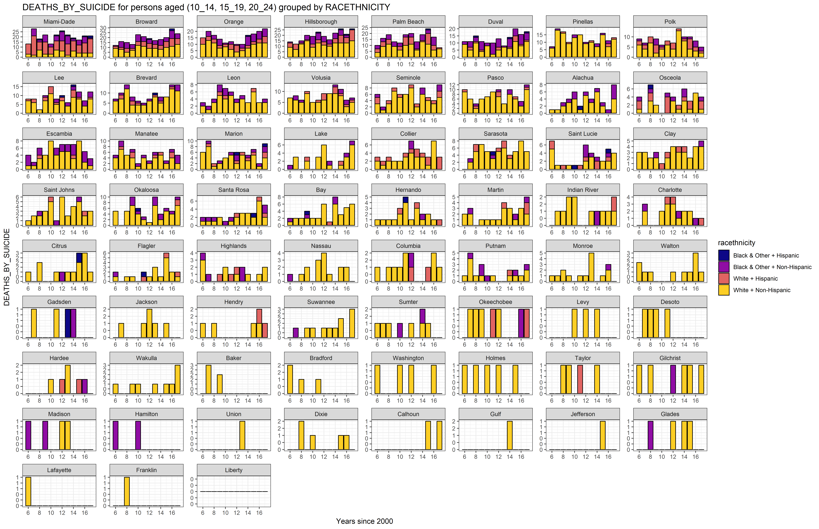

## Suicide Rates

### p6

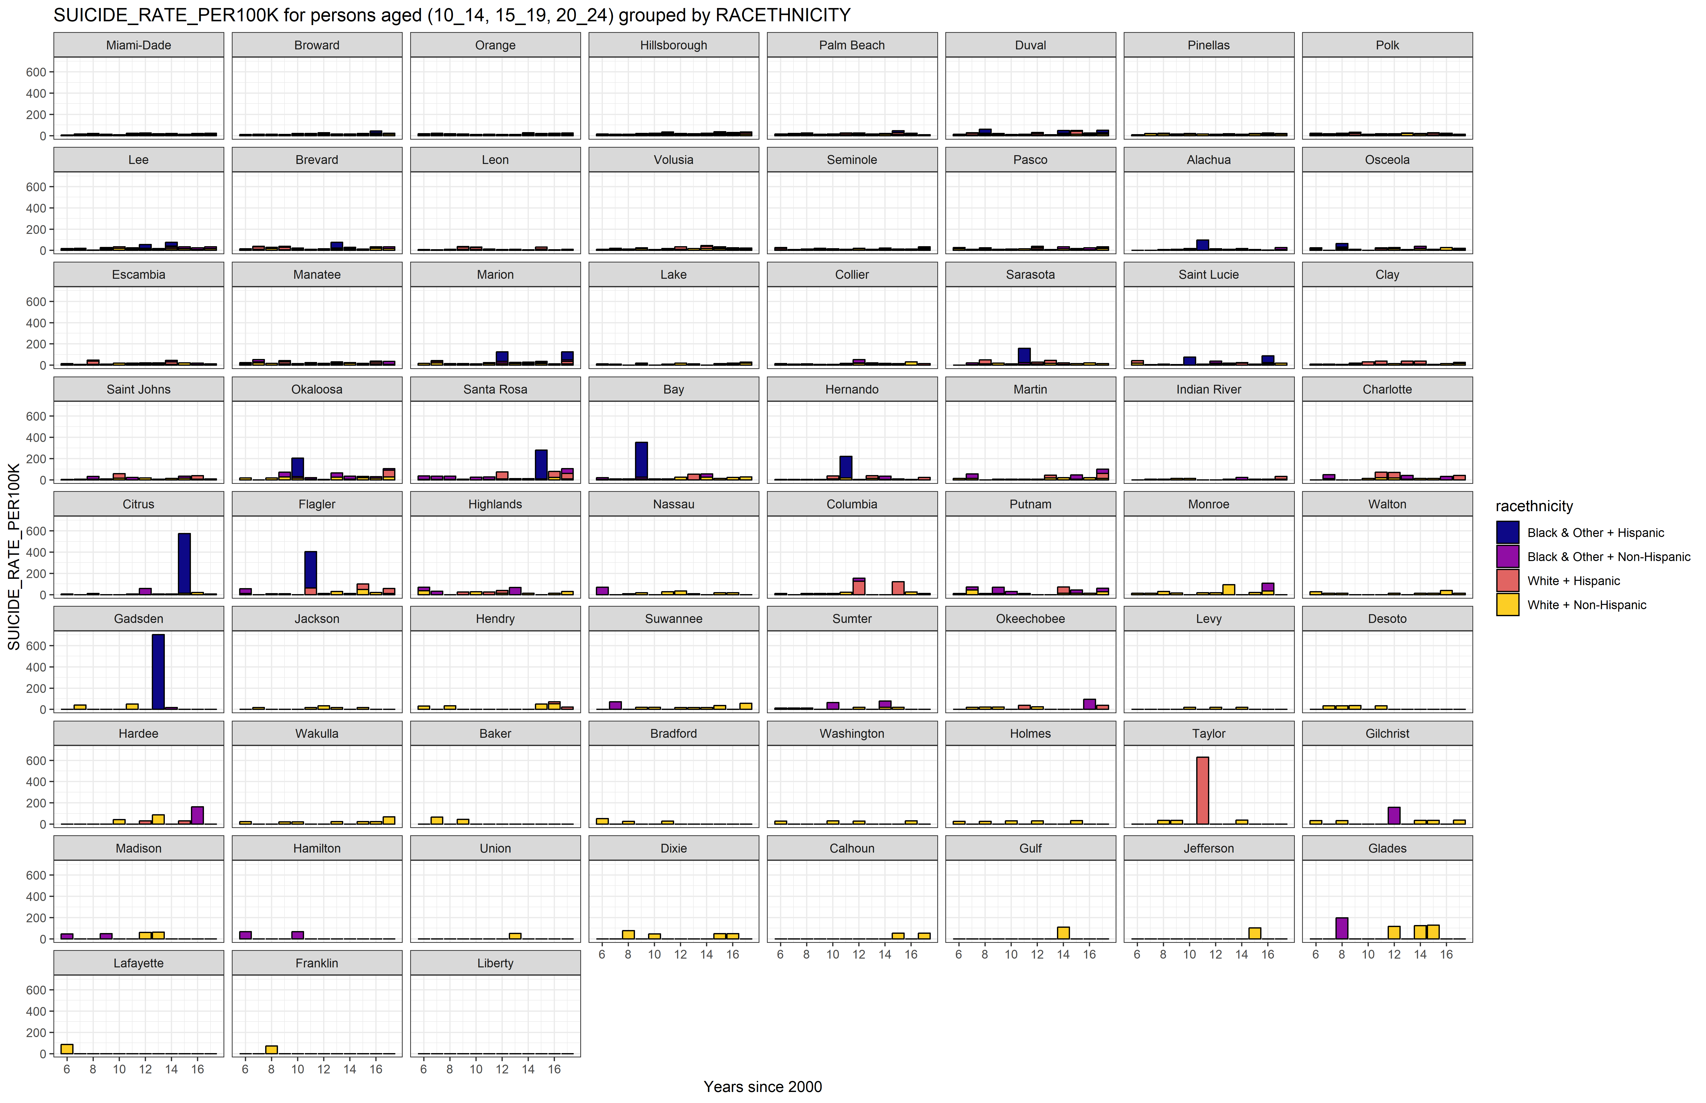

### p7

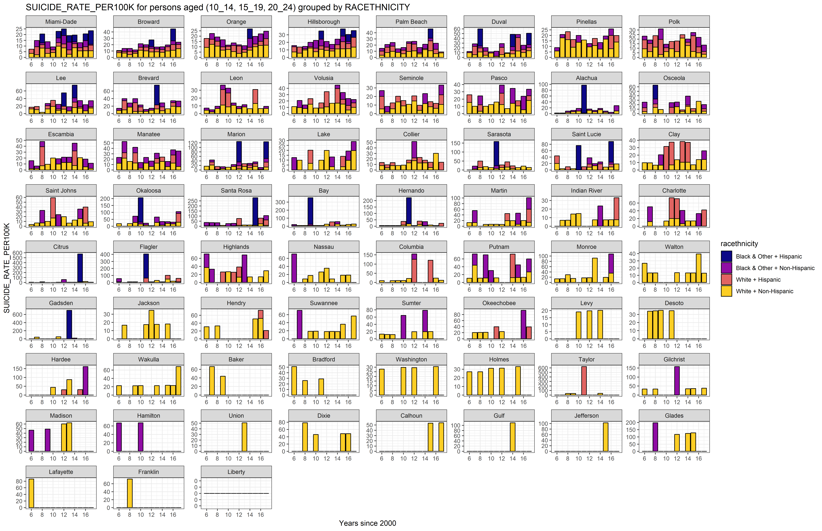

# III. Recapitulation

# Session Information

For the sake of documentation and reproducibility, the current report was rendered in the following environment. Click the line below to expand.

Environment

- Session info -------------------------------------------------------------------------------------------------------  
 setting value   
 version R version 3.5.2 (2018-12-20)  
 os Windows 10 x64   
 system x86_64, mingw32   
 ui RTerm   
 language (EN)   
 collate English_United States.1252   
 ctype English_United States.1252   
 tz America/Los_Angeles   
 date 2019-07-08   
  
- Packages -----------------------------------------------------------------------------------------------------------  
 package * version date lib source   
 abind 1.4-5 2016-07-21 [1] CRAN (R 3.5.2)  
 acepack 1.4.1 2016-10-29 [1] CRAN (R 3.5.3)  
 assertthat 0.2.1 2019-03-21 [1] CRAN (R 3.5.3)  
 backports 1.1.4 2019-04-10 [1] CRAN (R 3.5.3)  
 base64enc 0.1-3 2015-07-28 [1] CRAN (R 3.5.2)  
 callr 3.2.0 2019-03-15 [1] CRAN (R 3.5.3)  
 car 3.0-3 2019-05-27 [1] CRAN (R 3.5.3)  
 carData 3.0-2 2018-09-30 [1] CRAN (R 3.5.2)  
 cellranger 1.1.0 2016-07-27 [1] CRAN (R 3.5.3)  
 checkmate 1.9.3 2019-05-03 [1] CRAN (R 3.5.3)  
 cli 1.1.0 2019-03-19 [1] CRAN (R 3.5.3)  
 cluster 2.0.9 2019-05-01 [1] CRAN (R 3.5.3)  
 codetools 0.2-16 2018-12-24 [1] CRAN (R 3.5.2)  
 colorspace 1.4-1 2019-03-18 [1] CRAN (R 3.5.3)  
 crayon 1.3.4 2017-09-16 [1] CRAN (R 3.5.3)  
 curl 3.3 2019-01-10 [1] CRAN (R 3.5.3)  
 data.table 1.12.2 2019-04-07 [1] CRAN (R 3.5.3)  
 desc 1.2.0 2018-05-01 [1] CRAN (R 3.5.3)  
 devtools 2.0.2 2019-04-08 [1] CRAN (R 3.5.3)  
 digest 0.6.19 2019-05-20 [1] CRAN (R 3.5.3)  
 dplyr * 0.8.1 2019-05-14 [1] CRAN (R 3.5.3)  
 DT 0.6 2019-05-09 [1] CRAN (R 3.5.3)  
 evaluate 0.14 2019-05-28 [1] CRAN (R 3.5.2)  
 explore 0.4.2 2019-05-22 [1] CRAN (R 3.5.3)  
 fansi 0.4.0 2018-10-05 [1] CRAN (R 3.5.3)  
 forcats 0.4.0 2019-02-17 [1] CRAN (R 3.5.3)  
 foreign 0.8-71 2018-07-20 [2] CRAN (R 3.5.2)  
 Formula 1.2-3 2018-05-03 [1] CRAN (R 3.5.2)  
 fs 1.3.1 2019-05-06 [1] CRAN (R 3.5.3)  
 ggplot2 * 3.1.1 2019-04-07 [1] CRAN (R 3.5.3)  
 ggpubr * 0.2 2018-11-15 [1] CRAN (R 3.5.3)  
 glue 1.3.1 2019-03-12 [1] CRAN (R 3.5.3)  
 gridExtra 2.3 2017-09-09 [1] CRAN (R 3.5.3)  
 gtable 0.3.0 2019-03-25 [1] CRAN (R 3.5.3)  
 haven 2.1.0 2019-02-19 [1] CRAN (R 3.5.3)  
 Hmisc 4.2-0 2019-01-26 [1] CRAN (R 3.5.3)  
 hms 0.4.2 2018-03-10 [1] CRAN (R 3.5.3)  
 htmlTable 1.13.1 2019-01-07 [1] CRAN (R 3.5.3)  
 htmltools 0.3.6 2017-04-28 [1] CRAN (R 3.5.3)  
 htmlwidgets 1.3 2018-09-30 [1] CRAN (R 3.5.3)  
 httpuv 1.5.1 2019-04-05 [1] CRAN (R 3.5.3)  
 knitr * 1.23 2019-05-18 [1] CRAN (R 3.5.2)  
 labeling 0.3 2014-08-23 [1] CRAN (R 3.5.2)  
 later 0.8.0 2019-02-11 [1] CRAN (R 3.5.3)  
 lattice 0.20-38 2018-11-04 [2] CRAN (R 3.5.2)  
 latticeExtra 0.6-28 2016-02-09 [1] CRAN (R 3.5.3)  
 lazyeval 0.2.2 2019-03-15 [1] CRAN (R 3.5.3)  
 magrittr * 1.5 2014-11-22 [1] CRAN (R 3.5.3)  
 Matrix 1.2-17 2019-03-22 [1] CRAN (R 3.5.3)  
 memoise 1.1.0 2017-04-21 [1] CRAN (R 3.5.3)  
 mime 0.6 2018-10-05 [1] CRAN (R 3.5.2)  
 munsell 0.5.0 2018-06-12 [1] CRAN (R 3.5.3)  
 nnet 7.3-12 2016-02-02 [2] CRAN (R 3.5.2)  
 openxlsx 4.1.0.1 2019-05-28 [1] CRAN (R 3.5.3)  
 pillar 1.4.1 2019-05-28 [1] CRAN (R 3.5.2)  
 pkgbuild 1.0.3 2019-03-20 [1] CRAN (R 3.5.3)  
 pkgconfig 2.0.2 2018-08-16 [1] CRAN (R 3.5.3)  
 pkgload 1.0.2 2018-10-29 [1] CRAN (R 3.5.3)  
 plyr 1.8.4 2016-06-08 [1] CRAN (R 3.5.3)  
 prettyunits 1.0.2 2015-07-13 [1] CRAN (R 3.5.3)  
 processx 3.3.1 2019-05-08 [1] CRAN (R 3.5.2)  
 promises 1.0.1 2018-04-13 [1] CRAN (R 3.5.3)  
 pryr 0.1.4 2018-02-18 [1] CRAN (R 3.5.3)  
 ps 1.3.0 2018-12-21 [1] CRAN (R 3.5.3)  
 purrr 0.3.2 2019-03-15 [1] CRAN (R 3.5.3)  
 R6 2.4.0 2019-02-14 [1] CRAN (R 3.5.3)  
 RColorBrewer 1.1-2 2014-12-07 [1] CRAN (R 3.5.2)  
 Rcpp 1.0.1 2019-03-17 [1] CRAN (R 3.5.3)  
 readxl 1.3.1 2019-03-13 [1] CRAN (R 3.5.3)  
 remotes 2.0.4 2019-04-10 [1] CRAN (R 3.5.3)  
 reshape2 1.4.3 2017-12-11 [1] CRAN (R 3.5.3)  
 rio 0.5.16 2018-11-26 [1] CRAN (R 3.5.3)  
 rlang 0.3.4 2019-04-07 [1] CRAN (R 3.5.3)  
 rmarkdown 1.13 2019-05-22 [1] CRAN (R 3.5.3)  
 rpart 4.1-15 2019-04-12 [1] CRAN (R 3.5.3)  
 rprojroot 1.3-2 2018-01-03 [1] CRAN (R 3.5.3)  
 rstudioapi 0.10 2019-03-19 [1] CRAN (R 3.5.3)  
 scales 1.0.0 2018-08-09 [1] CRAN (R 3.5.3)  
 sessioninfo 1.1.1 2018-11-05 [1] CRAN (R 3.5.3)  
 shiny 1.3.2 2019-04-22 [1] CRAN (R 3.5.2)  
 stringi 1.4.3 2019-03-12 [1] CRAN (R 3.5.3)  
 stringr 1.4.0 2019-02-10 [1] CRAN (R 3.5.3)  
 survival 2.44-1.1 2019-04-01 [1] CRAN (R 3.5.3)  
 tibble 2.1.3 2019-06-06 [1] CRAN (R 3.5.3)  
 tidyselect 0.2.5 2018-10-11 [1] CRAN (R 3.5.3)  
 usethis 1.5.0 2019-04-07 [1] CRAN (R 3.5.3)  
 utf8 1.1.4 2018-05-24 [1] CRAN (R 3.5.3)  
 vctrs 0.1.0 2018-11-29 [1] CRAN (R 3.5.3)  
 viridisLite 0.3.0 2018-02-01 [1] CRAN (R 3.5.3)  
 withr 2.1.2 2018-03-15 [1] CRAN (R 3.5.3)  
 xfun 0.7 2019-05-14 [1] CRAN (R 3.5.3)  
 xtable 1.8-4 2019-04-21 [1] CRAN (R 3.5.3)  
 yaml 2.2.0 2018-07-25 [1] CRAN (R 3.5.2)  
 zeallot 0.1.0 2018-01-28 [1] CRAN (R 3.5.3)  
 zip 2.0.2 2019-05-13 [1] CRAN (R 3.5.3)  
  
[1] C:/Users/an499583/Documents/R/win-library/3.5  
[2] C:/Program Files/R/R-3.5.2/library

Report rendered by an499583 at 2019-07-08, 13:09 -0700 in 67 seconds.