GLS Activity: Coverage

Table of Contents

# Set the scene

Describe the working environment.

# Attach these packages so their functions don't need to be qualified  
library(magrittr) # pipes  
library(dplyr) # disable when temp lines are removed  
library(ggplot2) # graphs  
library(ggpubr) # documents

# Call `base::source()` on any repo file that defines functions needed below.   
base::source("./scripts/common-functions.R")

path_file_input <- "./data-unshared/derived/0-greeted-gls.rds"  
html_flip <- FALSE  
output_format = "pandoc"  
baseSize <- 10

#Put code in here. It doesn't call a chunk in the codebehind file.

dto <- readRDS(path_file_input)  
dto %>% pryr::object_size(); dto %>% class(); dto %>% names()

112 kB

[1] "tbl_df" "tbl" "data.frame"

[1] "region" "audience" "county_zipcode" "type_training" "n_trained" "date"   
[7] "county" "zipcode"

# assign aliases for this report  
ds <- dto

# create auxilary variables  
ds <- ds %>%   
 # dplyr::select(-county_zipcode) %>%   
 dplyr::mutate(  
 year = lubridate::year(date)  
 ,month = lubridate::month(date)  
 ,yearmonth = zoo::as.yearmon(date)  
 ,weekday = lubridate::wday(date)  
 ,rgn = car::recode(  
 region,  
 "  
 'central'='CN'  
 ;'southeast'='SE'  
 ;'northeast'='NE '  
 "  
 )  
 )  
  
ds %>% glimpse(60)

Observations: 1,017  
Variables: 13  
$ region <chr> "central", "central", "central",...  
$ audience <chr> "professionals", "professionals"...  
$ county_zipcode <chr> "Orange/32825", "Brevard/32796",...  
$ type_training <chr> "QPR", "QPR", "QPR", "QPR", "QPR...  
$ n_trained <dbl> 7, 35, 21, 21, 25, 22, 19, 24, 1...  
$ date <date> 2015-07-16, 2015-08-07, 2015-09...  
$ county <chr> "Orange", "Brevard", "Orange", "...  
$ zipcode <chr> "32825", "32796", "32804", "3280...  
$ year <dbl> 2015, 2015, 2015, 2015, 2015, 20...  
$ month <dbl> 7, 8, 9, 10, 10, 11, 12, 1, 2, 2...  
$ yearmonth <yearmon> Jul 2015, Aug 2015, Sep 2015...  
$ weekday <dbl> 5, 6, 6, 7, 1, 5, 4, 6, 5, 1, 7,...  
$ rgn <chr> "CN", "CN", "CN", "CN", "CN", "C...

# ds %>% explore::explore( )  
ds %>% explore::describe()

variable type na na_pct unique min mean max  
1 region chr 0 0.0 3 NA NA NA  
2 audience chr 0 0.0 2 NA NA NA  
3 county_zipcode chr 31 3.0 161 NA NA NA  
4 type_training chr 0 0.0 271 NA NA NA  
5 n_trained dou 12 1.2 83 0 35.21 3200  
6 date dat 4 0.4 656 NA NA NA  
7 county chr 31 3.0 25 NA NA NA  
8 zipcode chr 96 9.4 140 NA NA NA  
9 year dou 4 0.4 7 2014 2017.03 2019  
10 month dou 4 0.4 13 1 6.22 12  
11 yearmonth oth 4 0.4 57 NA NA NA  
12 weekday dou 4 0.4 8 1 4.74 7  
13 rgn chr 0 0.0 3 NA NA NA

# I Exposition

## all regions

Trained PROFESSIONALS by training type (for all years)

county

total_trained

Care Coordination

Family Training

Postvention

QPR

QPRT

Orange (central)

2333

140

96

106

1957

34

Saint Lucie (southeast)

1213

44

40

.

1073

56

Volusia (northeast)

816

65

42

14

652

43

Lake (northeast)

660

36

64

.

524

36

Palm Beach (southeast)

610

110

42

.

448

10

Seminole (central)

517

18

141

54

267

37

Brevard (central)

502

254

11

87

146

4

Saint Johns (northeast)

248

27

10

55

152

4

Duval (northeast)

235

5

.

.

220

10

Hernando (northeast)

215

.

85

.

130

.

Indian River (southeast)

195

.

.

.

194

1

Marion (northeast)

195

.

53

48

94

.

Osceola (central)

135

24

9

.

83

19

Clay (northeast)

127

.

28

.

99

.

Martin (southeast)

123

26

.

.

97

.

Sumter (northeast)

105

.

.

.

92

13

Flagler (northeast)

104

12

.

.

92

.

Citrus (northeast)

77

.

27

.

50

.

Levy (northeast)

34

.

.

.

34

.

Okeechobee (southeast)

22

.

.

.

22

.

NA (northeast)

19

.

19

.

.

.

Putnam (northeast)

13

.

7

.

6

.

Polk (central)

11

.

.

.

11

.

Leon (northeast)

8

.

8

.

.

.

Pasco (northeast)

6

.

.

.

6

.

Trained PROFESSIONALS by year (for all training types)

county

total_trained

2014

2015

2016

2017

2018

2019

<NA>

Orange (central)

2333

.

81

363

1161

582

146

.

Saint Lucie (southeast)

1213

.

49

230

551

356

27

.

Volusia (northeast)

816

.

20

174

238

342

28

14

Lake (northeast)

660

.

19

136

135

312

58

.

Palm Beach (southeast)

610

.

4

46

191

290

79

.

Seminole (central)

517

.

19

192

208

84

14

.

Brevard (central)

502

.

57

89

20

336

.

.

Saint Johns (northeast)

248

35

50

31

94

29

9

.

Duval (northeast)

235

.

148

65

22

.

.

.

Hernando (northeast)

215

.

21

85

25

20

64

.

Indian River (southeast)

195

.

.

67

51

27

50

.

Marion (northeast)

195

.

36

32

51

28

.

48

Osceola (central)

135

.

.

25

59

36

15

.

Clay (northeast)

127

28

25

.

.

74

.

.

Martin (southeast)

123

.

.

.

46

51

.

26

Sumter (northeast)

105

.

18

29

34

.

24

.

Flagler (northeast)

104

.

.

10

19

49

26

.

Citrus (northeast)

77

.

28

10

.

39

.

.

Levy (northeast)

34

.

.

.

.

34

.

.

Okeechobee (southeast)

22

.

.

13

8

1

.

.

NA (northeast)

19

.

.

.

.

19

.

.

Putnam (northeast)

13

.

.

7

6

.

.

.

Polk (central)

11

.

.

11

.

.

.

.

Leon (northeast)

8

.

.

.

.

.

8

.

Pasco (northeast)

6

.

.

6

.

.

.

.

Trained IN COMMUNITY by year (for all training types)

county

total_trained

2015

2016

2017

2018

2019

<NA>

Orange (central)

9337

1535

2883

3764

955

200

.

Volusia (northeast)

3948

125

1208

837

1438

340

.

Palm Beach (southeast)

2585

25

355

555

1400

250

.

Seminole (central)

2560

200

1550

650

160

.

.

Saint Lucie (southeast)

2113

25

88

955

830

215

.

Brevard (central)

1481

186

500

440

310

45

.

Flagler (northeast)

1375

.

160

237

743

235

.

Martin (southeast)

1000

.

45

490

340

125

.

NA (southeast)

455

30

425

.

.

.

.

Saint Johns (northeast)

389

250

.

.

109

.

30

Marion (northeast)

325

115

.

210

.

.

.

NA (northeast)

309

40

108

160

.

1

.

Indian River (southeast)

245

135

70

40

.

.

.

Lake (northeast)

206

8

183

15

.

.

.

NA (central)

200

200

.

.

.

.

.

Hernando (northeast)

115

.

115

.

.

.

.

Leon (northeast)

100

.

60

40

.

.

.

Sumter (northeast)

85

.

65

20

.

.

.

Osceola (central)

35

.

.

35

.

.

.

for(region_i in regions_available){  
 cat("\n## ", region_i, "\n")  
 ds %>% region_table(pick_region = region_i)  
 cat("\n")  
}

## central

Trained PROFESSIONALS by training type (for all years)

county

total_trained

Care Coordination

Family Training

Postvention

QPR

QPRT

Orange

2333

140

96

106

1957

34

Seminole

517

18

141

54

267

37

Brevard

502

254

11

87

146

4

Osceola

135

24

9

.

83

19

Polk

11

.

.

.

11

.

Trained PROFESSIONALS by year (for all training types)

county

total_trained

2015

2016

2017

2018

2019

Orange

2333

81

363

1161

582

146

Seminole

517

19

192

208

84

14

Brevard

502

57

89

20

336

.

Osceola

135

.

25

59

36

15

Polk

11

.

11

.

.

.

Trained IN COMMUNITY by year (for all training types)

county

total_trained

2015

2016

2017

2018

2019

Orange

9337

1535

2883

3764

955

200

Seminole

2560

200

1550

650

160

.

Brevard

1481

186

500

440

310

45

.

200

200

.

.

.

.

Osceola

35

.

.

35

.

.

## southeast

Trained PROFESSIONALS by training type (for all years)

county

total_trained

Care Coordination

Family Training

QPR

QPRT

Saint Lucie

1213

44

40

1073

56

Palm Beach

610

110

42

448

10

Indian River

195

.

.

194

1

Martin

123

26

.

97

.

Okeechobee

22

.

.

22

.

Trained PROFESSIONALS by year (for all training types)

county

total_trained

2015

2016

2017

2018

2019

<NA>

Saint Lucie

1213

49

230

551

356

27

.

Palm Beach

610

4

46

191

290

79

.

Indian River

195

.

67

51

27

50

.

Martin

123

.

.

46

51

.

26

Okeechobee

22

.

13

8

1

.

.

Trained IN COMMUNITY by year (for all training types)

county

total_trained

2015

2016

2017

2018

2019

Palm Beach

2585

25

355

555

1400

250

Saint Lucie

2113

25

88

955

830

215

Martin

1000

.

45

490

340

125

.

455

30

425

.

.

.

Indian River

245

135

70

40

.

.

## northeast

Trained PROFESSIONALS by training type (for all years)

county

total_trained

Care Coordination

Family Training

Postvention

QPR

QPRT

Volusia

816

65

42

14

652

43

Lake

660

36

64

.

524

36

Saint Johns

248

27

10

55

152

4

Duval

235

5

.

.

220

10

Hernando

215

.

85

.

130

.

Marion

195

.

53

48

94

.

Clay

127

.

28

.

99

.

Sumter

105

.

.

.

92

13

Flagler

104

12

.

.

92

.

Citrus

77

.

27

.

50

.

Levy

34

.

.

.

34

.

.

19

.

19

.

.

.

Putnam

13

.

7

.

6

.

Leon

8

.

8

.

.

.

Pasco

6

.

.

.

6

.

Trained PROFESSIONALS by year (for all training types)

county

total_trained

2014

2015

2016

2017

2018

2019

<NA>

Volusia

816

.

20

174

238

342

28

14

Lake

660

.

19

136

135

312

58

.

Saint Johns

248

35

50

31

94

29

9

.

Duval

235

.

148

65

22

.

.

.

Hernando

215

.

21

85

25

20

64

.

Marion

195

.

36

32

51

28

.

48

Clay

127

28

25

.

.

74

.

.

Sumter

105

.

18

29

34

.

24

.

Flagler

104

.

.

10

19

49

26

.

Citrus

77

.

28

10

.

39

.

.

Levy

34

.

.

.

.

34

.

.

.

19

.

.

.

.

19

.

.

Putnam

13

.

.

7

6

.

.

.

Leon

8

.

.

.

.

.

8

.

Pasco

6

.

.

6

.

.

.

.

Trained IN COMMUNITY by year (for all training types)

county

total_trained

2015

2016

2017

2018

2019

<NA>

Volusia

3948

125

1208

837

1438

340

.

Flagler

1375

.

160

237

743

235

.

Saint Johns

389

250

.

.

109

.

30

Marion

325

115

.

210

.

.

.

.

309

40

108

160

.

1

.

Lake

206

8

183

15

.

.

.

Hernando

115

.

115

.

.

.

.

Leon

100

.

60

40

.

.

.

Sumter

85

.

65

20

.

.

.

# II Scatter

## 1 County

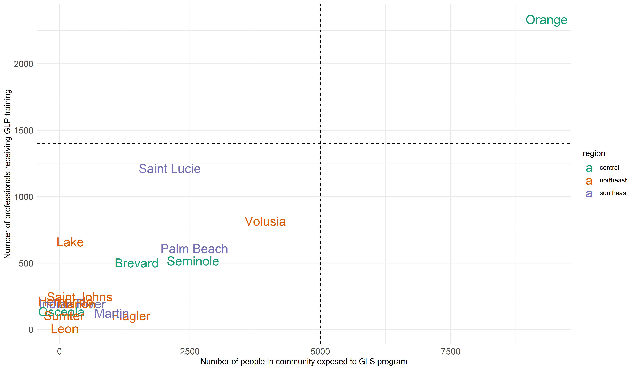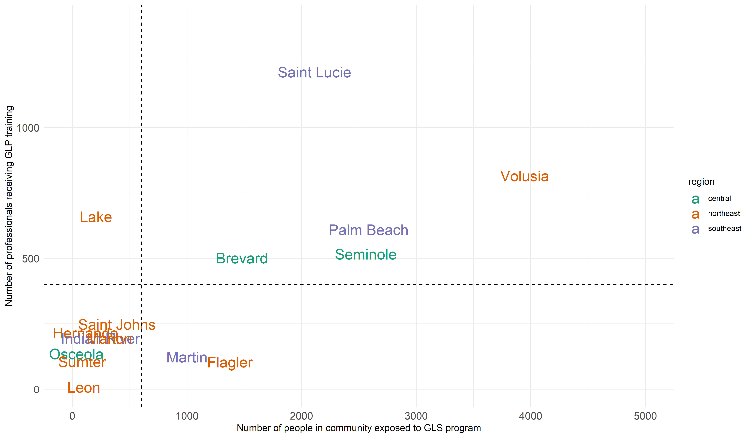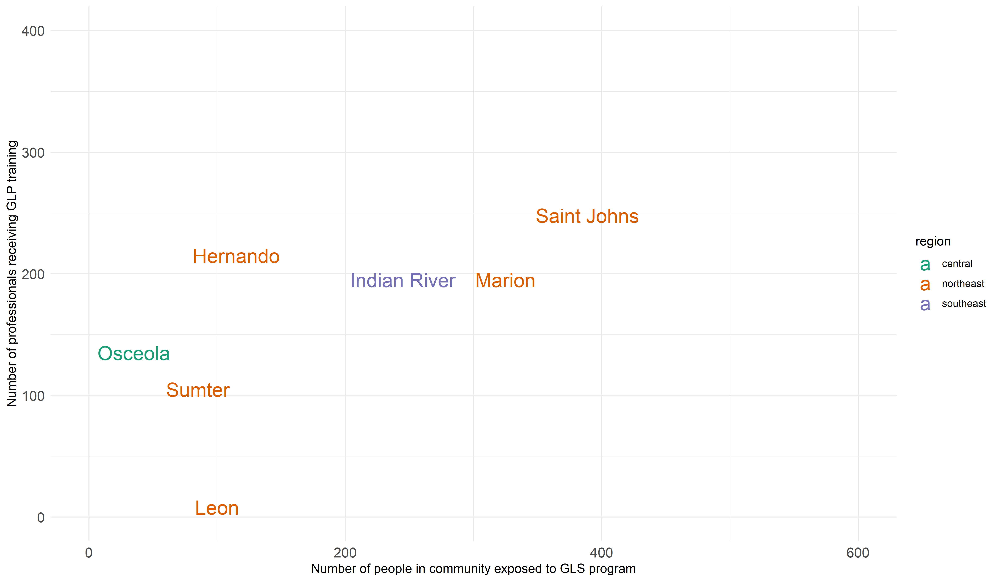

# III Coverage

## Combined

ds %>% show_coverage()

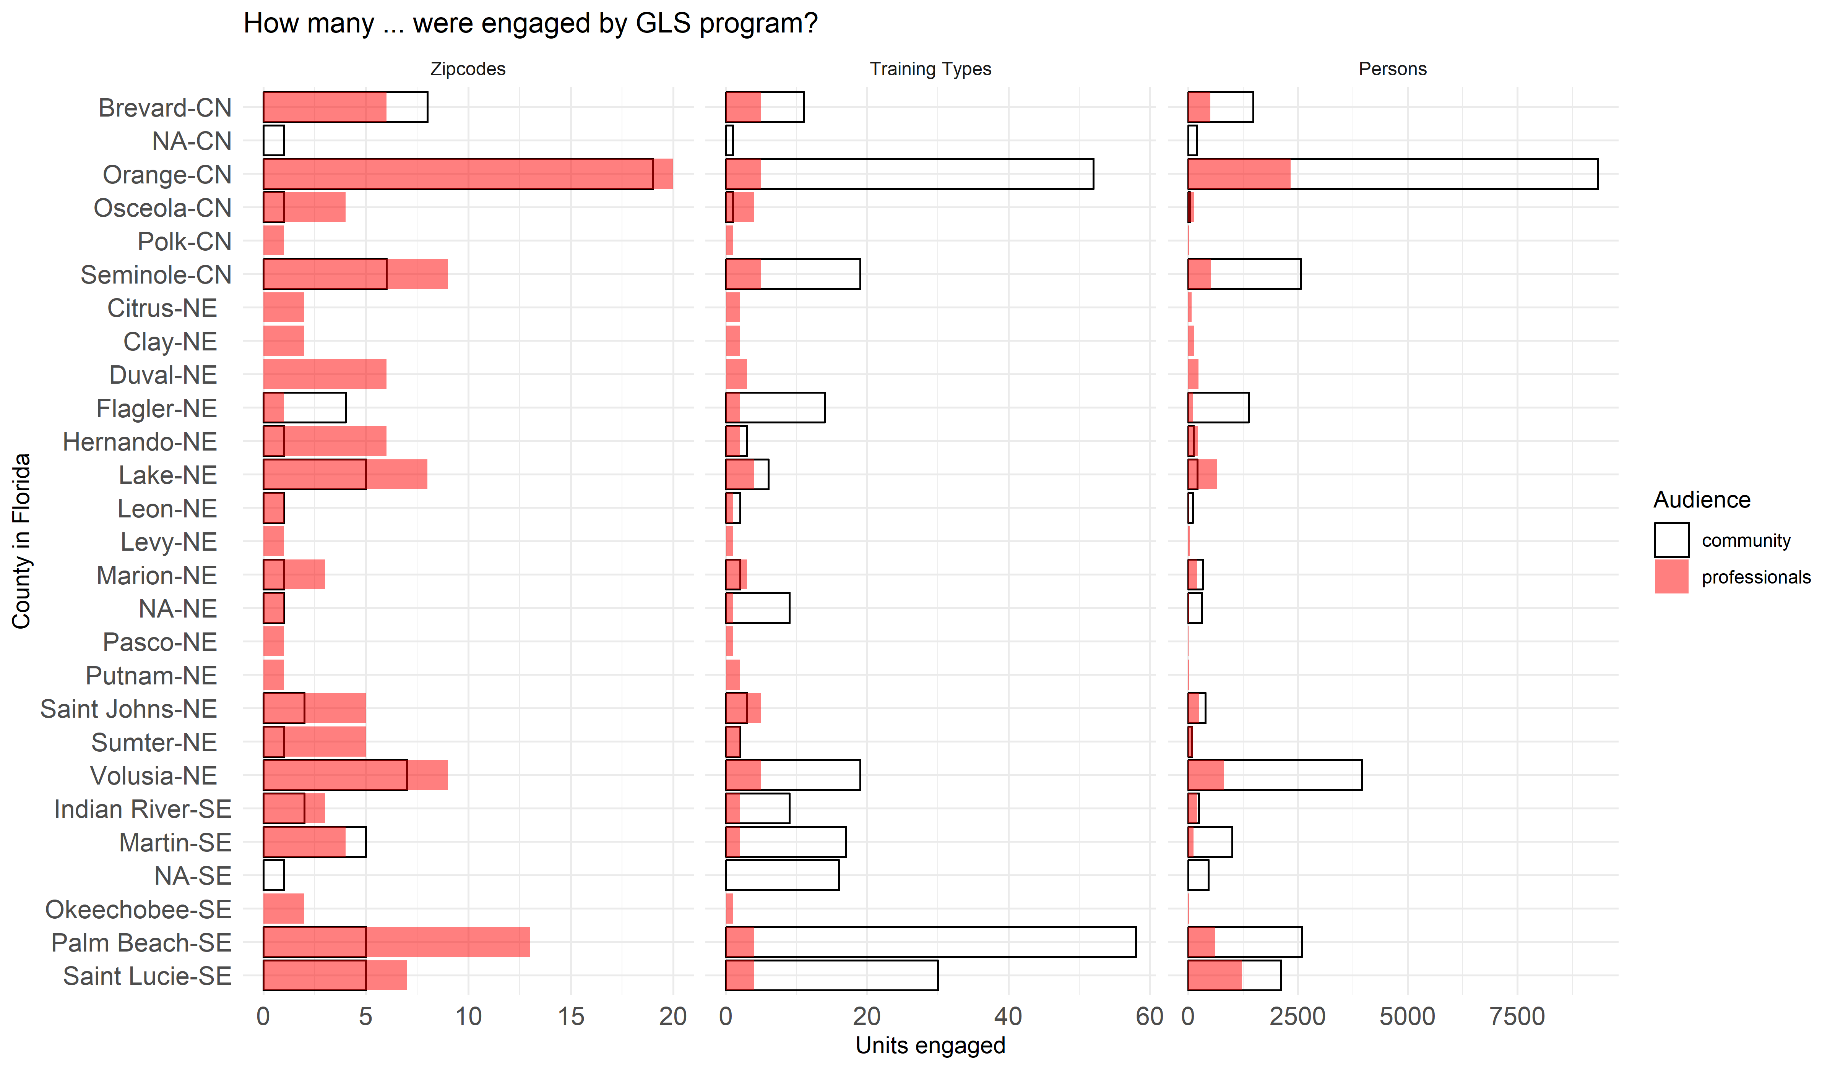

# to remove the outlier  
ds %>%   
 dplyr::filter( !county %in% c("Orange") ) %>%   
 show_coverage()

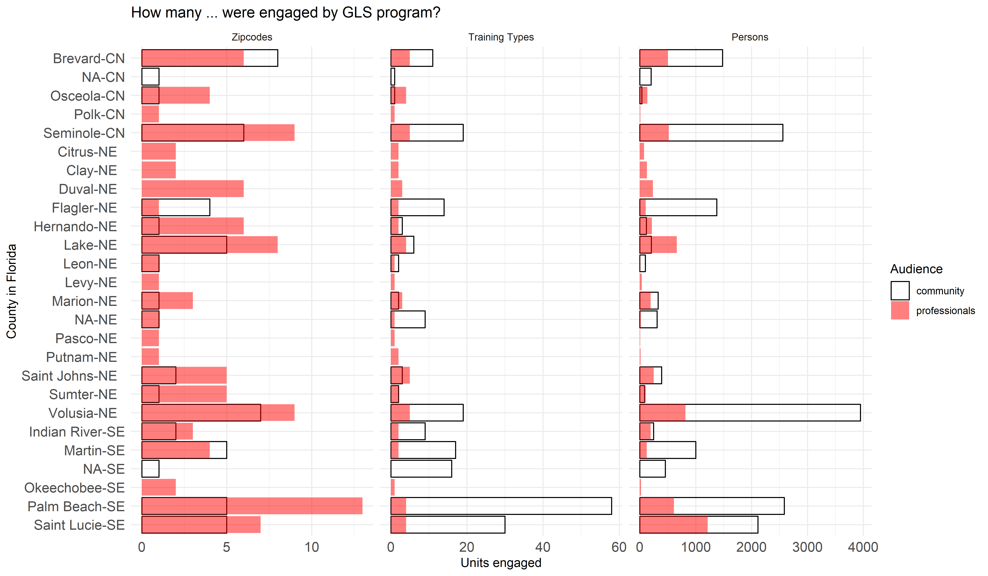

## Professionals

ds %>% show_coverage("professionals")

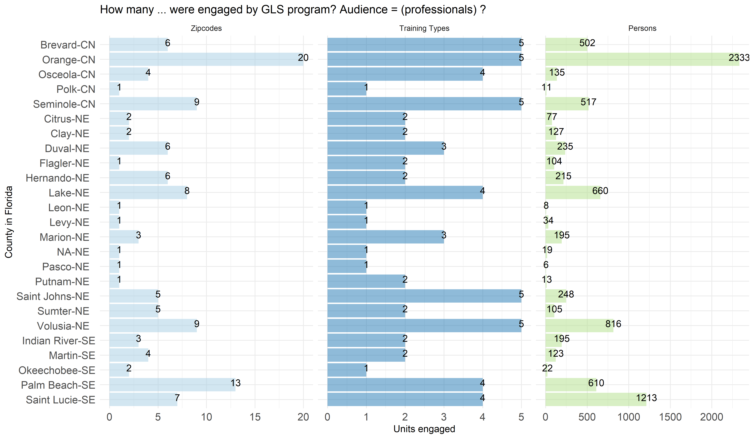

## Community

ds %>% show_coverage("community")

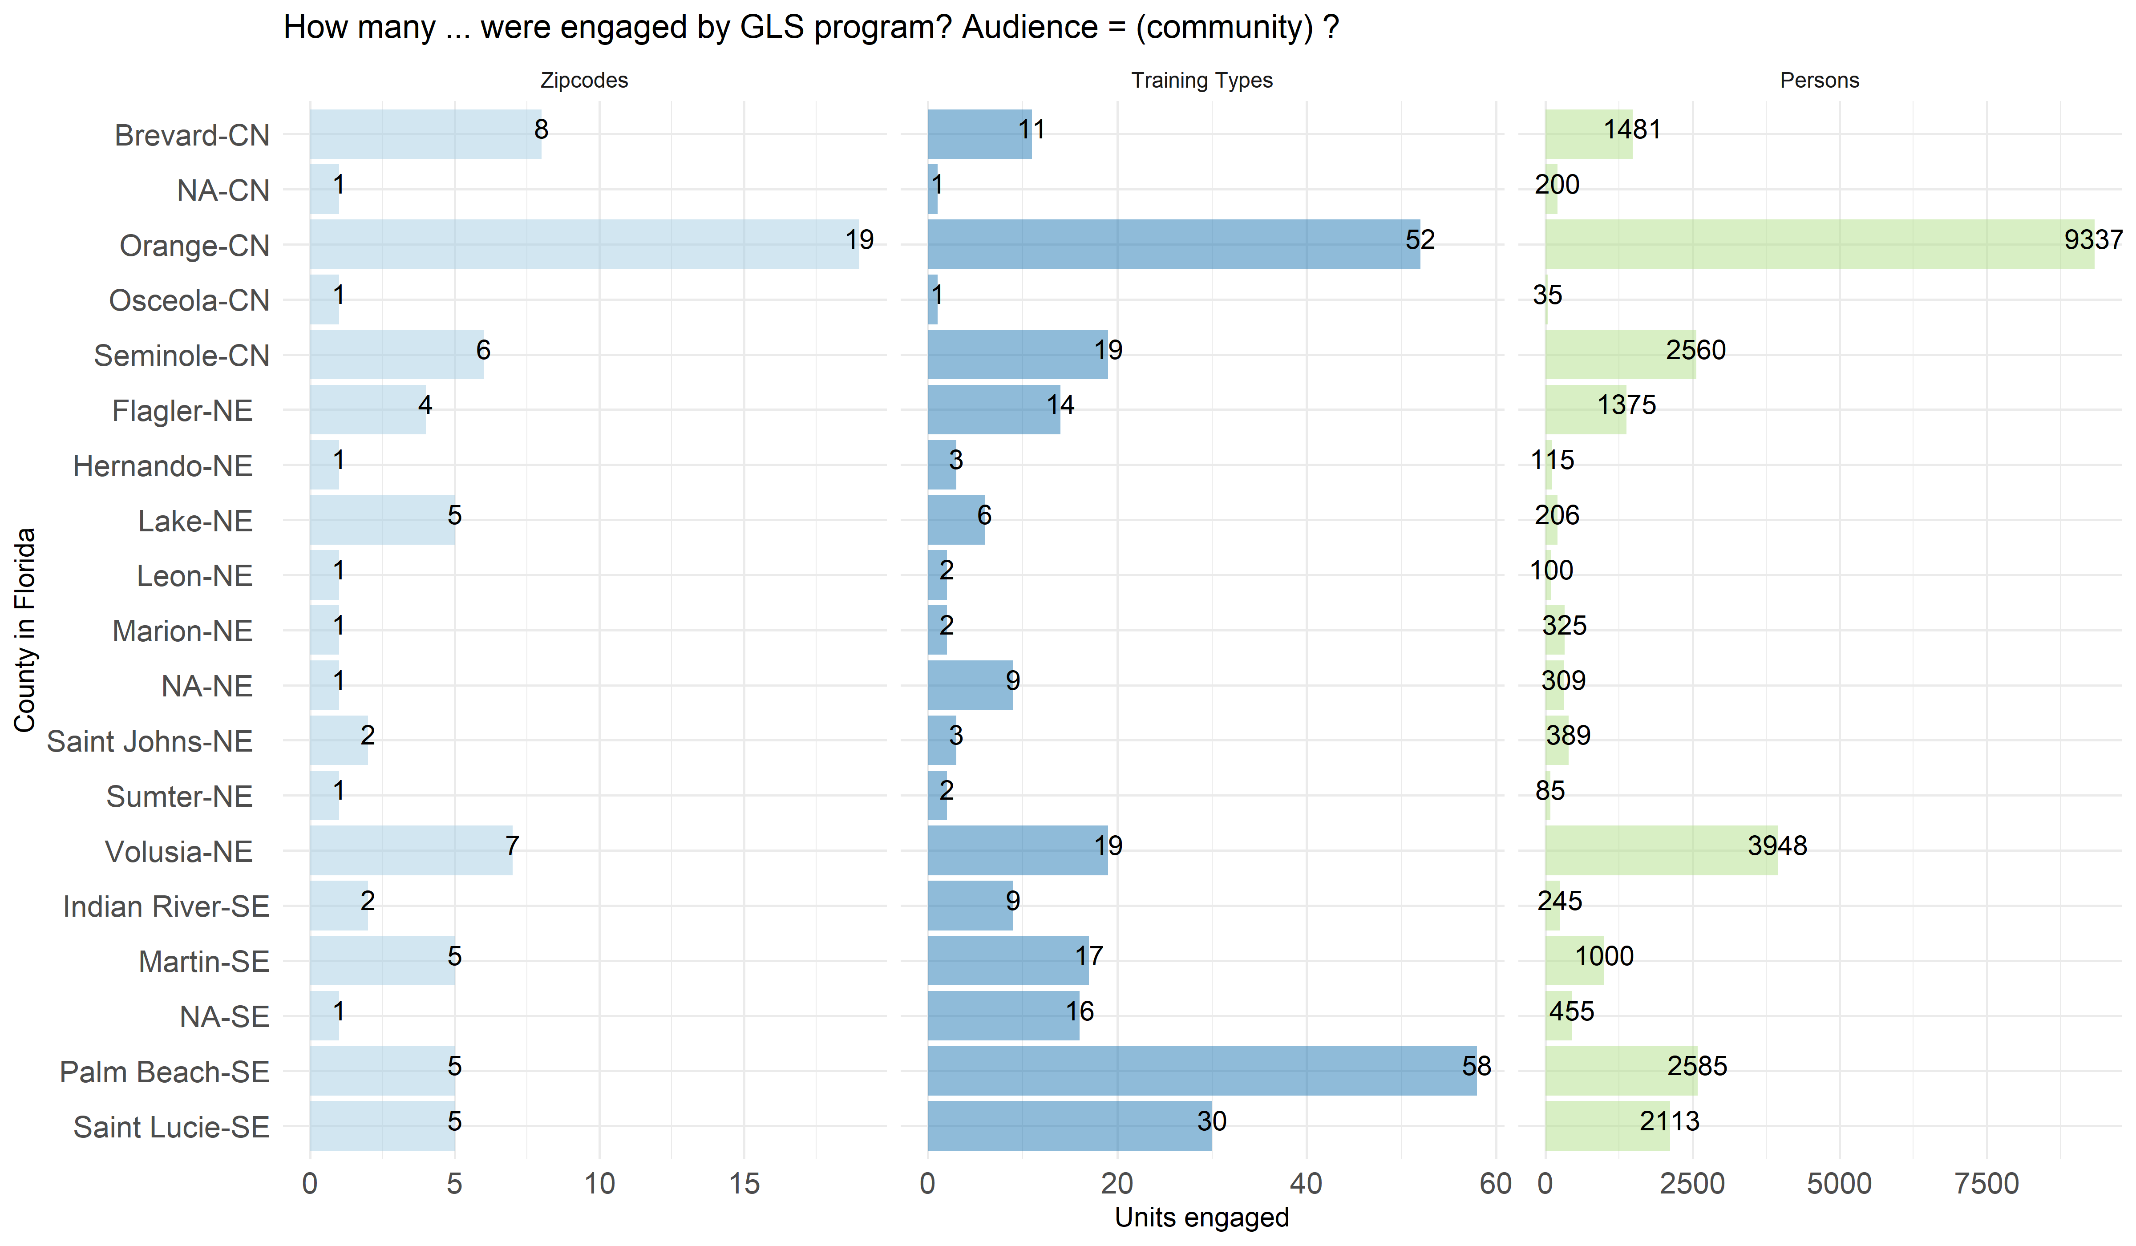

# IV Schedule

## Professionals

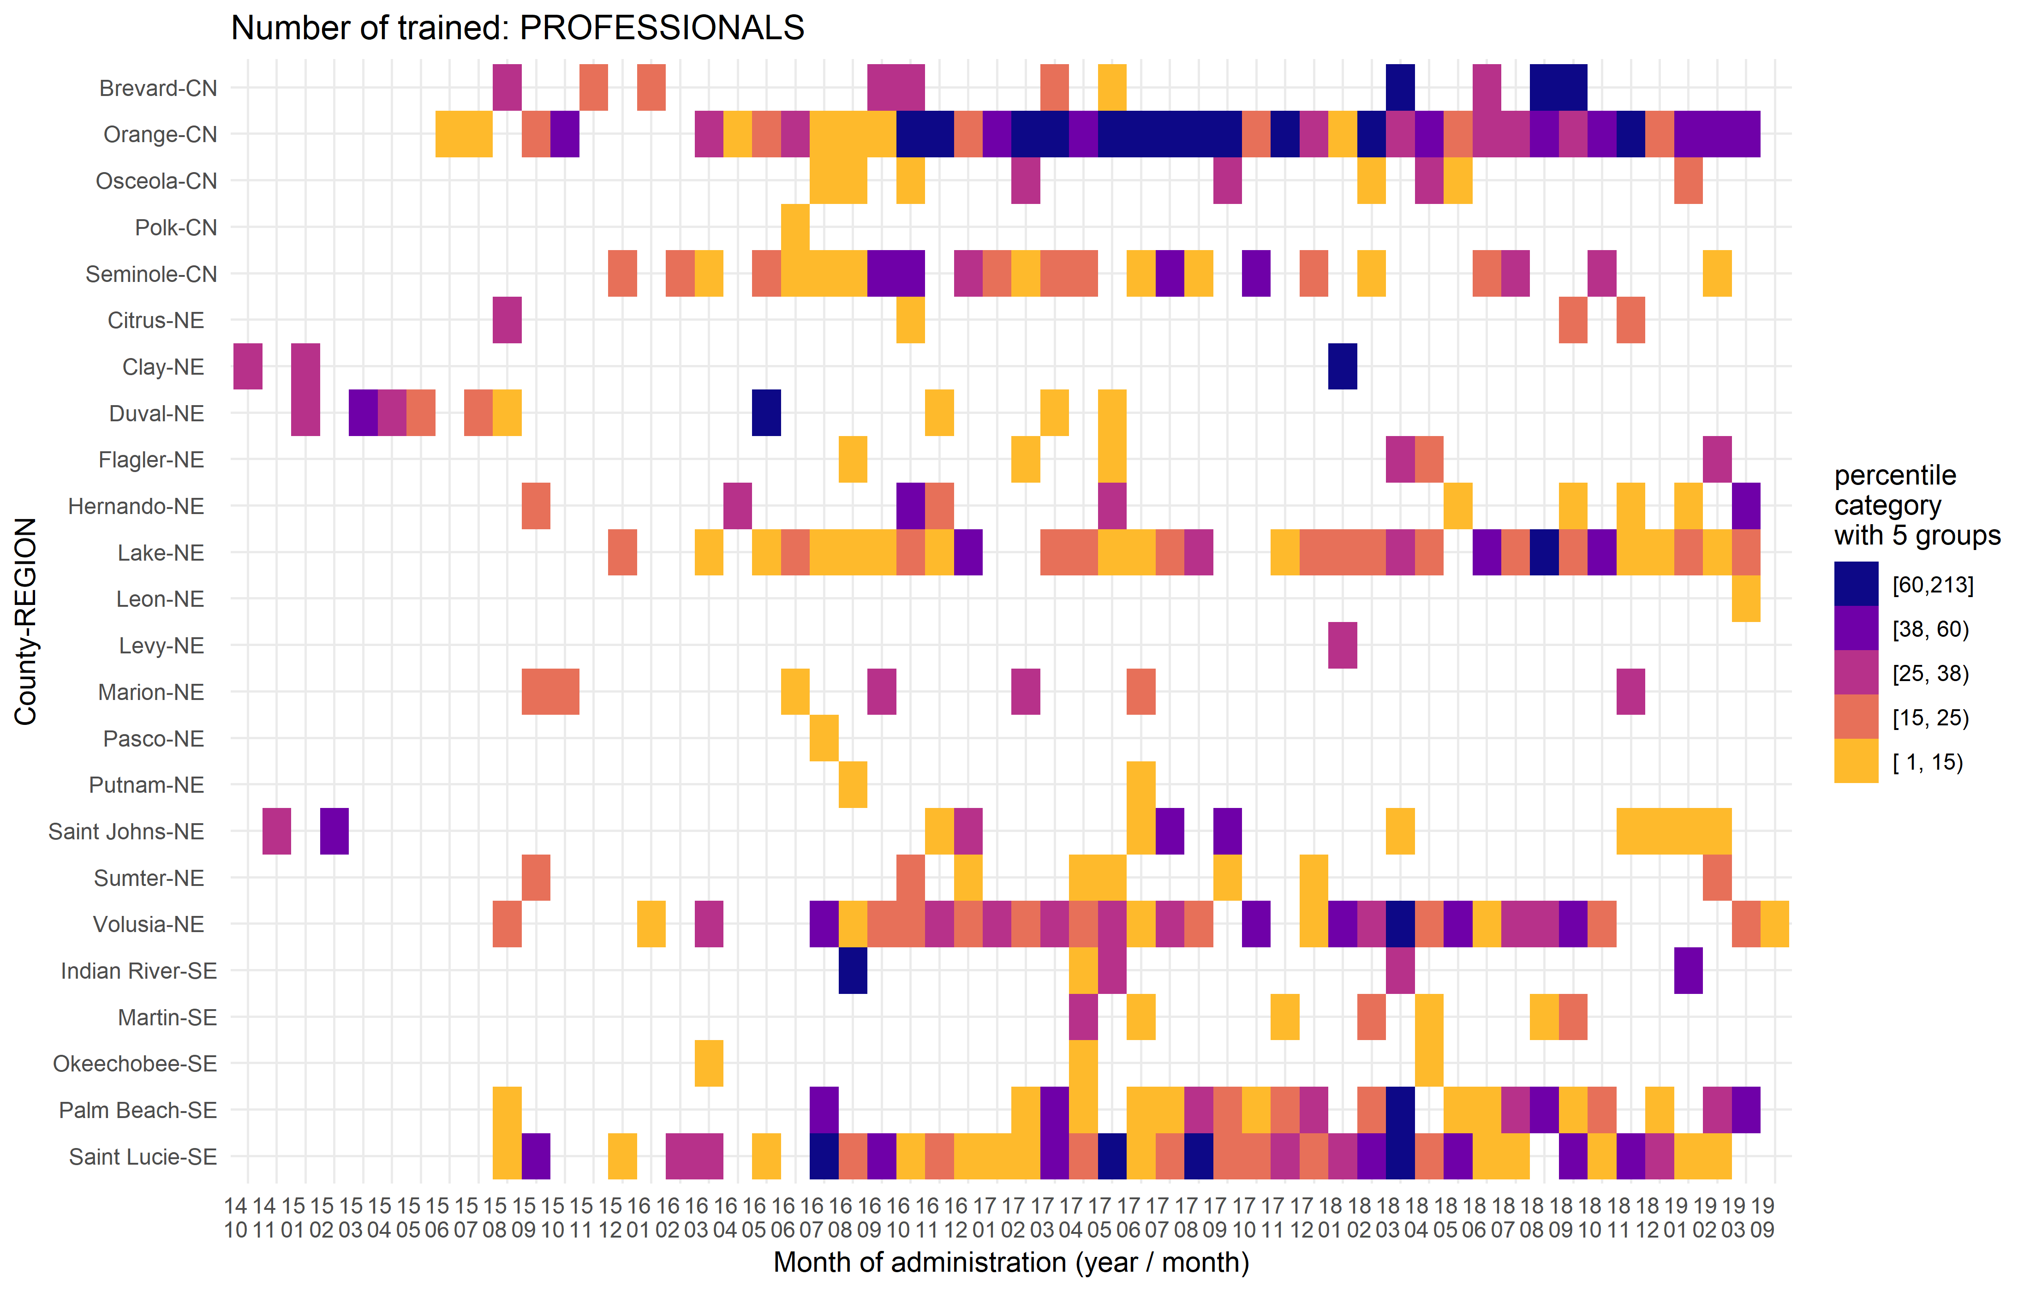

## Community

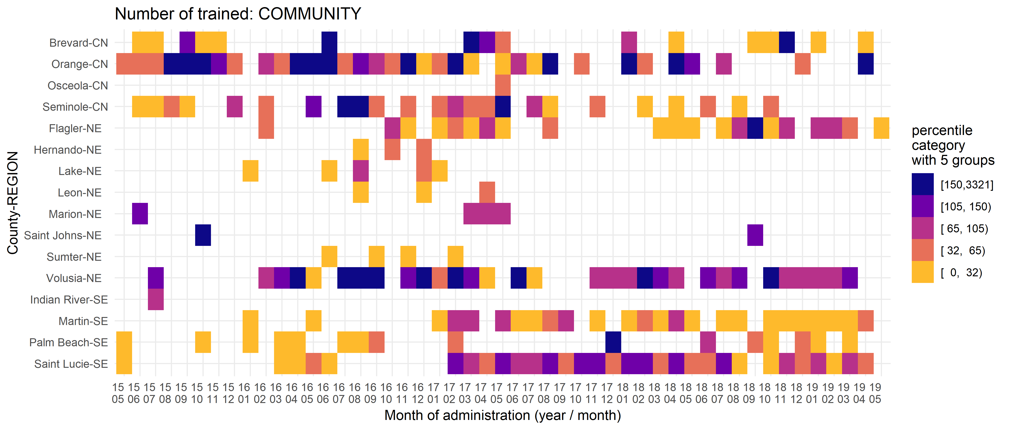

# V Accumulation

## Community + Professionals

### Raw

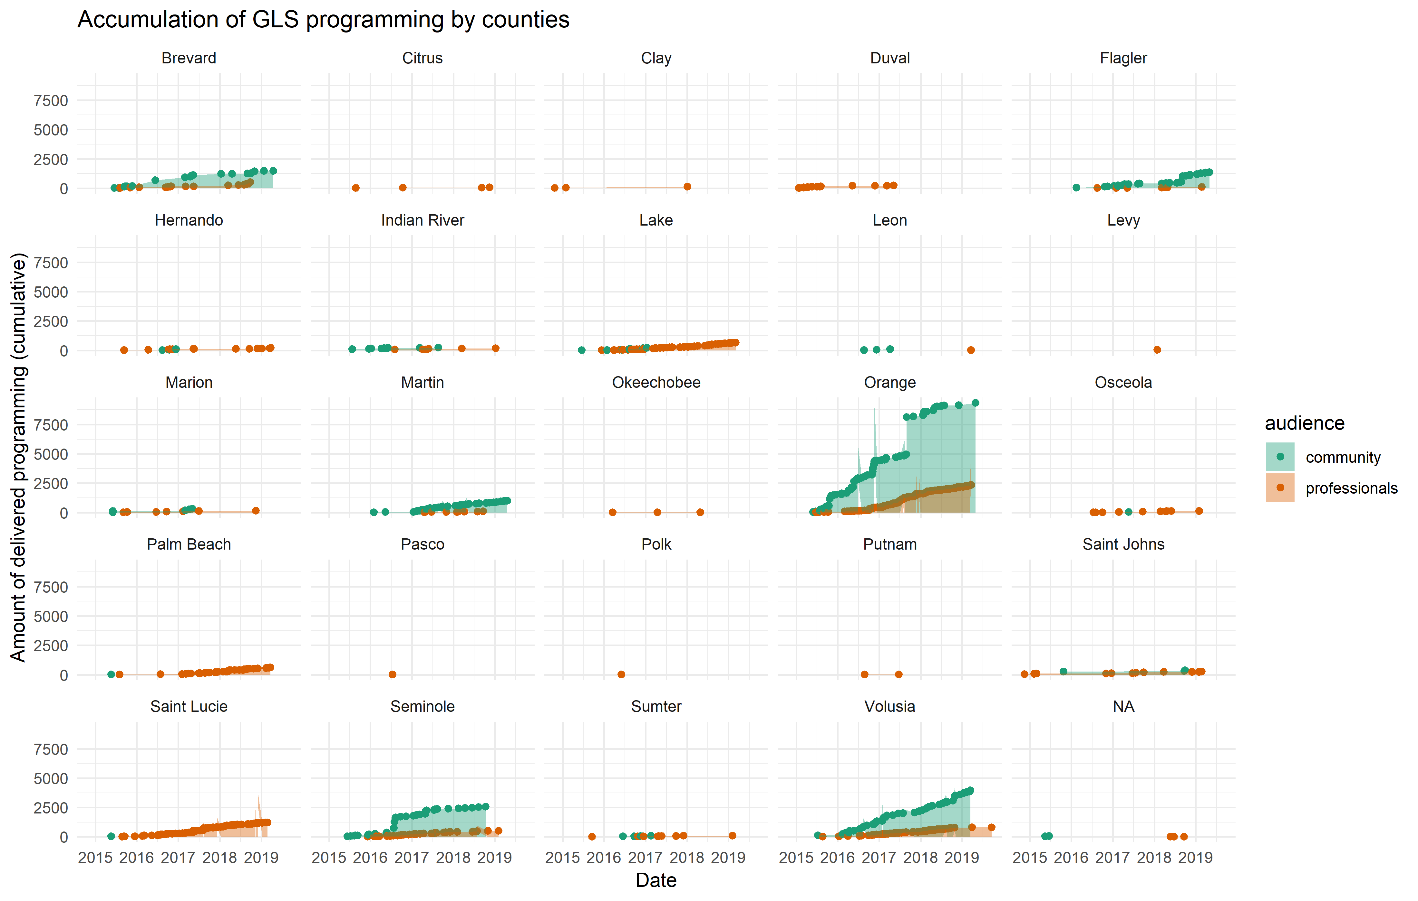

### Free Scale

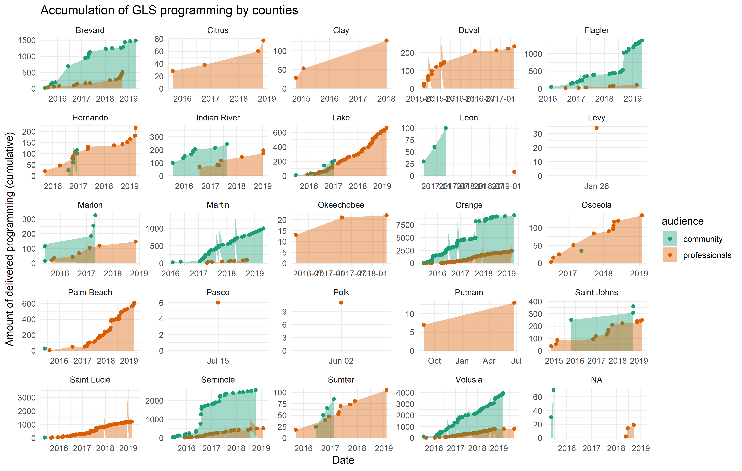

## Community

### Raw

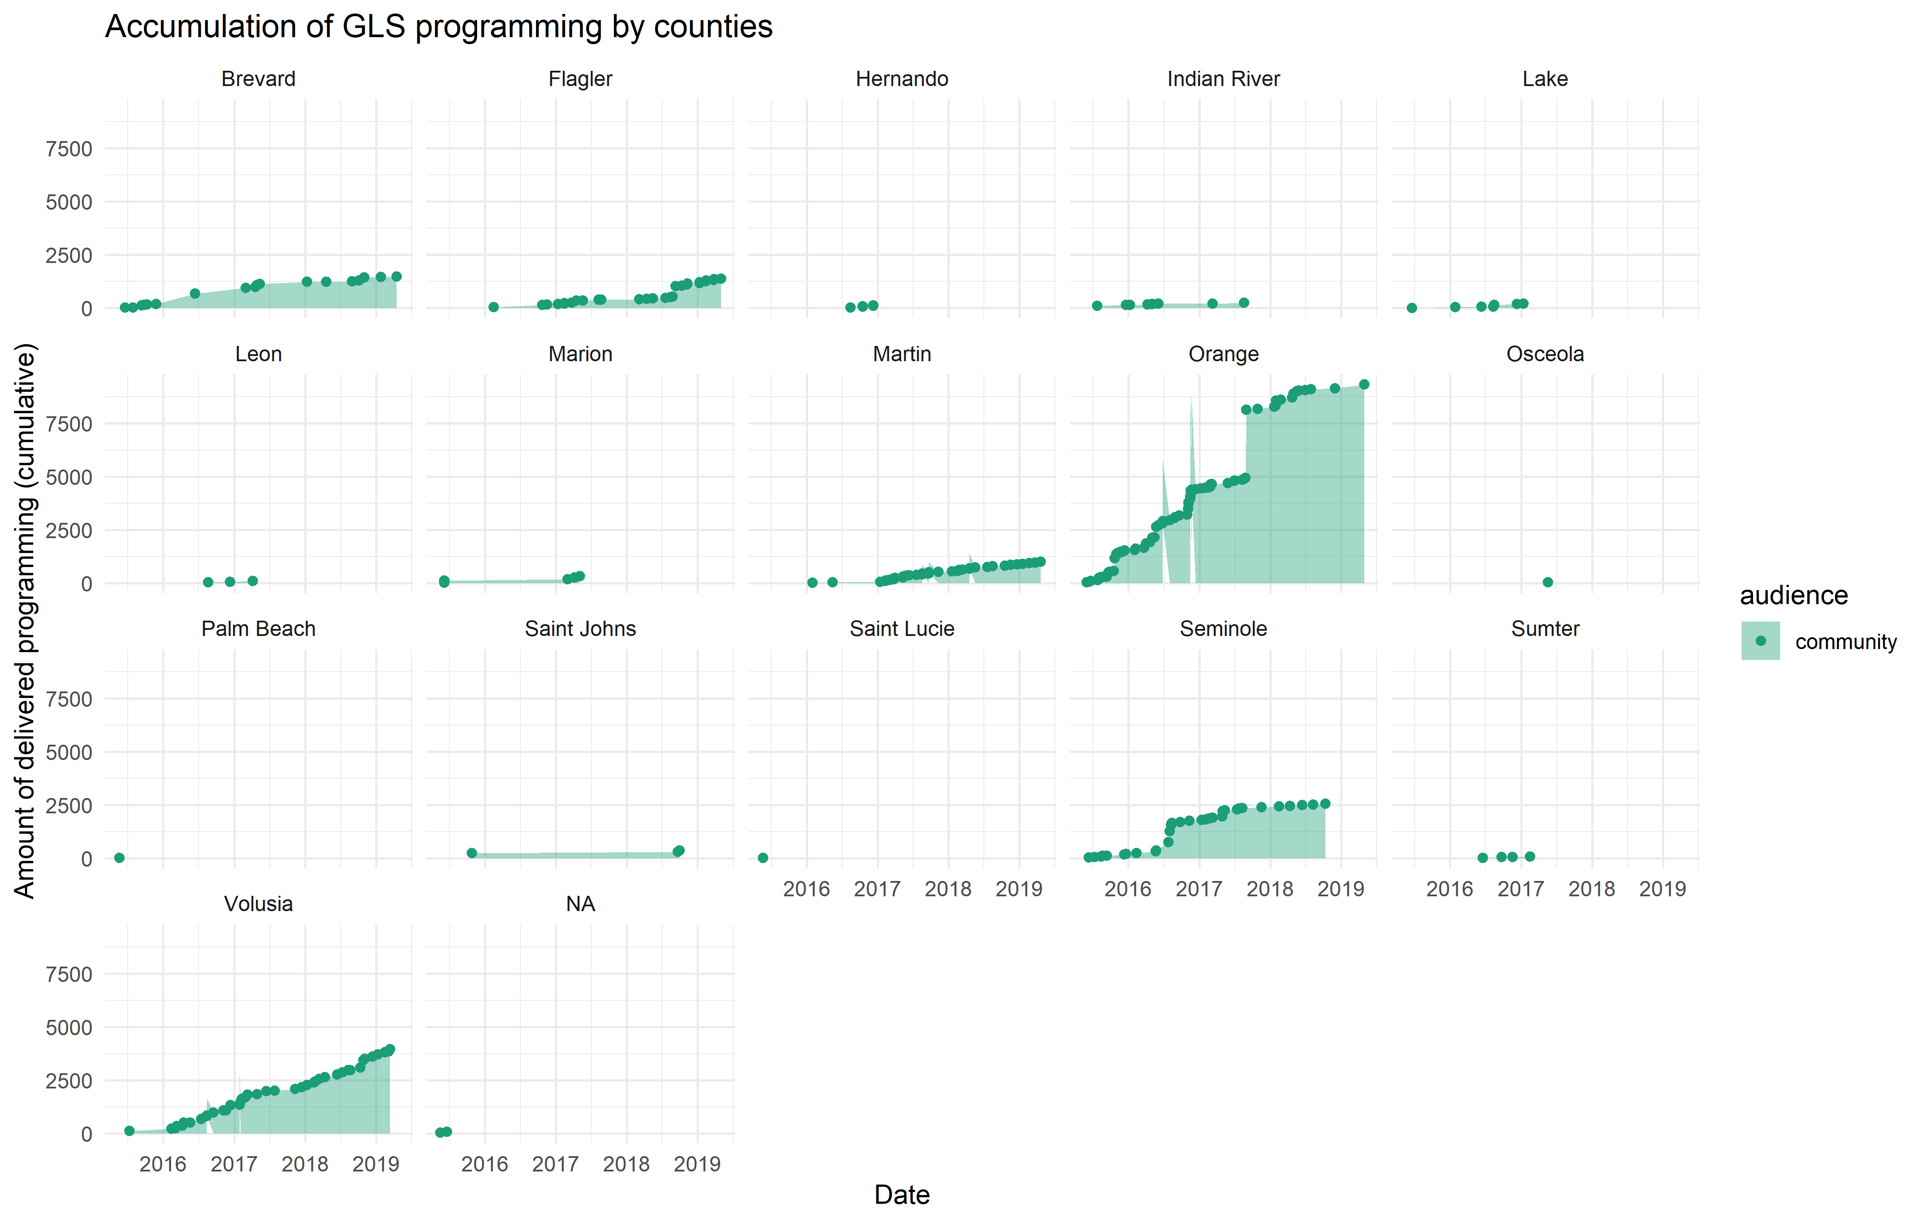

### Free Scale

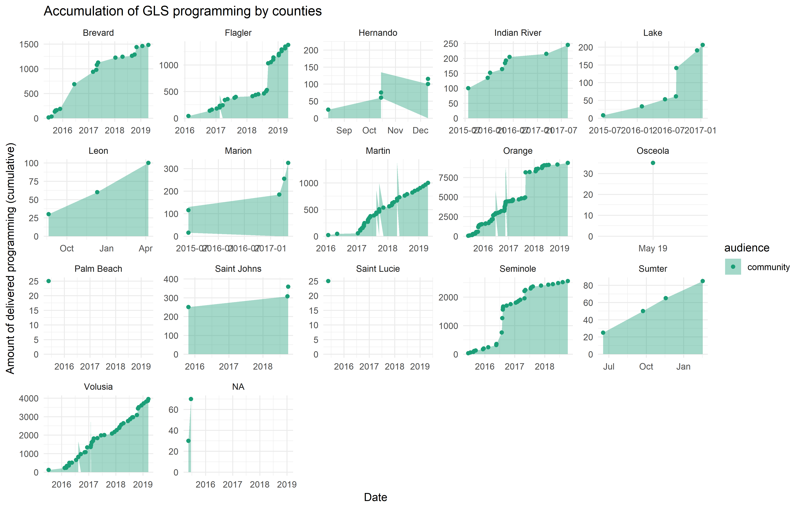

## Professionals

### Raw

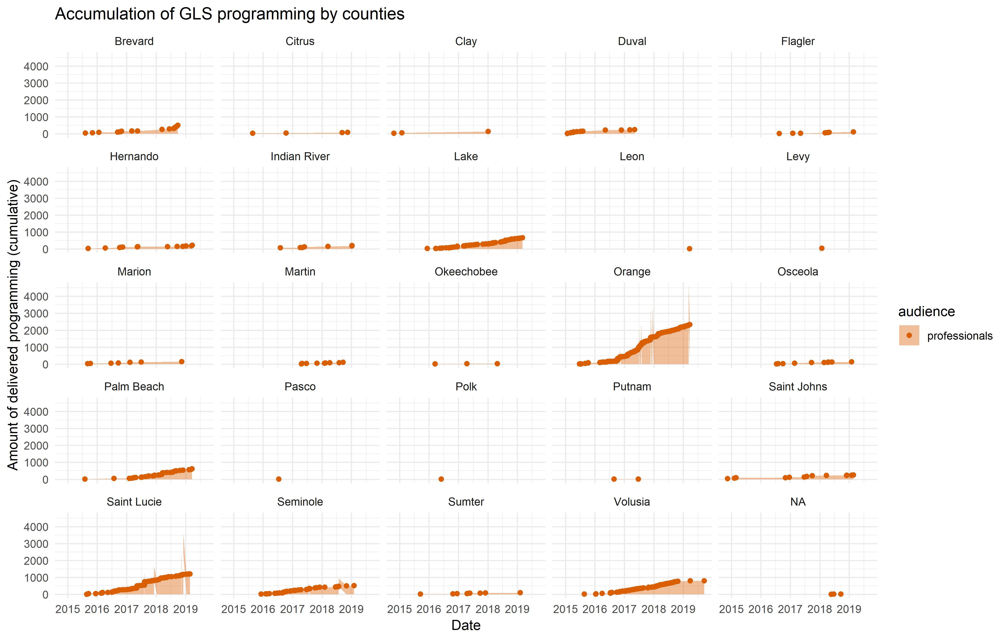

### Free Scale

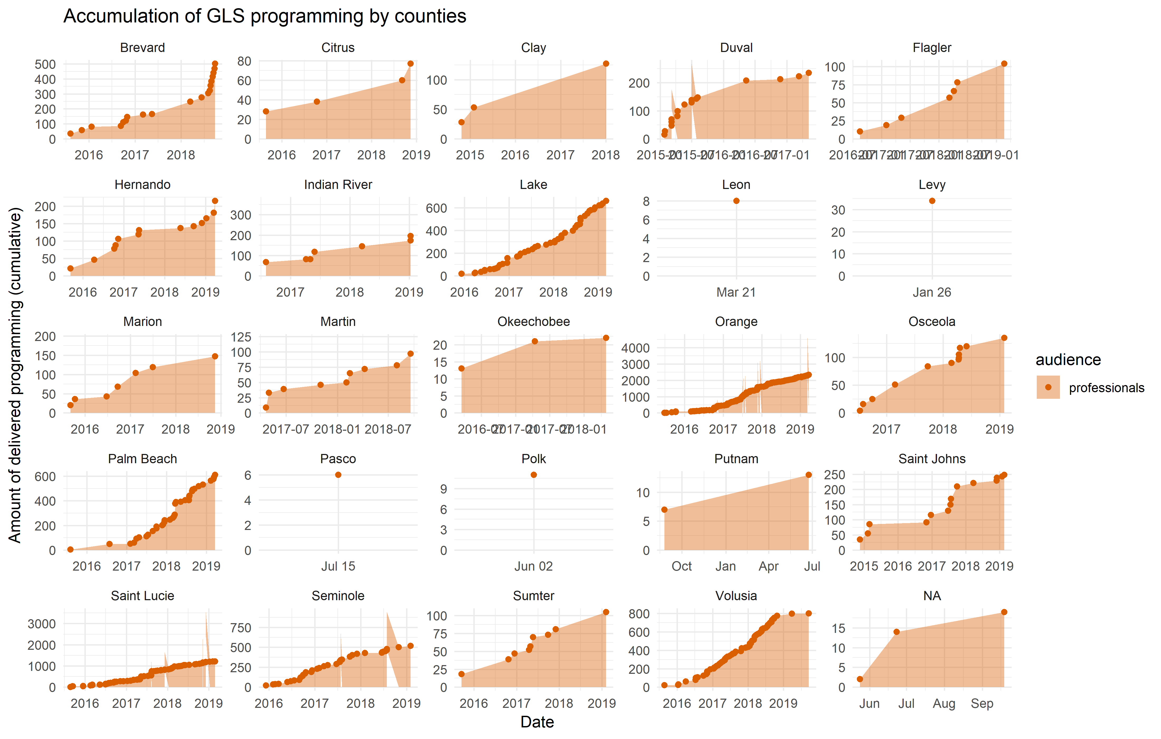

# III. Recapitulation

* **Orange** county received the most of GLS programming (1-scatter](#1_county_scatter))
  + The next cluser of counties with high programming:
    - **Volusia** + **St Lucie**
    - **Palrm Beach** + **Brevard** + **Seminole**
    - **Lake**

# Session Information

For the sake of documentation and reproducibility, the current report was rendered in the following environment. Click the line below to expand.

Environment

- Session info -------------------------------------------------------------------------------------------------------  
 setting value   
 version R version 3.5.2 (2018-12-20)  
 os Windows 10 x64   
 system x86_64, mingw32   
 ui RTerm   
 language (EN)   
 collate English_United States.1252   
 ctype English_United States.1252   
 tz America/Los_Angeles   
 date 2019-06-28   
  
- Packages -----------------------------------------------------------------------------------------------------------  
 package * version date lib source   
 abind 1.4-5 2016-07-21 [1] CRAN (R 3.5.2)  
 acepack 1.4.1 2016-10-29 [1] CRAN (R 3.5.3)  
 assertthat 0.2.1 2019-03-21 [1] CRAN (R 3.5.3)  
 backports 1.1.4 2019-04-10 [1] CRAN (R 3.5.3)  
 base64enc 0.1-3 2015-07-28 [1] CRAN (R 3.5.2)  
 callr 3.2.0 2019-03-15 [1] CRAN (R 3.5.3)  
 car 3.0-3 2019-05-27 [1] CRAN (R 3.5.3)  
 carData 3.0-2 2018-09-30 [1] CRAN (R 3.5.2)  
 cellranger 1.1.0 2016-07-27 [1] CRAN (R 3.5.3)  
 checkmate 1.9.3 2019-05-03 [1] CRAN (R 3.5.3)  
 cli 1.1.0 2019-03-19 [1] CRAN (R 3.5.3)  
 cluster 2.0.9 2019-05-01 [1] CRAN (R 3.5.3)  
 codetools 0.2-16 2018-12-24 [1] CRAN (R 3.5.2)  
 colorspace 1.4-1 2019-03-18 [1] CRAN (R 3.5.3)  
 crayon 1.3.4 2017-09-16 [1] CRAN (R 3.5.3)  
 curl 3.3 2019-01-10 [1] CRAN (R 3.5.3)  
 data.table 1.12.2 2019-04-07 [1] CRAN (R 3.5.3)  
 desc 1.2.0 2018-05-01 [1] CRAN (R 3.5.3)  
 devtools 2.0.2 2019-04-08 [1] CRAN (R 3.5.3)  
 digest 0.6.19 2019-05-20 [1] CRAN (R 3.5.3)  
 dplyr * 0.8.1 2019-05-14 [1] CRAN (R 3.5.3)  
 DT 0.6 2019-05-09 [1] CRAN (R 3.5.3)  
 evaluate 0.14 2019-05-28 [1] CRAN (R 3.5.2)  
 explore 0.4.2 2019-05-22 [1] CRAN (R 3.5.3)  
 fansi 0.4.0 2018-10-05 [1] CRAN (R 3.5.3)  
 forcats 0.4.0 2019-02-17 [1] CRAN (R 3.5.3)  
 foreign 0.8-71 2018-07-20 [2] CRAN (R 3.5.2)  
 Formula 1.2-3 2018-05-03 [1] CRAN (R 3.5.2)  
 fs 1.3.1 2019-05-06 [1] CRAN (R 3.5.3)  
 ggplot2 * 3.1.1 2019-04-07 [1] CRAN (R 3.5.3)  
 ggpubr * 0.2 2018-11-15 [1] CRAN (R 3.5.3)  
 glue 1.3.1 2019-03-12 [1] CRAN (R 3.5.3)  
 gridExtra 2.3 2017-09-09 [1] CRAN (R 3.5.3)  
 gtable 0.3.0 2019-03-25 [1] CRAN (R 3.5.3)  
 haven 2.1.0 2019-02-19 [1] CRAN (R 3.5.3)  
 highr 0.8 2019-03-20 [1] CRAN (R 3.5.3)  
 Hmisc 4.2-0 2019-01-26 [1] CRAN (R 3.5.3)  
 hms 0.4.2 2018-03-10 [1] CRAN (R 3.5.3)  
 htmlTable 1.13.1 2019-01-07 [1] CRAN (R 3.5.3)  
 htmltools 0.3.6 2017-04-28 [1] CRAN (R 3.5.3)  
 htmlwidgets 1.3 2018-09-30 [1] CRAN (R 3.5.3)  
 httpuv 1.5.1 2019-04-05 [1] CRAN (R 3.5.3)  
 httr 1.4.0 2018-12-11 [1] CRAN (R 3.5.3)  
 kableExtra 1.1.0 2019-03-16 [1] CRAN (R 3.5.3)  
 knitr * 1.23 2019-05-18 [1] CRAN (R 3.5.2)  
 labeling 0.3 2014-08-23 [1] CRAN (R 3.5.2)  
 later 0.8.0 2019-02-11 [1] CRAN (R 3.5.3)  
 lattice 0.20-38 2018-11-04 [2] CRAN (R 3.5.2)  
 latticeExtra 0.6-28 2016-02-09 [1] CRAN (R 3.5.3)  
 lazyeval 0.2.2 2019-03-15 [1] CRAN (R 3.5.3)  
 lubridate 1.7.4 2018-04-11 [1] CRAN (R 3.5.3)  
 magrittr * 1.5 2014-11-22 [1] CRAN (R 3.5.3)  
 Matrix 1.2-17 2019-03-22 [1] CRAN (R 3.5.3)  
 memoise 1.1.0 2017-04-21 [1] CRAN (R 3.5.3)  
 mime 0.6 2018-10-05 [1] CRAN (R 3.5.2)  
 munsell 0.5.0 2018-06-12 [1] CRAN (R 3.5.3)  
 nnet 7.3-12 2016-02-02 [2] CRAN (R 3.5.2)  
 openxlsx 4.1.0.1 2019-05-28 [1] CRAN (R 3.5.3)  
 pillar 1.4.1 2019-05-28 [1] CRAN (R 3.5.2)  
 pkgbuild 1.0.3 2019-03-20 [1] CRAN (R 3.5.3)  
 pkgconfig 2.0.2 2018-08-16 [1] CRAN (R 3.5.3)  
 pkgload 1.0.2 2018-10-29 [1] CRAN (R 3.5.3)  
 plyr 1.8.4 2016-06-08 [1] CRAN (R 3.5.3)  
 prettyunits 1.0.2 2015-07-13 [1] CRAN (R 3.5.3)  
 processx 3.3.1 2019-05-08 [1] CRAN (R 3.5.2)  
 promises 1.0.1 2018-04-13 [1] CRAN (R 3.5.3)  
 pryr 0.1.4 2018-02-18 [1] CRAN (R 3.5.3)  
 ps 1.3.0 2018-12-21 [1] CRAN (R 3.5.3)  
 purrr 0.3.2 2019-03-15 [1] CRAN (R 3.5.3)  
 R6 2.4.0 2019-02-14 [1] CRAN (R 3.5.3)  
 RColorBrewer 1.1-2 2014-12-07 [1] CRAN (R 3.5.2)  
 Rcpp 1.0.1 2019-03-17 [1] CRAN (R 3.5.3)  
 readr 1.3.1 2018-12-21 [1] CRAN (R 3.5.3)  
 readxl 1.3.1 2019-03-13 [1] CRAN (R 3.5.3)  
 remotes 2.0.4 2019-04-10 [1] CRAN (R 3.5.3)  
 reshape2 1.4.3 2017-12-11 [1] CRAN (R 3.5.3)  
 rio 0.5.16 2018-11-26 [1] CRAN (R 3.5.3)  
 rlang 0.3.4 2019-04-07 [1] CRAN (R 3.5.3)  
 rmarkdown 1.13 2019-05-22 [1] CRAN (R 3.5.3)  
 rpart 4.1-15 2019-04-12 [1] CRAN (R 3.5.3)  
 rprojroot 1.3-2 2018-01-03 [1] CRAN (R 3.5.3)  
 rstudioapi 0.10 2019-03-19 [1] CRAN (R 3.5.3)  
 rvest 0.3.4 2019-05-15 [1] CRAN (R 3.5.3)  
 scales 1.0.0 2018-08-09 [1] CRAN (R 3.5.3)  
 sessioninfo 1.1.1 2018-11-05 [1] CRAN (R 3.5.3)  
 shiny 1.3.2 2019-04-22 [1] CRAN (R 3.5.2)  
 stringi 1.4.3 2019-03-12 [1] CRAN (R 3.5.3)  
 stringr 1.4.0 2019-02-10 [1] CRAN (R 3.5.3)  
 survival 2.44-1.1 2019-04-01 [1] CRAN (R 3.5.3)  
 tibble 2.1.3 2019-06-06 [1] CRAN (R 3.5.3)  
 tidyr 0.8.3 2019-03-01 [1] CRAN (R 3.5.3)  
 tidyselect 0.2.5 2018-10-11 [1] CRAN (R 3.5.3)  
 usethis 1.5.0 2019-04-07 [1] CRAN (R 3.5.3)  
 utf8 1.1.4 2018-05-24 [1] CRAN (R 3.5.3)  
 vctrs 0.1.0 2018-11-29 [1] CRAN (R 3.5.3)  
 viridisLite 0.3.0 2018-02-01 [1] CRAN (R 3.5.3)  
 webshot 0.5.1 2018-09-28 [1] CRAN (R 3.5.3)  
 withr 2.1.2 2018-03-15 [1] CRAN (R 3.5.3)  
 xfun 0.7 2019-05-14 [1] CRAN (R 3.5.3)  
 xml2 1.2.0 2018-01-24 [1] CRAN (R 3.5.3)  
 xtable 1.8-4 2019-04-21 [1] CRAN (R 3.5.3)  
 yaml 2.2.0 2018-07-25 [1] CRAN (R 3.5.2)  
 zeallot 0.1.0 2018-01-28 [1] CRAN (R 3.5.3)  
 zip 2.0.2 2019-05-13 [1] CRAN (R 3.5.3)  
 zoo 1.8-6 2019-05-28 [1] CRAN (R 3.5.2)  
  
[1] C:/Users/an499583/Documents/R/win-library/3.5  
[2] C:/Program Files/R/R-3.5.2/library

Report rendered by an499583 at 2019-06-28, 11:17 -0700 in 38 seconds.